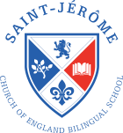

Dear Parents

Thank you for participating in our non-uniform day on Friday, the children were very excited to have the opportunity to wear their own clothes.
We greatly appreciate the bottle donations and the voluntary contributions that we have received from the children.

Our Christmas Bazaar only has five days to go!!! Preparations are well underway. This year our St. Jérôme Christmas Bazaar will be held on two floors, we will have the opportunity to start decorating the halls, Christmas trees and all available spaces. We have been advised that the school will provide access to the following floors:

- 2nd Floor on Thursday 14th December 2017 from 11am – 5:30pm
- Ground Floor on Friday 15th December 2017 from 1:15pm – 5:30pm

All help will be greatly appreciated, please do let us and your class reps know if you are able to assist with the set up or clear up of the Christmas Bazaar.

Posters

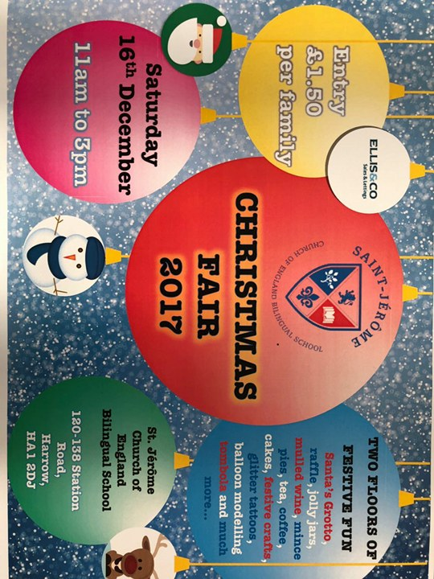
Ellis & Co have kindly agreed to print our posters advertising the Christmas Bazaar. The posters are available in reception please feel free to take a few of the posters and distribute these at any of your local venues i.e. local supermarkets, libraries, playgroups, church halls etc.

Raffle Tickets

Our raffle tickets are ready and raring to go. The tickets were put into our children’s school bags on Friday please can you sell these to your friends and family in preparation for the draw to be held at the Christmas Bazaar. Should you require more tickets these will be available from the School Office. The price per ticket is £1.50. Please return your counterfoils, monies you have collected and any unsold tickets to the School Office by Wednesday 13th December.
We have some amazing prizes a Samsung Galaxy Tablet, Christmas Hampers, Tickets to a soft play area, a free facial, a free class a Harrow Leisure, tickets to Fresh Art School to name a few.

Cake stall
The cake stall needs your cakes, so budding Mary Berry’s out there get your baking gloves on. The cake stall needs:
- Lemon Drizzle | - Red Velvet
- Brownies | - Clementine cake
- Shortbread | - Fairy Cakes
- Fruit cake | - Victoria sponge
- Banana bread | - Cupcakes
- Biscuits | - Chocolate cake
- Carrot cake

Please bring your cakes into school at 10:00am on the 16th December.
PLEASE ENSURE THAT ALL CAKES/BISCUITS DO NOT CONTAIN ANY NUTS OR NUT PRODUCTS (ALMOND FLOUR ETC). Please provide labels with your cakes and biscuits detailing all ingredients and potential allergens such as gluten, eggs, dairy and soya. This is not an exhaustive list please feel free to bake as you wish. Thank you for all your support.
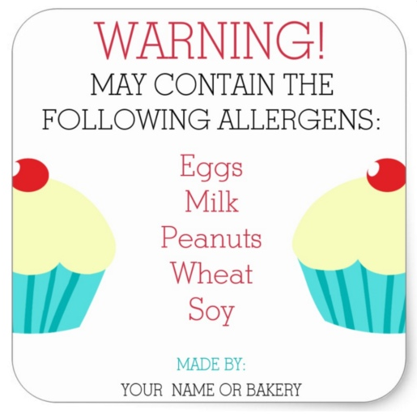
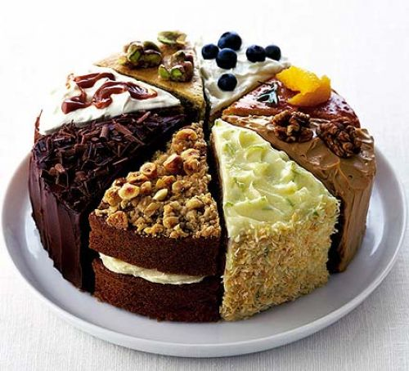

Santa’s Grotto
We are pleased to announce that Santa Claus will be visiting us for the Christmas Bazaar. Children will be able to visit Santa’s grotto and receive a gift. During the week before the bazaar, we will be at school pick up and drop off, so you can book a time slot. Visits to the grotto will cost £3.50 per child (£5 for two siblings, £6 for three) – payment on booking. Santa has a busy month so book early to avoid disappointment!

Thank you
Your PTFA

