Content of St Jérôme TV, hosted by Camembear and Madame Chadier

Autumn 1  2016 | French Lyrics and expressions | Literal translation and explanation | Explanation | Extra notes
Épisode 1 | Bonjour ! | Hello actually means good day. | That’s why we sign the word good and the word day | Bonjour is used all day in France up to the evening.
 | À la queue leu leu | In a line | The word queue comes from the French, meaning tail | This is a familiar and informal French quirky expression for classroom management and practising the vowel “a” and “e”.
 | Marche, marche, lentement | Walk, walk  slowly | The word marching in English is similar | The imperative of the verb in the singular is useful here, as if the pronoun “je” is added in the front, we can say “I walk”
Épisode 2 | Mes petites mains font tap, tap, tap  Mes petits pieds font paf, paf, paf  Un, deux, trois  Un, deux, trois  Trois petits tours et puis s’en va | My little hands do tap, tap, tap  My little feet do paf, paf, paf  One, two, three,  One, two, three  Three little turns and then go away | This is a very well-known traditional French nursery rhyme. Children can join at all levels, first just copying the gestures before being more confident to lead the song themselves | Children find the movement very amusing, especially the disappearing of the hands at the back
 | Rangeons, rangeons  La salle de classe | Let’s tidy up, let’s tidy up  The classroom | Great classroom routine song from www.sparklespeak.org.uk  Song and instrumental version available | At home, you can change “la salle de classe” to “la maison” or “la chambre”.
Épisode 3 | C’est midi, c’est midi  À table allons-y !  J’ai faim, miam, miam, miam  Bon appétit ! | It’s midday, it’s midday !  To the table, let’s go !  I am hungry, miam, miam, miam  Enjoy your meal ! | Midday and lunchtime as words are interchangeable in French.  Another great classroom routine song from www.sparklespeak.org.uk  Song and instrumental version available | A pupil has already succeeded at being humorous and tricking me, telling me just after lunch “j’ai faim”, with a big grin on his face! A real treat!  Pupils are only invited to start eating when everybody has been served and we all have wished “bon appétit” to each other.
 | Bonnes vacances ! | Good holidays ! | Please share with us when your children use French at home! | It makes us so happy!
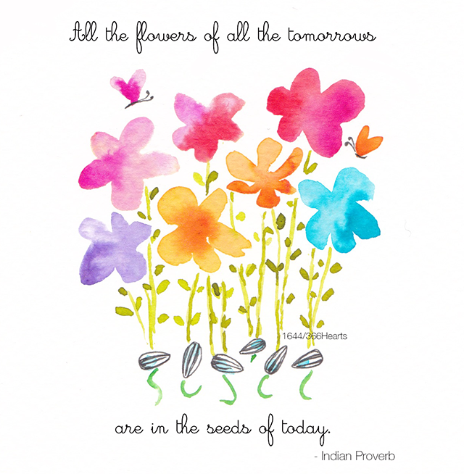
Illustration by Hazel McNab www.hazelmcnab.com and here is a link to receive an inspiring heart a day http://366hearts.com/, also on Facebook
Camembear resources can be found on www.headstartlanguages.co.uk

