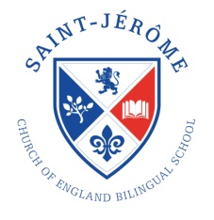
St Jérôme Church of England Bilingual School
Supplementary Application Form
For entry to Reception in September 2020
This form should be completed by any applicants who want to apply for a Foundation place at St Jérôme Church of England Bilingual School. Section A should be completed by the Parent/Guardian and Section B by a member of the Clergy.
Section A (to be completed by the parent/ guardian)

Child’s First Name(s) |  |  |  |  |  | Child’s Surname
Child’s Home Address
 |  |  |  |  |  |  | Full Postcode
Parent/ Carer |  | Title |  |  |  |  |  | First name or initial
Surname |  |  |  |  |  |  |  | Relationship to Child
Daytime phone |  |  | Mobile phone |  |  |  |  | Email

Section B (to be completed by a member of the clergy)

Note to clergy: The Governors, in association with the London Diocesan Board for Schools, would be most grateful if you could provide the following information so that we can allocate the Foundation places in line with the School’s Admissions Policy.

Name of Clergy |  |  | Phone number
Name of Church |  |  | Email address
Church Address

Is your Church either a full or associate member of Churches Together in Britain and Ireland or the Evangelical Alliance? Please circle  YES / NO | Has the child attended a church service with a parent, carer or guardian for at least two years on at least two occasions per month? Please circle  YES / NO

SIGNED: ............................................................................. DATE: .......................................................
(Signature of Clergy)

Return forms to office@stjeromebilingual.org or St Jérôme Church of England Bilingual School, 120-138 Station Road, Harrow, Middlesex, HA1 2DJ. The closing date is 15 January 2020. Information supplied will be used for registered purposes under the Data Protection Act 1998.

