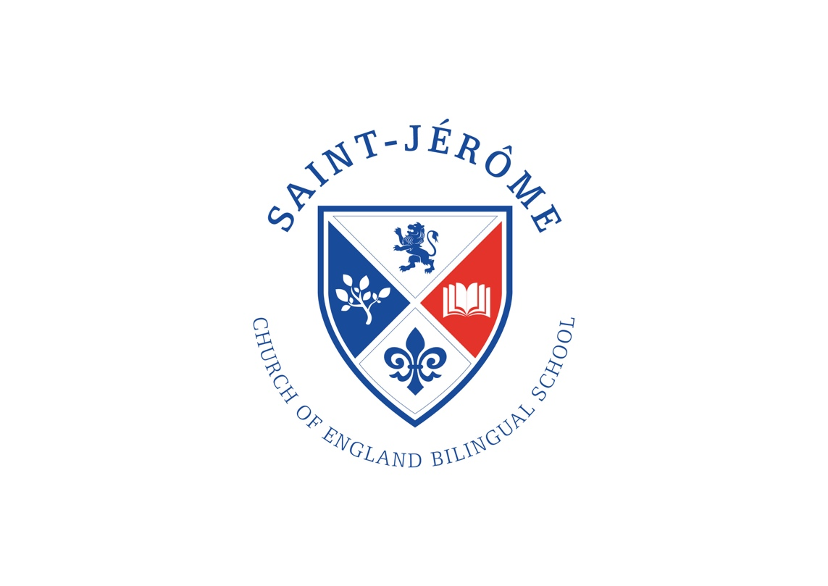

St. Jérôme Church of England
Bilingual School

Packed Lunch Policy

Aims
To ensure that we are giving consistent messages about food and health:
- To contribute to pupils’ health and wellbeing.
- To educate pupils about healthy choices.
- To promote consistency between packed lunch and school lunch.
- To improve the environment in respect to litter.
- To support the academies to maintain Healthy School status.

The Packed Lunch Policy Applies to:
- To all Year 3 pupils and their parents/carers providing packed lunches to be consumed within school or
- on a school trip during normal school hours.
- To all pupils eating snacks before and after school while on school grounds.
- To all staff eating a packed lunch within school or on a school trip during normal school hours in the presence of pupils.
Our school will:
- Ensure that fresh drinking water is available at lunchtime.
- Provide appropriate dining facilities for all pupils who bring a packed lunch.
- Work with parents to ensure packed lunches abide by the standards listed below.

EVERY DAY your packed lunch should include:
- At least one portion of a vegetable (carrot sticks, cucumber sticks, small tomato, lettuce).
- At least one portion of fruit (small apple, small banana, kiwi, grapes).
- Meat, fish or another source of non-dairy protein (lentils, chickpeas, humus, falafel).
- A starchy item, such as bread, pasta, rice, couscous, noodles or potatoes.
- A dairy food such as cheese, yoghurt, fromage frais or custard.
- A drink, such as water, semi-skimmed milk or a yoghurt drink.

Packed lunches should NOT include:
- Confectionery, such as chocolate bars and sweets.
- Nuts and nut products (we have a number of children with nut allergies in our school).
- Snacks, such as crisps should only be included occasionally.
- Meat type products, such as sausage rolls, pasties, individual pies and sausages should only be included occasionally.
- Cakes and biscuits are allowed but encourage your child to eat theses only as a part of a balanced meal.
- Fizzy drinks or drinks with a high sugar content.

Our school understands that some pupils may require special diets for medical or religious reasons that do not allow the standards to be met exactly. In this case parents are urged to be responsible in ensuring that packed lunches are as healthy as possible.

Parents / Carers are required to acknowledge the following:
- The school cannot provide refrigeration
- The school cannot reheat food
- Pupils must be able to open independently all items in their packed lunch e.g. yoghurt pots
- Under no circumstances should children share, swap or exchange the contents of their packed lunch with another child
- Packed lunches must be provided in a suitable lunch box and clearly labelled
- All food waste and wrappings will be sent home to enable parents to establish what their child has eaten
- Under no circumstances should parents provide a ‘take away’ meal

Working with Parents and Carers
Working with parents/carers is a vital part of our school’s ethos to food education and a necessary pre-requisite to achieving Healthy Schools and Rights Respecting Schools awards. Our school believes that our partnership with parents/carers enables us to plan the best possible food education and provision for our pupils.

Please return this reply slip to the School Office

I acknowledge the contents of the St. Jérôme Packed Lunch Policy and confirm we will adhere to the contents and that I have discussed this policy with my child(ren).

Signed: Date:

Parent of: Class:

