Our Planet
A Multilingual Poetry Workshop and Digital Storytelling Festival 2020

Aims of the digital storytelling project
- Connect children and young people with their environment, cultural heritage, and languages through telling stories that matter.
- Develop children’s imagination, creativity and multilingual repertories.
- Improve children’s communication skills and their ability to make meaning through narrative and still/moving images.
- Enable creative and critical use of digital technology to transform stories.
- Encourage critical thinking, active citizenship and international partnerships.

Stages of the project
The Teachers’ Handbook provides practical guidance for embedding multilingual digital storytelling work within a thematic unit of work and planning the following stages:
- Pre-production
- Production
- Post-production
https://goldsmithsmdst.com/handbook/

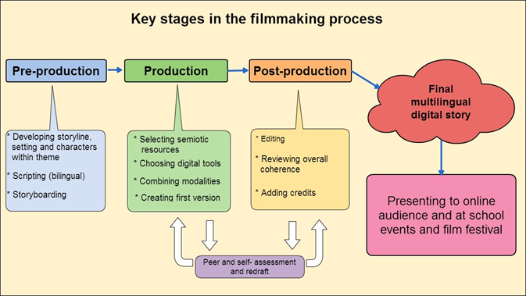

Timeline for participation in the multilingual digital storytelling festival 2020
- Planning for the project - start to look for stories and resources linked with the theme of the environment – Our Planet (November – December 2019).
- Pre-production – start work with the children on creating and transforming the stories (January- March 2020).
- Production – film and edit the digital stories (April – May 2020). Submit the finished digital story (3 – 5 minute story) by Friday 15 May 2020.
- Post-production – present the digital stories at Goldsmiths, University of London on Friday 5 June 2020.
The following are important notes to keep in mind about the project:
- The project theme for 2019-20 is Our Planet. At a time when environmental concerns are more pressing than ever, it is important to offer opportunities for young people both to develop their understanding of the issues locally and globally and to make their voices heard. For example, students could be asked to develop story ideas around any of the following: rewilding and saving species; plastic and food waste; local wildlife story; eco-warrior campaign; designing a city of the future; tree story; walking/cycling to school; bird migration; protecting our rivers and seas. Students may well have other takes and their ideas should be taken on board. The environment is a theme that features as part of the curriculum in most schools and thus may open up opportunities for valuable interdisciplinary collaborations.
- Careful planning is essential to guide students through the stages of developing ideas, storyboarding and scripting, filming, editing, presenting to an audience. Detailed advice is provided in the project’s Handbook for Teachers and in a range of other resources which can be accessed through the Professional Development section of the project website:
https://goldsmithsmdst.com/professional-development/
Teachers will need to take into account students’ language levels and help them to draw on structures and vocabulary that they are already familiar with as well as feeding in some new language. Some examples of language used in digital stories are provided in sections 7 and 12 of the Handbook for Teachers. Digital stories can incorporate poetry and song and this is something that teachers may wish to encourage.
- Please note that the Digital Storytelling Festival 2020 will take place at Goldsmiths, University of London on Friday 5 June 2020 from 1.00 – 4.00 pm. The deadline for submitting films is Friday 15 May 2020. Fuller information about this event will be provided in due course.

- We have recently updated our project website. It includes:
- General information about the project
https://goldsmithsmdst.com/
- A summary of work and links to a sample of films made over the years
https://goldsmithsmdst.com/2019/08/19/project-summary-and-film-sample/
- Guidance and resources for teachers
https://goldsmithsmdst.com/professional-development/

