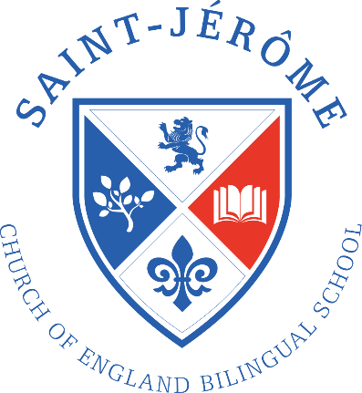
First 45 Key Words for Reception
Red words cannot be decoded using the pure sounds that children learn. They are words that have to be learnt by sight.
I | the | was | said | a
my | we | go | me | you
no | she | are | to | come
all | going | they | he | of
Green words can be segmented and blended using pure sounds, e.g. d-o-g and a-w-ay
away | dog | went | up | is
play | big | look | can | am
mum | like | cat | and | dad
see | on | this | it | at
day | get | yes | for | in

If you have any questions, please speak to your child’s class teacher.

