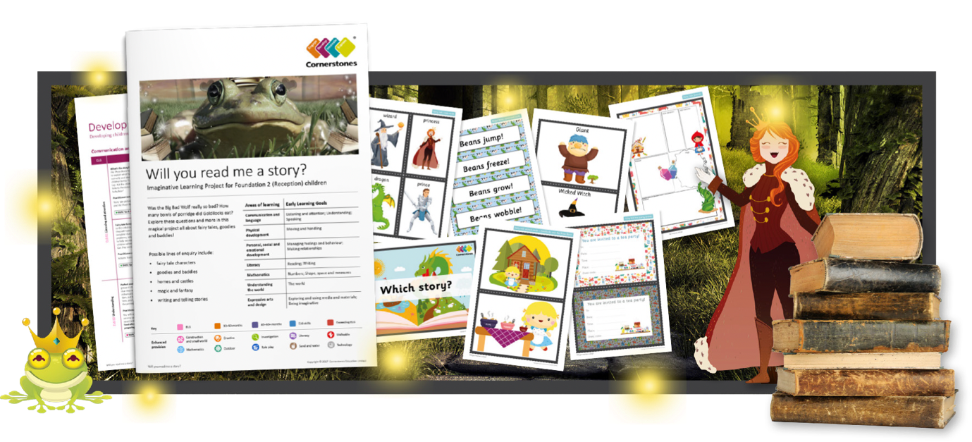
Welcome to the magical world of fairy tales! Was the Big Bad Wolf really so bad? How many bowls of porridge did Goldilocks eat? Let’s find out more about our favourite stories, and discover some new ones.
We will visit a local library or have them come to us to share stories. We’ll look at different character types, and decide whether our favourite characters are ‘goodies’ or ‘baddies’! Using different materials and shapes, we’ll build castles and bridges. We’ll read lots of stories and look at the ingredients that go into a fantastic fairy tale. We’ll be brave explorers and hunt for missing items from fairy tales.
Reading the story of The Elves and the Shoemaker, will encourage us to be busy elves and decorate shoes in our workshop. Contemporary versions of fairy tales will inspire us to write stories, and we’ll create story maps to retell familiar tales. Our mathematical skills will help us to count the buttons on gingerbread men, and estimate how many beans Jack has got! After reading Jack and the beanstalk, we’ll plant seeds and learn how to care for them. We’ll also test the right materials to make a bed for a princess, and houses for the Three Little Pigs.
Areas of learning | Early Learning Goals
Communication and language | Listening and attention; Understanding; Speaking
Physical development | Moving and handling
Personal, social and emotional development | Managing feelings and behaviour; Making relationships
Literacy | Reading; Writing
Mathematics | Numbers; Shape, space and measures
Understanding the world | The world
Expressive arts and design | Exploring and using media and materials; Being imaginative
Help your child prepare for their project
Reading fairy tales can sweep us away into a fantastical world. You could also watch children’s films on this theme and discuss the different types of characters. Alternatively, you could use toys to retell favourite fairy tales.
Copyright © 2017 Cornerstones Education Limited

