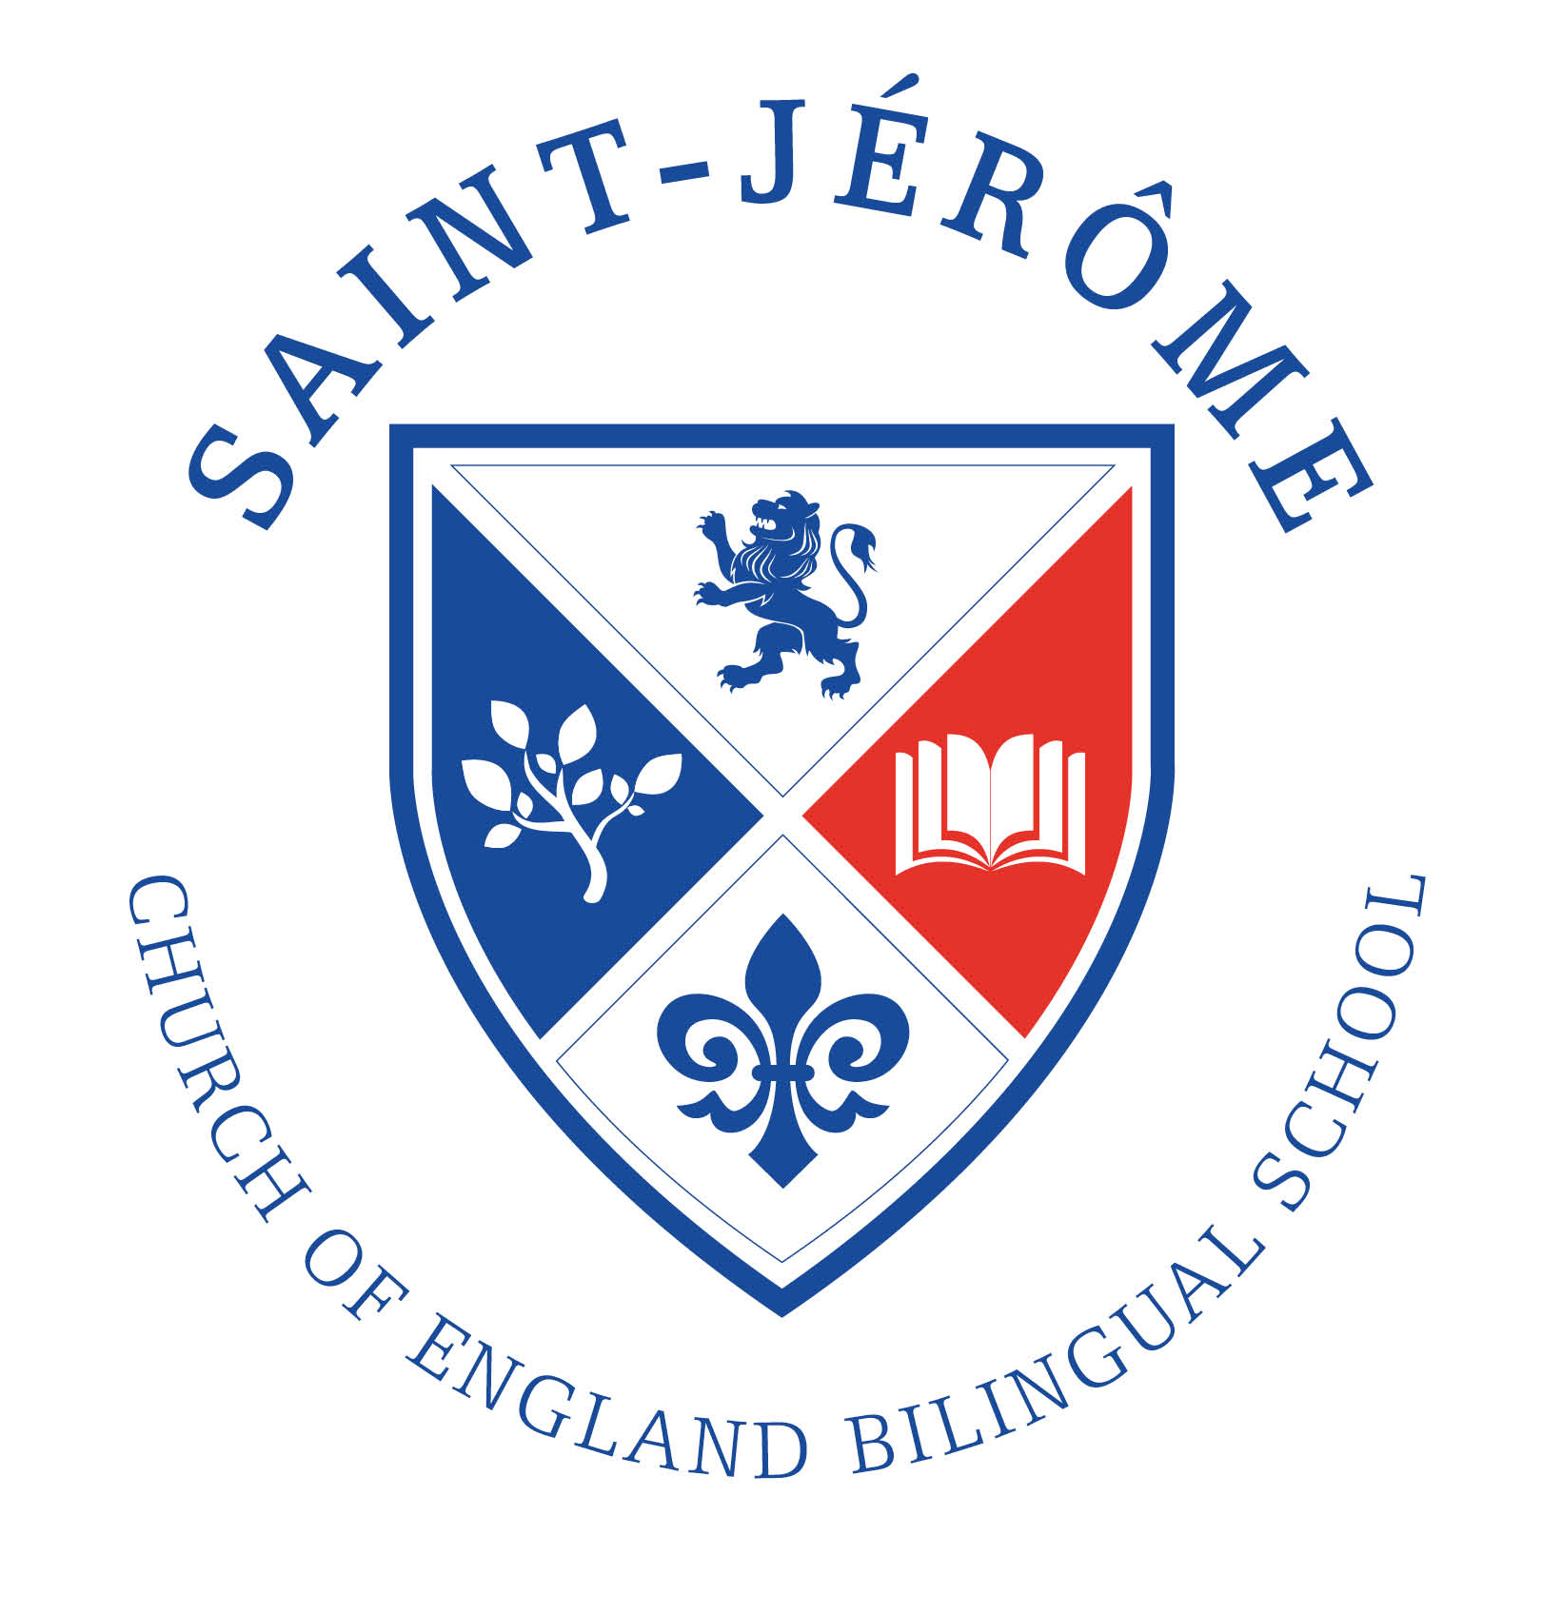 | ADMISSION POLICY  For admission to Reception in September 2021

St Jérôme’s is a Church of England primary free school, which opened in September 2016. When full, the school will provide 420 places for children between the ages of 4-11. The Church of England character underpins all that happens in the school. However this does not mean that all our pupils come from a Christian background, and children from all faiths and those with none are warmly welcome to apply.

St Jérôme’s is a bilingual school, English and French. This means that all the children who attend will spend some time learning in French as well as learning in English. The core subjects will be taught in English and other subjects will be taught in French and English or in French. Children do not need to be able to speak French before they join the school.

Published Admissions Number: There are 60 places available in Reception each year.
Oversubscription Criteria
In the event that there are more applicants than places available, and after the admission of pupils with an Education, Health and Care plan or a Statement of Special Educational Needs naming the school, priority for admission places will be allocated on the basis of the following oversubscription criteria which will be applied in this order:
- Children who are Looked After or Previously Looked After and those who immediately after being looked after became subject to adoption, a child arrangement order, or special guardianship order.
- The children of the two founders of the school who have been granted this provision by the Secretary of State for Education.
- Children with a Sibling on roll when they apply.
- Up to 12 places in each year group are designated as Foundation places and are allocated in the following order of priority:
(i) Child and at least one parent or carer who worships regularly⁴ in an Anglican Church
(ii) Child and at least one parent or carer who worships regularly⁴ in a church or chapel of another Christian denomination which is a member of Churches Together in Britain and Ireland and/or The Evangelical Alliance.
- The remaining places are designated as Open places5.

Sibling
‘Sibling’ refers to brother or sister, half brother or sister, adopted brother or sister, step brother or sister, foster brother or sister or the child of the parent/carer’s partner where the child for whom the place is sought is living in the same family unit at the same address as the sibling. A sibling relation does not apply when the child currently on roll will leave the school before the sibling starts.
Foundation Places
Up to 12 places in each year group will be designated as foundation places. You can apply for a Foundation Place if you worship regularly at an Anglican Church or at a Church or Chapel of other Christian denominations defined as those identified with ‘Churches Together in Britain and Ireland’ or who is a member of the ‘Evangelical Alliance’.
In this context, ‘regularly’ is defined as attendance by a child and parent/guardian/carer at a Church/Chapel at least twice a month for a minimum period of two years immediately before the date of application. Parents wishing to apply for a Foundation place should fill out a Supplementary Information Form which includes a signature from a Minister to confirm regular attendance. The only exception will be those families who have recently moved and can provide a letter from a Minister to confirm committed attendance at a different church.
Applicants for Foundation places who cannot be allocated a place under this criterion will be considered for an Open Place criterion 5.
Tie-breaker
Distance will be used as the first ‘tie-breaker’ if two or more applicants are equally qualified for a place within the oversubscription criteria 3, 4 and 5.
Distance is measured in a straight line from home to school, using a computerised mapping system based on ordnance survey data. The journey is measured in a straight line from the unique address point for the applicants Permanent Residence to centre point for the school site. This must be the address where the parent and child normally live and they must be living there on the closing date for receipt of application. In cases where applicants live equidistant from the school and places cannot be offered to both children, the available place will be allocated using a random selection.
The location of the school’s site is 120 -138 Station Road, Harrow HA1 2DJ Easting 515669 Northing 188706
Home address
The home address is where a child normally lives. Where a child lives with parents with shared parental responsibility, each for part of a week, the address where the child lives is determined using a joint declaration from the parents stating the pattern of residence. If a child’s residence is split equally between both parents, then parents will be asked to determine which residential address should be used for the purpose of admission to school. If no joint declaration is received where the residence is split equally by the closing date for applications, the home address will be taken as the address where the child is registered with the doctor. If the residence is not split equally between both parents then the address used will be the address where the child spends the majority of the school week.
How to apply
St Jérôme Church of England Bilingual School is now part of the co-ordinated admissions process. This means that parents should apply via the Common Application Form via their local authority.
Any applicant wishing to apply for a Foundation place should also complete a Supplementary Information Form (SIF). SIF is available from the school office or on the school website www.stjeromebilingual.org. SIF must be sent to the school office by email to admissions@stjeormebilingual.org or by post. If you are posting an application we recommend that you retain proof of postage.
The closing date for applications is midnight on Friday 15 January 2021.
The local authority will inform parents on Friday 16 April 2021 about the outcome of their application to St Jérôme Church of England Bilingual School. Parents must accept or decline the place offered by Friday 30 April 2021.
Twins and other multiple-birth children
In cases where only one place is available and twins or multiple-birth children tie for the last available place, then both or all will be offered a place even if this exceeds the planned admission number.
Where one twin has an Education, Health and Care plan or a Statement of Special Educational Needs that names the school, the other twin will be treated as having a sibling link for that academic year.
Pupils with a Statement of SEN or an EHCP
The admission of pupils with a statement of Special Educational Needs is dealt with by a completely separate procedure. If your child has a Statement of SEN or an Education Health and Care Plan you must contact your local authority SEN officer.
Deferred Entry in Reception Year
Parents can request that the date that their child is admitted to school is deferred until later in
the year in which they apply or until the term in which the child reaches compulsory school age. For Summer born children this is not beyond the end of the summer term. Parents can also request that their child attends part-time until their child reaches compulsory school age.
Admissions outside normal year groups “outside cohort”

Parents may apply for their children to be admitted outside of their normal year group, or “cohort”, either in a lower or higher year group. This may be appropriate, for example, if the child is gifted and talented or has experienced problems such as ill health.

To apply for a child to be admitted out of cohort, parents should complete a school application as normal via the local authority and additionally complete a ‘Deferral Entry Request’ Form for specifying St Jérôme Church of England Bilingual School. This form should be submitted to the local authority with any supporting evidence that demonstrates why it would be in the child’s best interests to be admitted out of cohort. Parental views, academic achievement, social and emotional development and, where relevant, medical views are examples of acceptable supporting evidence.

Requests to defer entry will only be accepted in exceptional cases.
Offers of places in a child’s correct chronological year group cannot be held until the following academic year. If deferred entry is agreed, parents will need to apply again in the following year to gain a place for their child.
Summer-Born Children
Summer-born children (those born between 1st April and 31st August) can legally be withheld from school until September 2022, which is the September following their fifth birthday. At this point, they will have missed a year of school, and will join a year group that is moving from Reception to Year 1. This would mean applying for a Year 1 place. Withholding summer- born children in this way is not generally recommended educationally.
If parents wish for their summer-born child to join the Reception class – instead of Year 1 – in September 2022, they must make a Deferred Entry request as above. This does not apply to children born in the autumn and spring as these children must legally be in school full-time in the term that starts after they turn five years old.
Out of Year Process

1. Enquiry received for admission of children outside their normal age group or summer-born application to be placed out of cohort. Parents are advised to complete an application for the correct cohort while the request is considered.

2. Parents must complete a Deferral Entry Request Application Form for St Jérôme Church of England Bilingual School. The form will require evidence to support the request by Friday 15 January 2021.

3. The Deferred Request Application will be sent by the Admissions Service to St Jérôme Church of England Bilingual School.

4. St Jérôme Church of England Bilingual School Governing Body which will decide whether to agree to the request or not.

5. St Jérôme Church of England Bilingual School will inform the Admissions Service of their decision.

6. For summer-born children applications, if St Jérôme Church of England Bilingual School’s Governing Body supports the request that entry to school is deferred, the parent will need to reapply for a place for the following year and the application will be processed in accordance with the co-ordination process.

Waiting List
If St Jérôme Church of England Bilingual School cannot offer a place you will be offered the opportunity of placing your child’s name on the waiting list. This waiting list will be maintained by the local authority strictly in the order of the oversubscription criteria and not in the order in which the applications are received. This means that the list will be reordered when a new applicant is placed on the list.
Appeals
Parents have the right to appeal to an Independent Appeals Panel. They must notify the school within 20 working days of the refusal of a place and details of how to appeal will be given at the time of refusal. The Academy Trust should be contacted at St Jérôme Church of England Bilingual School, 120-138 Station Road, Harrow, Middlesex, HA1 2DJ. Any appeal must be received by Friday 15 May 2021.
Withdrawal of Places
If the school and/or Academy Trust are given false information, the Academy Trust reserves the right to withdraw the offer of a place to the child at any time. Confirmation of address and other relevant proofs may be requested.
In-Year Admissions
Applications for In-Year admissions are made in the same way as those made during the normal admissions round. If a place is available and there is no waiting list then the local authority will communicate the Governing Body’s offer of a place to the family. If more applications are received than there are places available then applications will be placed on the waiting list and ranked by the Governing Body in accordance with the oversubscription criteria.
Fair Access
The school is committed to taking its fair share of children who are vulnerable and/or hard to place, as set out in locally agreed protocols. Accordingly, outside the normal admissions round the governing body is empowered to give absolute priority to a child where admission is requested under any local protocol that has been agreed by the Governing Body for the current school year. The Governing Body has this power even when admitting the child would mean exceeding the published admission number.

NOTES Within the meaning of paragraph 1.7 of the School Admissions Code published on December 2014.
The school has two Founders who are parents. The Founders provided the original inspiration for the school and have worked tirelessly to bring the school to fruition. This criterion applies to the children of these Founders.
‘Sibling’ refers to brother or sister, half brother or sister, adopted brother or sister, step brother or sister, foster brother or sister or the child of the parent/carer’s partner where the child for whom the place is sought is living in the same family unit at the same address as the sibling. A sibling relation does not apply when the child currently on roll will leave the school before the sibling starts. ⁴ ‘Regularly’ is defined as attendance by a child and parent/guardian/carer at a Church/Chapel at least twice a month for a minimum period of two years immediately before the date of application. ⁵ The distance that a child lives from the school is used to prioritise children within this criterion, see tie-breaker information below for details.

