Year 3 Maths
- Sequencing numbers: https://www.topmarks.co.uk/ordering-and-sequencing/caterpillar-ordering

- Make a sequence snake. Draw a snake and then divide its body into sections. Put in a starting number and then continue the sequence by adding the same number each time. Ask an adult to set the sequence for you (eg by giving the starting number and telling you what to add each time).
Challenge: Start with a big number and subtract the same amount each time or multiply by the same number each time instead of adding.

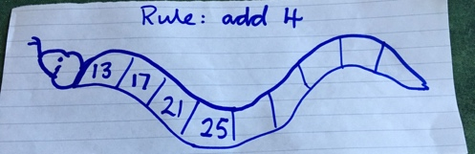
You could colour your snake to make it more interesting.

- Subtraction: https://www.topmarks.co.uk/maths-games/subtraction-grids

- Times tables and number facts: https://www.topmarks.co.uk/maths-games/hit-the-button

- Make a times table board like this:

1 x 8 = | 8
2 x 8 = | 16
3 x 8 = | 24
4 x 8 = | 32
5 x 8 = | 40
6 x 8 = | 48
7 x 8 = | 56
8 x 8 = | 64
9 x 8 = | 72
10 x 8 = | 80
11 x 8 = | 88
12 x 8 = | 96

Cut out the pieces so that you get 24 pieces (12 with questions and 12 with answers). Mix the pieces up and then match the answers to the questions. How quickly can you match the correct answers to the questions? How many times tables can you do?
Challenge: Can you make a division board and do the same with that?

- Write a poem or song to help you to remember the times tables.

