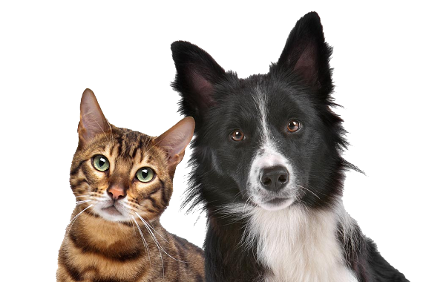
Paws, Claws and Whiskers

Year 1 English Home Learning from 20.04.20

Monday

Today we are going to begin our Paws, Claws and Whiskers topic. Can you think of anyone in your family or any friends who have a pet that you can have a phone call with?
Maybe someone you know has a cat, or a dog or a pet fish?

Can you think of some questions that you could ask a pet owner?
Think of all of the different things you would like to know about having a pet.
Here are some of my questions, you can use these to help you think of your own!

- What types of exercise does your animal do?
- What food does your animal eat?

Try to think of at least 5 questions, but there could be many more questions you’d like to ask!

Once you have finished, can you share your questions with someone at home?

Tuesday

Now that you have all of your questions, you are ready to ask an animal owner these questions!
Remember to listen very carefully to the response and see if you can even impress someone else in your home with your new knowledge.

If you do not have someone to ask these questions, here is a video link showing someone explaining how to look after pets, have a look and see what new information you can learn from it.

https://www.youtube.com/watch?v=pKosbOawGSY

Can you maybe do some of your own research on how to look after a pet?

*Remember to ask your grown up to help you when you are doing your research online*
Wednesday

I hope that you have discovered lots of new information about animals from whoever you have spoken to.

Now can you tell us what happened during your conversations?

You may like to present it as I have in the picture below…

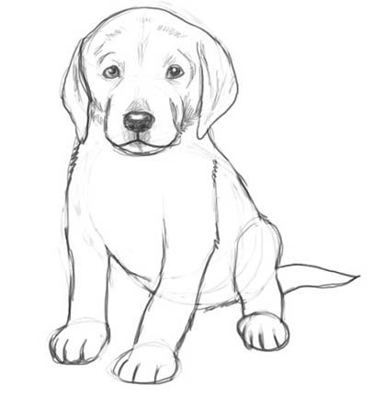

I found out that my sister walks her dog twice a day.
She feeds her dog food from a company called pedigree.
She takes her dog to the vet and that’s where its fur gets trimmed which is like getting your hair cut.
The most interesting fact that I found out is that sometimes her dog eats food that we eat!

Thursday

I hope you have had lots of fun learning about how to take care of a pet.

Now can you think about the animal you have learnt about and label a drawing of your animal?

What is a label?

A label is a list of words that help to understand a picture and its parts.

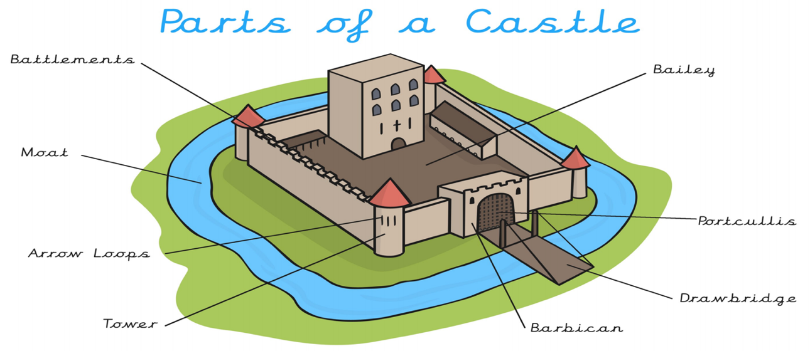
Here is an example of a drawing with labels…
Now can you draw a picture and label the parts of the animal you are looking at?
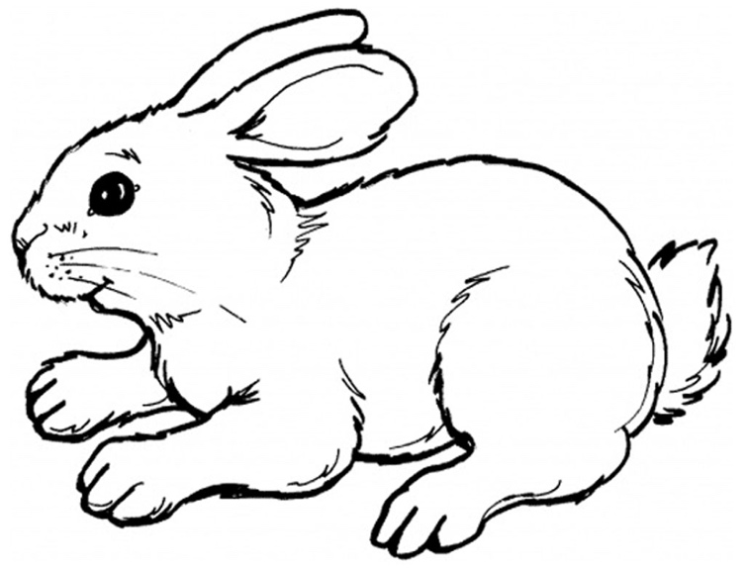

*Bonus- Can you write a sentence explaining how each body part that you have labelled is used? *

Friday
L.I. To be able to publish a poster

Now that we have learnt about the different ways that we care for pets; we are going to take a look at all of the different stories that we have read that have animals in them.

We are going to have a look at one of our favourite stories called the very hungry caterpillar. You may have this story at home but if not, here is the link to watch it.

Have a think about the following questions whilst you are watching.
- Why is the caterpillar so hungry?
- How many different foods did he eat?
- Why did he get a tummy ache?

Then pause the story at 5:47minutes, can you predict what is going to happen at the end of the story?

Now can you create a poster of the front cover of your favourite story.
You may want to think about including other characters on the front cover or redesigning it.

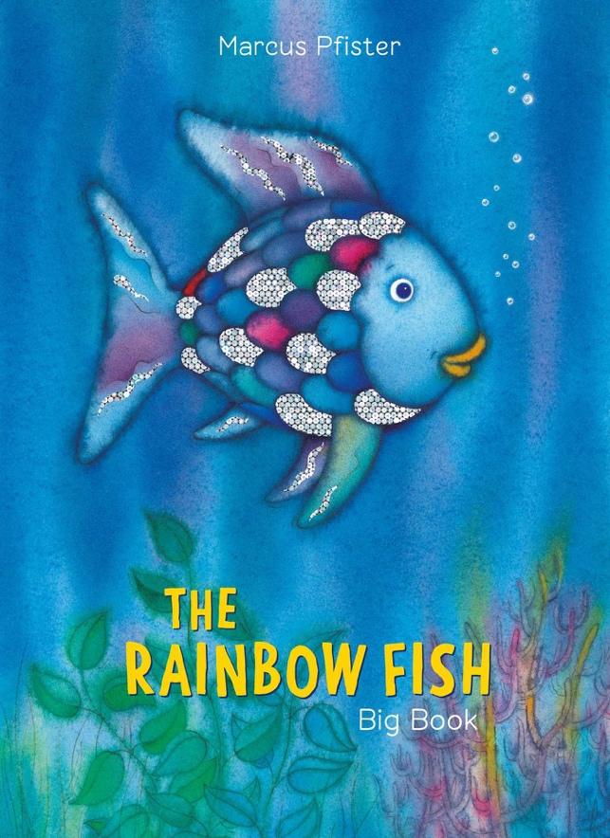
*Bonus- Can you write a summary of what happens in your story! *

Share with your favourite story with someone in your household!

