This week we are continuing to work with the story…
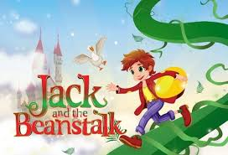

If you wish to remind yourself of the story, you can find a copy on our Home Learning page. We will firstly focus on developing our grammar skills and then begin to work on our writing skills.
Miss Dear and Miss Reynolds☺
Monday
LI: To explore the past continuous tense.

Remind yourself about verbs and about the past and present tense. After watching the videos, you can have a go at the activities underneath.

After you have watched the videos, write 4 sentences about Jack and his mum. Make sure that you have used:
- 2 verbs in the present tense
- 2 verbs in the past tense

Then, you are going to explore the past progressive tense.

- In the past progressive, you use “was” or “were” before another verb and add ‘ing’ at the end of the verb. For example: Jack and his mum were sleeping while the magic beanstalk was growing.

Play the “I was ____ing” and “you were ____ing” with someone at home:
- One person says two sentences using the past progressive tense. For example, they say “I was sleeping.” and “You were eating.”
- The other person checks that you used the correct tense [was/ were and -ing at the end of the verb]
- Then you swap.

Finally, write 3 sentences about Jack and the Beanstalk using the past progressive tense.
Use the past progressive verb tense word mat on our home learning page to help you.

Challenge:
Can you add some adjectives to describe your sentences even more?
Remember: adjectives are describing words.
Tuesday

LI: To recognise and use adverbs.

Remind yourself about adverbs. Discuss at home:
- What are adverbs used for?
- Can you give some examples of adverbs?

Have a go at the following two activities:
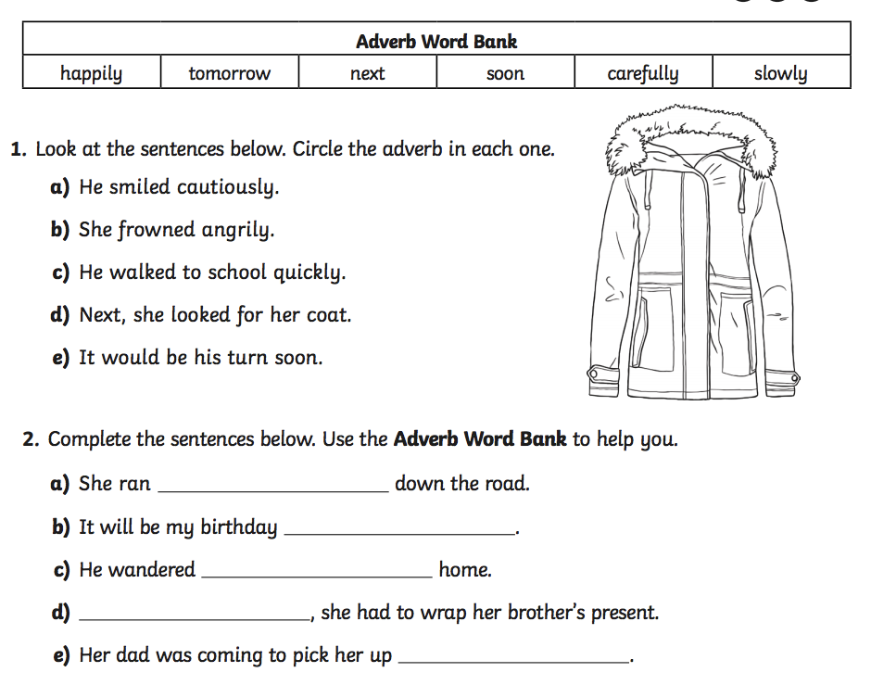

Challenge:
Write a small paragraph to describe Jack entering the castle and use as many adverbs as you can to describe Jack’s and the giant’s actions.
- For example: Jack entered the castle very quietly. The wooden floorboards creaked loudly under each of his steps. He carefully stepped alongside the walls of the giant castle with his eyes wide open to catch all of the gigantic sights around him.
You can watch a video showing Jack entering the castle first to give you some ideas.
Use the adverb word mat on our home learning page to help you.

Wednesday

Choose one of the following phonics activities to start off:
- Practise your phase 3 sounds and tricky words
- Practise your spelling rules using the puzzle matching game

LI: To design and describe a new imaginary plant.

Imagine you have just discovered a completely new, weird and wonderful plant or flower. Draw and label your plant with its amazing features. Think about:
- The colour, shape or texture of the petals and leaves?
- Does the plant have a perfume?
- Is any part of it safe to eat?
- Where does it grow?
- The name of the plant- can you make it an exciting name?
If you are struggling, have a look at the “inspiration plants” document on our home learning page to give you some ideas of features.

Challenge:
Use some exciting adjectives to describe the features of the plant.
Remember: adjectives are describing words.

Thursday

Watch the part of the story when Jack goes up the beanstalk.
Imagine Jack went up your own imaginary plant. Write a paragraph about Jack going up your plant and describe all of the challenges that Jack meets on your plant.

Challenge:
- Can you use some adverbs to describe some of Jack’s and of your plant’s actions?
- Can you use the past progressive tense in some of your sentences?
Use the adverb word and past progressive mats on our home learning page to help you.

Friday

Finish and read over your paragraph.
Check for capital letters, full stops/ punctuation at the end of your sentences, missing words.
Share your work with someone at home and send it in to us at: homelearning@stjeromebilingual.org . We would love to read your work and share some work on the St Jerome Quill!

If you have already finished, why not have a go at this week’s reading activities. Choose to do bronze or silver or gold. You can also choose to write your answers on paper or answer the questions verbally with someone at home.

