Year 2 Topic Activity

The Royal Horticultural Society Campaign for School Gardening
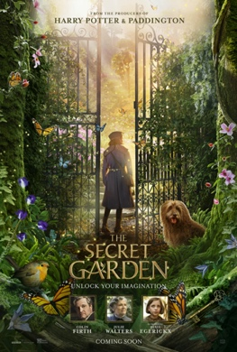

Design a secret garden competition

Clambering through the overgrown trees and bushes, you come across a set of tall glistening gates. You put your hand into your pocket and pull out the heavy iron key you found hidden in some rocks. Could it be?...

You carefully place the key inside the lock and turn…

Buzzing with excitement, you push the heavy gates and with a loud creak they slowly open.

You step through the gates and gasp at the view of your secret garden…

While the nationwide release of The Secret Garden film has been moved to the summer, The Royal Horticultural Society (RHS) are still delighted offer this exciting opportunity for young gardeners and visionaries to take part in an exclusive competition.

The RHS would like young people to imagine they have discovered the gates to a hidden, secret garden and to let us know what it looks like.

They can choose how they would like to showcase their garden. Perhaps they would like to draw or paint their design, create a collage or model, or even plant up a miniature version of it

To find out more click here.

To enter:
Download the Secret Garden entry booklet. In here will be some inspiration for the design as well as a form to complete. Entries should be submitted on a single piece of A4 paper, along with the entry form, and emailed or posted to The Campaign for School Gardening team (details in the booklet) by 30 April 2020.

Entrants should think about the different elements of their garden and let us know why have they chosen them. Would they like their garden to attract wildlife with pollinator friendly plants or be a calming place to think with a gentle stream running through it? Their garden can have whatever they wish in it but just be sure to explain why.

Prizes:
Our very special judges will be picking their favourite garden based on the design and reasons behind it. The winner will have the chance to see their garden, or elements of it, brought to life either in their school or in their community.

The winner and runners up will also win an exclusive movie goody bag!

Click here to read the full terms and conditions.

Please also send any work you do to us at homelearning@stjeromebilingual.org

