Year 3 Maths Week Beginning 27th April 2020

Remember to use Mathletics every day and collect the certificates! You can also use Hit the Button or the Daily 10 to practise number bonds, times tables, doubles and halves – how fast can you do them? Here are the links:
Hit the Button
Daily 10

Monday:
LI: To multiply by 2, 3, 4, 5 and 8
This is a picture of a function machine:
Function
Input Output
X2
12
6

If I put 6 in the left hand side (this is the input) and put x2 in the function box, then the output will be 12 because 6 x 2 = 12. This can be shown in a table like this:
Input | Function | Output
6 | X2 | 12

What would be the output if I have 6 in the input and x4 as the function?
Input | Function | Output
6 | x4

I can put any times table in the middle, such as x3 or x8.
If I put the input as 3 and the output is 12, what function must I have in the middle? You need to work out:
3 x ? = 12
Input | Function | Output
3 | x | 12

I’m sure you worked out that the function is x4.
Now answer these questions:
These are the inputs for a x3 function machine. Can you fill in the missing numbers? The first one has been done for you.
Input | Function | Output
6 | x3 | 18
12
8
10
7

Here are the Outputs for the x3 function machine. Can you find the inputs? The first one has been done for you.
Input | Function | Output
11 | x3 | 33
 |  | 9
 |  | 24
 |  | 27
 |  | 15

Challenge: Can you make a function machine for another times table? Remember to put the input for some questions and the output for others.

Tuesday
LI: To solve problems including multiplying and scaling.

Today you will need to use what you know about multiplication to solve problems.

The picture shows a family of giants. There is the baby, her big brother and her dad. The big brother is 3x as big as the baby and the dad is 5x as big as the baby. So, if the baby is 2m tall how tall is her brother? He must be 2x3m tall so he is 6m tall. How tall is her dad? He must be 2 x 5m tall so he is 10m tall.
Use the interactive dice from nrich to get a number (remember to use the purple cog shape to set the dice to 0-9) . Use this number as the height of the baby and then work out how tall her brother and her dad will be. Do this 5 times using the dice to give you the height of the baby each time.

Now answer these questions based on a different family. The new family has Timmy, Helga and their mum. Helga is twice as tall as Timmy and mum is 4x as tall as Timmy. Timmy is the smallest.

If you just know Helga’s height, how can you work out Timmy’s height?
If you just know Helga’s height, how can you can you work out mum’s height?
If you know mum’s height, can you work out Helga’s height without working out Timmy’s?
If Helga is 8m tall, how tall is Timmy? How tall is mum?
Explain to someone at home how you worked out the answers.

Challenge: Have you mastered the times tables?
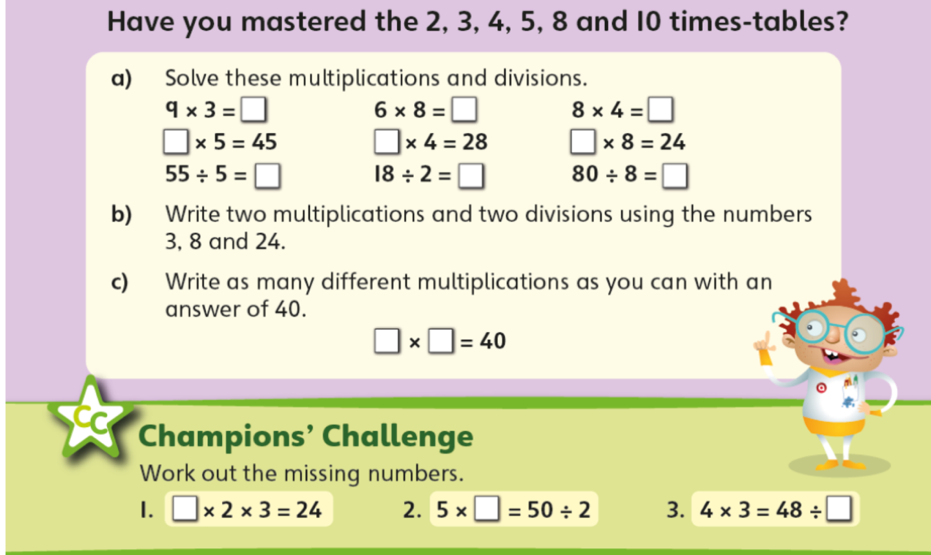
Wednesday
LI: To use known multiplication facts to work out other facts.

If I know the 3 times table, I can use this to work out the 30 times table. Like this:
1x3=3 1x30=30
2x3=6 2x30=60

Write out the 3 and 30 times tables like I did. Think about what happens. Can you see a pattern?
Can you do the same for the 4 and the 40 times tables?
Look at these masks:
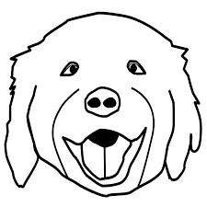

The bear mask costs 20p. The monkey mask costs 40p. The cat mask costs 30p and the dog mask costs 50p.
Work out the cost for these masks:
3 bear masks =
5 monkey masks =
2 cat masks =
4 dog masks =
6 bear masks =
8 cat masks =
3 monkey masks =
7 dog masks =
Don’t forget to write the number sentence for each question.

Thursday
LI: To solve problems involving multiplication and scaling

Can you use your knowledge of multiplication to solve these problems?
Don’t forget to write the number sentences for each one and remember to read the questions carefully.
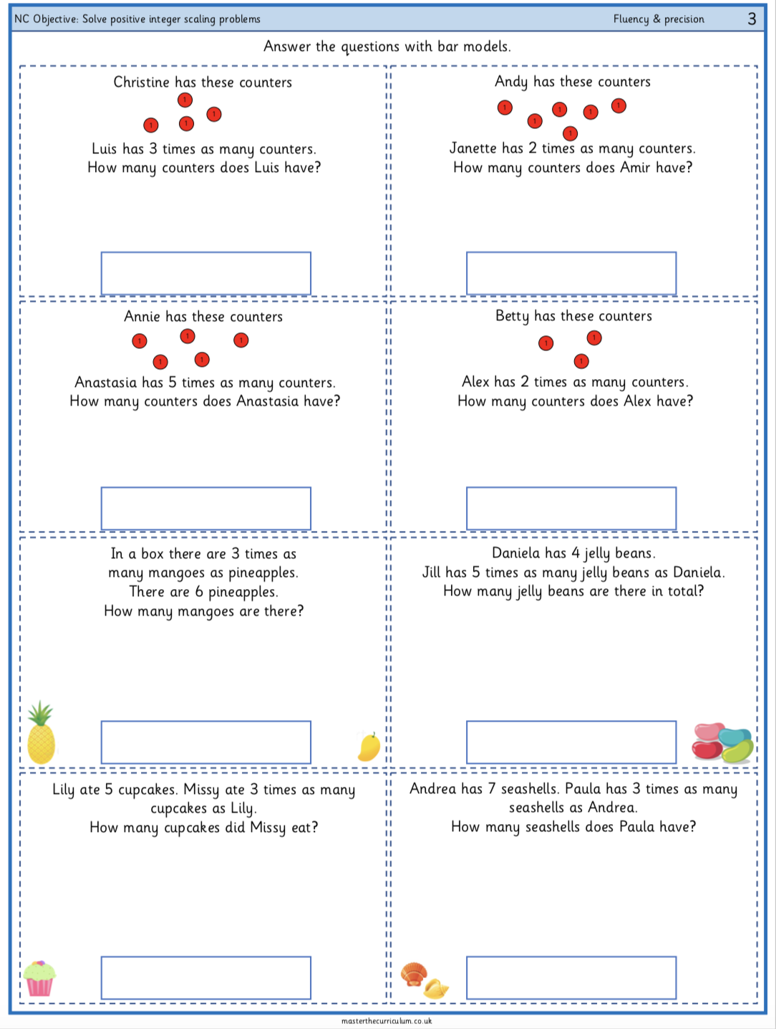

Challenge: Make up some word problems of your own. Write them out and solve them. Can you make them be 2 step problems?

Friday
LI: To solve word problems and puzzles

Can you solve these puzzles and problems? Use the pictures to help you.
