Maths Home Learning week beginning 1.6.2020

As part of our Topic this half term, ‘Why do zebras have stripes?’ enjoy listening to the story ‘Abigail’. click here for the story and see how many different things you can count. What different animals were introduced? How many different animals were in the story? Enjoy listening to the story throughout the week.

Monday - Counting on and back

Today, you will need number cards 1-20 to count on and back from any number to 20. If you’re feeling confident, choose numbers above 20. Shuffle the cards and place them in a pile face down. Turn over one card at a time and count down from this number to 0, then count up from this number to 20 (or a higher number if you are feeling confident). For example, if 11 is turned over:

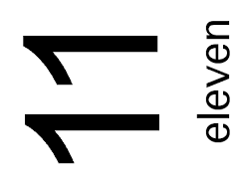

Counting down: 10, 9, 8, 7, 6, 5, 4, 3, 2, 1, 0.

Counting up: 12, 13, 14, 15, 16, 17, 18, 19, 20.

You can use a ruler as a number line to remind you of the order of the numbers if it is needed. Continue to take the next number card from the pile until you have counted on and back with all the number cards.

Tuesday – Counting to 100

click here to download ‘number splat’ to count from 0 to 100. Choose any number from the 100 square and practise counting on and back from this number as far as you can. Use the numbers of the 100-square to help you if you need to.

For example, if 48 is chosen:

Counting back: 47, 46, 45, 44, 43, 42, 41, 40, 39, 38, 37, 36 …
Counting on: 49, 50, 51, 52, 53, 54, 55, 56, 57, 58, 59, 60, 61 …

Can you record counting on and back starting from different numbers?

Wednesday – counting to 100

Use your fingers to count to 100. You can also use the 100-square to help you.

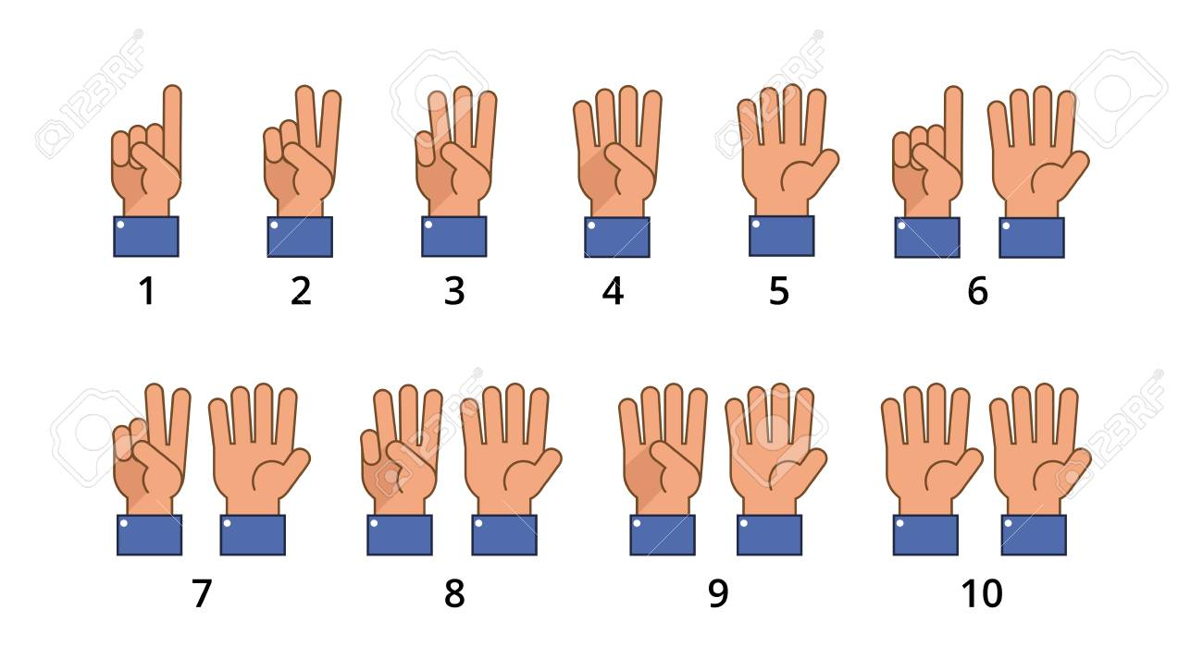

When you reach 10, and subsequent tens numbers, wiggle all your fingers.

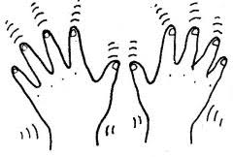

When you have reached, how many 10s did you count? How many 10s are there in 100? You can also use the 10s column in the hundred-square to help you.

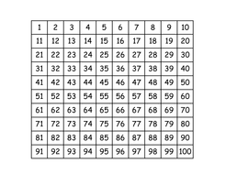

There are ten 10s in 100.

Thursday – Spider counting

Can you find a small toy spider or another animal in your home to help with your counting today? Put your spider on number 10. Remember the rhyme Incy Wincy spider and how he was washed down the pipe? Imagine that the pipe are the numbers going down in 10s.
Ten, twenty, thirty, forty, fifty, sixty, seventy, eighty, ninety, one hundred. Remember to wiggle all your fingers for each 10s number. What did you notice about all the numbers from twenty to ninety? These numbers are at the end of each row and are the ‘cup of tea’ numbers – we have reached the end of a row on the 100-square and so we get to have a cup of tea. They are different to thirteen, fourteen, fifteen, sixteen, seventeen, eighteen, nineteen.
Practise counting up and down in 10s using the hundred-square.

Friday – How many tens?

Remember counting in 10s yesterday and the ‘cup of tea’ numbers, today we will be taking this further.

Using the 100-square, choose a different 10s number each time. For example, 70. Count in 10s to that number: 10, 20, 30, 40, 50, 60, 70. How many 10s are there in 70? Count in 10s to 70, counting out a finger for each 10 to show there are seven 10s in 70.

For all the 10s numbers, record how many 10s there are in each number.
You could use the following table:

10s number | Number of 10s
70 | 7

Can you spot a pattern between the 10s numbers and how many 10s there are in each number?

Do you remember how to count to twenty in French? Here is a fun song to recall it: Chanson 1-20.

