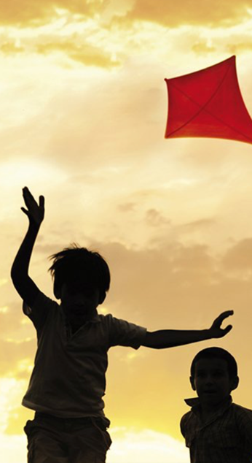
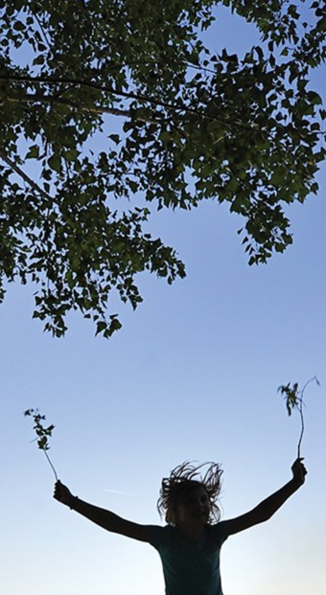

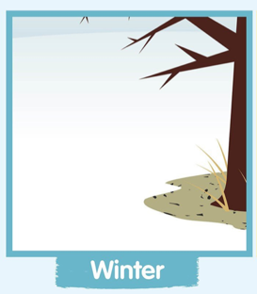
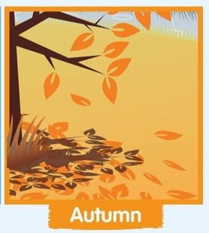
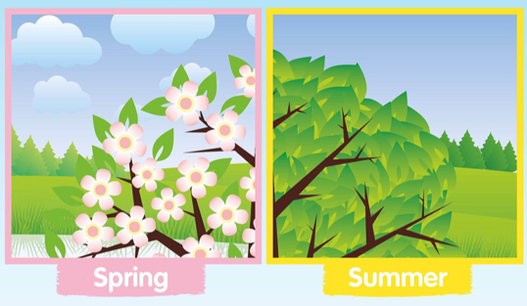
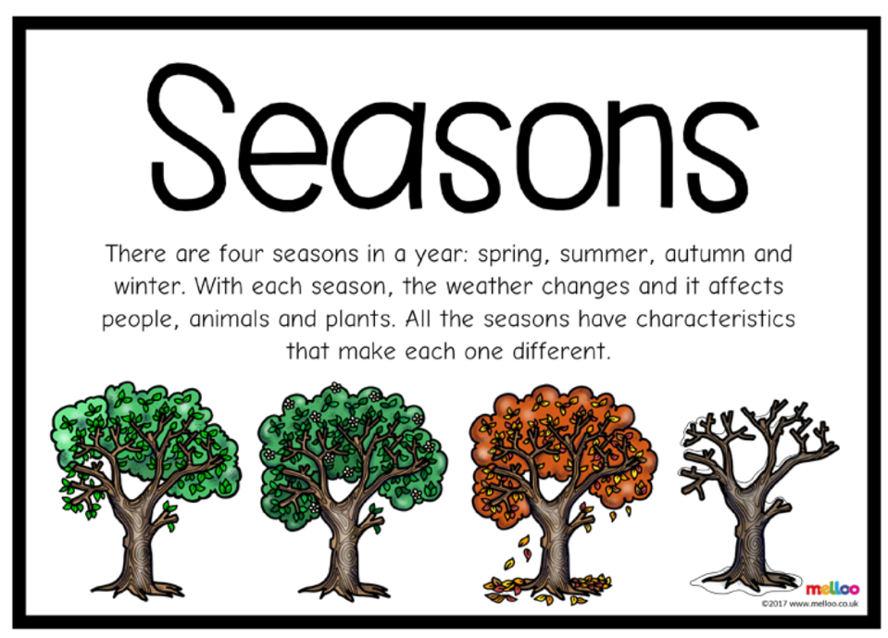
SCIENCE
Today we are going to be learning about the four seasons and observing the changes that happen in each season.
There are four seasons in the year. Can you tell your grown up what you think they are? Have a look below to see if you remembered all four seasons.
Watch this video to learn more about the changes that happen in each of the four seasons - VIDEO
Splendid
Skies

Task
Think about the weather in each of the seasons. Is it usually hot or cold? Does it rain a lot or maybe even snow? What kinds of clothes would you wear in each season?
I want you to pack four suitcases – one for each season of the year. In each suitcase think about what you might need to bring. I have put one example in each for you, take a look…

