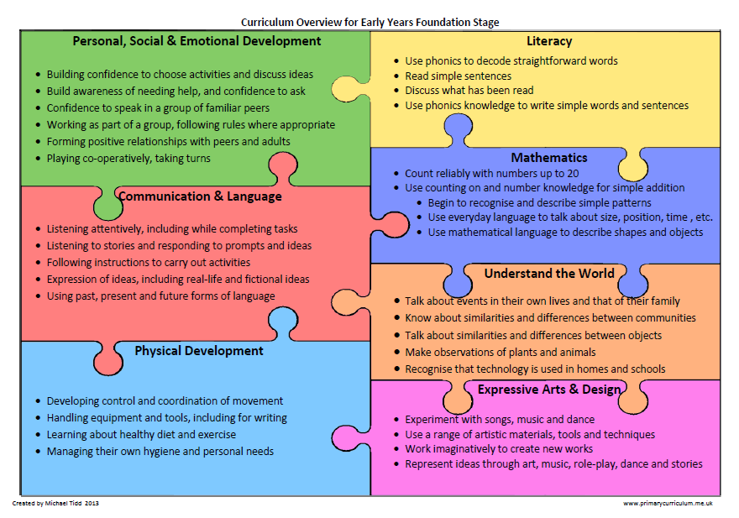

Week commencing:11.5.20 – Each area of the Foundation Curriculum is carefully used in our planning to support your child’s ongoing and developing skills.

Complete a phonics activity daily and practice handwriting family b, h, p try using Letterjoin

Letters and sounds daily lessons

Phase 3 Tricky Words song
Phase 4 Tricky Words song
Reading – share with your child a few of these books Phonic based reading books
Journey by Aaron Becker

This book has no words, you decide the words in your head as the story unfolds. How does it make you feel? What happens in the story? Which is your favourite part and why? Can you retell parts of the story to a member of your family?

Write and illustrate the parts of the story you enjoy most. Create speech bubbles for the characters. How does having no words help you explore this story? Could you make a story like this of your own? Where would you go and what would you see? What would you draw as your transport? Have a go at making your own story up and send them into school, we would love to see them.

Travelling around the World

Here are two little French animations about travelling in French: Les pays du monde and Un escargot part en voyage .

Look at these three destinations and pack a case for each one (see template or draw your own)
Make a list of all the clothes packed in each suitcase.
Which suitcase has the most/least clothes in? Why do you think that is?

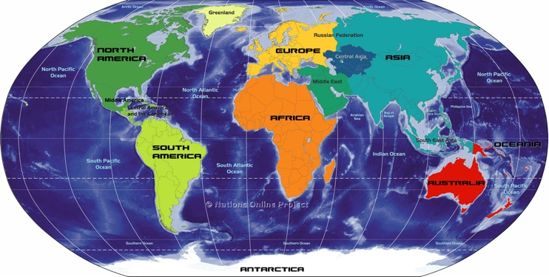

Print out or draw a suitcase for each journey and fill it by drawing the clothes you would take to each destination. Which suitcase might be the heaviest? Why? The lightest? Why?

Use your model cars, buses or anything with wheels to experiment how different surfaces can affect the speed of your vehicle. If you haven’t got any vehicles don’t worry, try making one with a box and cotton reels or bottle tops or construction toys. Explore ramps and surfaces using things at home e.g. shiny book, plank of wood, carpet, bubble wrap. During your investigations make a ramp raising it higher and lower. How does this affect the speed? Record your findings in a simple table.
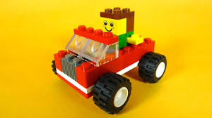
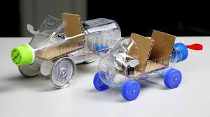

If you could travel anywhere in the world, where would you go? What would you most want to do and see?
Make your own postcard using the templates or draw your own on some paper or card. Create your holiday destination by drawing or sticking a photograph on the front and then writing about your imagined holiday. Do send a copy into school, we would love to see them.

.

If the weather is nice this week how about washing your scooter or bike. Fill a bucket or bowl with water and washing up liquid and give it a good scrub. Ask your parents to time you to see how long it takes to do a good job. They may ask you to wash some things for them too.

If the weather is nice this week how about washing your scooter or bike. Fill a bucket or bowl with water and washing up liquid and give it a good scrub. Ask your parents to time you to see how long it takes to do a good job. They may ask you to wash some things for them too.

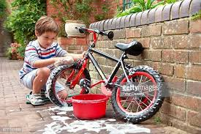Great for washing your hands too! Washing your hands song
Je lave mes mains

Just for fun Up, up up! Magic Train Ride We all going travelling by

Maths home learning

Click here to select counting songs to sing before starting your Maths activities.

Monday
Counting in 10s.

click here to download ‘number splat’.

Have a look at the hundred square. How many patterns can you see in the 100 square? What number does each row end in? Can you count in 10s by looking at the number at the end of each row? What do you notice about these numbers? They all end in a zero!
Practice counting in 10s forwards and backwards using the 100 square.
Tuesday

Counting in 2s

Use the hundred square ‘number splat’ from yesterdays maths activity. Today we are going to count every other number. Point to number one but put your fingers to your lips. Point to number 2 and say, two, point to 3, fingers to lips, point to four and say, four, and so on until 20. When we say every other number, we are counting in 2s.

Look around your home. Can you find ten 2p coins? Practice counting your 2p coins in 2s. How much money do you have in total?

Can you colour in the numbers as you count in 2’s on your 100 square?
100 Square
1 | 2 | 3 | 4 | 5 | 6 | 7 | 8 | 9 | 10
11 | 12 | 13 | 14 | 15 | 16 | 17 | 18 | 19 | 20
21 | 22 | 23 | 24 | 25 | 26 | 27 | 28 | 29 | 30
31 | 32 | 33 | 34 | 35 | 36 | 37 | 38 | 39 | 40
41 | 42 | 43 | 44 | 45 | 46 | 47 | 48 | 49 | 50
51 | 52 | 53 | 54 | 55 | 56 | 57 | 58 | 59 | 60
61 | 62 | 63 | 64 | 65 | 66 | 67 | 68 | 69 | 70
71 | 72 | 73 | 74 | 75 | 76 | 77 | 78 | 79 | 80
81 | 82 | 83 | 84 | 85 | 86 | 87 | 88 | 89 | 90
91 | 92 | 93 | 94 | 95 | 96 | 97 | 98 | 99 | 100

Wednesday

Counting in 5s

Use your 100 square from yesterday’s activity. Can you count in 5s to 50? When you reach 5, can you wave one hand in the air? For example, one, two, three, four, five (wave one hand), six, seven, eight, nine, ten, (wave both hands) Colour in each 5s number on the 100 square as you say it. What do you notice? They all end in 5 or 0. Look how they are in two lines down the 100-square.
Thursday

Sharing odd and even numbers

You will need:
One piece of paper with ‘odd’ and one piece of paper with ‘even’ written on it.
Number cards 2-20, shuffled and placed face down so the numbers can’t be seen.
Objects for counting such as crayons, Lego pieces, small toys

Take one card at a time from the pile. Find the same amount in your objects, for example:

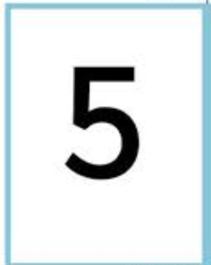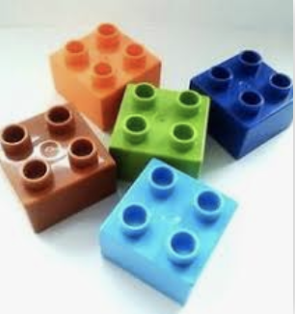

Share the objects equally in two groups. Are there any left over? If there are any left over, the number is odd. Place it in the ‘odd’ pile. When you try to share them equally, you get an odd one left over. Repeat with the other numbers, sharing them equally in two groups. If there are no objects left over, the number is even.
Record your ‘odd’ and ‘even’ numbers in a table:

Odd Numbers | Even Numbers

Friday

Finding halves and doubles

You will need:
20 objects for counting such as crayons, Lego pieces or small toys
Number cards 1-10, shuffled and face down

Turn over the card on the top of the pile. Using your objects, find that number of objects then double them. For example:

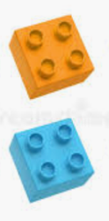
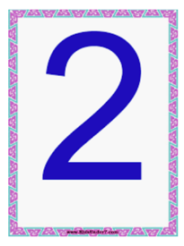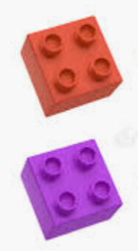

Add the objects together: 2 + 2 = 4

Repeat with the rest of the numbers from the pile.

Record your ‘doubles’ in the following table:

Number | Double | Answer
2 | 2 | 4

What do you notice when you double the numbers? Are the numbers odd or even? Use your table from the previous activity to check.

This time, use the number cards 2, 4, 6, 8 and 10. Shuffle the cards and place them face down.
Turn over the top card. Can you halve the number? Use your counting objects to help you.

Use Mathletics: Operations with number, Doubles and halves to 10 to reinforce halving and doubling.

To also count in French, please listen to these two songs and singalong:
Les Titounis 1-10. We have been singing numbers from 10 to 20 on the tune of Frère Jacques. Hum the tune and ask your child whether they remember it. To recall you can learn and repeat the numbers from 10-20 in French, click on this link: Learning French numbers from 10-20 and sing along to this Numbers 1-20 song

Please remember that you can find all French songs and stories taught in reception on the Reception French Pinterest.

