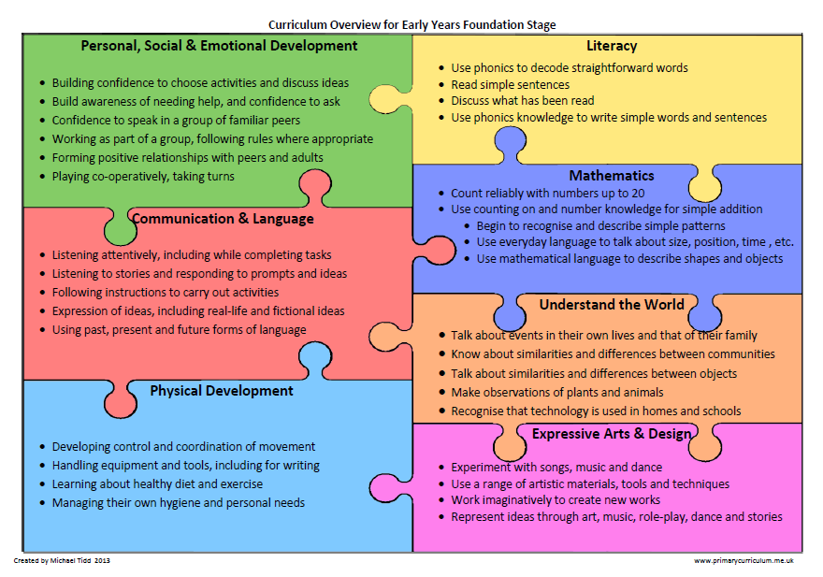

Week commencing:18.5.20 – Each area of the Foundation Curriculum is carefully used in our planning to support your child’s ongoing and developing skills.

Complete a phonics activity *daily and practice handwriting family b, h, p & m, n, r try using Letterjoin

Use these letters to make words and put them in a sentence.

*Letters and sounds daily lessons

Phase 3 Tricky Words song
Phase 4 Tricky Words song
Reading – share with your child a few of these books Phonic based reading books
This week have a look through a newspaper or a range of books to spot key words in the texts. Play a game finding how many times you can find ‘and’, ‘the’ or ‘of’. Think of your own words to find, especially in a non-fiction book.

Try to find a sentence that you think is interesting and change a few words to make a new sentence, for example;

Lily the ant is queen of the biggest ant´s nest and today was her birthday.

Billy the ant is king of the smallest ant’s colony and today he had a party.

Milly the bee buzzed over the ant’s nest because it was her birthday.

Get creative design an imaginary vehicle.
• explain what you want your vehicle to be able to do, for example, fly, float or travel on the road
• create a simple design brief
• draw a labelled diagram to show your ideas
• describe how your vehicle is the same or different to a real one.
• Take a picture of your design and creation and send them into school.

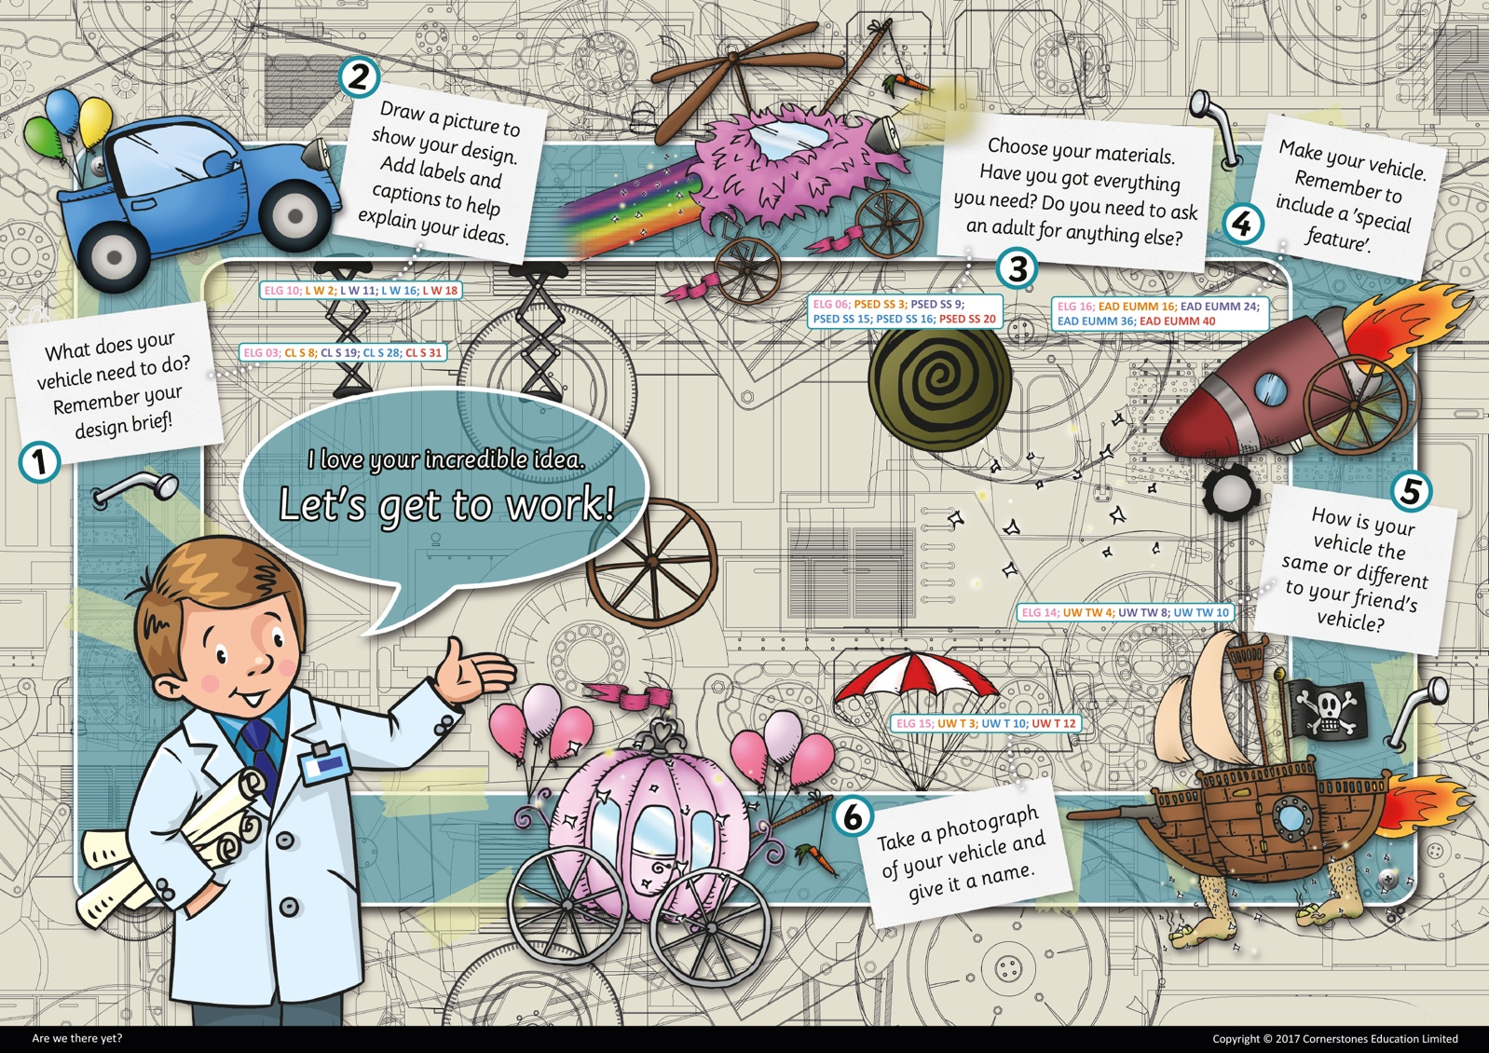

Now you have made your vehicle, write about an adventure or ask your parents to record your ideas and then draw your vehicle on its adventures and annotate your work. I think this will be your best work and I can’t wait to see it! Don’t forget to send pictures to homelearning@stjeromebilingual.org.

We all know the song ‘if you’re happy and you know it clap your hands’, I would love you to think of six new ideas to add to this song. Make a list of your ideas to share in school.

Have some fun with bubbles this week;

Bubble mixture
Makes 350ml
Prep 5 minutes
- 50ml washing-up liquid (one part)
- 300ml water (six parts)
1. Measure the washing-up liquid into a container, such as a jam jar or glass bottle.
2. Slowly add in the water, being careful not to create too many bubbles at this stage. Gently stir the mixture together to combine – a chopstick is perfect for this.
3. If you can, let the bubble mixture rest before using it, as it will make your bubbles even better.
4. When you’re ready, dip your bubble wand into the mixture and start blowing bubbles!

Homemade bubble wands
If you don’t have a wand from a store-bought pot of bubbles, don’t despair! You can have fun by looking for different items around the house that can be used to make bubbles. Here are some ideas to get you started:
- Paperclips – bend them into wands or use as they are
- Straws
- Biscuit cutters
- Pipe cleaners
- Fly swatters

Can you make a bubble within a bubble? Have a go! 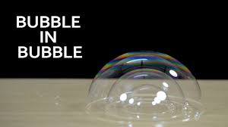

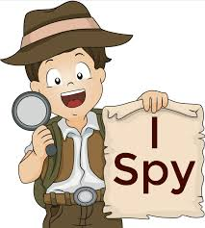

Play a game of ‘I spy’ with your family

How to Play I Spy
You can play I Spy with two or more people.
To begin, one person, spies something. The item must be something that all the other players can see in the room.
The "It" player recites the line "I spy with my little eye, something beginning with..." (the beginning sound of the word).
The other players then take turns to give their answers.
The player who is "It" can only respond with "yes" or "no."
If a player thinks he knows what the mystery item is, he can guess directly: "Is it a shoe” "Is it a truck?" "Is it Dad's sunglasses?"
When somebody guesses correctly, then he or she becomes "It." The game moves forward with the new "It" spying a different item and beginning by reciting "I spy with my little eye, something beginning with..."

