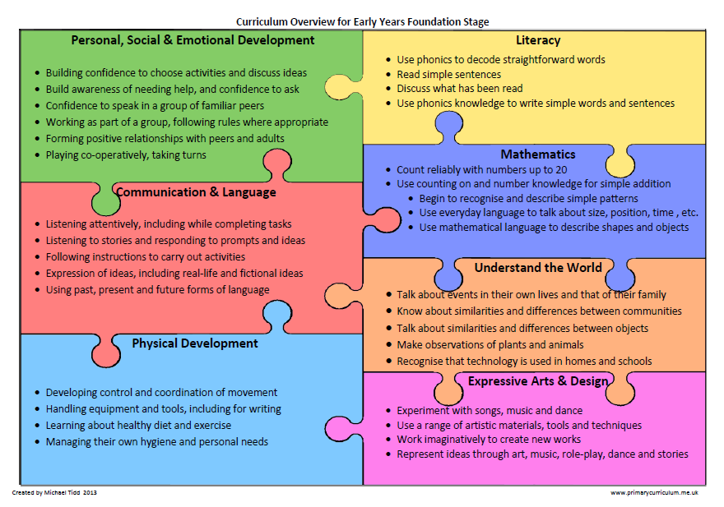

Week commencing: 4.5.20 – Each area of the Foundation Curriculum is carefully used in our planning to support your child’s ongoing and developing skills.

Daily practise of phonics and then choose one or two activities to do in a day – Enjoy!

Phonics phase 3 games to play together:

What’s the sound? Time trial Tricky Trucks

Phase 3 Tricky Words song
Phase 4 Tricky Words song
Reading – share with your child a few of these books Phonic based reading books
Try this yes/no game Yes / No Yeti
Hello from all the children of the world Find out how to say ‘hello’ in other languages.

The Hundred Decker Bus Listen to this amusing story and then use the story writing template to write your own story. What sort of decks would you add? Where would you travel to? Who might your passengers be?

Print off the templates and complete this over the week. See if you can write some ‘blurb’ (what the book is about or what you will see in it – aim for 3 or 4 lines) on the back page.

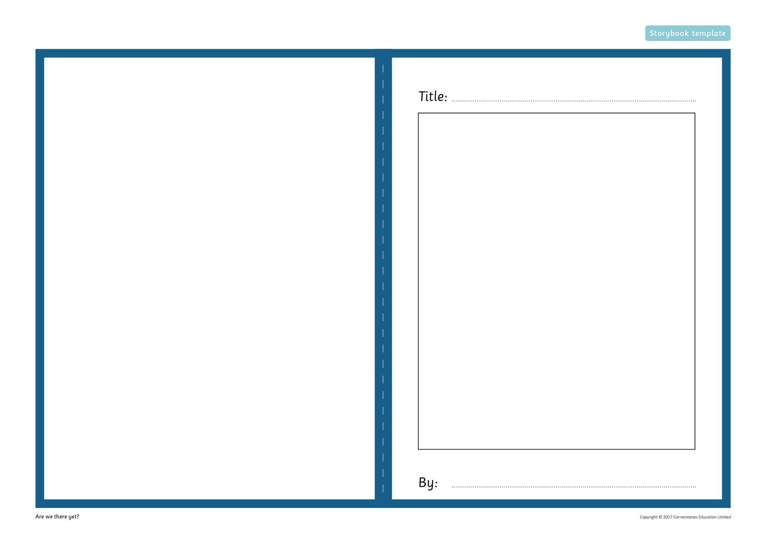

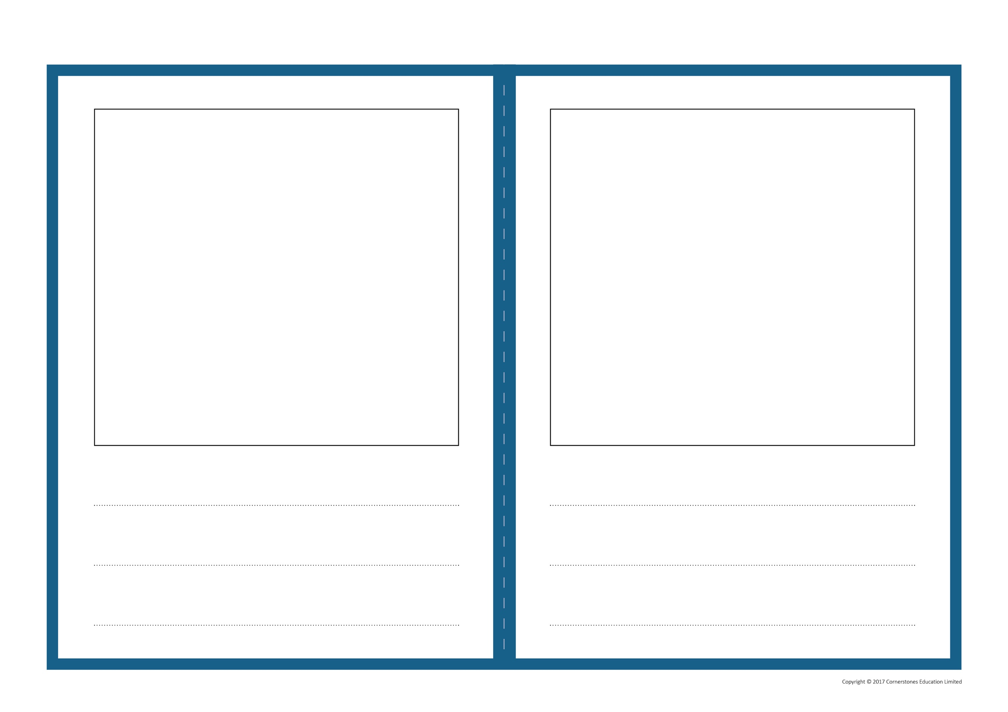

Be a detective, watch the The Hundred Decker Bus story several time and see if you can spot these characters in the book
Look carefully
- Woman with orange hair and half-moon spectacles
- Boy with a football
- White-bearded man in a cap, sometimes with a dog
- Man wearing square glasses and a green 7 yellow bobble hat
- A man wearing an orange turban
- Clown
- Boy eating a banana
- Lady knitting a scarf that gets longer and longer
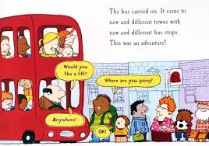
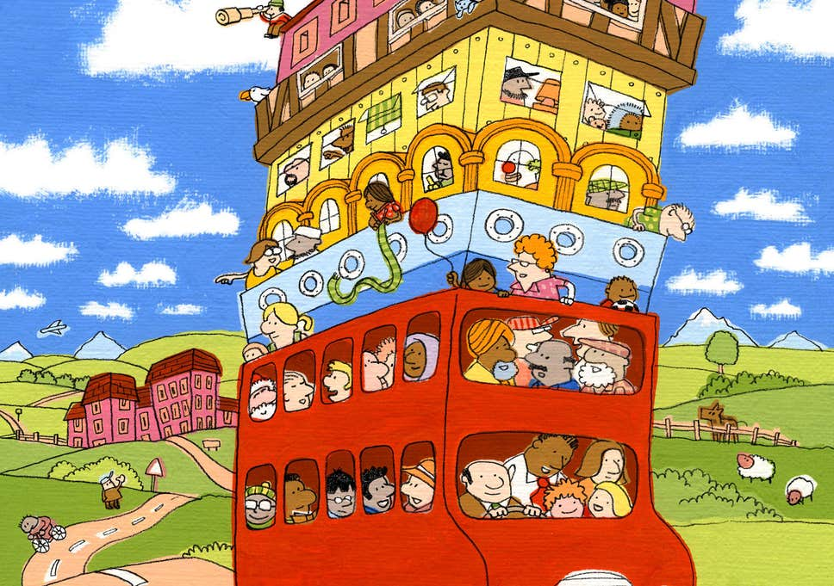
Or to help you look at these pictures:

Bus Songs Sing along to some of these songs – I didn’t think there were so many!

Here is a adapted French version of The wheels on the bus English song and many other French nurseries rhymes your child might enjoy Les roues du bus.

Double-decker-bus template Print off the template and draw you and your friends on the bus. Make a list of things you might see on a journey. Don’t forget to give your bus a number at the front and create an advert to go on the side.

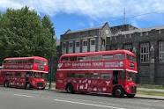

Play the STOP, GET READY & GO game!

On go, jump up and down, on get ready, run on the spot, stop means sit down (have a breather!)
Play as many times as able and change the actions.

Watch Stop and Go with numberjacks

Using a round biscuit tin lid or something similar, pretend you have a bus steering wheel and drive around the room or garden. Maybe set up some traffic lights or pretend a chair is a roundabout, remember to stop and pick up passengers (Use your toys for this) have fun being a bus driver.

Double Decker Bus Video

Can you answer these questions about bus travel?

How do you make the bus stop at the bus stop?

Where does the driver sit?

How many people can the bus hold?

How do you get the bus to stop where you want it to?

How do you clean a double decker bus?

Where is the engine in the bus?

What are the people called, who fix a bus?

What was the bus drivers name?

Why not make a 3D bus using a large box or a 2D bus using card or paper? Don’t forget to add detail to make them look as real as possible.

Design a bus ticket for your special bus. Think about the colours you could use, how much it will cost, what size will it be?

Imagine your ticket was a magic ticket and it took you to London. What would you see?
Here is an animation in French of a girl travelling to London and taking a bus tour.
Draw some pictures of London landmarks that you pass – don’t forget to send them into school or photograph them and email them in. We look forward to seeing your work.

Sometimes we all need a little relaxation and quiet, relax and enjoy these gentle breathing and stretching exercises
Breathing and Stretching

Sing Counting songs such as:

Five little speckled frogs

10 fat sausages sizzling in a pan

10 little monkeys jumping on the bed

Maths activities

Monday Doubling numbers to 1-10
You will need: two of your favourite toys
Two dice (or one thrown twice)
Twenty objects such as pencils, lego pieces, counters

Throw the two dice (or one dice twice) and add up numbers thrown. If you throw a 6, throw the dice again. The total that is thrown on the dice is the amount of objects you need to give to each of your toys – you don’t want one toy thinking you like the other toy more! Whatever number you roll, you need to double it as both toys need the same number of objects.

For example: if a 5 and 3 are thrown, 5 add 3 is 8. Each toy needs to be given 8 objects. To find out what double 8 is, count up all of the objects. Count on from the first toys objects (put 8 in your head) and count on the second toys objects. For example: nine, ten, eleven, twelve, thirteen, fourteen, fifteen sixteen.

8 + 8 = 16. Double 8 is 16. You also know that half of 16 is 8.

Repeat throwing the dice to get different totals and working out the doubles for each one. Write out each one as an addition sentence: 5 + 5 = 10. When you have got all the doubles from 1-10, hide the answers and try and remember the double for each number.

Tuesday

Halve even numbers to 20

You will need objects for counting such as Lego pieces, blocks or marbles

Using your number cards that you made before, find all the even numbers to twenty (2, 4, 6, 8, 10, 12, 14, 16, 18, 20) and shuffle the numbers. Turn over the first number and find that number of pieces. Then put them into two equal groups to work out what half of the number is. Record what the number was and what half of the number is.

For example: Half of 8 is

4 4

Repeat with different even numbers and record what half of the number is.

Mathletics – Operations with number – doubles and halves to 10

Wednesday

Sharing money between toys
You will need: a dice, two of your favourite toys, 2p 4p, 6p, 8p, 10p and 20p on pieces of paper and fix these to the faces of the dice, twenty 1p coins or something similar.

Using your two favourite toys, throw the dice and share the money shown on the dice equally between your two toys. They must get the same amount each or one of your toys will be upset! You can either take the number of 1p coins shown on the dice and say ‘One for you, one for you..’ until there are no more coins left or give the toys the same amount of coins if you know, without counting how many are needed for each toy. How do you know if its fair? Repeat with throwing the dice to share other amounts between the two toys.

Thursday

Sharing dinosaurs between four caves
You will need: Twenty objects for counting, four objects to represent caves
Have a look at the picture with the dinosaurs and caves.

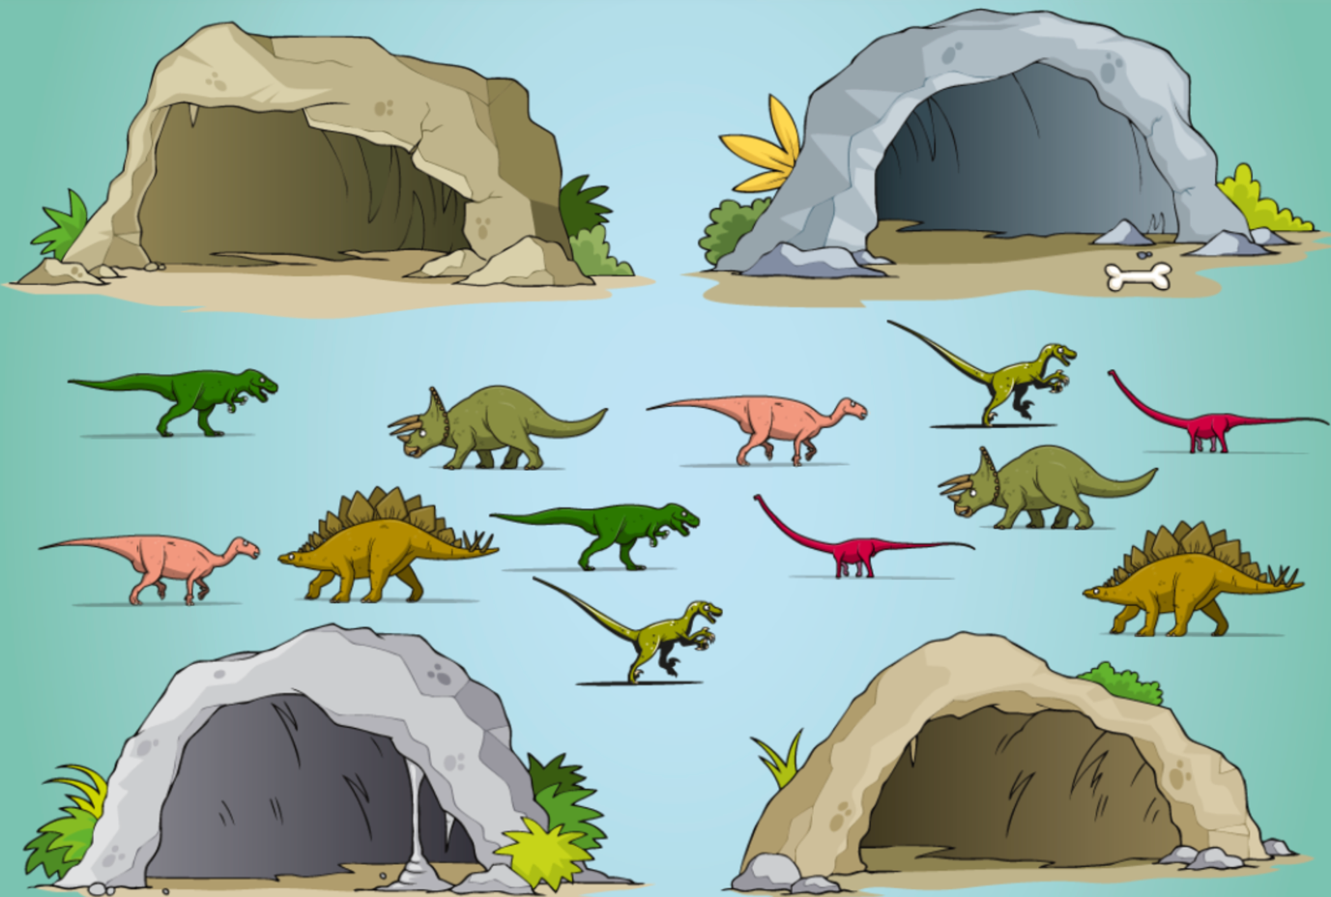
These 12 dinosaurs are looking for a place to sleep for the night. They have found these four caves. They like to spread out (even dinosaurs need to social distance themselves!) and will squabble if more dinosaurs are in one cave than another. You need to help share the dinosaurs equally between the four caves.
Can you write it as a number sentence?
For example, 12 dinosaurs shared between four caves is _____________
What would happen if there were 20 dinosaurs and four caves? How many dinosaurs would there be in each cave? Use your four objects that represent the caves and your 20 counting objects to help you solve the number problem.

Mathletics – Operations with number – Share the treasure

To also count in French, please listen to these two songs and singalong:
Les Titounis 1-10. We have been singing numbers from 10 to 20 on the tune of Frère Jacques. Hum the tune and ask your child whether they remember it. To recall you can learn and repeat the numbers from 10-20 in French, click on this link: Learning French numbers from 10-20 and sing along to this Numbers 1-20 song

Please remember that you can find all English and French songs and stories taught in reception on the Reception Pinterest .

