Year 1 – Maths
Week commencing 11th May 2020

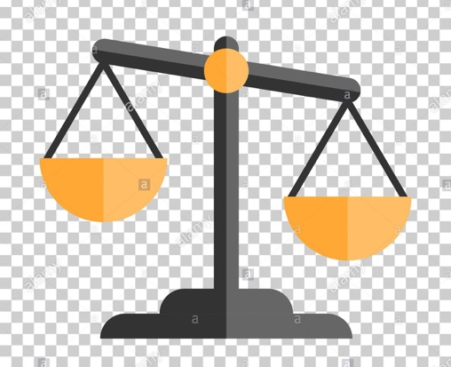
MONDAY

Weight
We are going to be looking at learning about weight and comparing objects that are heavier and lighter.

Task 1
- Choose 10 objects from around your home

- Find a piece of paper and draw the table below:

Objects to compare | Heavier object
1.
2.
1.
2.
1.
2.
1.
2.
1.
2.

- Choose 2 of your 10 objects, hold 1 in your left hand and 1 in your right hand. Which one feels heavier? Which one is weighing your arm down a little more than the other?
- Repeat activity making sure to fill in your results on your table.

What did you notice about the heavier objects? Were they the BIGGER objects? OR were they SMALLER? Discuss with your grown up.

Remember that although an object might be bigger, it does not always mean that it is heavier!
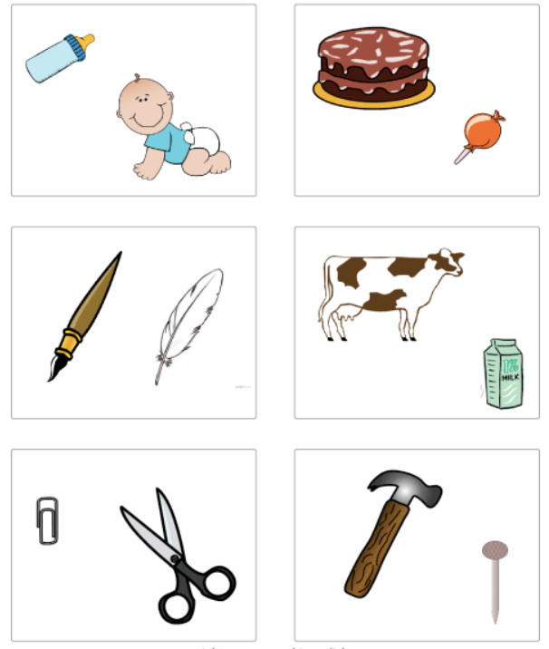
Task 2
Bottle - Lighter
Baby - Heavier
Take a look at the pictures. In each square there are 2 objects, which do you think is heavier and which do you think it lighter?

Draw the pictures, label them and under each one and write if it is their HEAVIER object or the LIGHTER object. (The first one has been done for you.)

Can you make up some of your own?

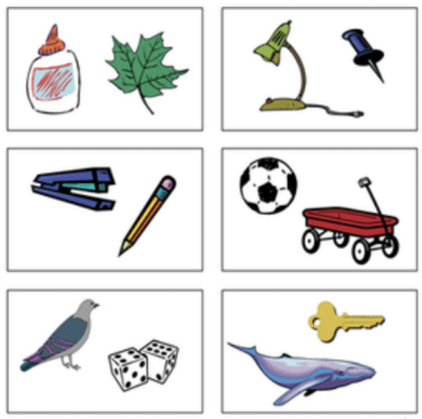

TUESDAY
Block/Bar Graphs

Today we are going learn about block graphs and how we can make a block graph from information (or what we could call data.)

Below is a table of information about different fruits and how many cubes they weigh. Can you use the information to make a block graph? The first block has been done for you.

Fruits | How many cubes it weighs?
Apple | 20 cubes
Banana | 25 cubes
Kiwi | 15 cubes
Pineapple | 40 cubes
Grape | 10 cubes
40 cubes
Fruits
How many cubes it weighs?
If you want a little more information about block graphs then click on this link: Block Graphs

Grape
Kiwi
Banana
Apple
35 cubes
30 cubes
25 cubes
20 cubes
15 cubes
10 cubes
5 cubes
Capacity
Pineapple

WEDNESDAY

Watch the link below to find out more about capacity:
Capacity video

Task

- Find 3 different sized containers (examples: a cup, mug, glass, water bottle, finished milk container, empty can)

- Estimate which container you think has the greatest capacity – which container will be able to hold most water

- Fill a cup with water and pour it into the first container. How many cups of water are needed to fill the first container? Repeat for the other two containers

- Which container holds the most water? (It will be the container where you had to fill and put the greatest number of cups.) Was your estimation correct?

THURSDAY
Capacity Challenges

Read the capacity challenge cards below. Can you carry out as many of the challenges as possible? Discuss and write the answers on a piece of paper.
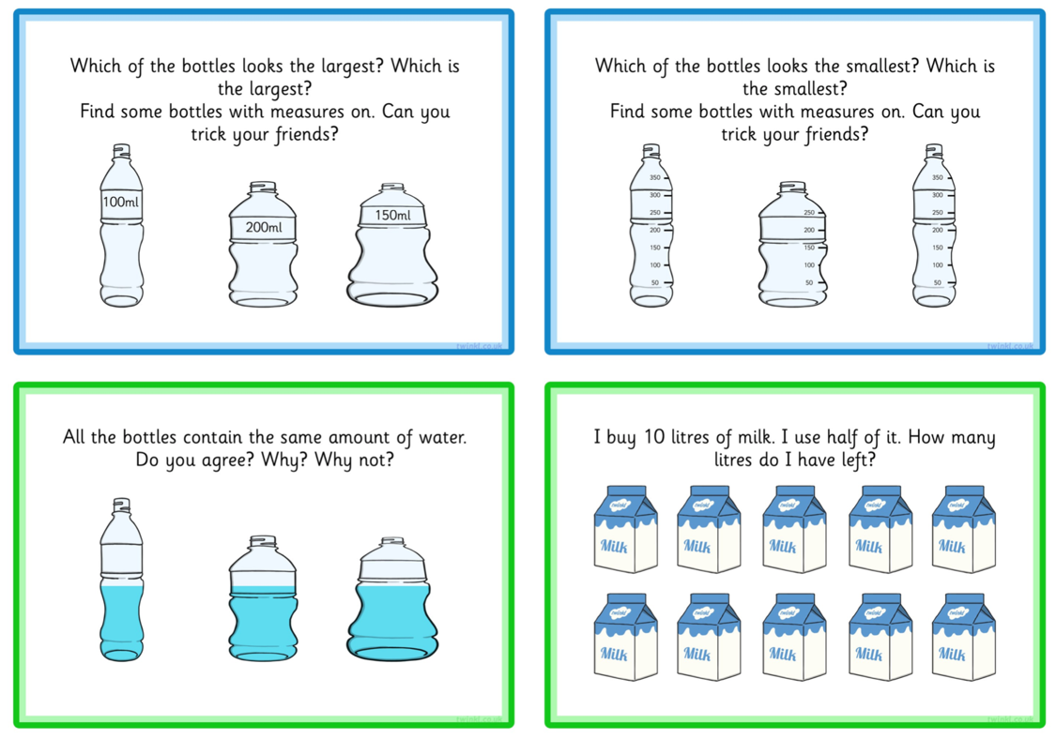
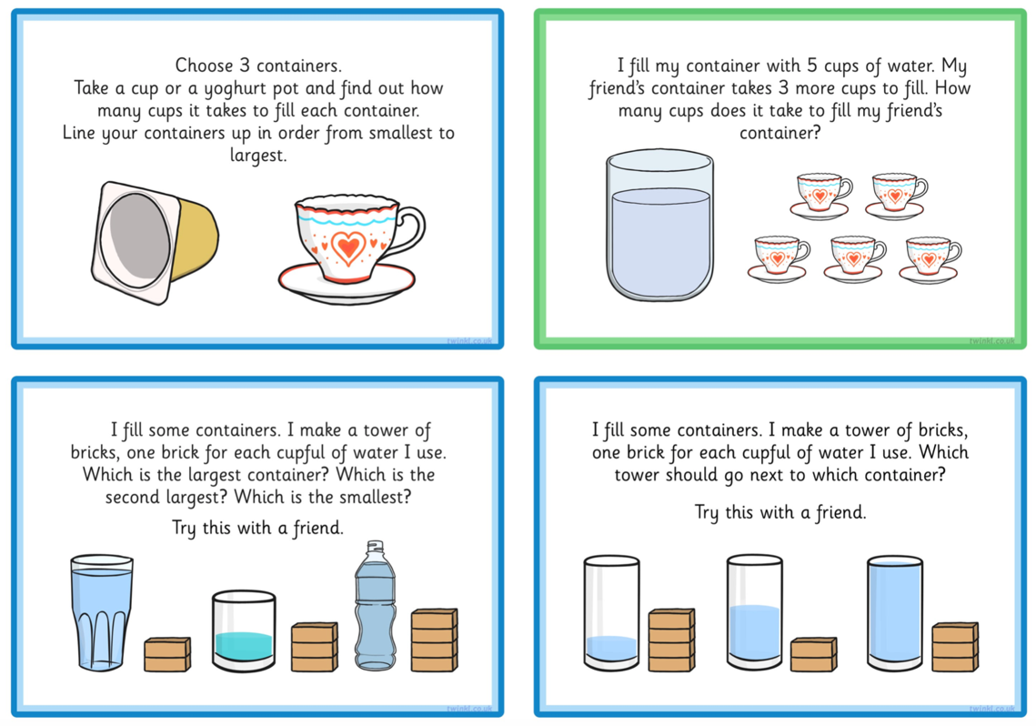

FRIDAY
Measuring capacity in ml (millilitres)

You can use measuring equipment such as measuring jugs and measuring cylinders to find out how much liquid there is in a container.

Look at the measuring jugs below and colour the correct amount of liquid. The first one has been done for you.
