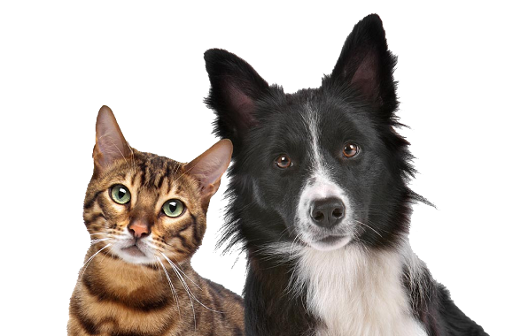
Paws, Claws and Whiskers

Year 1 English Home Learning from 04.05.20

Monday
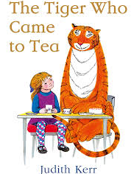
I hope you enjoyed last week’s Home Learning and had lots of fun writing all of your fantastic stories! Make sure you share them with your family and friends!
This week we are going to continue reading books about animals. Our first story is ‘The Tiger Who Came to Tea’.

Before you read the story, have a think about the following questions;
- What do you think this book will be about?
- How do you think this book will end?
- Who is the author of the book?

Click here to have a listen to the story.

Can you answer these questions?

- What was Sophie drinking in the kitchen at the beginning of the story?
- What colour were Daddy’s trousers?
- What animal was at the door?
- How many sandwiches did the tiger eat?
- How do you think Sophie’s mummy felt when the tiger was eating all of the food?
- Do you think the tiger was being good or naughty when he ate all the food? Why?

Tuesday

I hope you enjoyed reading the story. What was your favourite part?

Now that you have read the story can you retell the story to someone else who has not read it? Maybe you can ask them what they think will happen at the end before you even tell them!

I have put some pictures below to help you remember what happened in the story.
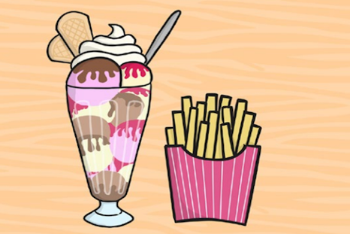
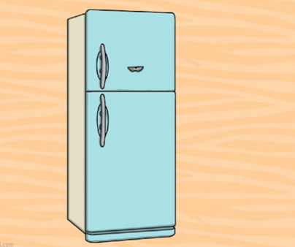
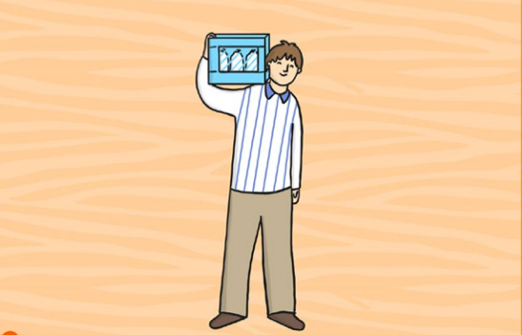
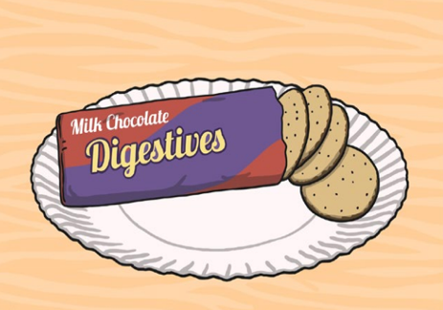
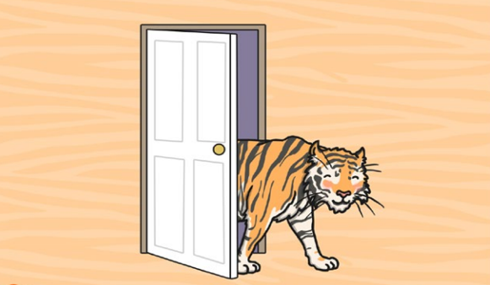
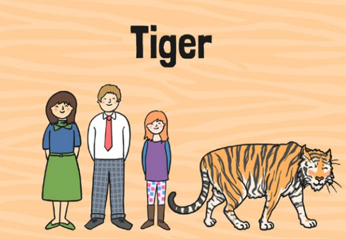
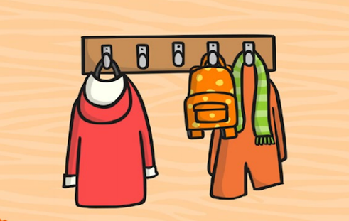
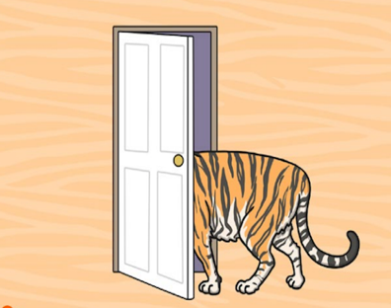
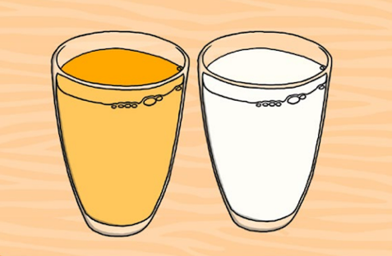
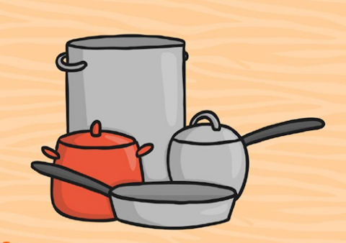
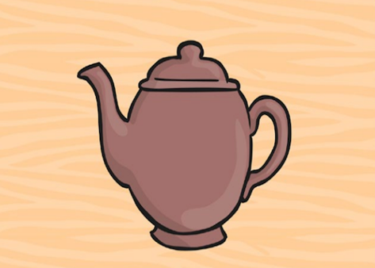
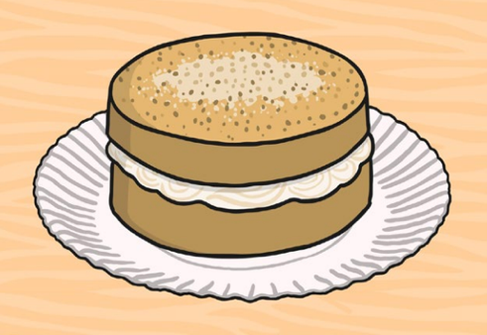
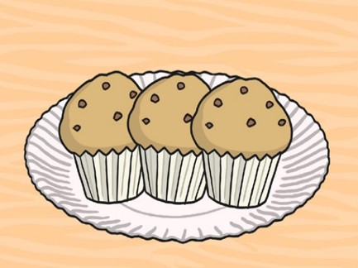
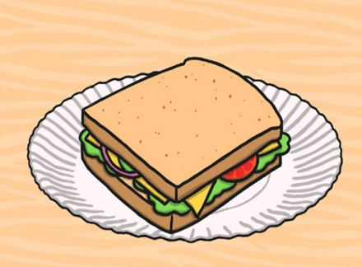
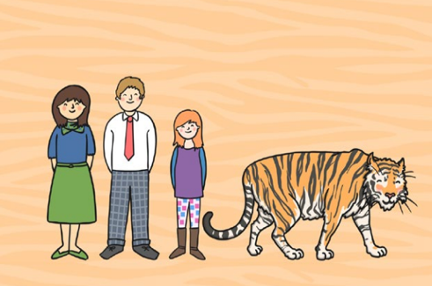
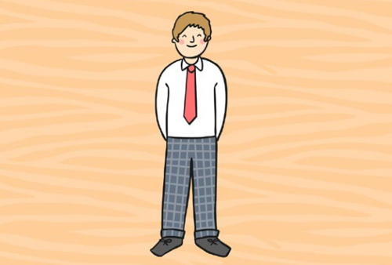

I hope the person you have told the story to has enjoyed it just as much as I did!

Wednesday
Now that we have retold the story, that means you know it very well. Remember, the link is still at the top of the page should you need it to refresh your memory of the story.
Today, I would like you to think of all the things the tiger ate when he came to tea!

Can you make a list of things the tiger would be able to eat if it came to tea at your house?
Maybe you could make a shopping list of all the things you would like the tiger to eat if it came to your house? Have a think of all of the things you would like the tiger to eat.

I have made an example of the things the tiger would be able to eat if it was to come to my house. I can’t wait to have a read of all of the yummy things that you may have in your house!

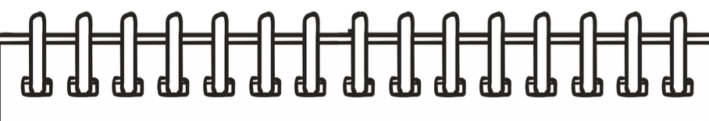
Remember to use all of the key features of writing a list, I have made an example below!

List of things the tiger could eat if he came to my house
- Eggs
- Bread
- Bun and Cheese
- Rice and peas
- Plantain
- Spaghetti
- Jerk chicken
- Water
- Patties
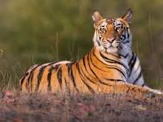
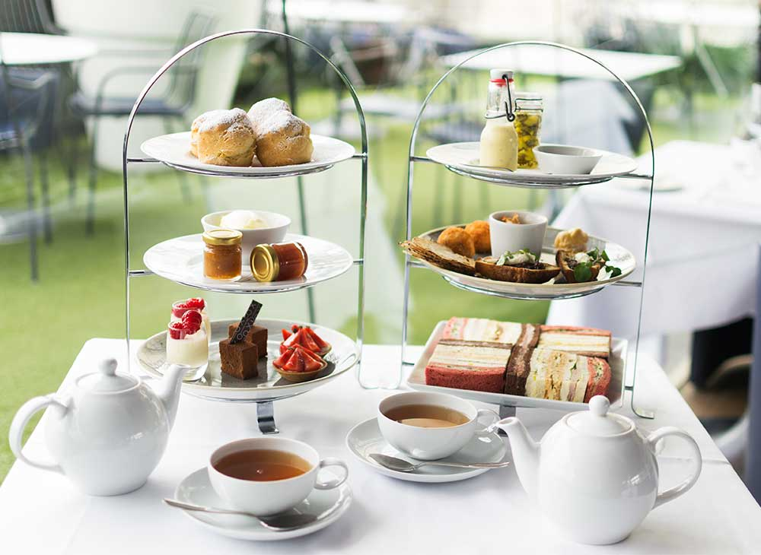
- Jollof rice

Thursday

We have been having lots of fun learning about tigers. Today we are going to gather some information about tigers because tomorrow we will be writing booklets about tigers.
I want you to imagine that a tiger came to live at your house.
What types of food would they hunt and eat?
How would they play, behave and move?
Have a think about how you would take care of your tiger at your home.
Can you write some sentences?
I have attached some information and some links to help you find your facts.
- Amazing Animals: The Tiger - YouTube
- 10 tiger facts! - National Geographic Kids
- Wild tiger cub - BBC Attenborough - YouTube
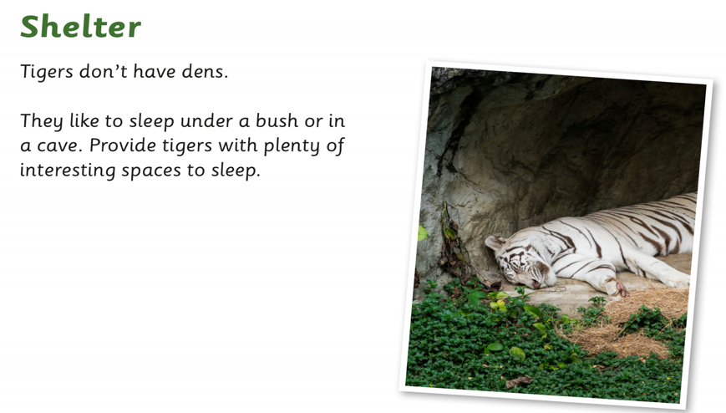
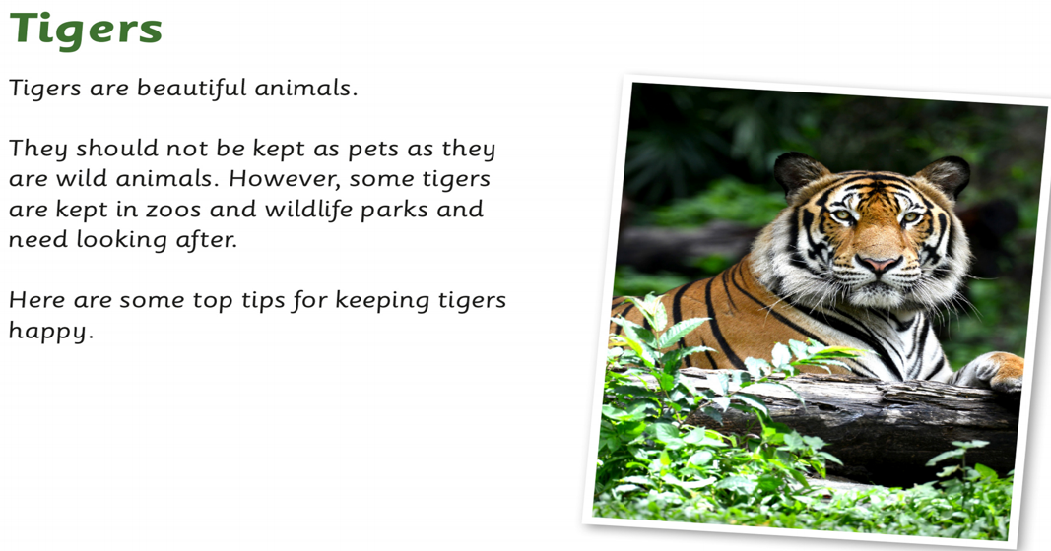
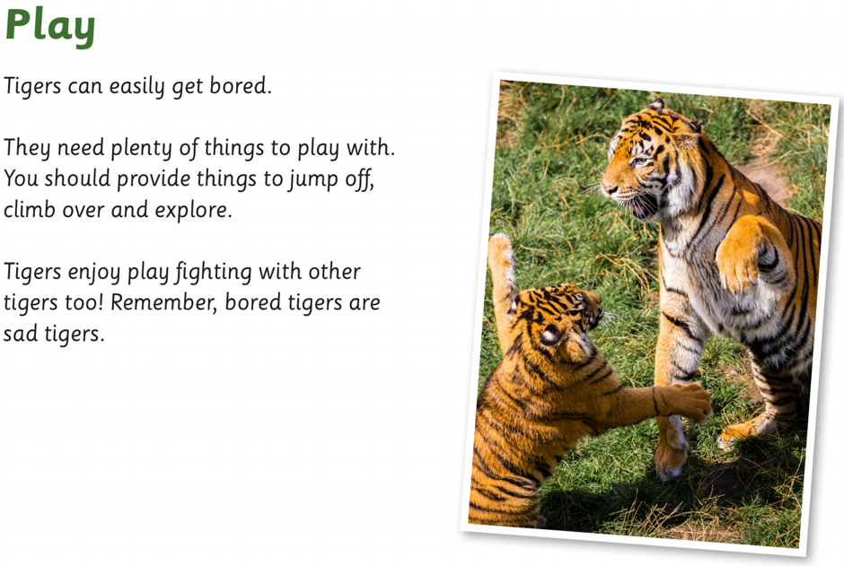
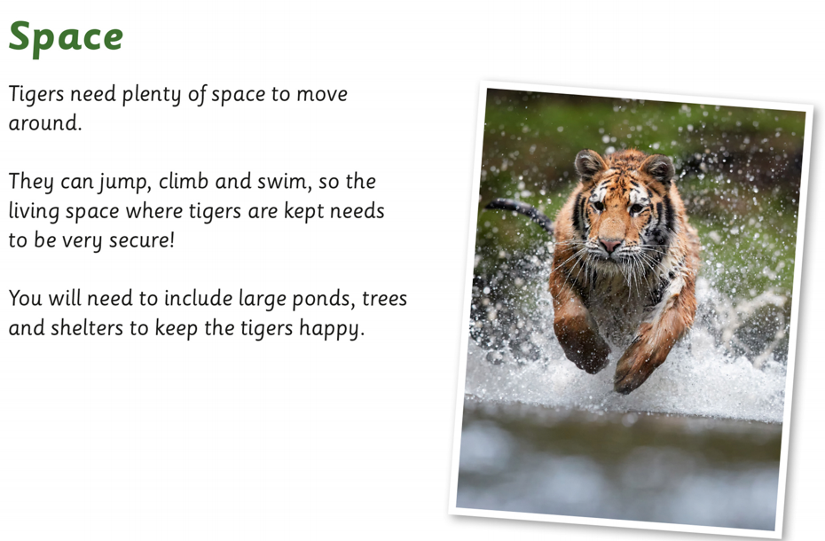
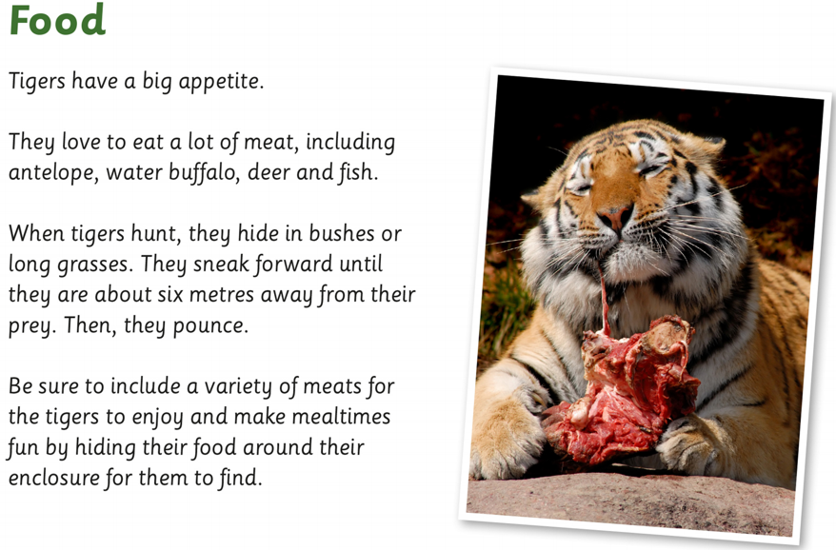
What interesting things have you found out about tigers?

Friday

Well done for collecting lots of information about tigers! Now can you create a poster or a booklet about how to care for a tiger, once you have done so ensure you share the information with friends or family.

Remember to add lots of drawings and colour, maybe even some decoration. If you have created a booklet, include your title and front cover!

Have a look below for some examples!
