This half term we are learning about…
Street Detectives

Monday
LI: To explore the story and characters of “The way back home”.

During the next few weeks, we are going to be working with the story “The way back home” by Lina Schwamkrus. You can find and watch it by clicking on the title.
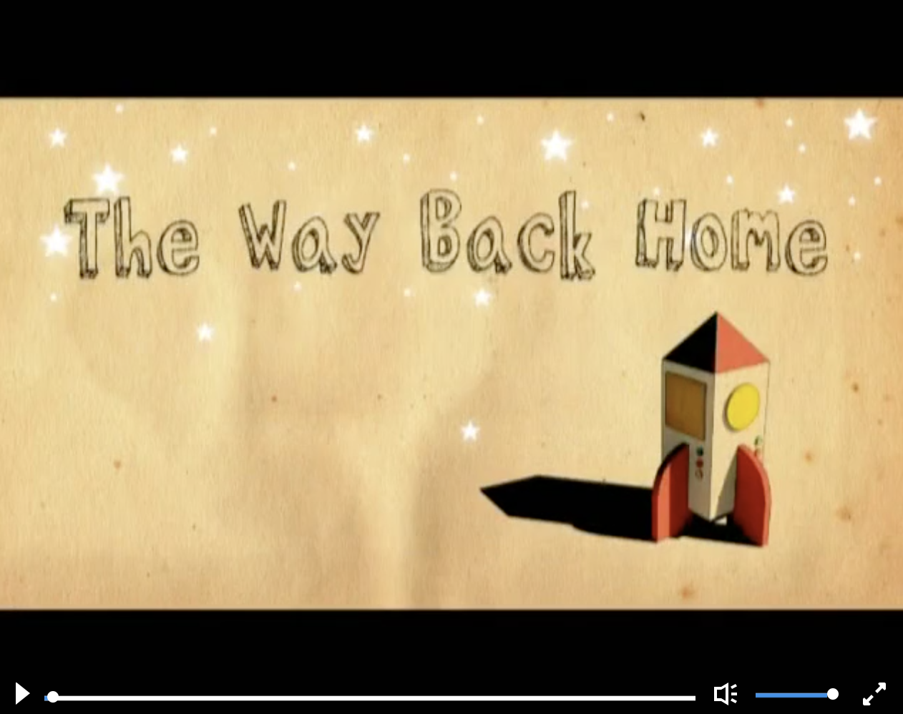
Watch the video and act out the story if you can.
Think about the following questions:
- How do you think the young boy feels before flying off in a rocket? Why?
- How do you think he feels when his rocket breaks down on a planet? Why?
- How do you think the alien feels when he sees the young boy? Why?
- What could the alien be saying to the boy? Act out the conversation between the young boy and the alien if you can.

After you have watched the story, discuss the following questions about the story with someone from home:
- Do you like the story? Why? What is your favourite?
- What message do you think this story shares? (for example, about kindness and helping each other)
- Where do you think the young boy goes to next?

Challenge:
Can you create a list or a mind map of adjectives to describe one of the characters?
How many really exciting adjectives can you find about the different characters?
Remember: adjectives are describing words.
Tuesday
LI: To summarise and sequence the story.

Talk about the story with someone at home if you can. Can you describe the story of “The way back home” in 10 main events (or fewer)?

Then, have a go at drawing a story map to sequence the story.
Below is an example of a story map for a different story.
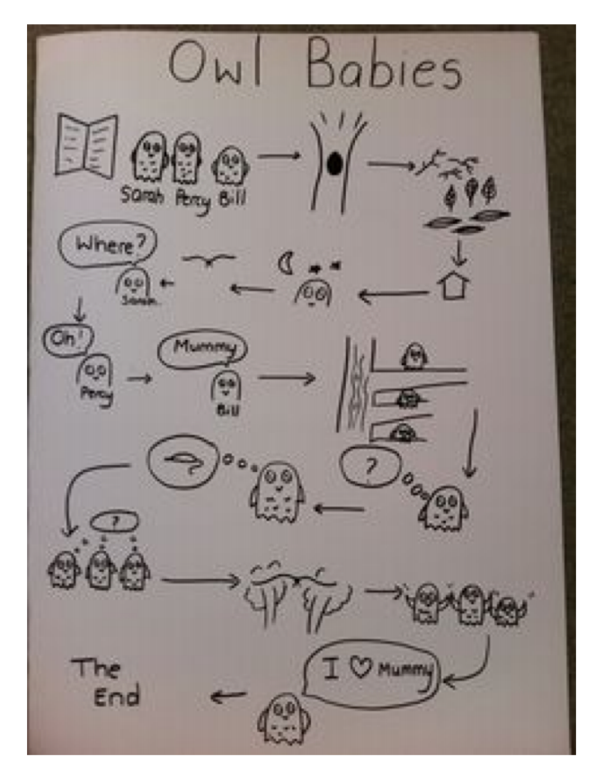

Challenge:
Can you write a short caption to explain what happens in each picture of your story map?

Wednesday
LI: To use my story map to write a story for “The way back home” (part 1).

If you can, explain your story map to someone at home. Together, check that your ideas make sense and whether you need to make some parts of your story clearer.
Then have a go writing the first half of your story (or as much as you can). Remember to use your story map.
Take your time to describe each part of your story with as much detail as possible. If you are struggling, watch a part of “The way back home” and remind yourself of what happens.
See how many conjunctions, adverbs, adjectives and progressive verbs you can use! Use the different word mats on our home learning page to help you.
If you completed the adjective challenge on Monday, use these adjectives in your work.

Thursday
LI: To use my story map to write a story for “The way back home” (part 2).

If you can, read the first part of your story to someone at home. Together, check that your sentences make sense and whether you need to make some parts of your story clearer.
Then continue and finish writing your story (or as much as you can).
Remember to use your story map. Take your time to describe each part of your story with as much detail as possible. Remember that if you are struggling, watch a part of “The way back home” to remind yourself of what happens in the story.
See how many conjunctions, adverbs, adjectives and progressive verbs you can use! Use the different word mats on our home learning page to help you.

Friday
LI: To edit my work.

If you can, read your story to someone at home. Together, check that your sentences make sense and whether you need to make some parts of your story clearer.

Then, if you haven’t done so already, finish your story.

If you have finished your story, read it over and check for spellings, capital letters, full stops/ punctuation at the end of your sentences, missing words. You can use the phonics matching game on our home learning page to help you with your spellings.

If you wish, send your story to us via: homelearning@stjeromebilingual.org . We would love to read your work!

If you have already finished writing and editing:
Why not have a go at this week’s grammar activity about prefixes? Check the Prefix trees document on our home learning page, follow the instructions and have a go at filling another of the prefix trees.

