Year 2 Maths

Have a go at the exercises that focus on each learning intention for each day. Do as many exercises as you can. Remember to use your number facts and to write your working out down to help you find the answers. If you need more help or want an extra challenge:

- Click here for How to work out a value with coins
- Click here for How can different notes and coins make the same total?
- Click here to view some maths games
- Click here to complete a Friday Challenge. You can challenge yourself on any day.
If you wish, you can share your maths work with us at: homelearning@stjeromebilingual.org

Miss Reynolds and Miss Dear

Monday
LI: To add/subtract 2-digit numbers to/from 2-digit numbers by counting on/back
To understand addition and subtraction as inverses of each other and use this to find relationships
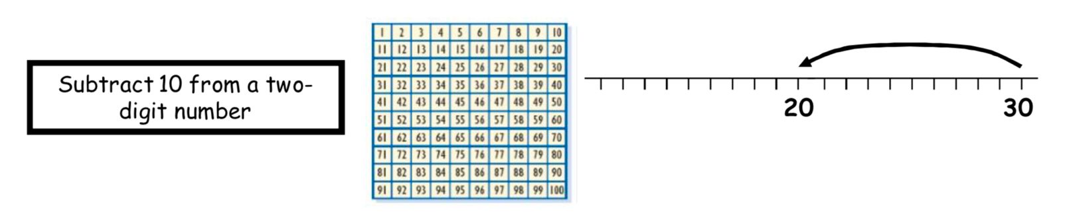
Using the 100-square (you can find a 100 square on our home learning page)
58 – 32 =
Put your finger on 58 and jump it up three rows to count back 30
Next count back two from 28 to 26.
You know 8 – 2 = 6 because you also know that 6 + 2 = 8.
Then complete the subtraction sentence 58 – 32 = 26.

Using cubes, objects or drawings.
69-35 =
Draw 6 tens and 9 ones
Next, cross out the tens you are taking away and the ones you are taking away (3 tens and 5 ones)
Then, count the tens and the ones you have left (e.g. 3 tens and 4 ones).
Finally, complete the subtraction sentence 69-35= 34.

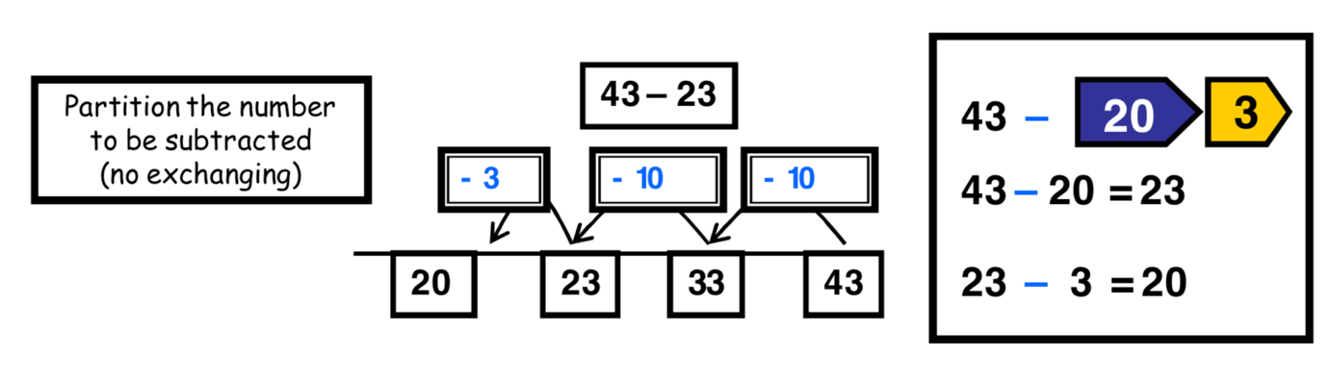
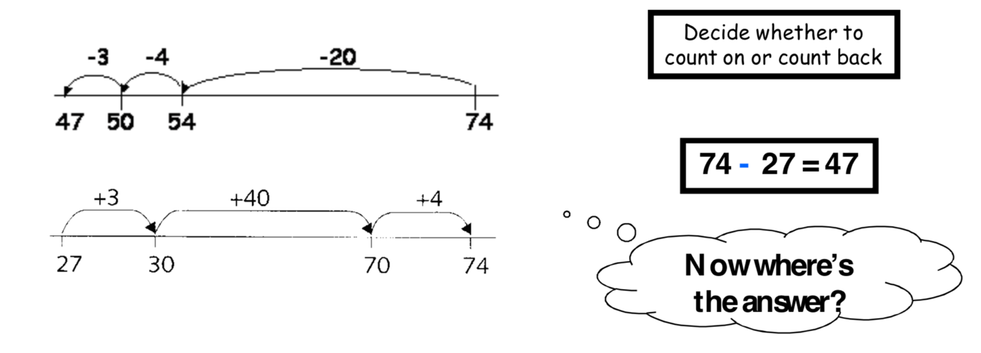

57 - 23 = | 95 - 73 =
84 - 52 = | 86 - 45 =
63 - 45 = | 84 - 71 =

Challenge 1:
A teacher opens a new pack of 48 pencils. She gives a pencil to each of the 32 children in the class. How many pencils are now left in the pack?
There are 59 elephants and 33 are cooling off in the water. How many elephants are not in the water?
Annie has 33 stickers. Dexter has 54 stickers. How many more stickers does Dexter have?

Challenge 2:
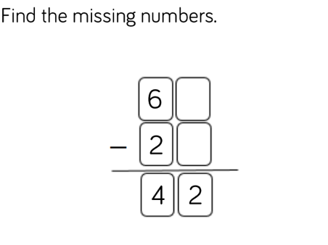

Is there more than one solution to the above find the missing numbers challenge?

Tuesday
LI: To add/subtract 2-digit numbers to/from 2-digit numbers by counting on/back
To understand addition and subtraction as inverses of each other and use this to find relationships

We can use subtraction to check addition. We know addition undoes subtraction but it is also true that subtraction undoes addition.
54 + 23 =
54 + 20 = 74,
74 + 3 = 77.
We can check this by doing a subtraction.
77 – 23
77 – 20 = 57,
57 – 3 = 54

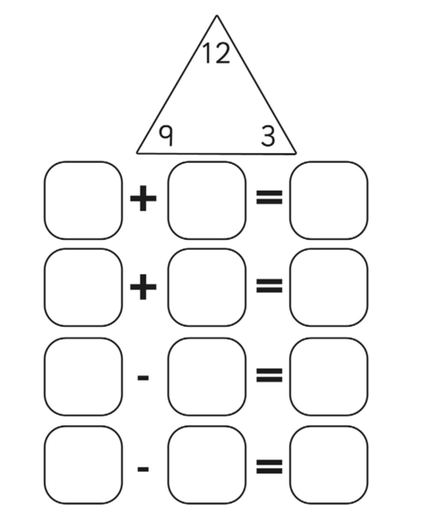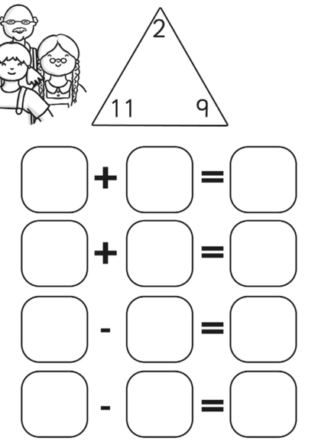

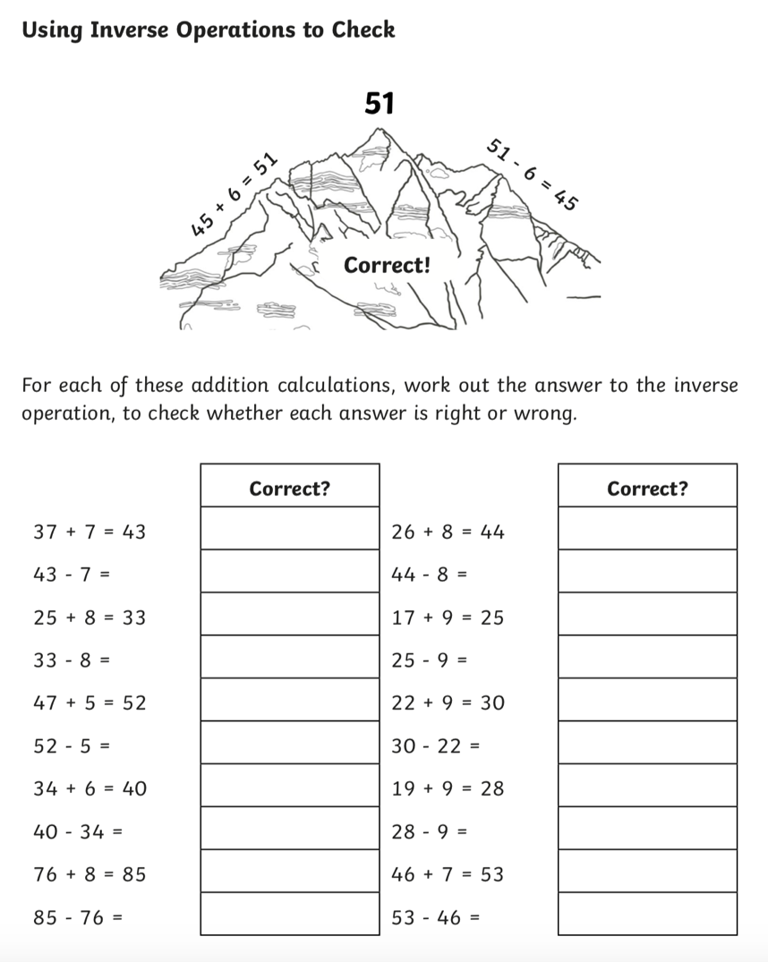

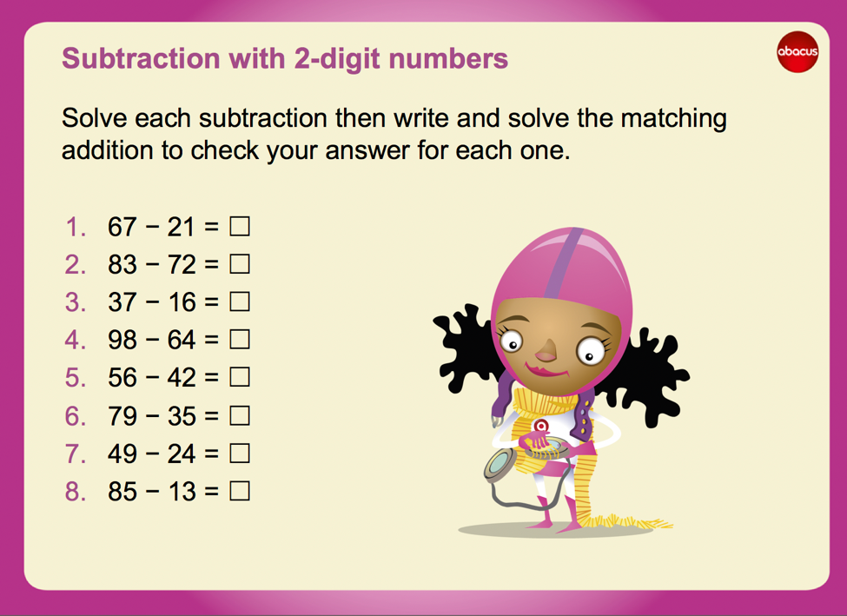

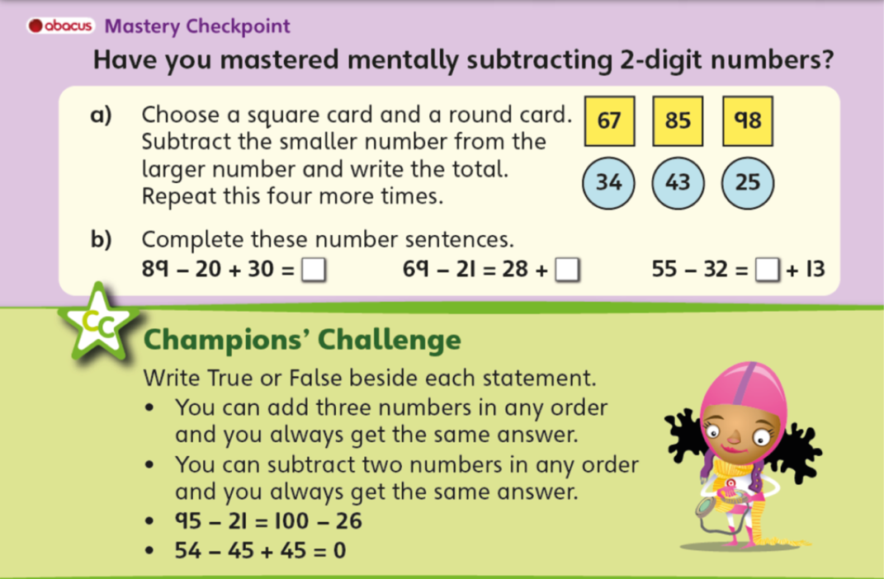

Wednesday
LI: To add three or more small (< 20) numbers using number facts (e.g. bonds to 10, doubles)

- In a pot there are 7 green pencils, 8 blue pencils, 6 red pencils and 2 orange pencils. How many pencils are there in the pot altogether?
- On a village pond there are 9 ducks, 5 ducklings, 7 swans and 5 geese. How many birds are there in total?
- Miss Jones bakes some cakes for the school fair. She bakes 8 fairy cakes, 6 iced buns, 9 fruit scones and 8 doughnuts. If they are all sold for 2p each, how much money is paid in total?
- Dan is playing a game with 4 darts. His first dart scores 7, his second scores 5, his third scores 8 and his fourth scores 9. His last score was 25. How many more did he score this time?
- Amy, Livy, Sunita and Mohammed agree to put their money together for their school charity appeal. Amy has 5p, Livvy has 7p, Sunita has 9p and Mohammed has 3p. One of their mums says she will double their money as it is for a good cause. How much money did they give altogether?
- Chloe and her friends find conkers under a tree. Chloe picks up 9 conkers, Jan picks up 7 conkers, Zoe picks up 6 conkers and Rory picks up 8. If there were 40 conkers under the tree, how many did they leave on the ground?

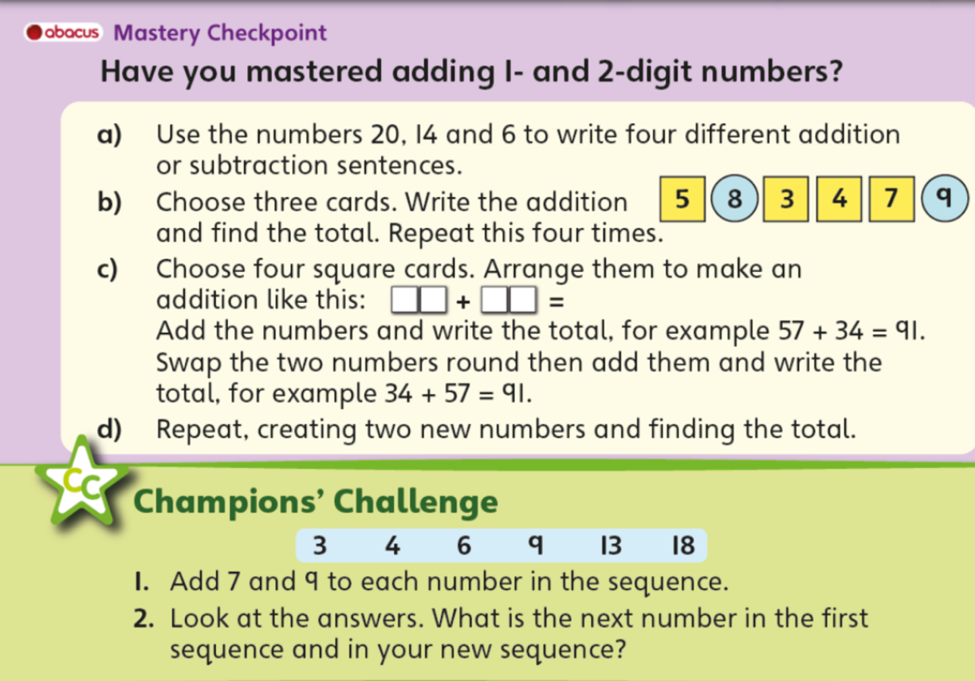

Challenge
Click here to complete the 4 Dom challenge

Thursday
LI: To record amounts of money using £, p notation

Amounts less than one pound are usually written in pence only. We write p afterwards to stand for pence, e.g. 25p.
We write amounts more than £1 like this: £4·25. This is the £ sign: we use a decimal point to separate the pounds from the pence.
Four-pound coins, a 20p coin and a 5p coin are written £4·25.
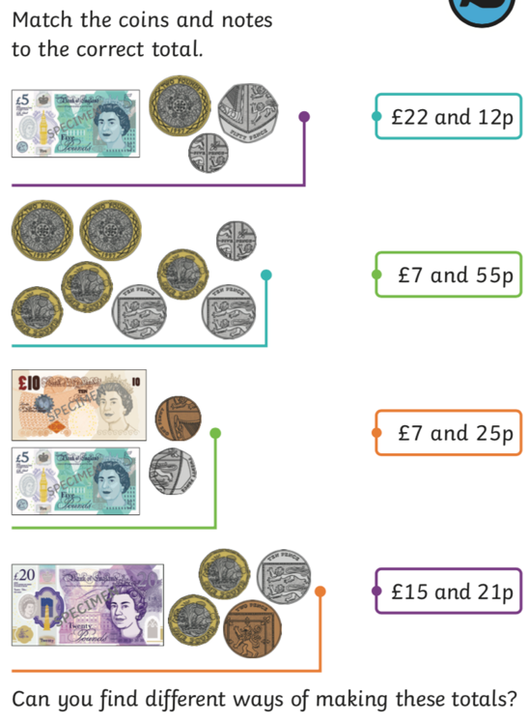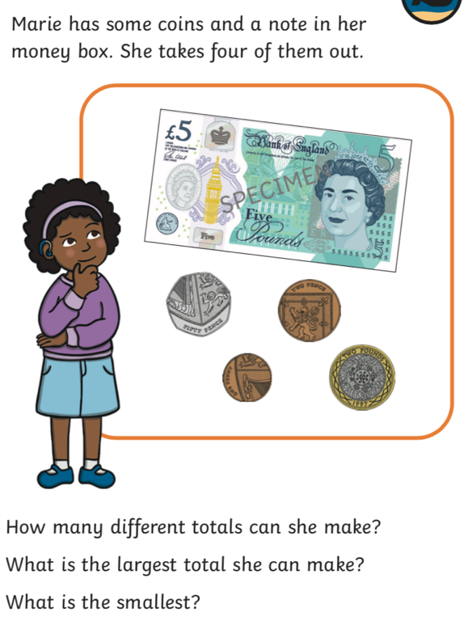

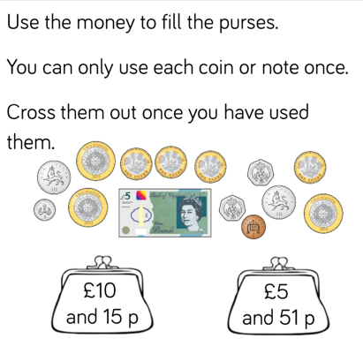
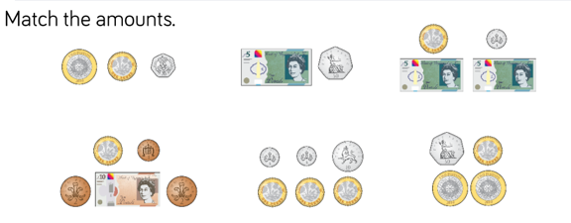

Challenge
Paying the exact amount
What coins could you use to pay the exact amount of £4·56 for a book?
What is the biggest coin you could use? We could use two £2 coins.
What is the next biggest coin we could use? And the next? And what else would we need?
We could use £2 coins, a 50p coin, a 5p coin and 1p coin.
Are there other ways to make £4·56?

What coins could you use to make the following amounts?

£3·25 | £7·75 | £12·69
£5·65 | £10·05 | £15·99

Friday
LI: To use money notation as £ and pence including beginning to recognise and write amounts such as £2·03 and £2·30, and find more than one way to solve a money problems

