Feel free to have a go at some of these lovely activities that relate to our topic…

Street Detectives!
The following activities all explore our local community in the past and in the present. We hope you enjoy them and we’d love to see your fantastic work on these activities! You can share your work by sending it to: homelearning@stjeromebilingual.org.
Miss Dear and Miss Reynolds☺
PSHE
People who work in our community
This activity will help you to learn about the ‘special people’ who work in our community and who are responsible for looking after and protecting us. It will also help you to recognise that there are special people who work in the community to help and protect people include police officers, firefighters and healthcare workers. They can be contacted in an emergency by dialling 999 or 112.
Discuss with someone at home: What is a community?

- A community is a particular area where a group of people live. E.g. A new store opened next to the school in my community.

- A community is also group of people who live close together or have shared interests.

Think about the people who work in and help look after our community.

Make a list of all of the different people you can think of and draw pictures of them.

Describe what each of these people does and explain why their work is so important.

Below are some pictures to help you think about people who work in our community.

Every job is important and we are sure that you can think of many other people who you would like to draw and explain why their work is vital.

Find out how you call the Fire Brigade, the Police or ask for an ambulance in an emergency.
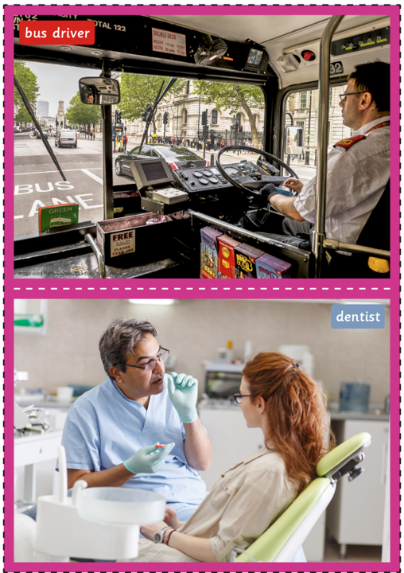
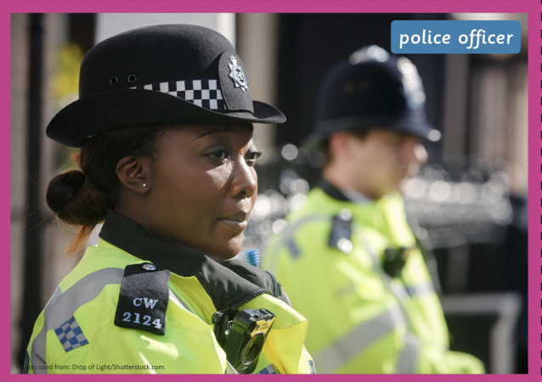
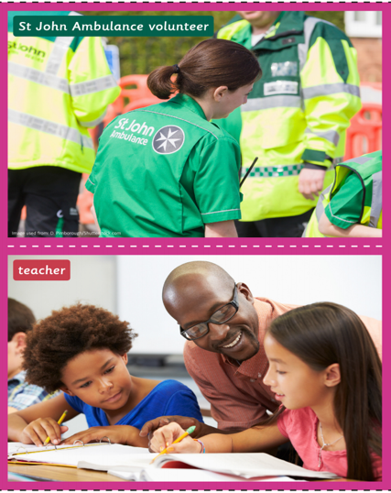
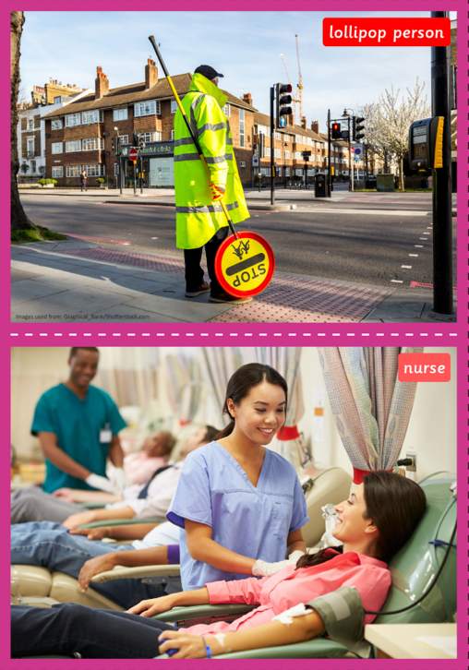

Geography

Explaining preferences

This activity will help you to think about your local environment and the parts of it that you really like.

Talk with someone at home:
- What does ‘local environment’ mean?
- What do you enjoy about living in Harrow? Why?
- What is your favourite place in Harrow?

Choose a part of your local area that you really enjoy. For example, this could be a park or building.
Draw a picture of this area and add a few sentences to explain why you like it so much.
Please share these areas with us! We would love to put a file of your favourite places in Harrow together. You can use the following address: homelearning@stjeromebilingual.org.

