Feel free to have a go at some of these lovely activities that relate to our topic…

The scented garden!
We hope you enjoy them and we’d love to see your fantastic work on these activities!
Miss Dear and Miss Reynolds☺
Science
LI: To grow a whole plant from a small part of a plant and to find out what plants need to grow and stay healthy.

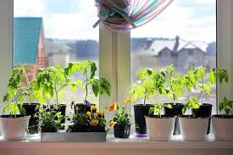
You could grow your own windowsill garden from kitchen scrap! With a little time and patience there are vegetables that you can re-grow again and again from kitchen scraps. Food scraps that will grow easily on a windowsill include pineapple, onions, potatoes, celery, garlic, onions and carrot tops.
You will need some flower pots. You can recycle containers or make your own newspaper pots for your plant to grow in!

How to re-grow a plant from a kitchen scrap:

The following websites will help you to use the vegetables you may already eat at home.
- Version 1
- Version 2

Find out what plants need to grow to help your take care of your own plant! Observe you plants daily and record your findings. Share pictures of your plants with us at: homelearning@stjeromebilingual.org. We can’t wait to see them!

Geography/ Science

LI: To explore and create maps. To discover new types of plants.
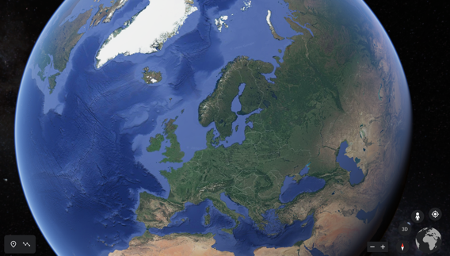
Try to find your home and your local park on google earth by entering your address in the search box.
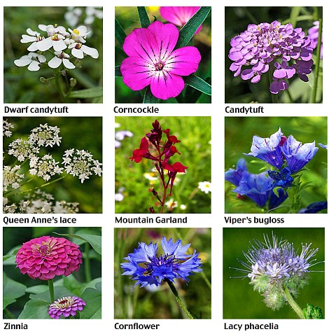
Explore your garden or take a quick walk around your local park. Have a look at the plants that are growing there. Take some photos and find out the names of the different plants. Remember the names of the plants you see; how many you see and where you found them in your garden/ the local park.
- To help you name the different plants use the plant names document, potentially harmful plant table and flower spotter sheet on the year 2 home learning page

Then, draw a map of the local park or of your garden, and plot where you found the different flowers.
- Plotting means to add onto the map where we have found the different flowers; we can use symbols and a key (for example dots or rosses or a quick symbol of the flower/ plant).
Remember to include a key and symbols in your maps.

Alternative (if you cannot go to your local park):

Use the tree planting planning tool to create your own garden or school playground! You can create your maps using the online tool or draw your own imaginary garden/ playground map. Add in the flowers you would like to see in the garden.

You can share your maps with us by sending them to: homelearning@stjeromebilingual.org. We look forward to seeing your fantastic garden/ park maps or your imaginary gardens!

