Year 3 Home Learning week beginning Monday 18th May – English / ICT

This week you will working directly from this file so the first thing you need to do is ask your grown up to download this file and save it with under your name. Every day, you will need to access this new file from your desktop and save it regularly so you don’t lose what you have worked on. On Friday, we ask that your grown up send this file as an attachment to an email to the school so that we can see your work.

If you prefer to print the pages and write directly on them, that’s is ok too. Just remember to take a picture and upload your work when you have finished.

Monday
LI: To use simple organisational devices such as headings and sub-headings.
Use what you now know about rivers to complete the diagram (in the resource sheets at the end of this plan) showing the different stages of a river, from source to mouth.
To make the task simpler, we have provided a glossary and website links (below) that describe different features and stages including source, tributaries, mountains, meander, flood plain and waterfall.
We are expecting everyone to complete the diagram and, as a challenge, we would like you to present some information about those features using headings and sub-headings.

http://www.onegeology.org/extra/kids/earthProcesses/rivers.html
https://www.dkfindout.com/uk/earth/rivers/

Tuesday
LI: To check that longer texts make sense.

Read the set of given instructions entitled, ‘How to make a river’. Can you identify any mistakes and comment on the use of technical vocabulary, how clearly the writer has presented their instructions and whether they are correctly sequenced?
You can evaluate and edit the instructions with the highlighter pens function, notes and annotations straight on to the sheet and save the file when finished, or you can do this on paper if you prefer.
You can try out your instructions by making the model of a river if you have the things needed.

Wednesday
LI: To spell words with the uh sound spelled as ou.

Watch the BBC Bitesize clip here.
Find as many words as you can where ou is used to make the uh sound. Write an interesting sentence using each word.

Thursday
LI: To recall and consolidate your knowledge.

Complete page 1 of the quiz sheet (in the resources section) but without looking up the answers. Once you have had a go on your own, you can research and look up the answers.
Remember, you don’t have to print it, you can just click in each box and type in your answer. Save your file every day and email it back at the end of the week.

Friday
LI: To recall and consolidate your knowledge.

Complete page 2 and 3 of the quiz just as you did yesterday.

Resources wb: 18/5/2020
Name:

If you cannot print this sheet, you can still complete it by typing your answer in the boxes and email this page back to school.
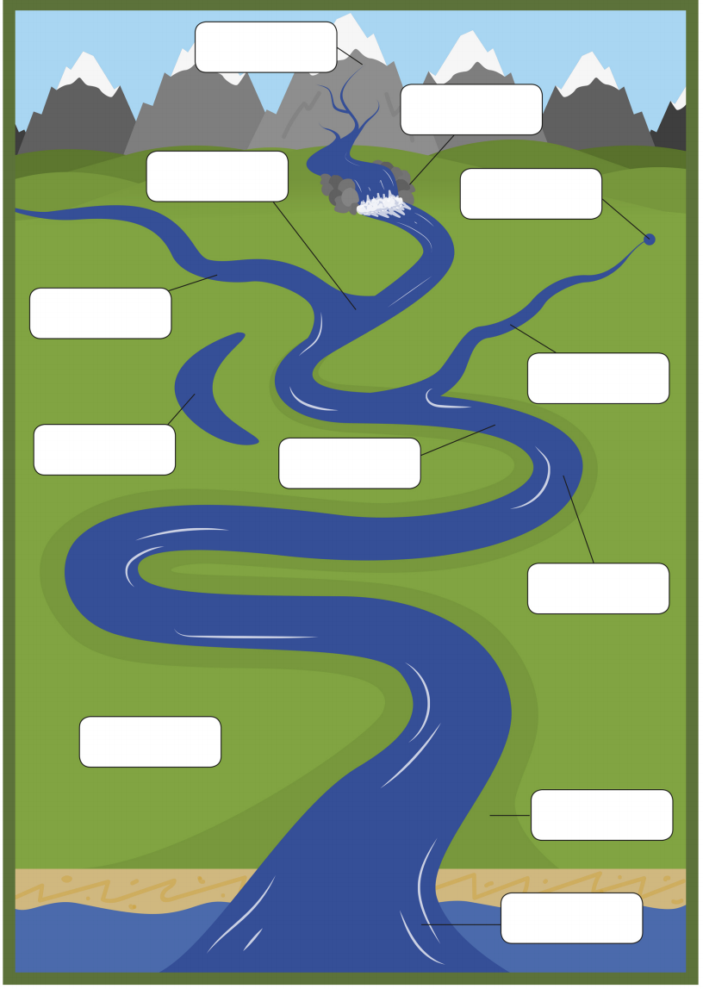

source

Glossary
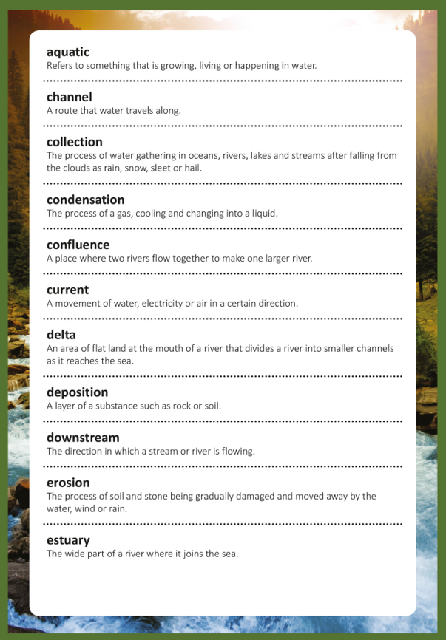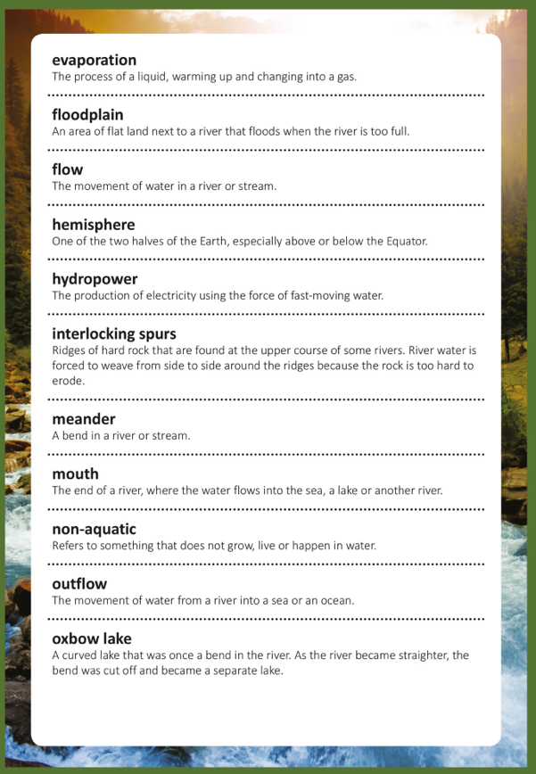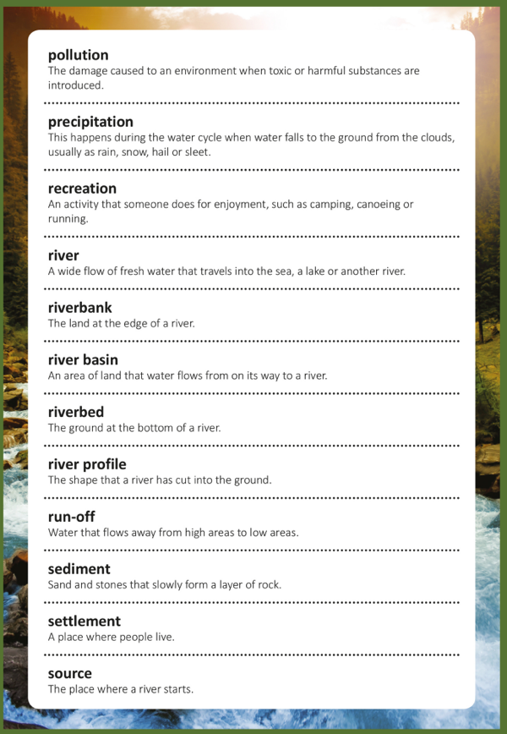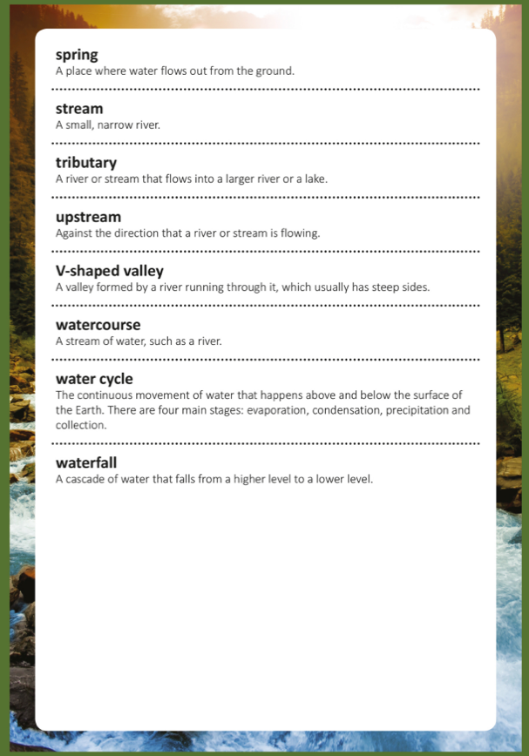

Resource for Tuesday 19/5/2020
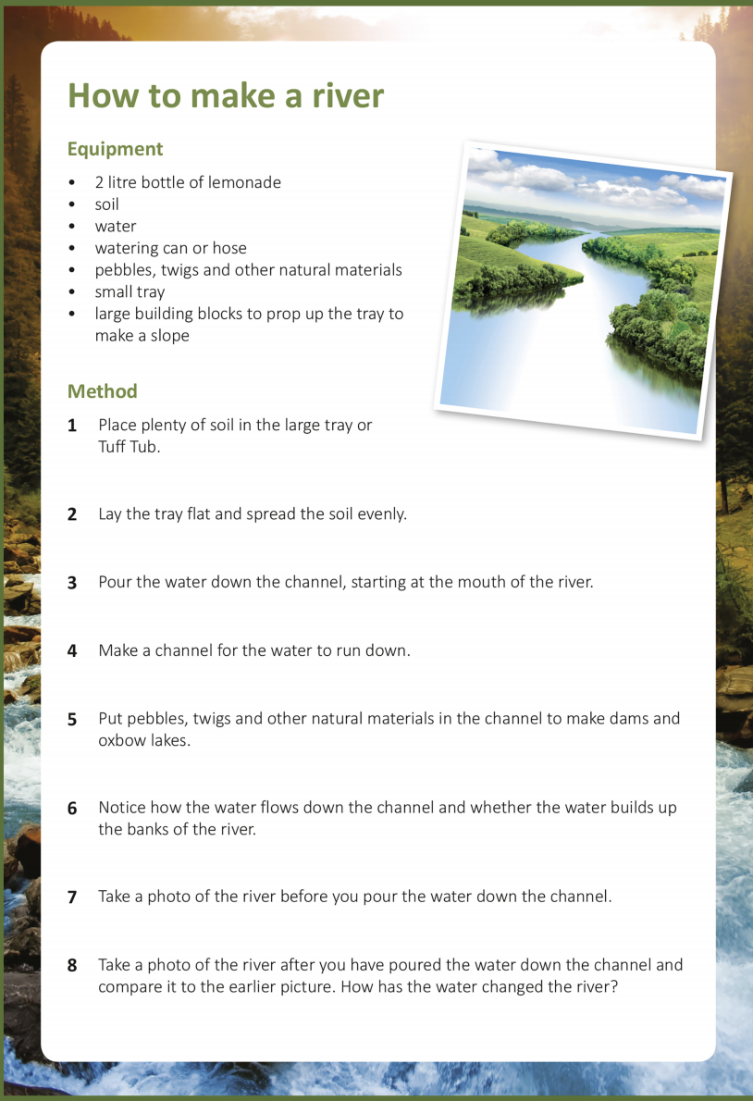
In the equipment section: Are all the items needed?

In the method section: Is the ordering correct?

Resources wb: 19/5/2020
Name:

If you cannot print this sheet, you can still complete it by typing your answer in the boxes and email this page back to school.