This week you will be practising adding in columns and you will be adding more than two numbers. Remember to use your understanding of place value to put the digits in the correct column. You will also be subtracting by counting forwards on a number line and solving word problems.

Monday

LI: To add 2 or more 2-Digit numbers or 3-Digit numbers
Take a 0-9 dice or use a spinner (remember to use the purple cog at the top right to make sure that your dice or spinner is 0-9) to create 4 1-digit numbers. As quickly as you can, add the 4 numbers in your head. Remember to use known facts. Do this 4 times.

Look at this number sentence: 34 + 43 + 85 =. how would you find the total of these numbers? You could work it out in our heads by adding two numbers, then another and finally the last, or by partitioning and adding all the 1s then all then 10s.
When we are adding more than two numbers often we need to write out a column addition and add the 1s, then the 10s, then the 100s, etc. This is especially useful for adding more than two numbers or really big numbers. Use the column method to add the numbers to find the answer – remember to set the numbers out in the correct columns. Like this: Add the ones first (4+3+5 =12) put the 2 in the ones column and the 1 in the tens column in the space we left. Then add the tens (30+ 40 + 80 +10= 160) then put the 6 in the tens answer and the 1 in the hundreds. So the answer is 162.
H T O
3 4
4 3
8 5
__ 1___
1 6 2

Now use the same method to add these numbers – be careful to put the digits in the correct column. The first one has been done for you:

214 + 83 + 312 =

H T O
2 1 4
8 3
3 1 2
1 ___
6 0 9

- 32 + 41 + 42 =
- 17 + 35 + 23 =
- 33+ 84 + 46 =
- 117 + 626 + 157 =
- 371 + 132 + 444 =
- 228 + 269 + 202 =
- 533 + 227 + 86 =
- 374 + 68 + 427 =
- 362 + 569 + 64 =
- 136 + 353 + 53 =

Challenge: Can you write 4 word problems which involve adding 3 numbers?

Tuesday

LI: To add 2 or more 2-Digit numbers or 3-Digit numbers

Use this link to The daily 10. Set it to level 2 using the purple “choose” button, then click on addition from blue “choose” button and then click on three one-digit numbers using the green “choose” button. Finally set the time at 20 seconds or manual (this will go to the next sum when you click). Write your answers on paper and then check when you have finished by clicking on “reveal all”.
Repeat this at least 3 times.

Today we will practise the method we used yesterday so start by looking back to yesterday’s examples and make sure that you understand.

Now try these questions.

- 365 + 226 + 113 =
- 231 + 247 + 326 =
- 135 + 353 + 235 =
- 233 + 537 + 153 =
- 617 + 157 + 162 =
- 341 + 263 + 172 =
- 539 + 214 + 238 =
- 352 + 391 + 74 =
- 532 + 348+ 53 =
- 474 + 282 +28 =

Challenge: Can you work out what the missing numbers are in these sums?

H T 0 H T O
3 5 5 5 7
4 2 + 2 6 2 +
______ _____
7 8 8 _ 1.__

Wednesday

LI: To use a number line to subtract 3-digit numbers.

Start by practicing number bonds to 10 and 100 using Hit the Button.

Today you will be using these number bonds to help you to subtract on a number line by counting forward.

If I wanted to subtract 478 from 523 I would write it like this: 523 – 478 =
Do you remember the frog jumping along the line? You would write the smaller number at the beginning of your line and the bigger number at the end of the line. Then, starting at the small number, “hop” to the next multiple of 10, then to the next multiple of 100 and finally to the end number. Then you add up the hops. Like this:

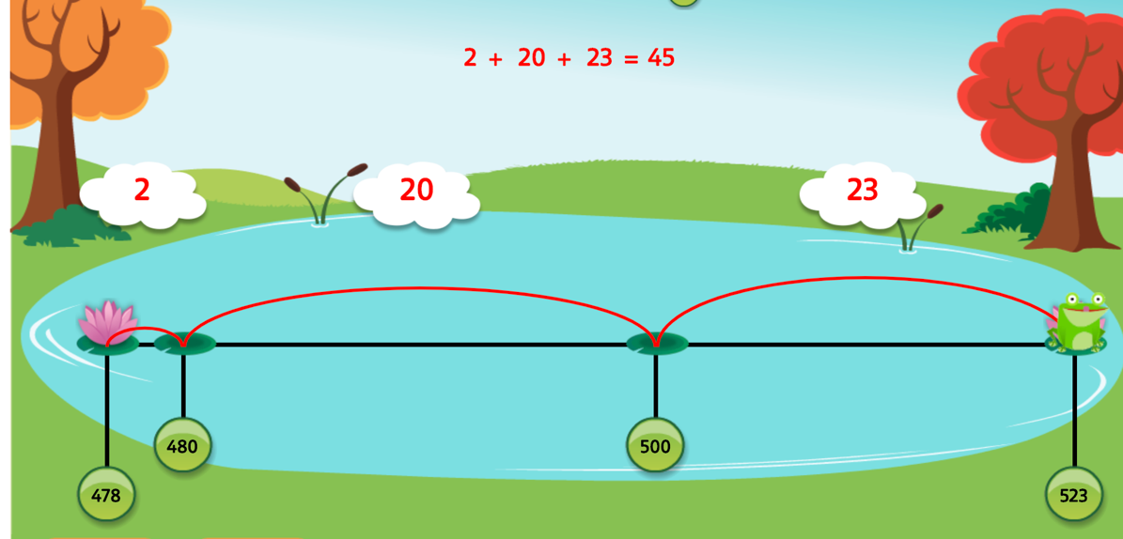

Now draw your own number line to answer these questions. Remember to use you knowledge of number bonds to 10 and 100 when you hop along the line.

- 316 – 285 =
- 385 – 342 =
- 614 – 578 =
- 763 – 717 =
- 823 – 792 =
- 517 – 469 =
- 931 – 884 =
- 727 – 681 =
- Joe has read 164 pages of his book. The book has 238 pages. How many more pages does Joe need to read to finish his book?
- Lily has 86 stickers. Her sticker book has 12 pages with 10 stickers on each page. How many more stickers will Lily need to complete the book?

Thursday
LI: To use a number line to subtract 3-digit numbers.

Practice the 8 times table using Hit the Button.

Use a number line to subtract these numbers. Remember to start with the small number and count up to the big one by hopping from the small number to the next multiple of 10 , then to the multiple of 100 and then to the end number. Look back at yesterday’s frog subtraction if you want a reminder.

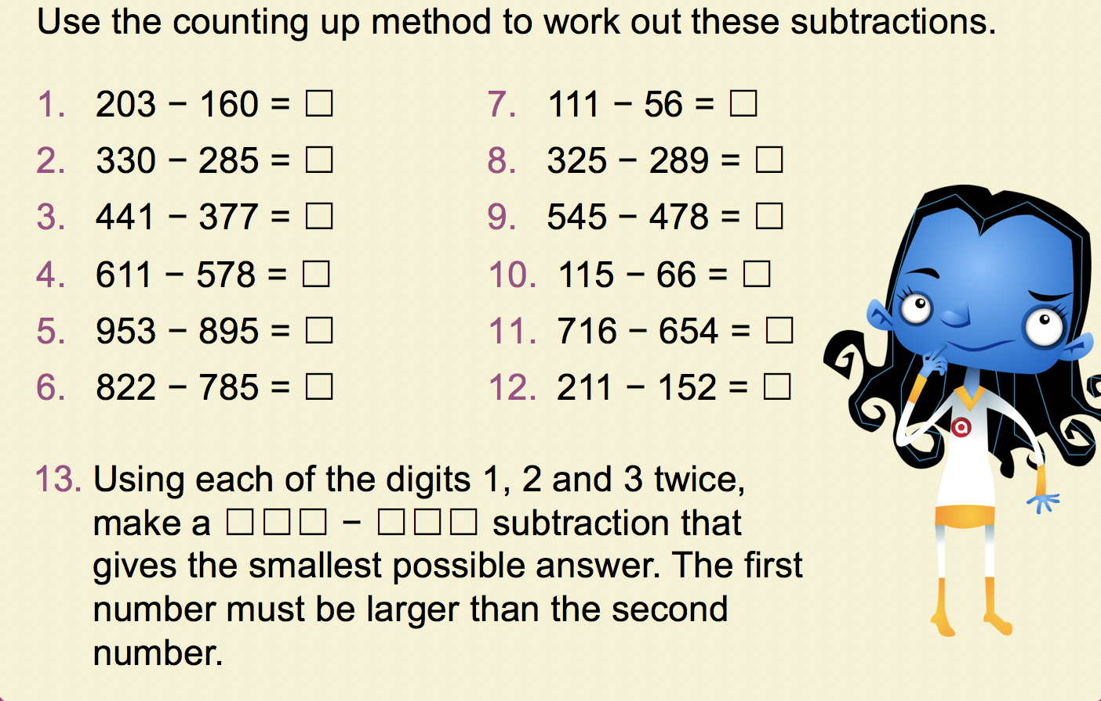

Friday
LI: To solve word problems involving addition and subtraction.

Use these to help you when you solve the word problems:

Read the problem
Underline the important information
Choose the method of calculation.
Solve the problem (make sure that you show how you did it)
Answer the question
Check your answer

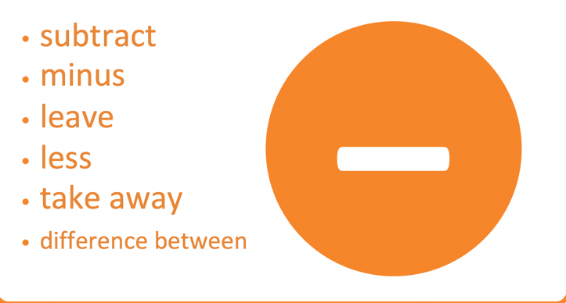

Here are the questions:
- A jug contains 255ml of juice. Ted poured a carton of 330ml in to the jug. How many ml of juiv=ce are there in the jug now?
- A plank of wood is 225cm long. Mr Amin saws a small piece off. The plank is now 187cm long. How long was the piece that Mr Amin sawed off?
- Susan picks up 2 tins from the shelf. One weighs 425g and the other weighs 240g. What do they weight altogether?
- A baby elephant weighed 118kg at birth. After 6 weeks, it weighed 96kg more. How much did it weight then?
- There are 883ml of milk left in a carton. When full, the carton held 925ml. How much milk had been used?
- A lorry driver drove 496km to deliver food to the supermarket. The next day he drove back but because of a diversion he drove 511km back. How much further did he drive on the way back?

Challenge: write a word problem for each of these questions and work out the answer.

348 + 71 =
126 – 89 =

