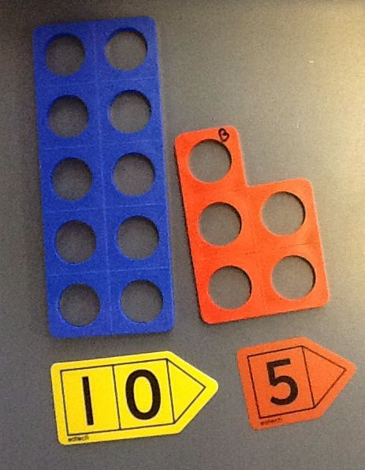
Maths – Year 1
Week commencing – Monday 1st June 2020

MONDAY

Today we are going to be focusing on PLACE VALUE. What is place value? Can you tell someone in your household what place value means? Maybe you could write an example to help explain?

Watch this link to help remind you what place value is: LINK

Task 1
Have a look at these 2-digit numbers below. Can you write down how many tens and how many ones are in each number? Use the example to help you

49 | 52 | 17 | 84 | 23 | 69 | 40 | 37 | 31 | 79
46 | 86 | 31 | 27 | 84 | 99 | 25 | 17 | 20 | 80
4 9

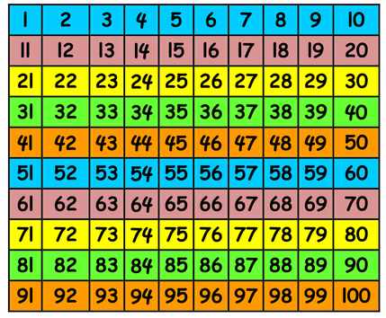
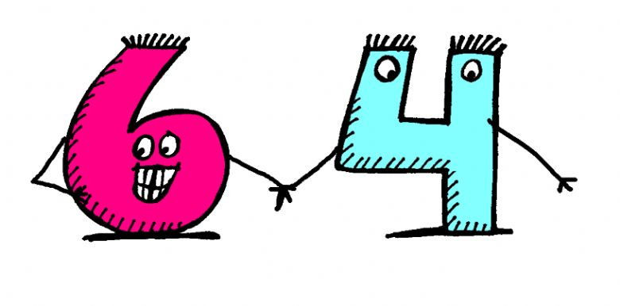
Task 2
1) Have a look at the 100 square.
2) Pick any THREE 2-digit numbers and write them down.
3) Now, look at the place value of the digits in your chosen numbers. Which number has the most tens? Which number has the most ones?
4) Write your three numbers in order from biggest to smallest using their place value to help you.
5) Now pick three new numbers and repeat activity as many times as you can!
TUESDAY
You are doing so well with your place value skills – well done! Today we are going to be
There are 9 ones in this number
There are 4 tens in this number
looking at PARTITIONING 2-digit numbers. What does partition mean?

PARTITIONING - is when you split or separate a number

Have a look at the following example. I am going to split this 2-digit numbers into its tens and ones:

Task
Find a piece of paper and use the example above to help you partition these 2-digit numbers.

WEDNESDAY
Today we are going to be using out place value skills to help us put 2-digit numbers in order from smallest to biggest.

What you will need:
- Some scrap pieces of paper
- Any pen or pencil
- Your super clever maths brain

Task
Get your scrap paper and rip it up into little raffle-ticket sized pieces of paper. On every little piece, write a 2-digit number (for example 29 or 48 or 14.) Now fold/scrunch each bit of paper up and put them all in a container (you could use a cup or a bowl or even a hat!) Now take out FOUR bits of paper and look at the different 2-digit numbers, look at the FOUR numbers I picked…
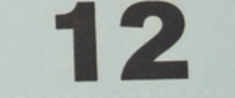
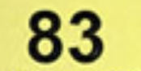
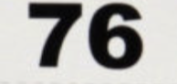
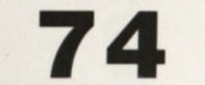

Now I want you to use your place value skills to rearrange these numbers and put them in order from smallest to biggest. REMEMBER if you have two number that both have the same number of tens then make sure you look at how many ones they have – this will help to tell you which is number is bigger.

I have put my numbers in order from biggest to smallest. I am a right?
Once you have put your first four numbers in order from smallest to biggest, fold them up and put them back in your container. Now pick 4 more numbers and repeat activity as many times as you can!

Challenge
Can you choose FIVE numbers and see if you can put them in order from smallest to biggest?
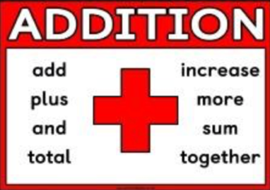
THURSDAY

Today we are going to be using our place value skills to help us solve addition sums.

Task
- Pick any 2-digit number from 100 square below.
- Look at its place value – how many tens does it have and how many ones does it have?
- Write the addition sum for your 2-digit number. Look at my example below.

Example – I have picked the number 63.

There are 6 tens in 63
There are 3 ones in 63

Therefore my sum would be 60 + 3 = 63
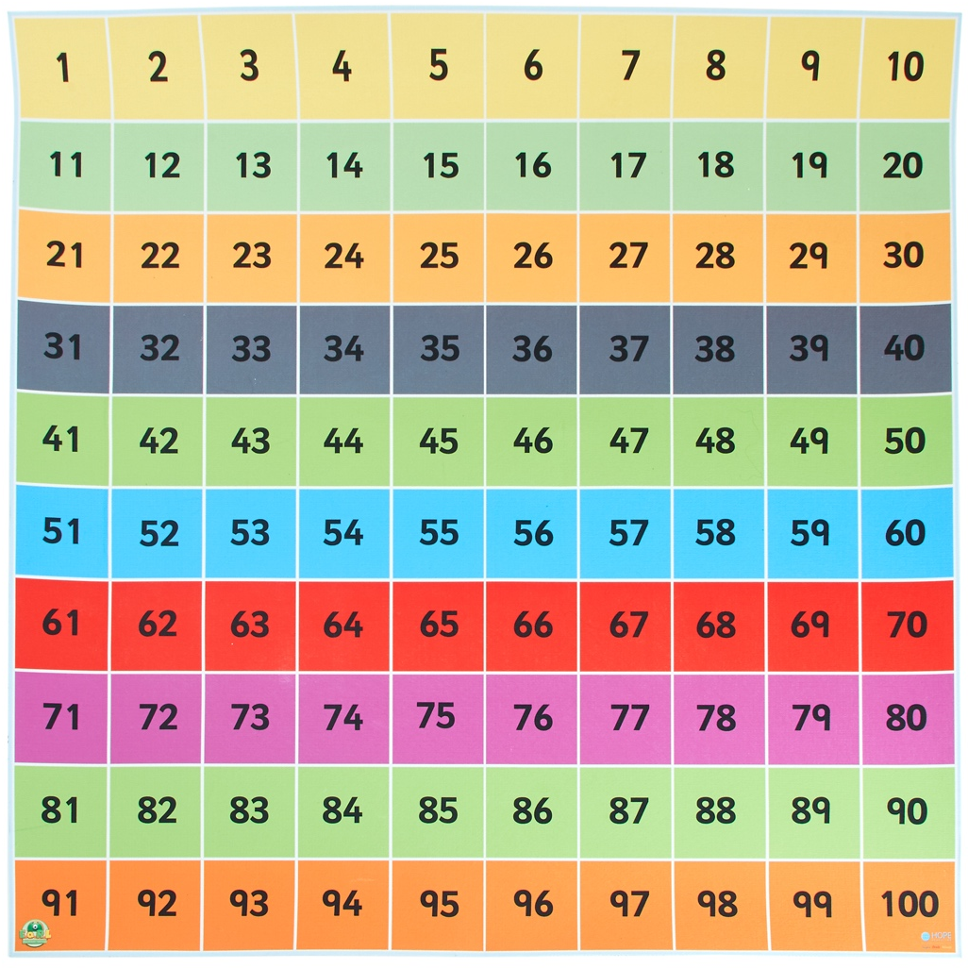
Pick ten 2-digit numbers and write the addition sums for them. Use the example above to help you
FRIDAY
You have done some brilliant work this week on place value – well done!

It is now time for you to use all your place value skills and knowledge and become NUMBER DETECTIVES! Have a look at the number mysteries below and see if you can use all that you have learnt this week to solve the mysteries. Good luck

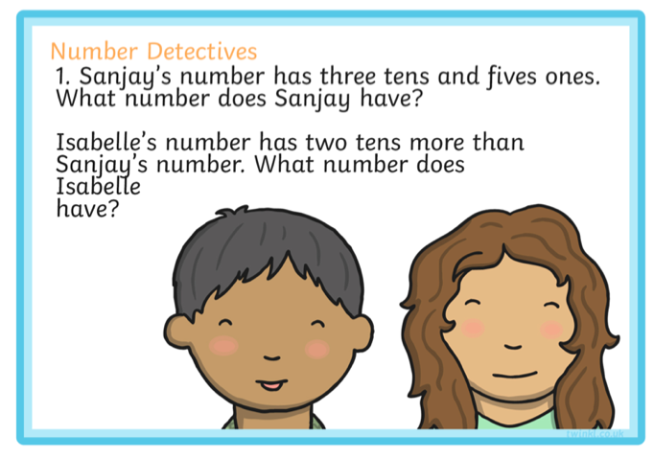
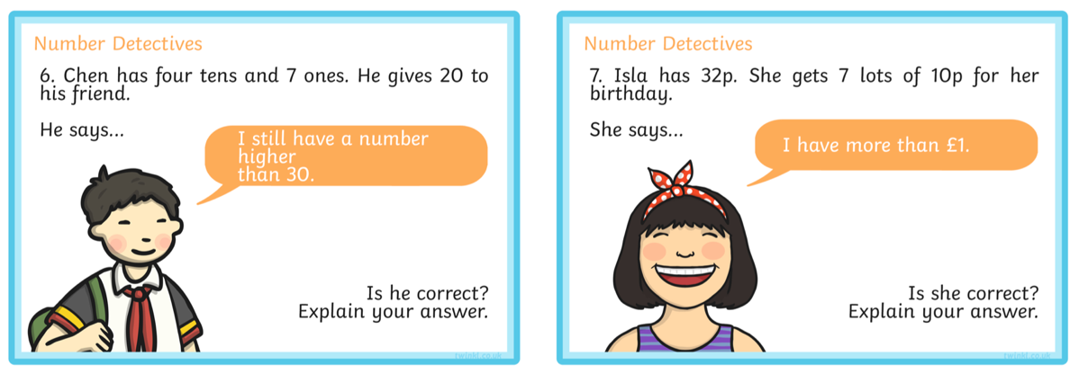
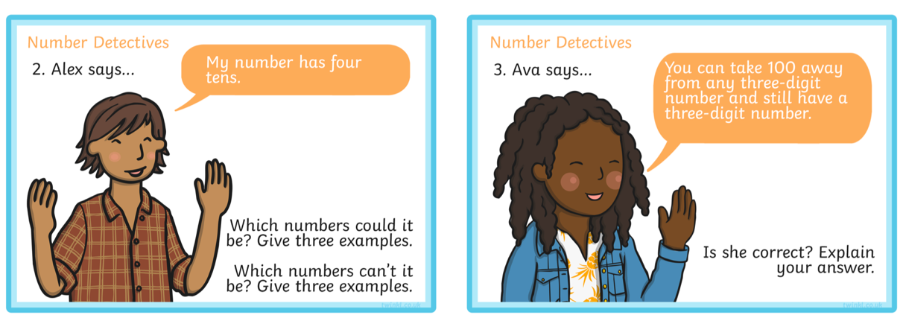
Challenge
Can you try and write your own place value mystery questions? Maybe your grown up or someone is your household can try and solve your mysteries? Have fun!

