Bonjour les enfants! I hope you are all well and ready for our new exciting theme:
Scrumdiddlyumptious Yr3 Art Project

Learning Intention Year 3
To use and combine a range of visual elements in artwork.
Visual elements include colour, line, shape, form, pattern and tone.

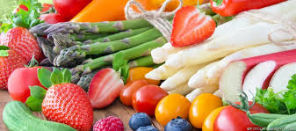
Des fruits et des légumes: Miam, miam, miam …

To get you into the mood, here is a song to sing along to: La parade des aliments and remember you can find some more food songs on the constantly updated Yr3 Pinterest board.

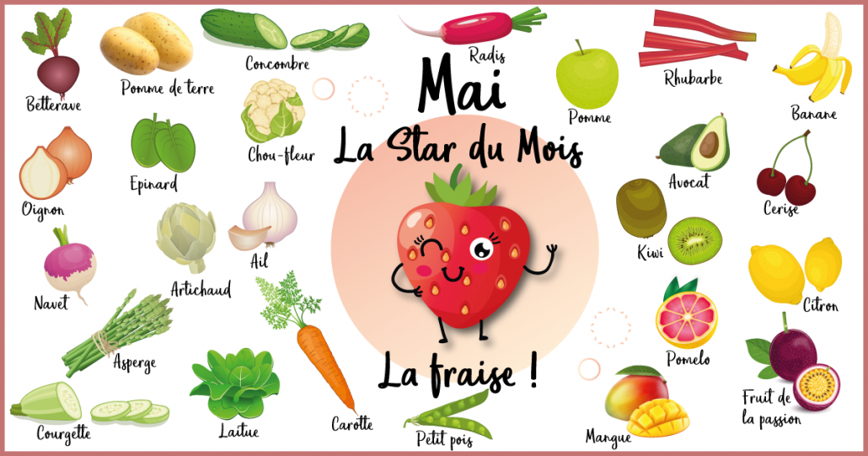

- First, I would like you to have several attempts at observing different fruits and vegetables, looking carefully at detail, such as colour, shape, line, tone, pattern and form.
- What do they feel like?
- Is the skin lisse / smooth or rugueuse /rough?
- Did you touch them, smell them?
- Do you like the look of the fruit? Explain why you do or why you don’t?
- You could use scales and rulers to measure weigh and compare them.
- Look at their texture and scent.

- On an A4 piece of paper, you now should describe your observations using artistic and sensory vocabulary.

- Then, I would like you to prepare several pieces of A5 paper (a normal piece of paper A4 cut in half)

- Now, using these pieces of paper, I would like you to have several attempts at drawing these different fruits and vegetables.
Look carefully again at detail, such as colour, shape, line, tone, pattern and form.

Colour these in carefully with colouring pencils.

- Next, I would like you to assemble all these drawings together to make a mini sketch book of your observations. Have you thought of adding a tittle page for it?

To do this, you will need to use a punch hole and a piece of ribbon, wool or string.

Put all your drawings together and then make two holes along the left-hand side of your drawings.
Using a piece of ribbon, string or wool pass it through the holes and make a small bow towards the front.

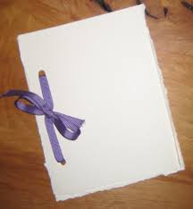

Other ideas you could explore:
Take pictures of the fruit and vegetables from close up or from further away.
Cut the fruit and take pictures. Look at the details.
Look at light and shadows.

Finally,
how do these fruit and vegetable you have been drawing grow?
Where do they come from?

Maybe you could imagine that one of the fruit or veg you have been looking at, has written you a letter using lots of little drawings to tell you the story of its journey in order to arrive in your kitchen: What would it look like?

We’d love to see any artwork you make at home so please feel free to email us your work over the coming weeks.
Of course, please do carry on exploring these other links:
Some Galleries to Explore on the Internet
https://www.accessart.org.uk
http://nationalgallery.org.uk
http://www.saatchigallery.com
http://www.tate.org.uk
http://artfulparent.com
http://www.npg.org.uk
Here is a great resource for adults on looking at art and how to talk about art:
http://www.artjunction.org/archives/looking@art.pdf

Again, below, is a particularly good resource from Access Art that offers a simple set of drawing exercises. The exercises are completely adaptable for all ages and abilities from Year 1 to year 6. Doing ten minutes of drawing every day is really fun:
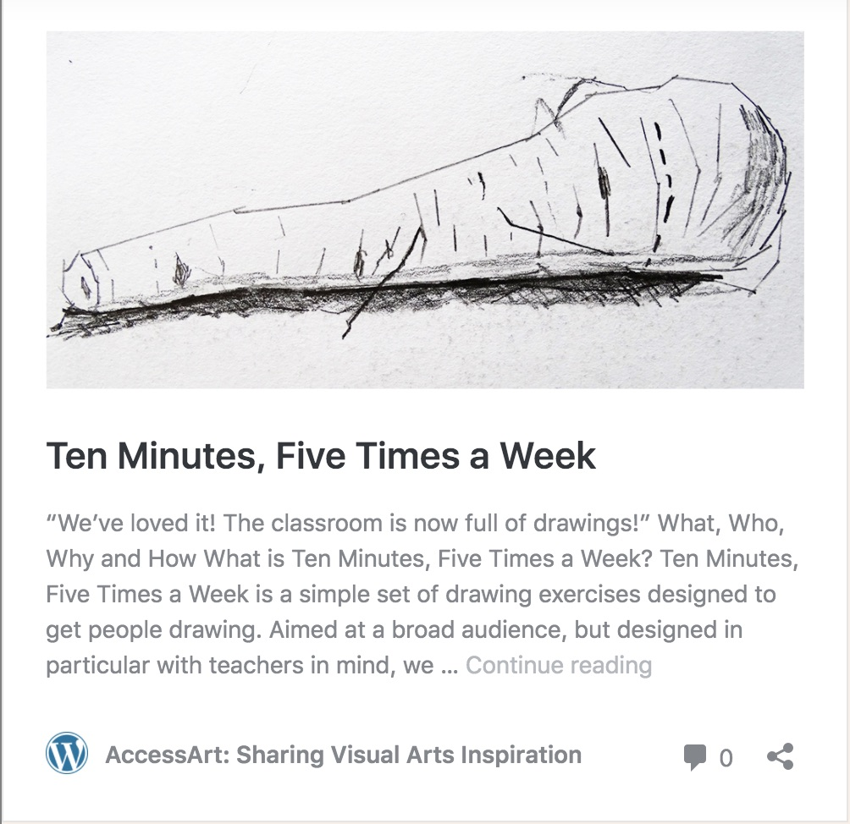
I wish you all the best and look forward to seeing some of your artwork!
Keep well and I hope you will enjoy looking, drawing and maybe eating les fruits et légumes you have drawn en salade, have fun et peut-être bon appétit!
from Madame Perrot

