Bonjour les enfants et parents des classes deux ! Week 4 - 22 juin 2020

We are so proud of our St Jérôme pupils who have between all of you accumulated over 3000 medals on Languagenut and we are now ranked 35 in the world, with only 120 pupils enrolled to play, that is an amazing achievement! Bravo et continuez !
Remember: Don’t do all the activities set in the homework in Languagenut in one go! It’s better for your long-term memory that you practise French every day a little bit.
Our seasonal song is Quand c'est l'été .Please sing along and dance to it at every opportunity and certainly before you start French work to put you in the mood.
Lundi 22 juin 2020 - Monday 22nd June 2020
Sing along to Quand je vais à l'école to get you in a French frame of mind. Have you ever heard of a French island called "Martinique" ? Look where it is on a map and find the capital town of that French Department. Which continent is it on? Through this Voici ma ville video you can explore it further and answer the questions below using the following list of words: à la bibliothèque - l'orange- les enfants -la poste - l'ananas- Raïka- la cathédrale- la pomme-cannelle- onze ans- et les adultes-le grand marché.
- What is the name and age of the girl who is going to show you around?
- What is the first building that you discover?
- Where can you find some "livres"?
- Who are the 'livres" for ?
- What fruits are shown to you?
- Where does she buy the fruit?
I hope you enjoyed the virtual travelling to another country.
Mardi 23 juin 2020 - Tuesday 23rd June 2020
I wonder whether you feel like singing along to Quand je vais à l'école today?
We would like you to carry on your French learning with the bilingual course called High-Five.
Remember that you need to create a free login yourselves under adult supervision if you haven't done so yet and to always have parental supervision when you are on the internet.
Let's go with Mathilde to a "Office du tourisme"(the Tourism Information Bureau/Office) and ask where things are. to watch Video Lesson 16- À l'Office du Tourisme on High Five.
Which question word is Mathilde using? Which song has this question word in the chorus? Look in the Yr2 St Jérôme Pinterest Board to find it.
Reading the Notes for Teachers 16 can help you with deeper understanding and learning before you do the Activity Sheet 16a. Please print it in black and white.

Mercredi 17 juin 2020 - Wednesday 17th June 2020
After some singing along to our gorgeous seasonal song Quand c'est l'été, you can listen to the Radio Show 16 and do the Activity Sheet 16b. Please print it in black and white. I wonder which is your favourite place to visit in a town?
Jeudi 18 juin 2020 - Thursday 18th June 2020
Today's challenge is to read the Lesson Transcript 16 . You can read it aloud or ask a member of your family to be Emma and you can read Mathilde's words to teach Emma.
Extension: Could you rewrite bits of the lesson transcript, making sure you use the sentence correctly: "où est ... le/la +m noun " and taking care to use the determiner “le” in front of masculine nouns and “la” in front of feminine nouns. You can send a voice or video recording of you reading loud the above script or your rewritten script.
Vendredi 19 juin 2020 - Friday 19th June 2020
Quand je vais à l'école and Quand c'est l'été both contain in the title a noun with an accent on. Which ones are they?
Yes it is "école" and "été" ! Do you remember the sound the letter "é" makes? é est foncé, a dark purply colour. When you sing along to these songs, can you write down all the words that have the "é" letter and focus on repeating them well.
In school we are taking regular 5-minute fitness breaks thanks to the generosity of the Five-a-day team. We are thrilled that we can share with you these resources to use at home to take fitness breaks.
You will have been emailed a letter with the login for you to use at home at your convenience.
To start learning saying your right from your left, watch and move to the Robot French fitness routine playing to the No Subtitles, so that your child concentrates on the visual movement of the instructor and the French instructions through listening, not reading words.

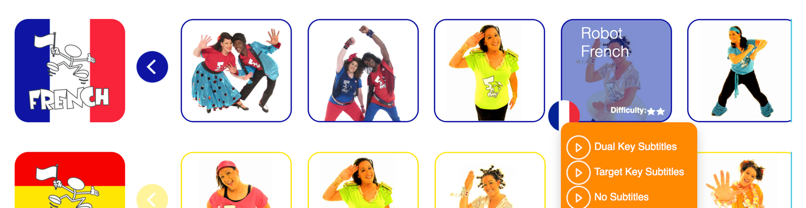
You can always enjoy all the songs and stories we have done in Yr2 St Jérôme Pinterest Board.
You can send any of your work or questions to french@stjeromebilingual.org . We are always happy to receive messages: "Madame Chadier aime les messages".
We hope you will enjoy this week’s activities!
Have a good week!

Salut, au revoir et à bientôt, Madame Chadier

