Reception Maths Home learning week beginning 22.6.20

Monday – Comparing soft toy heights

Can you find three soft toys in your home of different heights? Which is the tallest? Which is the smallest? How do you know? You could put each toy standing beside each other and put them in height order from the shortest to the tallest.
To find out the height of each toy, what object could you use? For example, a pencil, stick, your hand. You should use the same object once or objects of the same length, such as matchsticks so your measuring is accurate.
Estimate how many of your object you would need to measure each soft toy. Use your object to measure each of the soft toys. Record how many of each object you needed to measure each toy. Compare your estimate with the actual length of the toys.

Toy | Estimate | Actual
Soft toy 1
Soft toy 2
Soft toy 3

Tuesday – Comparing soft toy weights

Have a go at making your own balance weighing scale using some string and a hanger. You can either attach a paper plate to each end of the coat hanger or a bucket. Soft/small toys you find should not be too heavy and small enough to fit in your containers at each end of the balance. 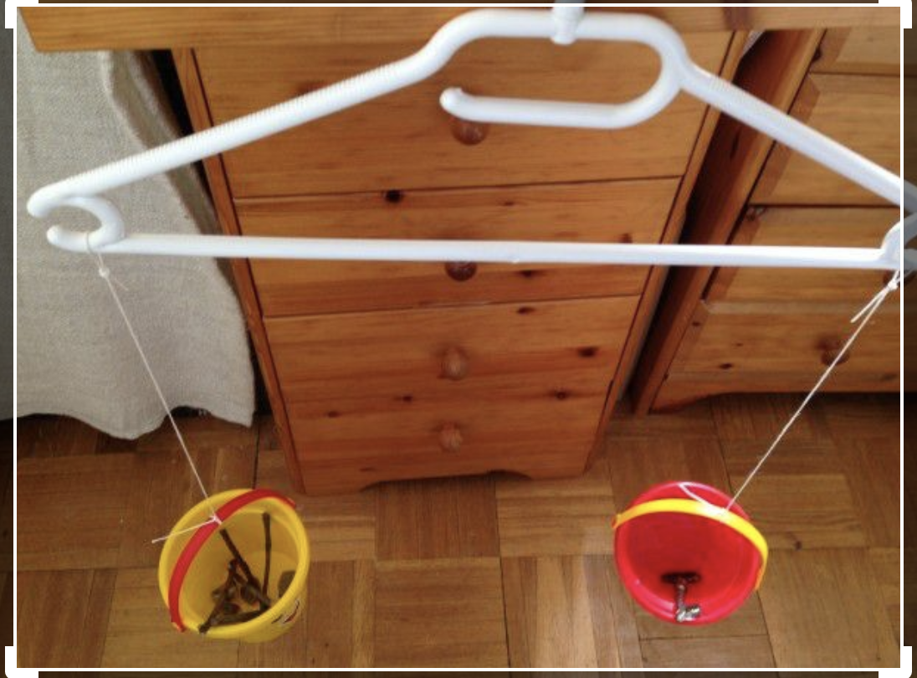
Can you find two soft toys that weigh a different amount? Which is heavier and which one is lighter? Big things are not always heavy. If you have a large bag of cotton wool, is it heavier or lighter than your soft toys? Place the cotton wool in one balance on the scales and the soft toy in the other. Which side goes down? Whichever one goes down is the heaviest.

Use Lego bricks or other objects that are similar in weight. Estimate how many Lego bricks will be needed to balance the soft toy. Place one of your soft toys in one balance on the scales. Find out how much it weighs by putting in Lego bricks/other objects that are the same until the balance is level. Count how many objects you used to make the balance level. Repeat with your other soft toys estimating first and find out which one weighs the most – which soft toy needed the most objects to balance the scales.

Record your estimate for each soft toy and how much they weighed using the objects. Keep your balance weighing scale in a safe place to be used again on Friday.

Toy | Estimate | Actual

How close were your estimates with the actual weights of the toys?

Wednesday – measuring drink bottle capacities

Look for different bottles in your home to compare the capacities. You could use empty water bottles, a drinks bottle, a juice carton or a milk bottle. They need to be different sizes and hold different amounts of water.

Look at the bottles you have found and predict which bottle holds the most and which one holds the least amount. The tallest bottle will not necessarily hold the most amount of water. Find a small container such as a yoghurt pot or a ladle. Estimate how many yoghurt pots of water or ladles of water it will take to fill each bottle. Record each estimate before using the yoghurt pot or ladle to fill each container with water. Record how many yoghurt pots or ladles were needed to fill each container.

Bottle | Estimate | Actual
Milk bottle
Drink bottle
Water bottle
Juice carton

How close were your estimates to your actual amounts of yoghurt pots/ladles needed?
Were your predictions right?

Thursday – Hand lengths

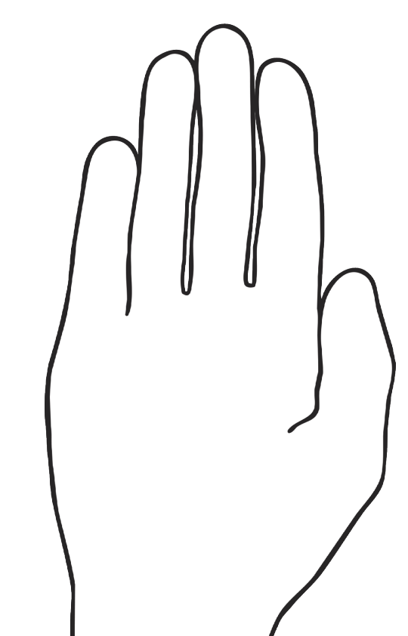

Carefully draw round your hand. Measure your hand from the bottom to the top of your hand using Lego bricks/cubes or objects that are similar in size. Record how long your hand is in objects/cubes. Carefully draw round a family member’s hand and measure their hand in objects/cubes. What is the difference in size? Can you draw round another family members hand? How much longer or shorter are their hands from your own? Who has the longest hand in your family? Who has the shortest hand in your family?

Friday – Weighing a selection of objects

Use your balance weighing scale that you made on Tuesday. In your home, find a selection of items that you could weigh to compare their weights. You could find a toilet roll, toothpaste tube, small ball, small cars, small toys. Compare the weights of the objects by putting them at each end of the balance weighing scale. Can you work out which item is the heaviest/lightest by putting different objects at each end of your weighing balance?
Using cubes/blocks or something similar, weigh each of your objects in turn. Record how much each item weighs.

Object | Weight in cubes/blocks

