This week we will be adding and subtracting mentally and using written methods and using measures.

Monday
LI: To find the perimeter of rectangles and solve addition problems involving measures.

Activity 1:
Answer these questions. The first one has been done for you.
- 1l = 1000ml
- 1m = cm
- 1km = m
- 3km = m
- 6000m = km
- 2l = ml
- 400cm = m

Today we will be finding the perimeter of rectangles. The perimeter is the distance all around the outside of a 2D shape. So to find the perimeter of a rectangle, we just need to add up the lengths of all of the sides.
Think about a football pitch. Not all football pitches are the same size.

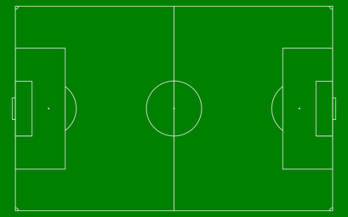
115m
74m

We know that the opposite sides of a rectangle are the same length so to find the perimeter, we would add up all the sides. We can do this by putting 4 numbers in column or we can double each number and then add the answers, like this.
Double 115m = 230m
Double 74m = 148m

H T O
2 3 0
1 4 8
3 7 8

The perimeter of this football pitch is 378m

Now it is your turn. Answer these questions:
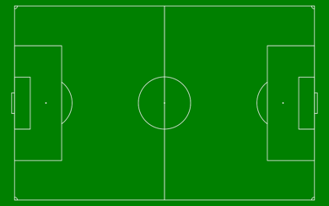
64m
114m
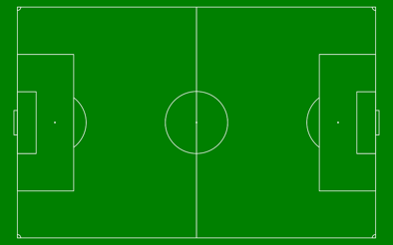
59m
116m

113m
63m

118m
84m

Now complete these additions using the column method:

118 + 157 =
353 + 427 =
585 + 284 =
378 + 435 =
368 + 267 =
$64 + 372 =

Challenge: A new playing field can be either 90m by 110m or 80m by 120m. Which will have the bigger perimeter?

Tuesday
LI: To solve addition problems involving measures.

Look at this calculation:

6 + 8 + 3 =

How would you add this mentally? Work out the answer and write down how you would do it.

I could do: 6 + 3 = 9, then 9 + 8 =17.

Use the nrich dice set to 0-9 (use the purple cog) to roll three 1-digit numbers and add them. Think carefully about the order you would add in and why you hose that way. Repeat this 6 times.

In maths, we need to be able to add in our heads (mentally) and using written methods. We will use column addition today, estimating first, to practice our mental addition, and then calculating.

Here is the example:
If you ran three hundred and twenty-six metres, then one hundred and forty-nine metres and then two hundred and thirty-three metres, how far did you run altogether?

Estimate: To estimate I round the numbers to the nearest 10 and then add them.
330 + 150 + 230 = 300 + 100 + 200 + 50 + 30 + 30 = 710
So now I know that the answer should be around 700.
Now I add in columns:
H. T. O
3 2. 6
1 4 9 +
2 3 3
1 1____
7 0 8

Then I can use the estimate to check – is my answer about 700?

Now it’s your turn! Solve these problems. Don’t forget to use RUCSAC!

Each child swims on three days. How far does each one swim?
 | Tom | Sara | Sunil
Monday | 346m | 348m | 425m
Tuesday | 238m | 392m | 166m
Wednesday | 174m | 194m | 257m

Find the total weight of these fruit combinations:

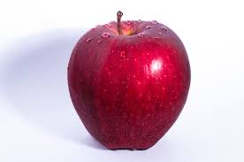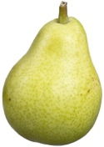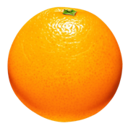

178g + 114g + 216g. =

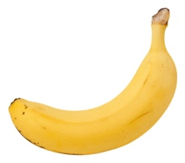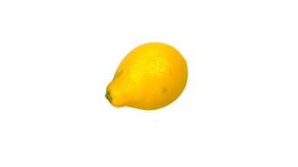

225g + 156g. + 110g =

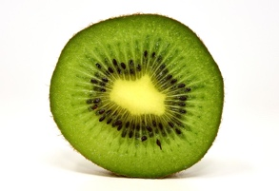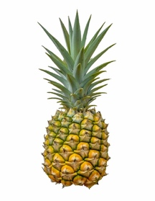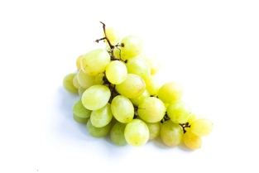

117g +. 305g +. 186g. =

Now try these.

Mme Mills has some containers each with an amount of water in. The first has 246ml, the second has 119ml and the third has 238ml. What is the total amount of water that Mme Mills has?

Mr Wade has some bottle of juice. The first one has 174ml, the second has 265ml and the last one has 132ml. How much orange juice does Mr Wade have altogether?

Mrs Clarke has some containers with coloured water in for science. The first one has 492ml, the second has 195ml and the final one has 103ml. How much coloured water does she have?

Challenge: arrange the digits 1-9 to make three 3-digit numbers which add to give the largest possible total. Explain how you know that you are right.

Wednesday
LI: To subtract a 3-digit number from a 3-digit number.

Do this subtraction by counting forwards on a number line. Look back to the frog jumps last week if you need a reminder.

547 – 473 =

Now use the same method to try this investigation. Read it carefully!

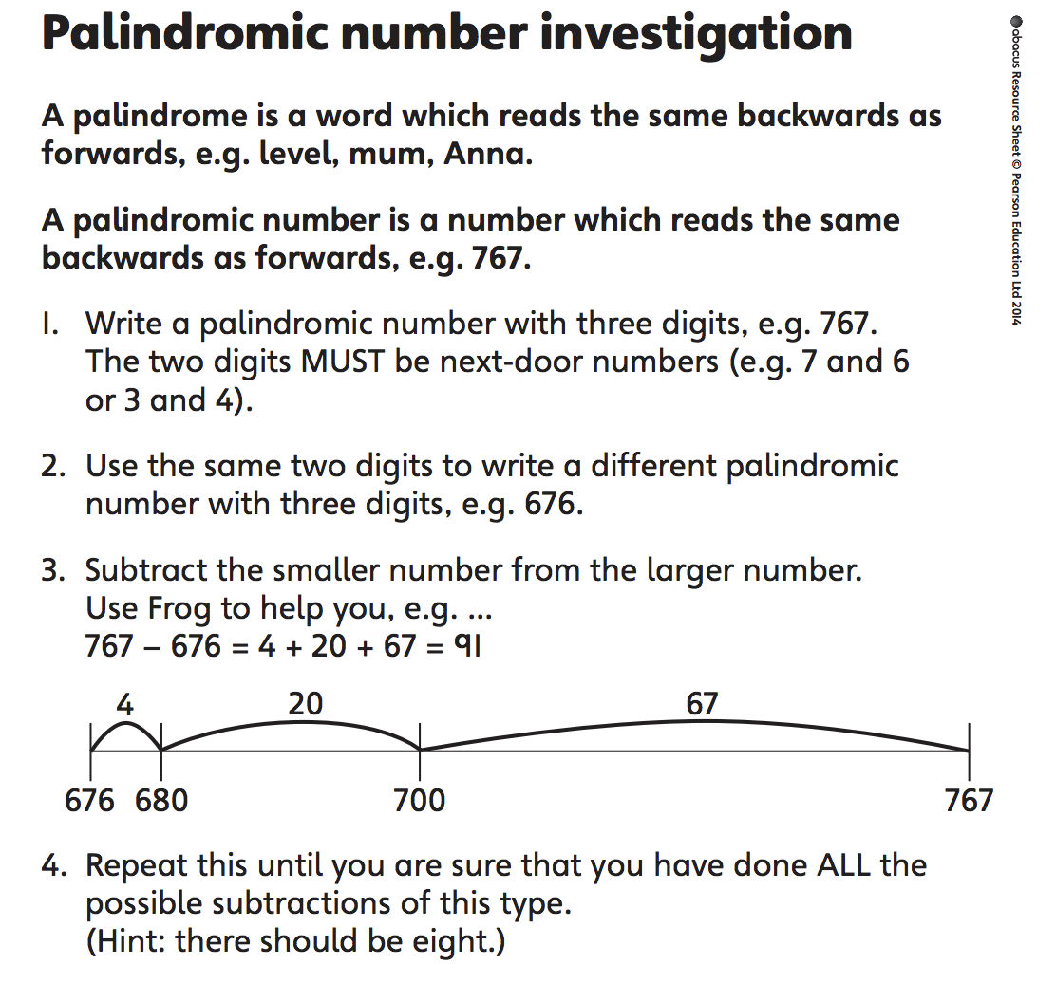

Try to explain the answers you got and what you found out.

Now repeat the investigation but using multiples of 10 starting with consecutive (next door) digits eg: 760 – 670 or 430 – 340. What do you notice this time?

Thursday
LI: To subtract 3-digit numbers using a number line.

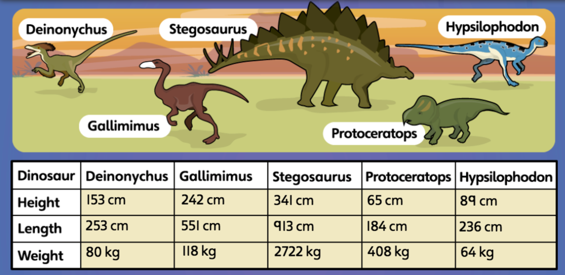

Look at the information in the table and answer these questions.
- How much taller is the Stegosaurus than the Gallimimus?
- How much heavier is the Gallimimus than the Deinonychus?
- How much longer is the Hypsilophodon than the Protoceratops?

Challenge: Write 3 subtraction questions of your own and work out the answers.

Now have a go at the mastery checkpoint sheet.

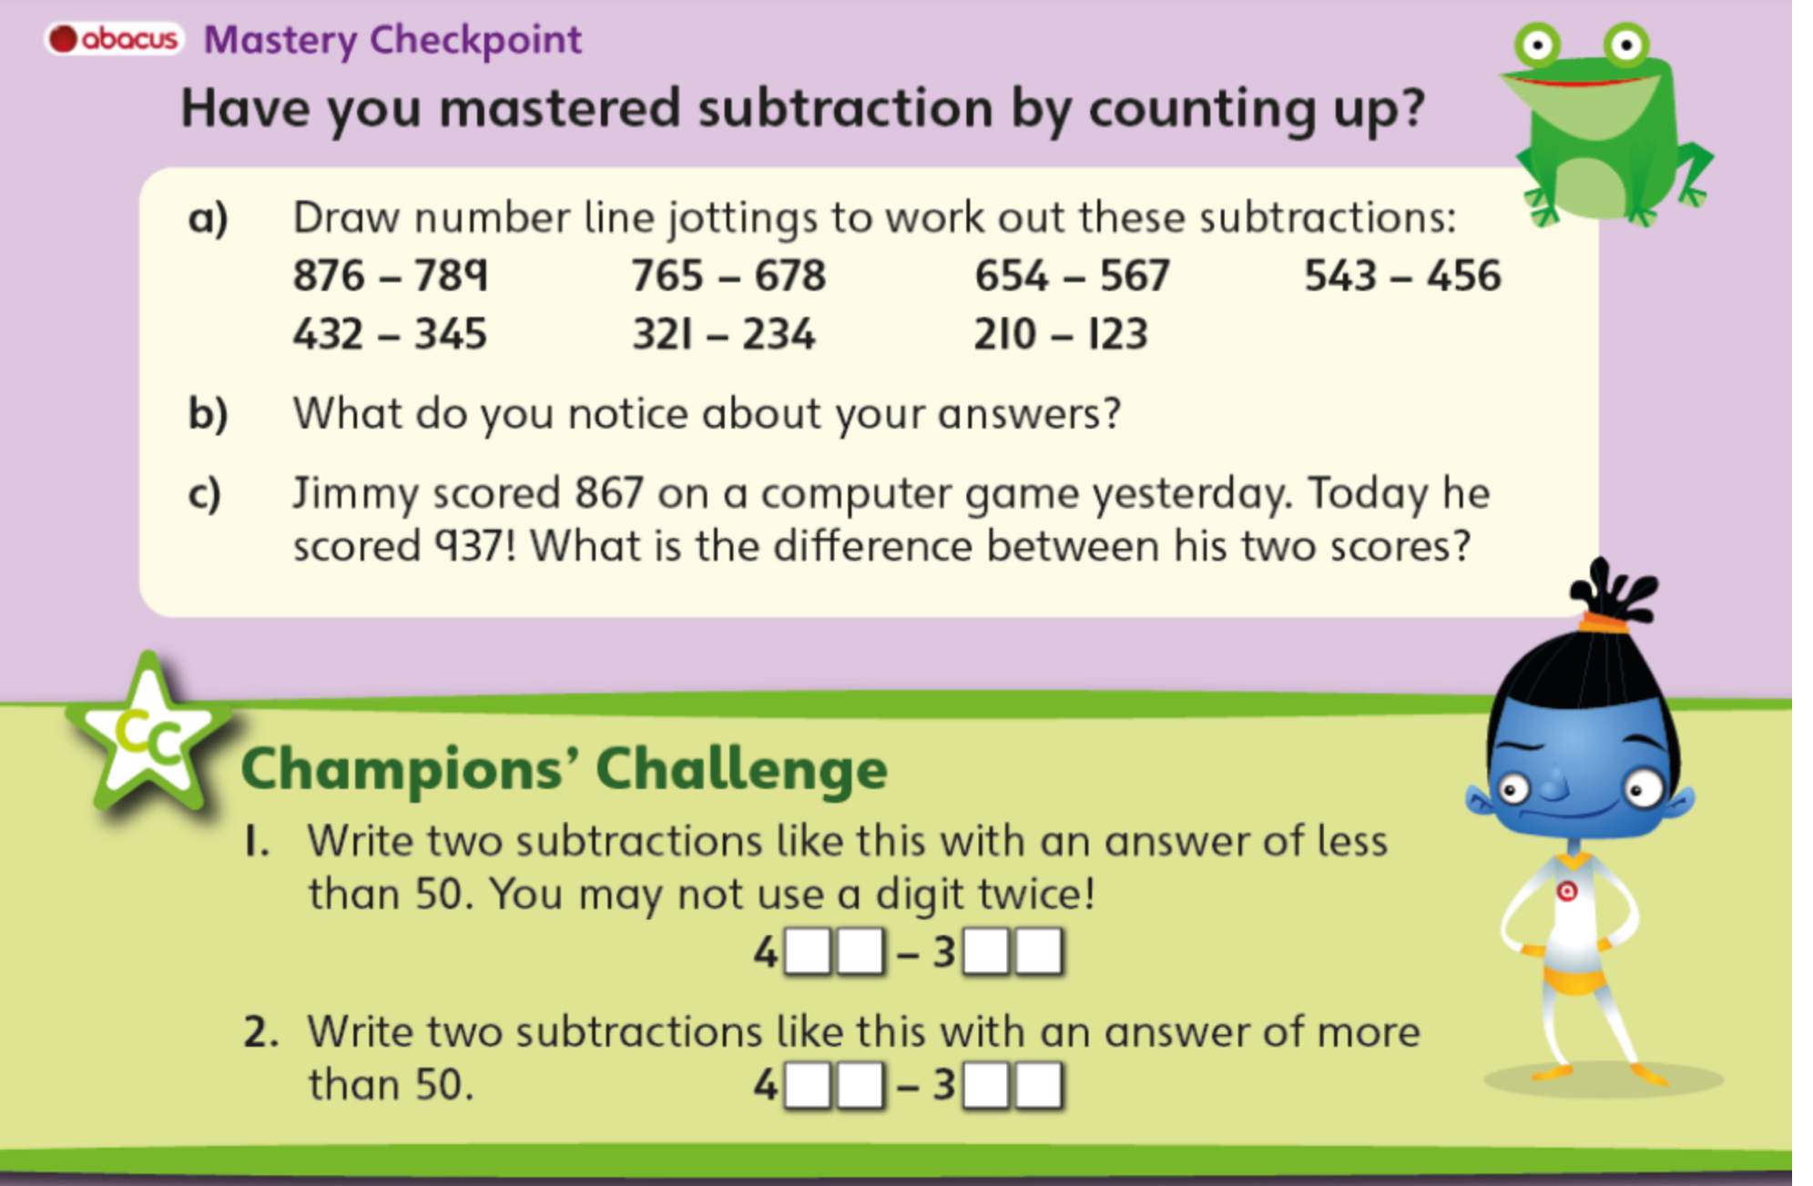

Friday
LI: To choose an appropriate method to calculate.

Now you are really good at addition and subtraction, today we will practise more but the trick is to choose the BEST way to do it.

When we are adding, we can add in our heads (mentally), by making some notes or by using the column method. Look at these:

400 + 350 =
285 + 172 + 831 =

One of these can be done mentally but the other is best done in columns. Which do you think is which?

It is easy to add multiples of 10 in your head but when there are more numbers it is best to use the column method. It is the same when subtracting. Look at these:

322 – 286 =
350 – 110=

You can do the second one in your head by doing 350 – 100 = 250 and then take away the 10 but the first one is better using the number line.

Now do these questions but remember to look first and decide which whether to do it mentally or using a written method.

- Look at these calculations. Choose 3 to do in your head and 3 to do using column addition.
357 + 402 = 642 + 128 = 174 + 312 =
467 + 217 = 48 + 37 = 736 + 150 =
483 + 111 = 385 + 261 =

- Complete 3 of these calculations by counting up on the number line and three by subtracting the hundreds and then the tens.
421 – 386 = 674 – 103 = 632 – 589 =
121 – 49 = 707 – 679 = 841 – 350 =

- Amy has saved £186. She buys a CD player for £55. How much money does she have left? Think about the method you will use.
- Two numbers add up to 88. The larger number is 24 more than the smaller number. The smaller number is 32. What is the larger number? Can you find 2 wats to work this out?

