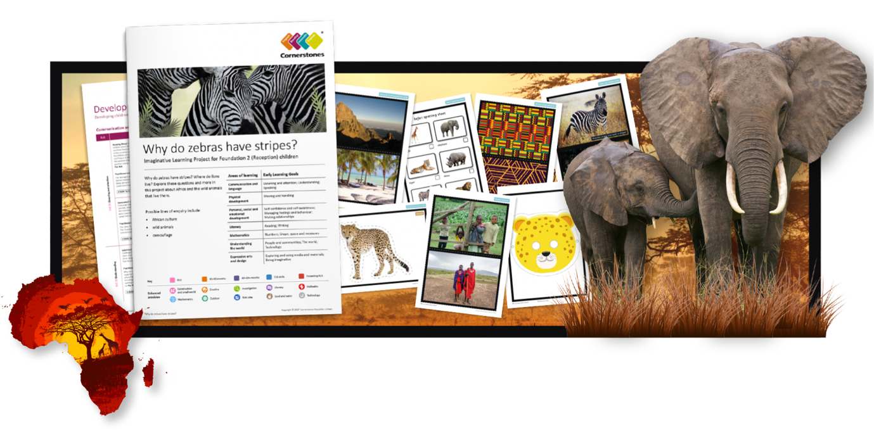
Why Do Zebras Have Stripes?
Hamjambo! Why do zebras have stripes? Where do lions live? It’s time to discover amazing Africa and the wild animals that live there.
This half term, we’ll be looking at African dance and music, singing and playing instruments. We’ll learn where Africa is and what the landscapes, people and wildlife are like across this stunning continent. Who
are the Maasai? What is camouflage? Where is the Serengeti? Let’s find out! We’ll learn about what school is like for African children, use our senses to explore a ‘market stall’ of African foods. We’ll use our imaginations to explore African animals, record animal noises and write our own call and response songs. Using sticks, we’ll make African-themed marks in soggy soil, and create an African landscape using sand, rocks, gravel and driftwood. In mathematics, we’ll count and estimate animal numbers and in literacy, use labels and captions to identify animal traits. Then we’ll get creative, tapping out syllables on homemade drums as we talk and try our hand at African printing.
At the end of the project, we’ll make a book and write a funny story about wild animals in unusual settings.
Areas of learning | Early Learning Goals
Communication and language | Listening and attention; Understanding; Speaking
Physical development | Moving and handling
Personal, social and emotional development | Self-confidence and self-awareness; Managing feelings and behaviour; Making relationships
Literacy | Reading; Writing
Mathematics | Numbers; Shape, space and measures
Understanding the world | People and communities; The world; Technology
Expressive arts and design | Exploring and using media and materials; Being imaginative
Help your child prepare for their project
Africa is awesome! Why not research to find out more about this cool continent? You could also curl up on the sofa and watch The Lion King, Tarzan, Born Free or Madagascar. Alternatively, tear up coloured paper and make a vibrant animal collage. Can you include a range of animal markings?

