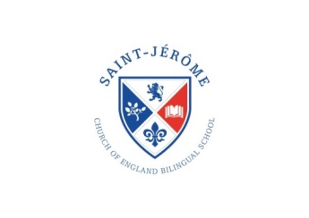

St. Jérôme Church of England   
Bilingual Primary School

Term Dates 2020-21

**Michaelmas Term 2020**

Term starts: Monday 7th September 2020

(Year 1 – Year 4 Pupils only)

Half Term: 26th October 2020 to 30th October 2020

Term ends: Thursday 17th December 2020 at 1.15 pm

**Epiphany Term 2021**

Term starts: Wednesday 6th January 2021

Half Term: 15th February 2021 to 19th February 2021

Term ends: Wednesday 31st March 2021 at 1.15 pm

**Trinity Term 2020**

Term starts: Monday 19th April 2021

May Day: Monday 3rd May 2021

Half Term: 31st May 2021 to 4th June 2021

Term ends: Wednesday 21st July 2021 at 1.15 pm