Splendid Skies

Week Beginning 22/06/2020

Monday
Last week we had lots of fun writing various lists. I wonder if you can now help your grown-ups write lists of things they need?
This week we are going to be thinking about different writing that you may do whilst you’re on holiday. Many people send postcards or letters whilst they are on holiday to those they love.

Here are some postcards that have been sent by Teddy from a range of hot places around the world. Have a look at the postcards below, to find out what Teddy has been doing in different countries.

Now that you have read Teddy’s postcards, can you write a list of things that Teddy has done in each country.
Can you write a list of places he has visited?
Can you write about what the weather was like in each country?
I wonder what new exciting things you have learnt about the countries that Teddy has visited?

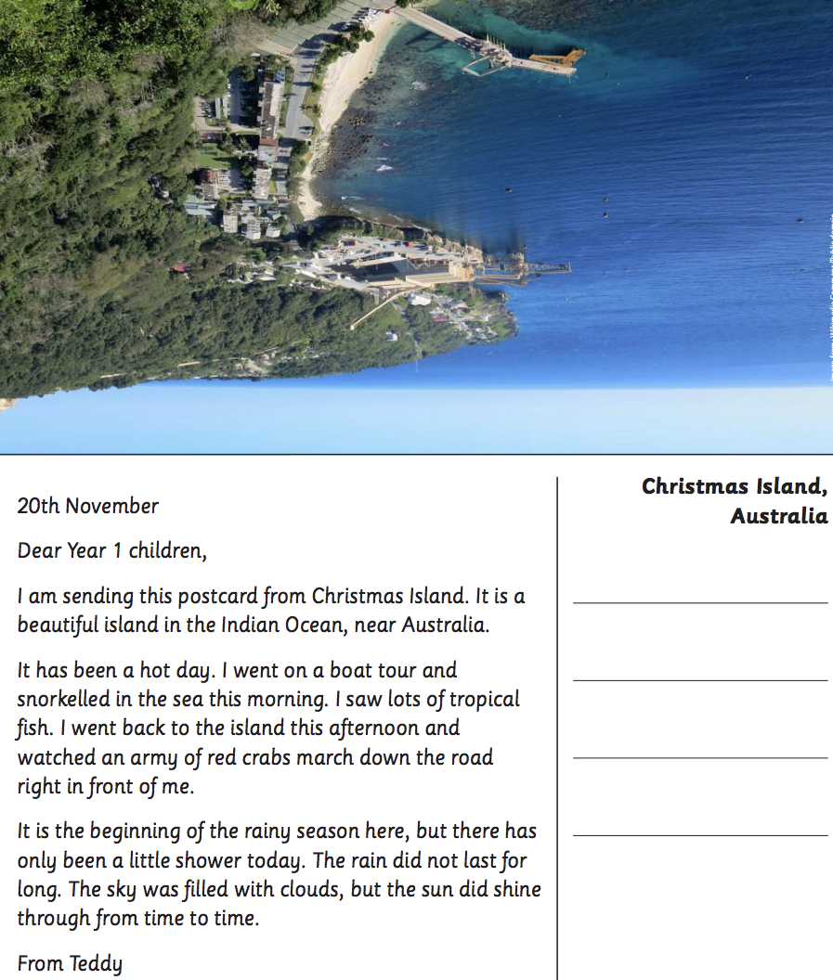
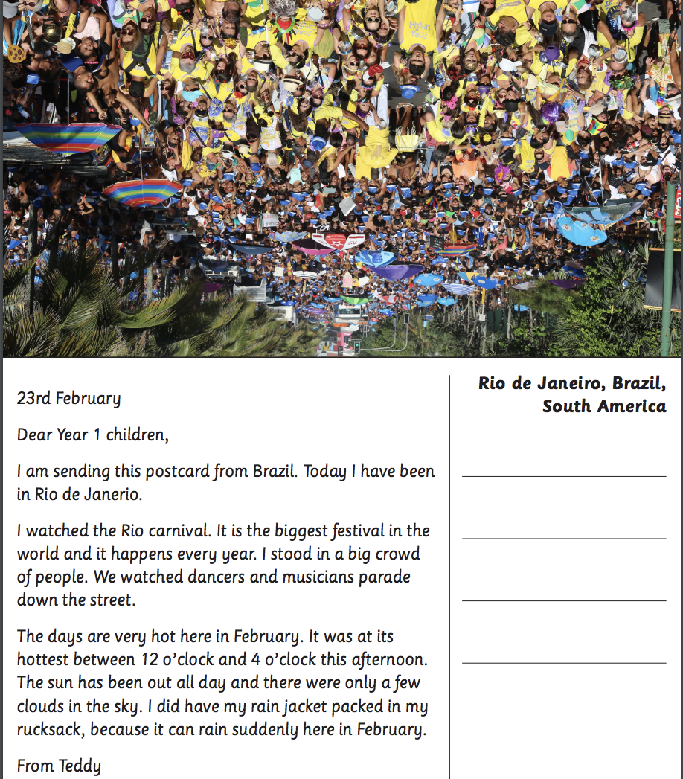
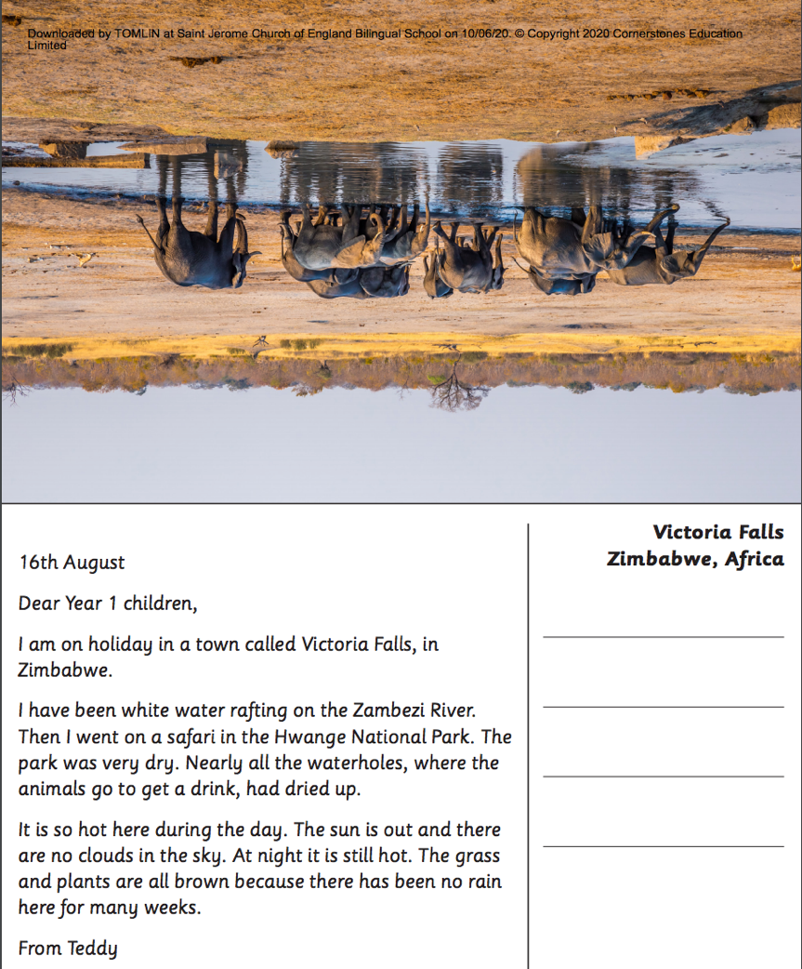

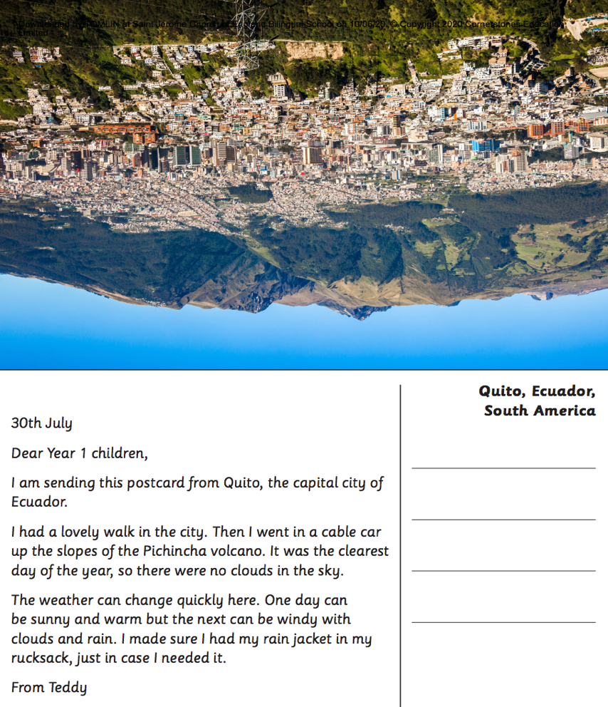

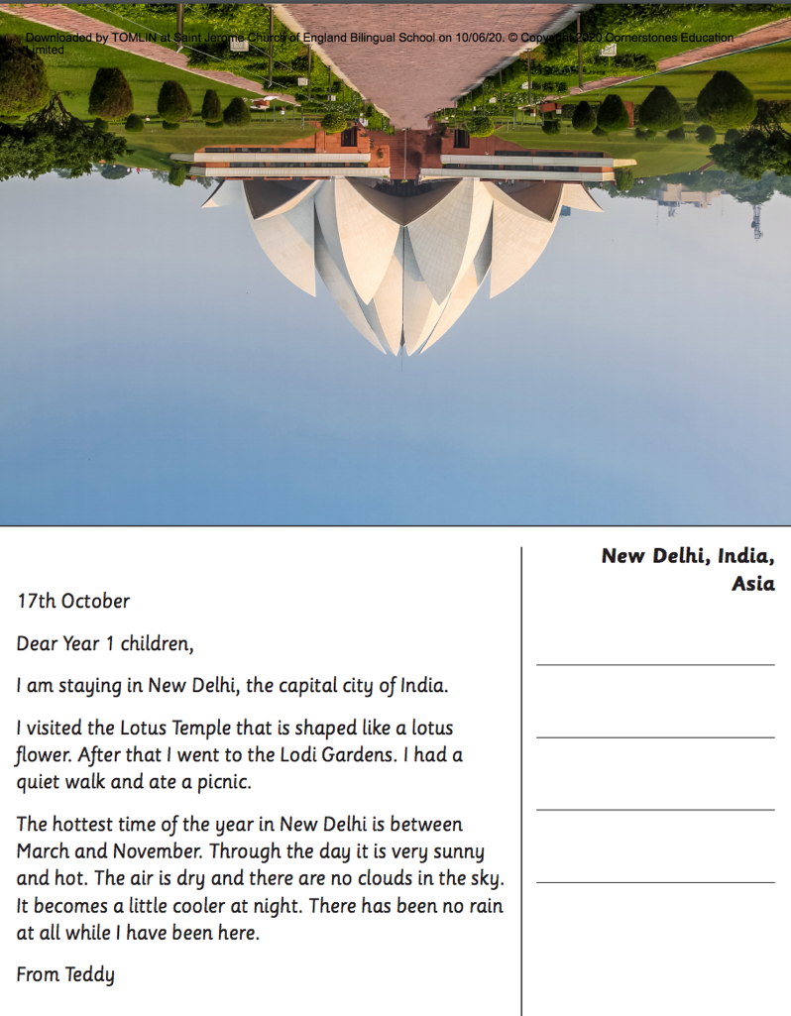
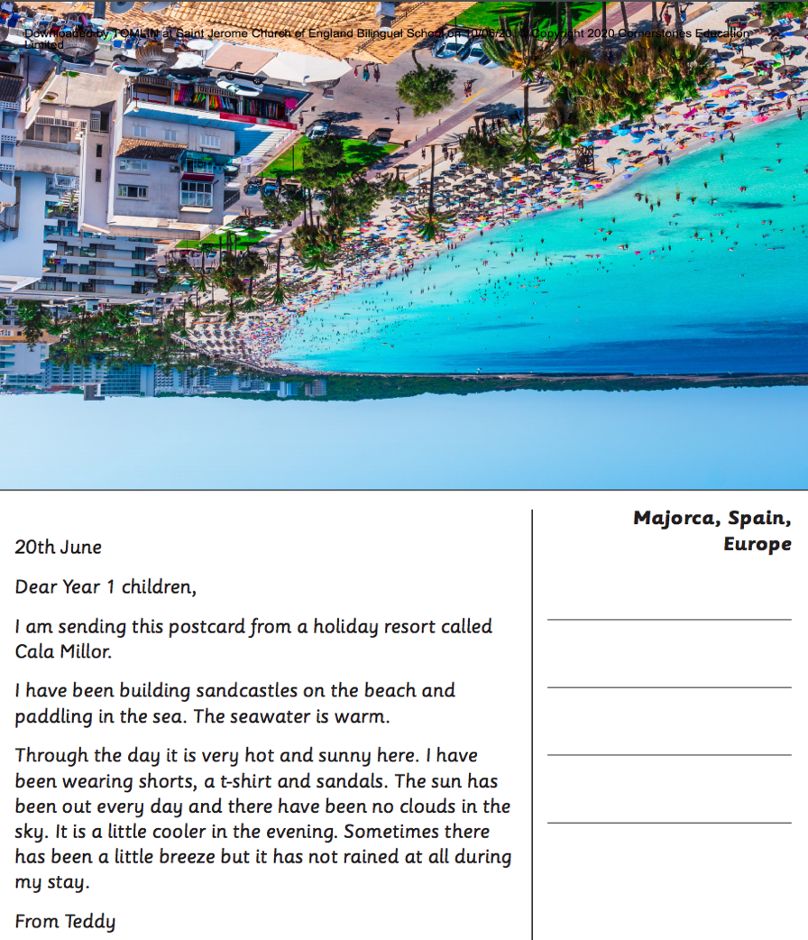
Tuesday

I’m sure you have learnt lots of new interesting things about different countries when you had a read of Teddy’s postcards.

Today we are going to be having a look at different activities that can be done in different countries.

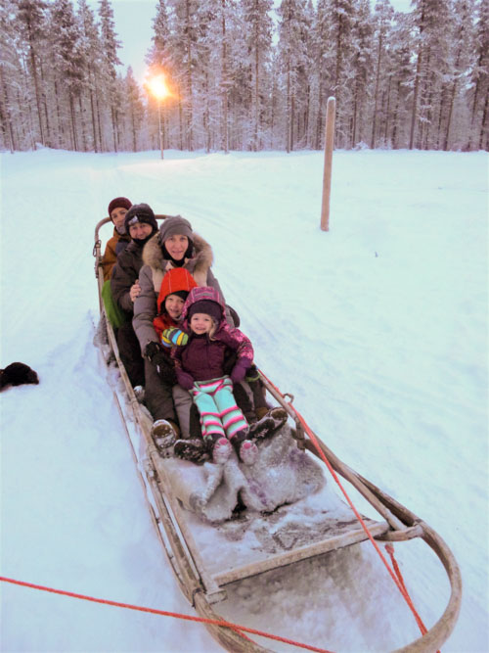
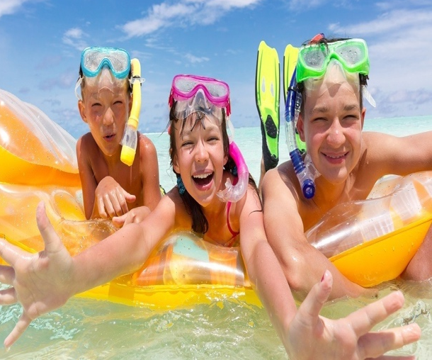
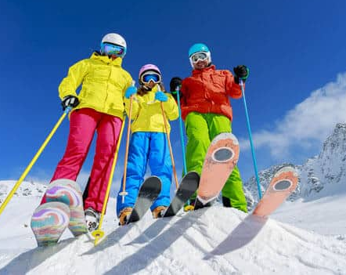
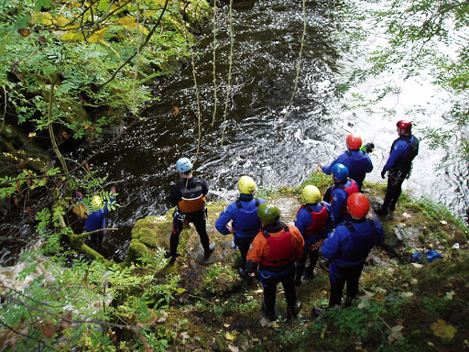
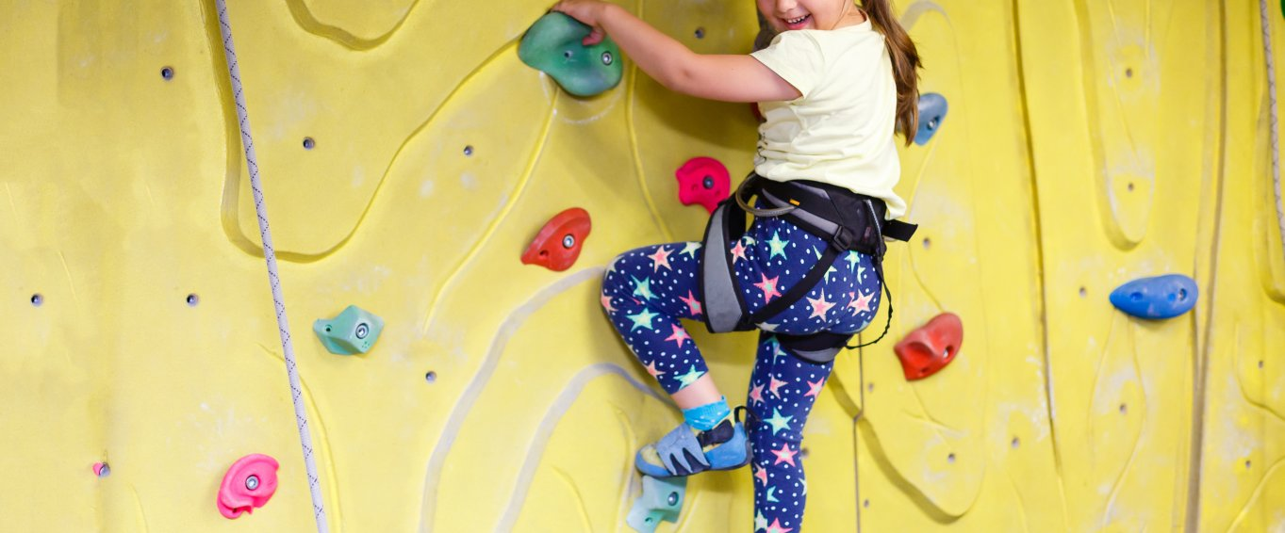
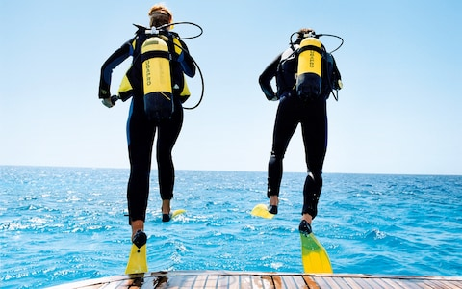
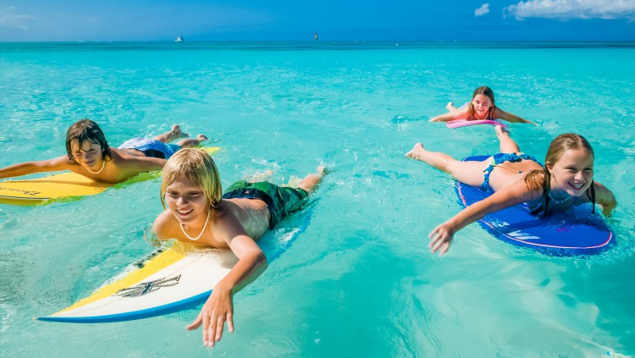
Can you have a think of other countries that you may have visited, maybe you have some pictures of what the weather was like or what you can do in that country?
Once you have had a look at the pictures, can you cut and stick them to create a mind map of things you’d like to do in another country. Once you have done that can you then write a sentence underneath to explain what is happening in the picture?

Maybe you have some of your own pictures of you taking part in holiday activities that you’d like to show. Remember you can send your pictures to homelearning@stjeromebilingual.org.

Wednesday
I wonder what super cool holiday acitivies you found out about yesterday? Maybe there were some you did not even know about?
Today we’re going to have a look at some holiday pictures. Whilst looking at these pictures I would like you to imagine yourself in these pictures.
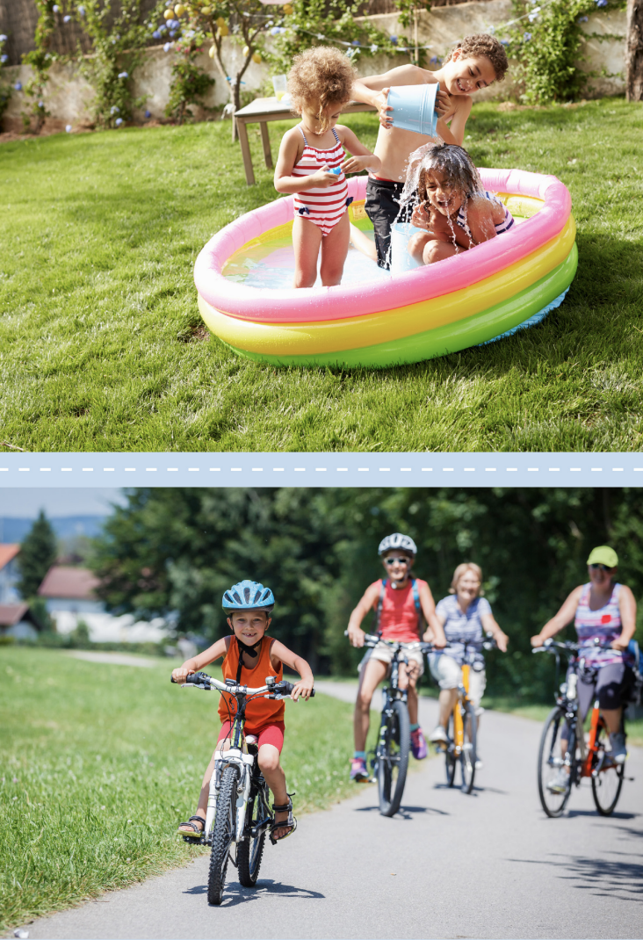
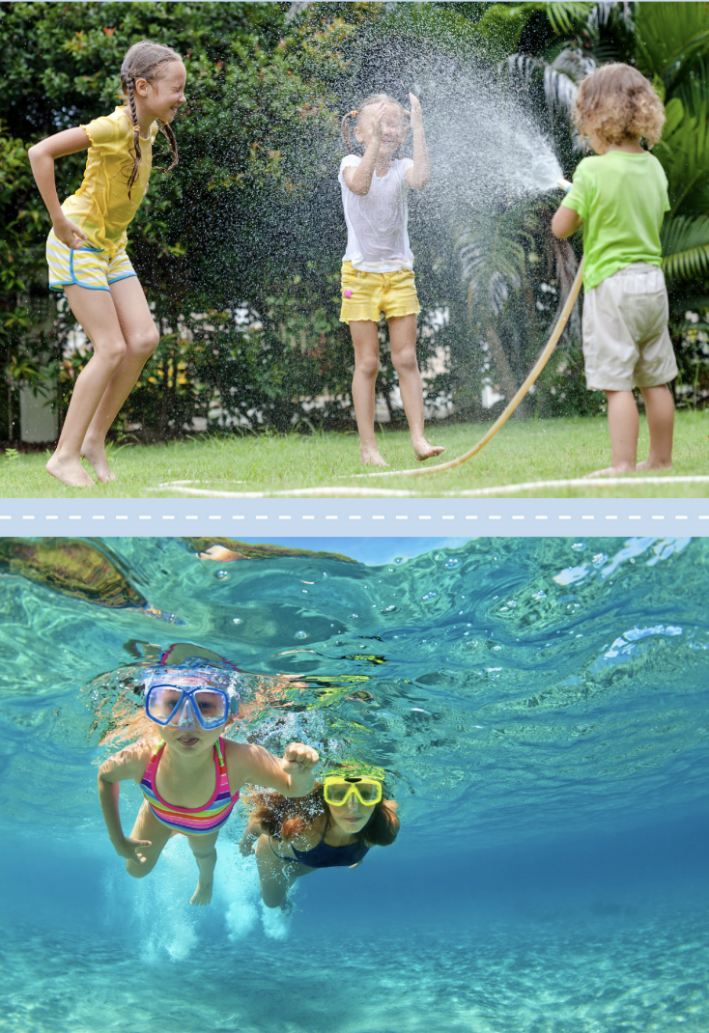
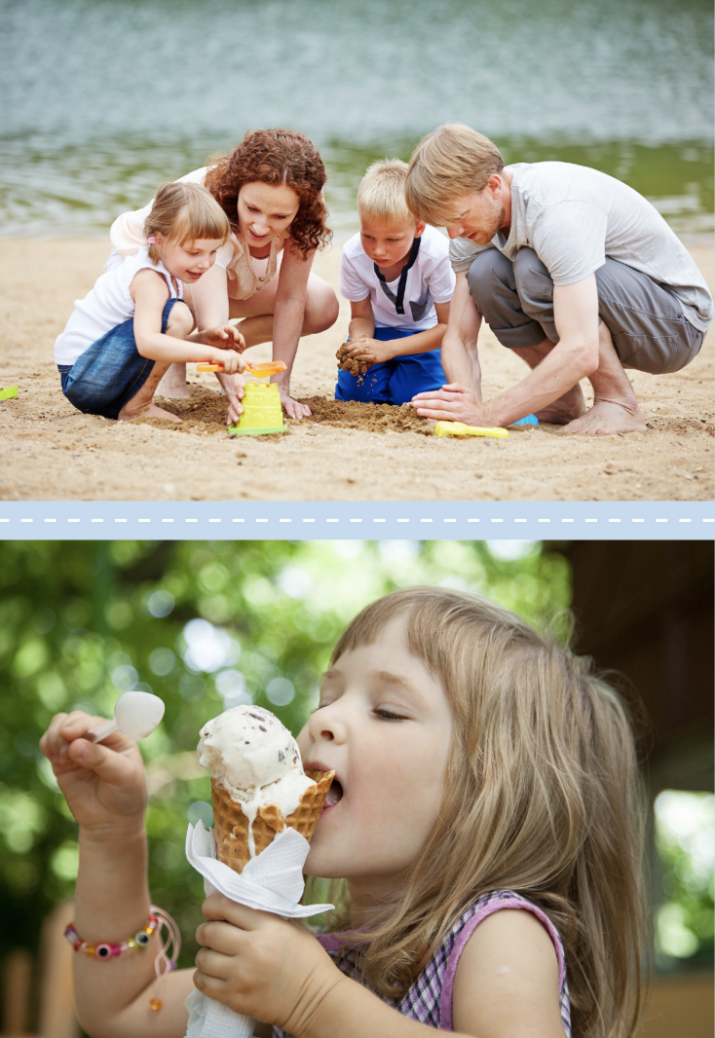
Have a look at the pictures below.
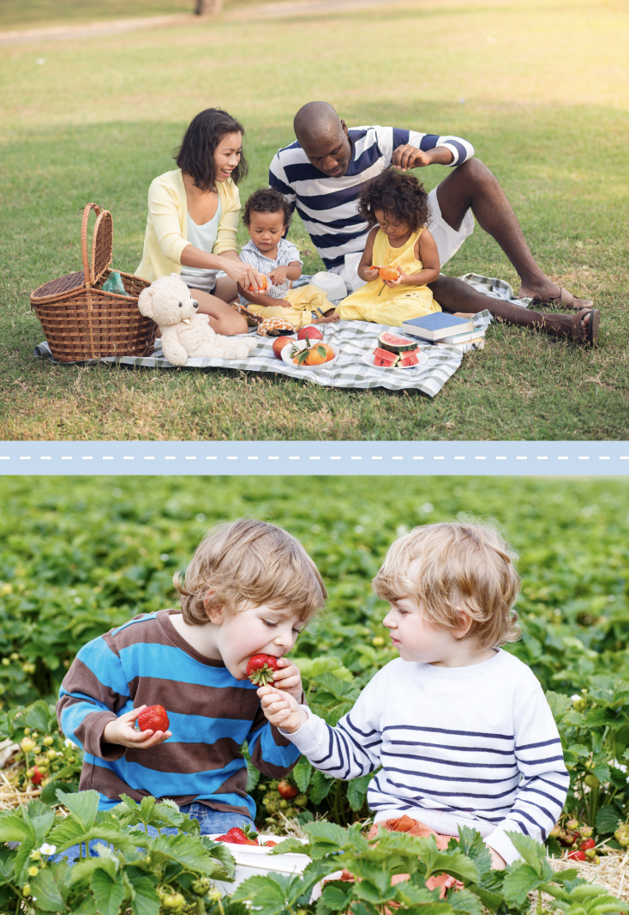
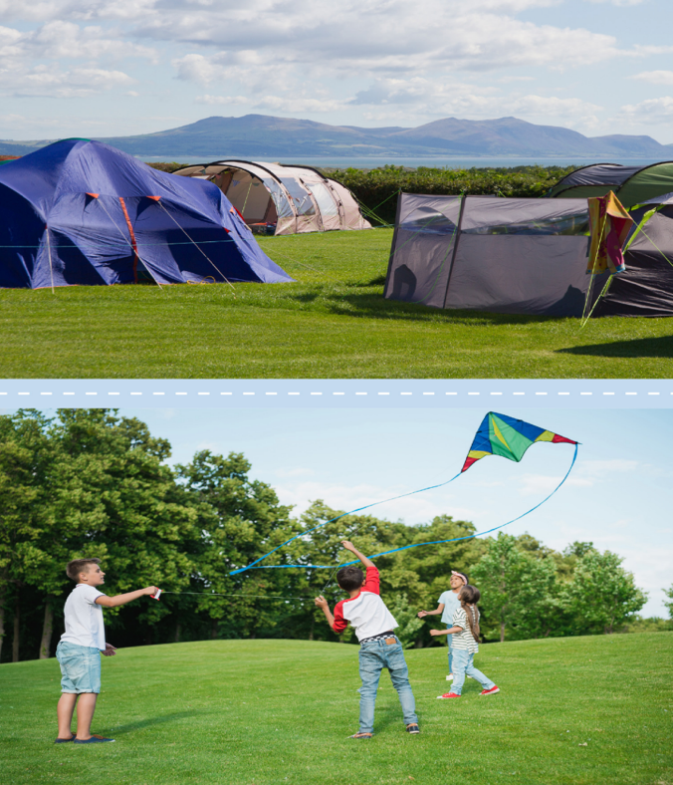

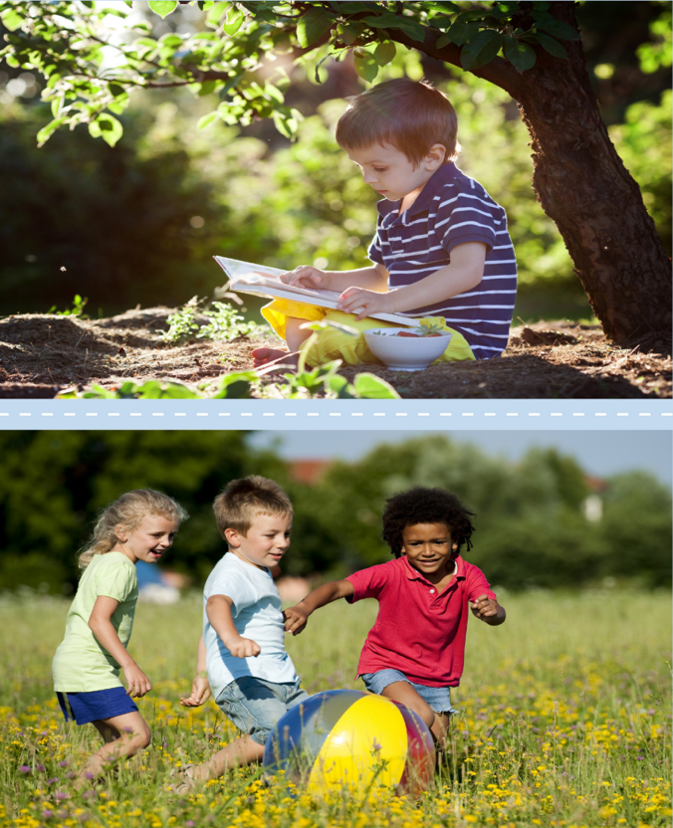
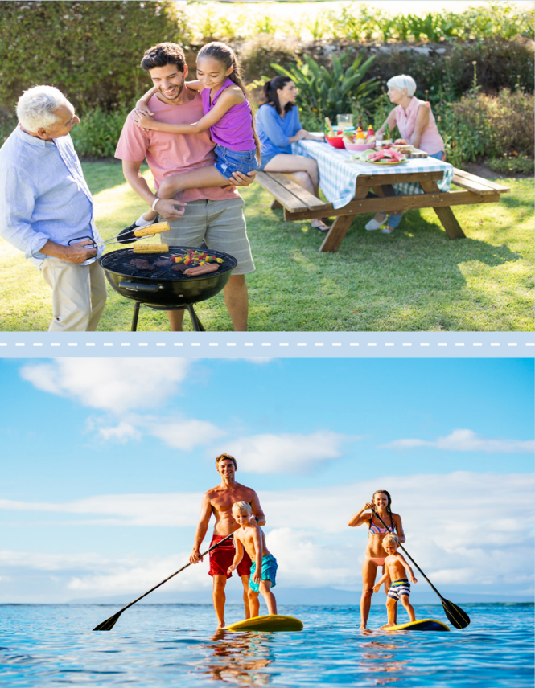

Once you have had a look at the pictures, can you write some sentences that relate to each of the pictures?
Here are some examples
- The weather is sunny and I am playing in the park with a ball.
- Today the weather is sunny and I am blowing lots of bubbles in the sun.
- Now the weather is sunny and I am flying my kite in the wind.
- Today the weather is sunny and I am reading my interesting book under the tree in the shade.
Thursday

I’m sure you had lots of fun having a look at the different holiday pictures. I wonder what fantastic sentences you have created about the pictures that you have seen? Today I would like you to imagine you are on holiday in one of those destinations, you are going to write a postcard back to teddy.

Things to remember
- How to start a postcard
- Tell Teddy where you are on holiday
- Tell Teddy what you have been doing
- Tell Teddy what the weather is like
- Maybe you could recommend that Teddy should visit your holiday destination

Once you have written your postcard, make sure you read it to a grown-up.

Friday

Fantastic work, I am sure you have created some excellent post cards. Now that you have finished, can you draw a picture on the back of your postcard?
You may want to draw a picture of your favourite holiday destination, or the destination that you had imagined you were in.

Once you have done that can you draw a stamp at the top. Can you remember where the stamp should go?

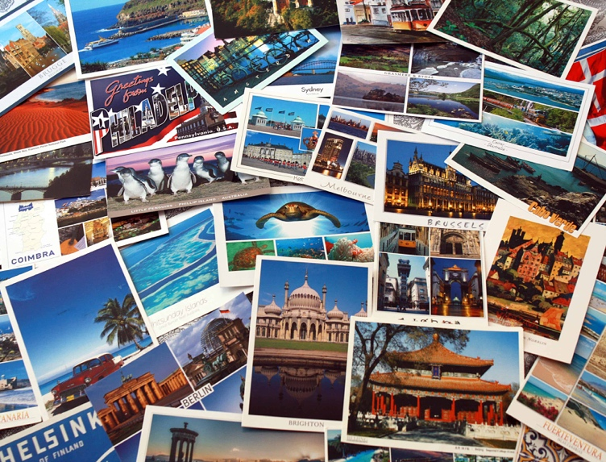
Here are some examples of post cards, take a look, you may see one you would like to recreate on the back of your postcard.
