This week we will continue to explore…
Street Detectives
… and to work with…
“The way back home” by Lina Schwamkrus
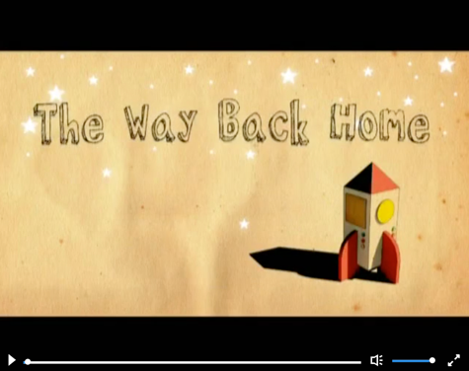

Remind yourself of the story “The way back home” if you wish too. Over the next two weeks, you will explore the features of persuasive writing and think about why you like living in Harrow. Next week, you will write a persuasive text to convince the young boy to come and live here.

If you wish, send your work to us via: homelearning@stjeromebilingual.org . We would love to read it!

Monday
LI: To explore the features of persuasive writing.

Read the text below with someone at home. Discuss:
- Why do you think the text was written?
The text is trying to persuade customers to go to the hotel.
- What do you think it means to persuade someone? [Ask an adult to help you click on the blue underlined word to find a definition]

Watch the BBC video about persuasive texts. Then look at the list of features below.
Read the “House Sales Adverts” on our home learning page and see if you can find some of the features mentioned in the video and on the list.
The features of persuasive writing are:

- Eye-catching title (to make the reader want to read more)
- Clear point of view (argument you believe in)
- Present tense
- Strong points with evidence (facts or other people that agree with you)
- Conjunctions
- Strong words (powerful adjectives)
- Sometimes: conclusion to summarise the opinion.

Challenge: Can you find any words or phrases that you think you might want to use in your own writing? Make a list of them and keep it safe for next week.

Tuesday
LI: To reflect on the reasons that I like living in my local area.

To convince the young boy to come and visit Harrow, you will need to come up with reasons you like about living in Harrow. Discuss your local area with someone at home:
- What can we find in Harrow? (for example: schools, shops, parks, etc.)
- What can we do in Harrow? (for example: dance lessons, play football, etc.)
- Do you like living in Harrow? Why?
- What do you like most about Harrow? Why?
- Where do you enjoy going to on your free time? Why?
- Do you know anything that makes Harrow Special? If so, what?
- Is there anything that could be improved?

If you can, ask other people about you about their experience and their opinion (what they think) about living in Harrow.

Make a list of the reasons for living in the local area. Keep it safe for your work later on.

Challenge: Think about something someone might not like about living in Harrow. What could you say to convince them it is not as bad as they think?

Wednesday
LI: To practise using sentence starters and coordinating and subordinating conjunctions in my writing.

Have a look at the reasons you listed yesterday. Talk about them with someone at home and check whether you forgot anything (or if you have other ideas to add). Sentence openers can help you be more persuasive. Have a look at the Sentence Openers board game for some examples of persuasive sentence openers.

Use the “Sentence Openers board game” our home learning page and a dice to play the following game:
- The aim of the game is to win as many points as possible by creating a sentence which uses a sentence opener and a conjunction.
  - You win 1 point for using one of the sentence openers on the board game
  - You win 2 points for using a sentence opener AND a conjunction in your sentence.
- Roll the dice and move forward by that number.
- The colour you land on will tell you the sentence opener you have to use to recall one of the reasons you listed on Tuesday.
  - Make sure you have the list of reasons you wrote down to help you create sentences in the game.
- Use any conjunction you wish to use in your sentence to win an extra point.
  - You can use the coordinating and subordinating conjunctions word mats on our home learning page to help you.
- If your sentence makes sense, you win 2 points and your partner has a go (you can also choose to play the game individually and keep going until the end of the board game).
  - You can write down the sentences if you wish to, or simply play the game verbally. It could be useful for you to write a couple down to help with the rest of the work this week.

Challenge: Can you come up with your own sentence opener to help you convince other people?

Thursday
LI: To use the features of persuasive writing and conjunctions in my writing (part 1).

Remind yourself of some of the features of persuasive writing:
The features of persuasive writing are:

- Eye-catching title (to make the reader want to read more)
- Clear point of view (argument you believe in)
- Present tense
- Strong points with evidence (facts or other people that agree with you)
- Conjunctions
- Strong words (powerful adjectives)
- Sometimes: conclusion to summarise the opinion.

Look at the pictures on the right.
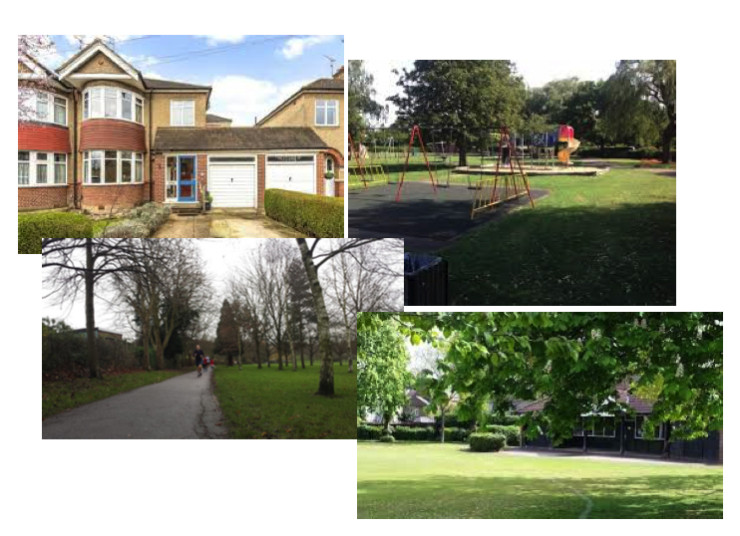
Write a paragraph (at least 6 sentences) to persuade someone to buy this house (in Harrow) and to live in Harrow.

Take your time to think about the features of persuasive writing and why someone would want to buy the house or live in Harrow.

See how many conjunctions, adverbs, adjectives and progressive verbs you can use! Use the different word mats on our home learning page to help you.

You can also use the sentence openers and conjunctions that you used last lesson.

Friday
LI: To use the features of persuasive writing and conjunctions in my writing (part 2).
To edit my work.

If you can, read your paragraph with someone at home. Together, check that your sentences make sense and whether you need to make some parts of your work clearer.

Then, if you haven’t done so already, finish your paragraph.

If you have finished your paragraph, read it over and check for spellings, capital letters, full stops/ punctuation at the end of your sentences, missing words. You can use the phonics matching game on our home learning page to help you with your spellings.

If you have already finished writing and editing:

If you have already finished, why not have a go at the following reading activities. Choose to do bronze or silver or gold. You can also choose to write your answers on paper or answer the questions verbally with someone at home.

