Year 2 Maths

Have a go at the exercises that focus on each learning intention for each day. Do as many exercises as you can. Remember to use your number facts and to write your working out down to help you find the answers. If you need more help or want an extra challenge:

- Click here for the Three Times Table Song

Click here for Repeated addition and multiplication: Describing arrays

Click here for The relationship between multiplication and division
- Click here to view some maths games
- Click here to complete a Friday Challenge. You can challenge yourself on any day.
If you wish, you can share your maths work with us at: homelearning@stjeromebilingual.org

Miss Reynolds and Miss Dear

Monday
LI: To count in 3s, begin to recognise numbers in the 3 times-table. To recall multiplication and division facts for the 3 times table.

You may use a beaded number line to help you to answer the questions. Challenge yourself to learn your three times table or to practice your times tables by reciting them to an adult or by writing them.

Write the multiplication sentences: ☐ × 3 = 12; ☐ × 3 = 18. This will help you to recall your times tables.
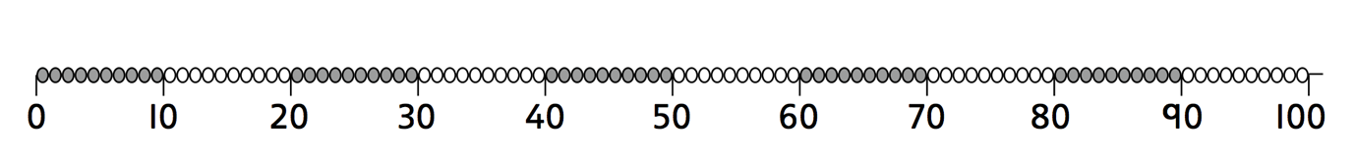

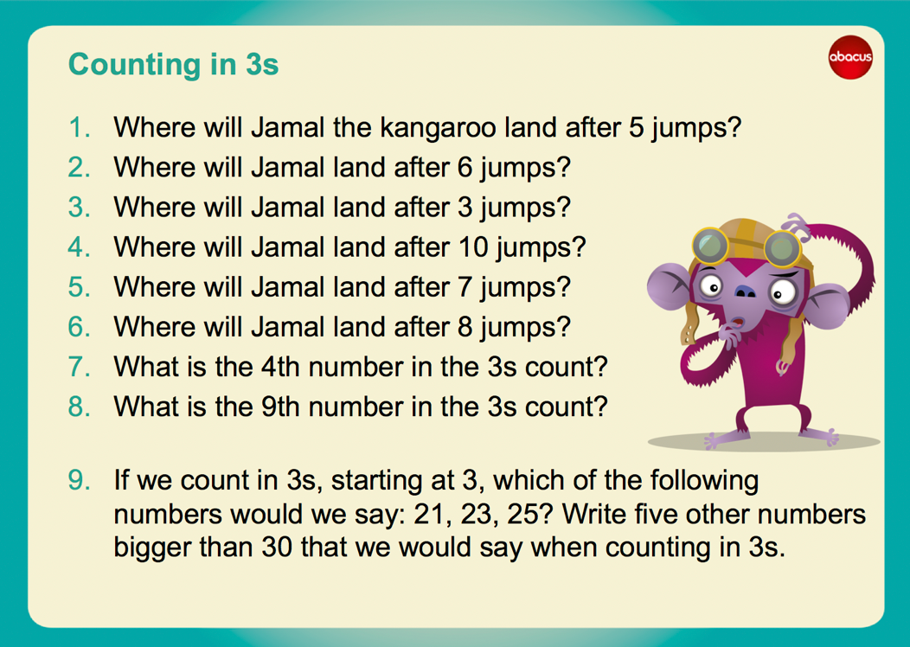
Extension

Click here to investigate Skip Counting
Find the squares that Froggie skips onto to get to the pumpkin patch. She starts on 3 and finishes on 30, but she lands only on a square that has a number 3 more than the square she skips from.

Tuesday
LI: To multiply using arrays and friendly numbers. Understand that multiplication is commutative and use it in mental calculations

Multiplication is the same as repeated addition.
3 x 5 is the same as 5 + 5 + 5 or 3 + 3 + 3 + 3 + 3
Arrays help children to learn about multiplication. An array is a visual representation (picture) of the multiplication process, usually using dots arranged into rows and columns. The number of rows multiplied by the number of columns equals the total number of dots. Arrays can also be used for division by groups the dots into their rows or columns.

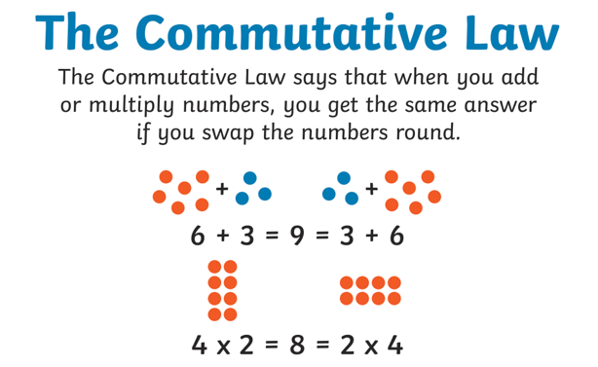
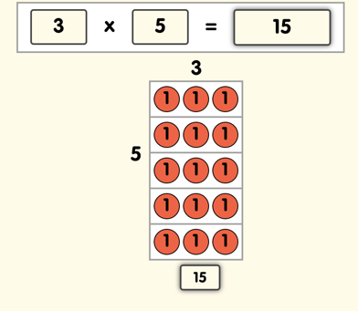
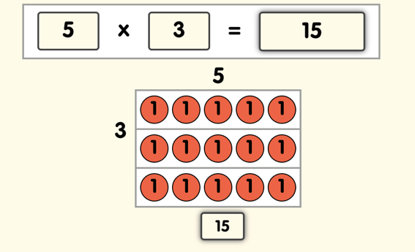

Times-table poster
Make a poster with an array for each multiple of 3 to 30.
Write the multiplications by the side of each array.

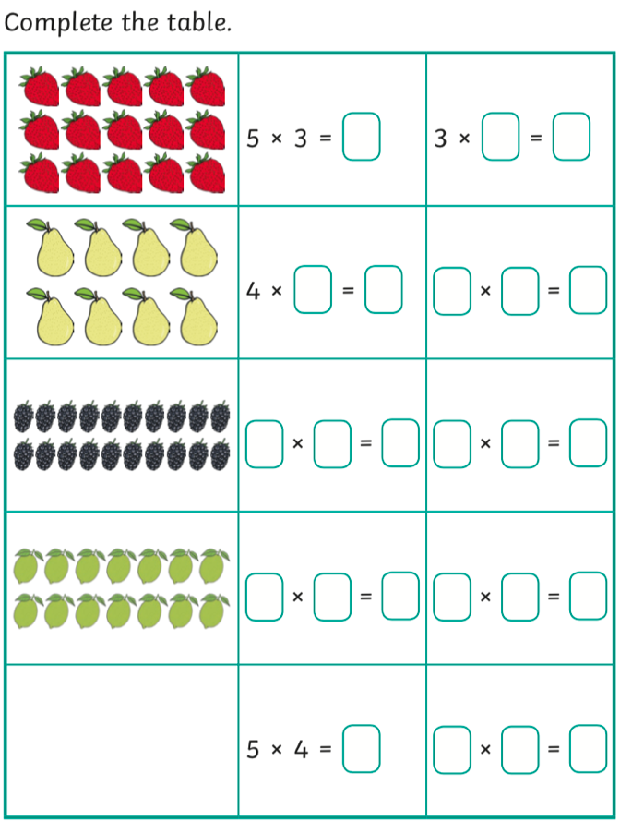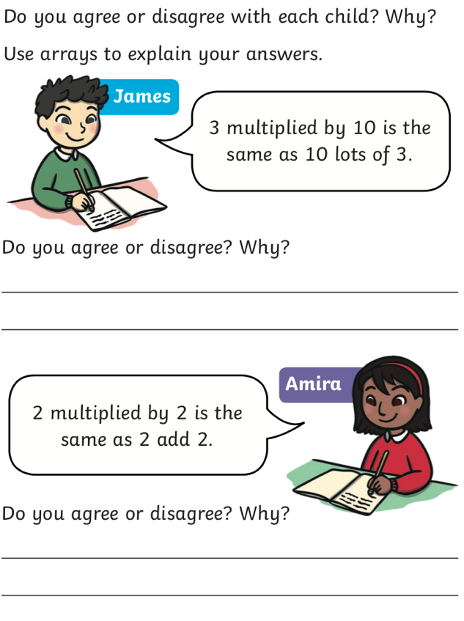

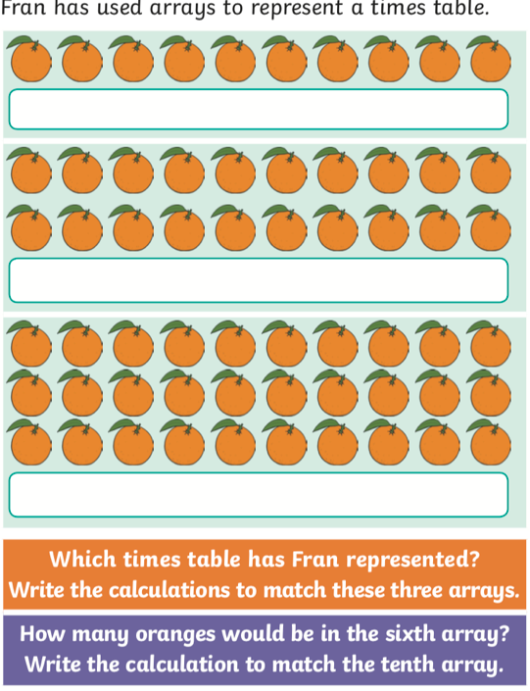

Wednesday
LI: To write multiplications to go with arrays and use arrays to solve multiplication problems, and understand that multiplication is commutative.
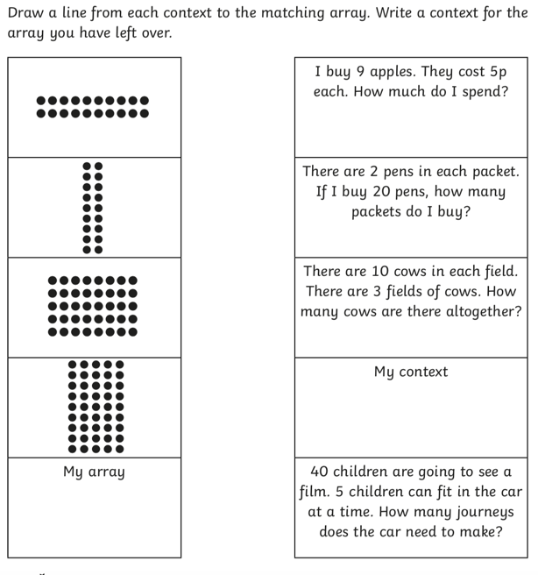
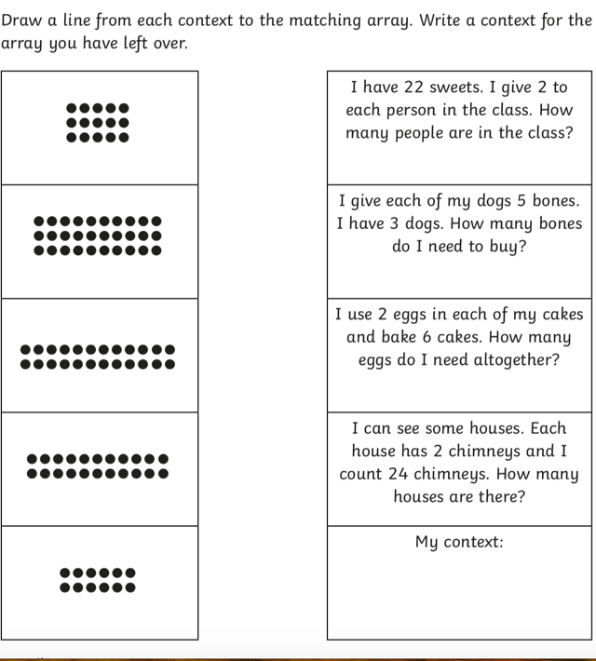

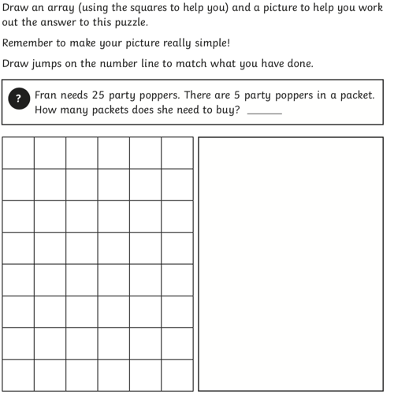
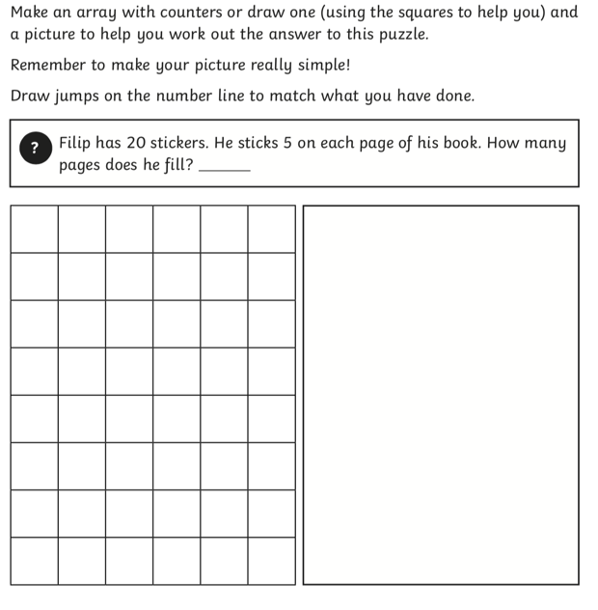
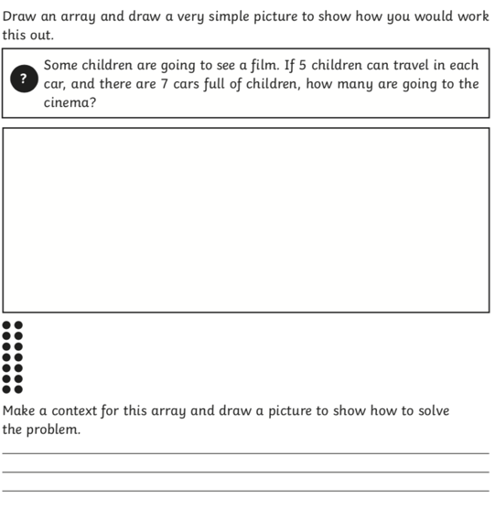
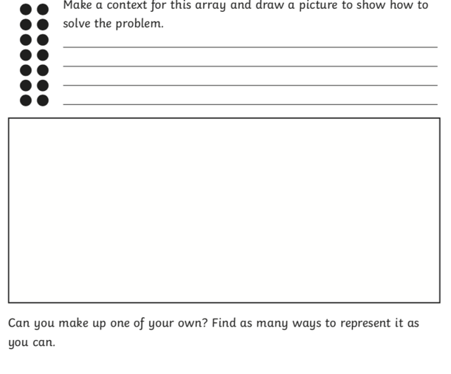

Thursday
LI: To begin to solve divisions as multiplications with a missing number and understand that division and multiplication are inverse operation

Inverse Operations : Inverse operations are opposite operations that reverse each other and cancel each other out.
Inverse operations are opposite operations.

Addition is the inverse operation of subtraction and multiplication is the inverse of division.

Examples

Addition and Subtraction
15 - 6 = 9 or 15 - 9 = 6
6 + 9 = 15 or 9 + 6 = 15
Multiplication and Division
12 ÷ 3 = 4
12 ÷ 4 = 3
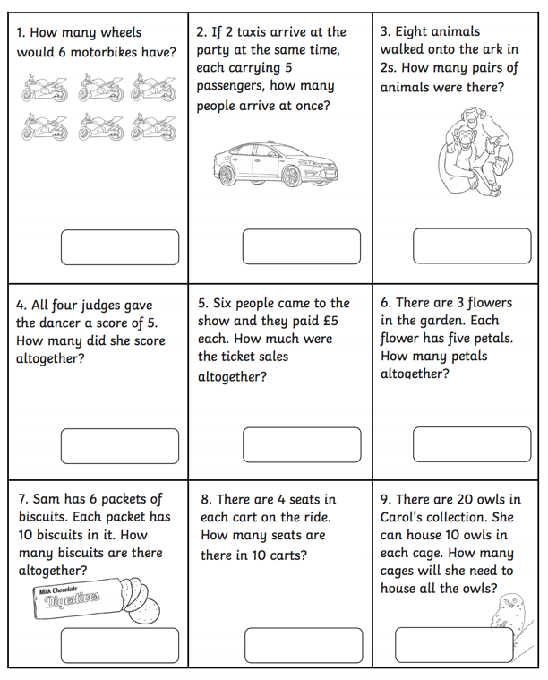
In Year 2, students begin to recognise that the inverse of division is multiplication, and that this sum can also be solved by expressing it as : 4 x 3 = 12 or 3 x 4 = 12.

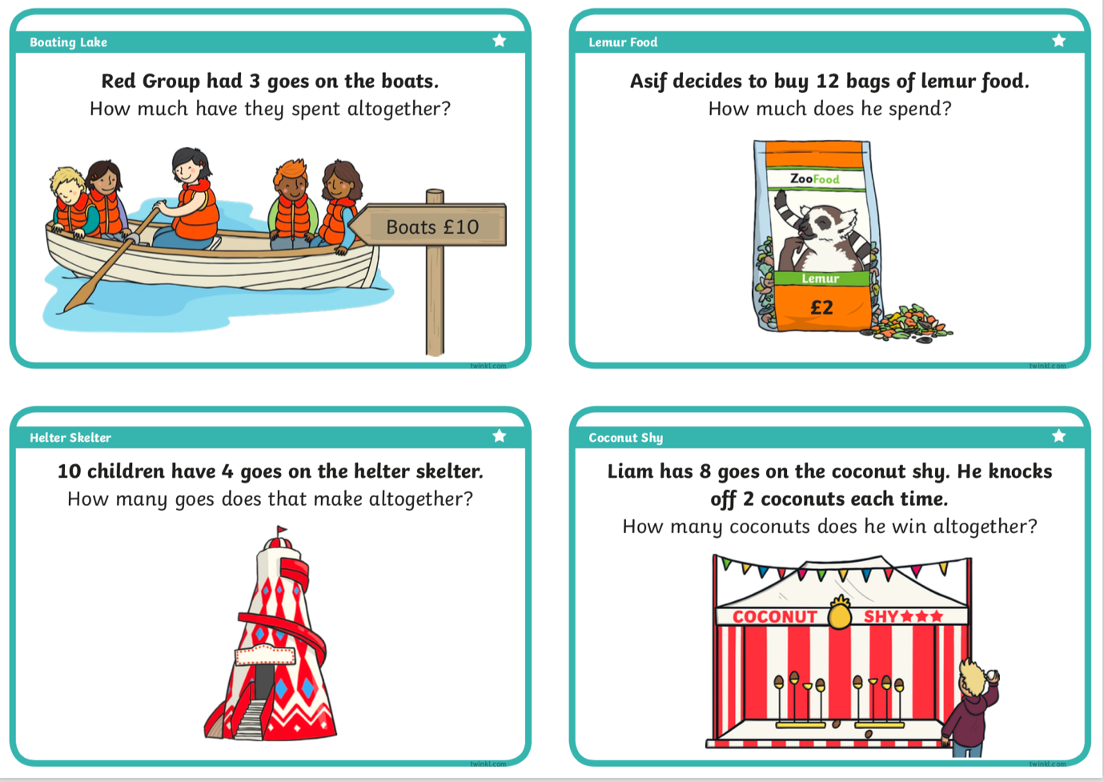
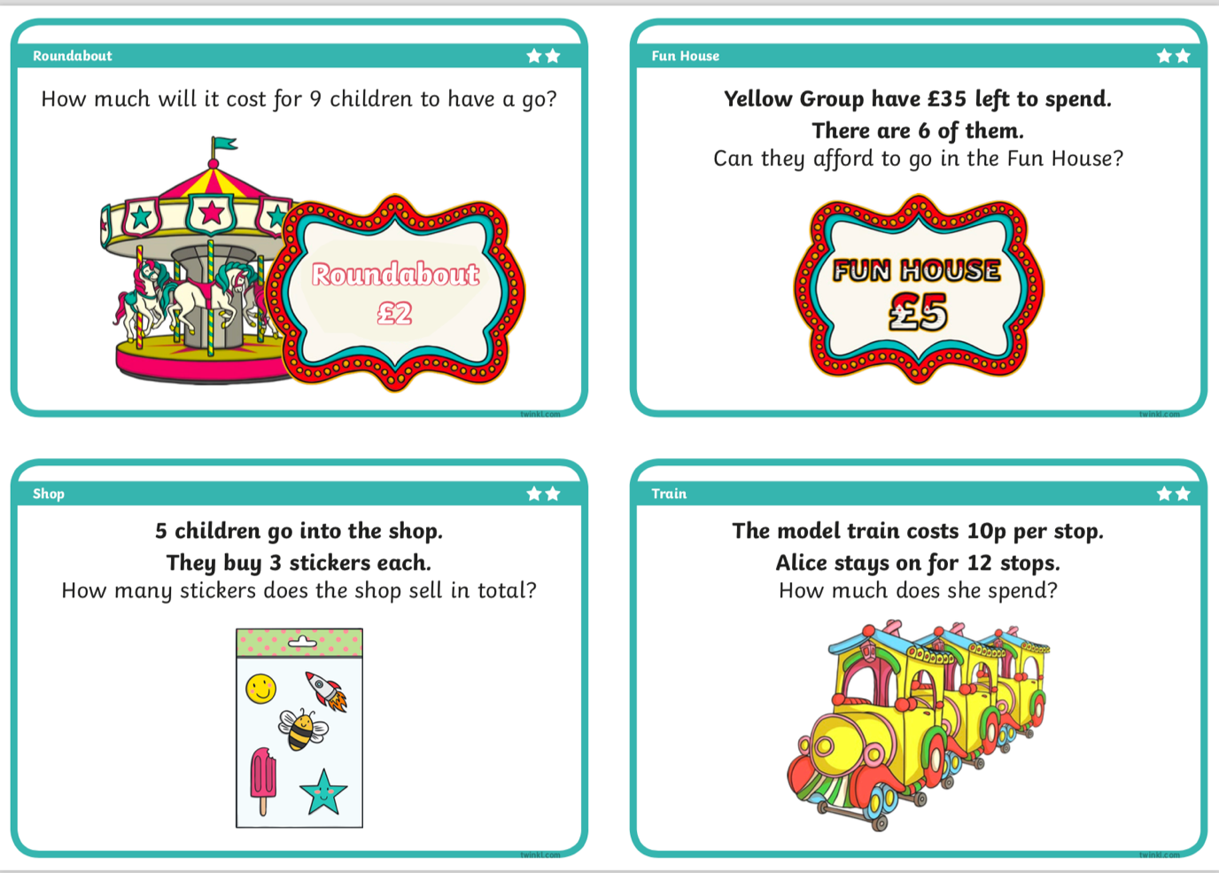

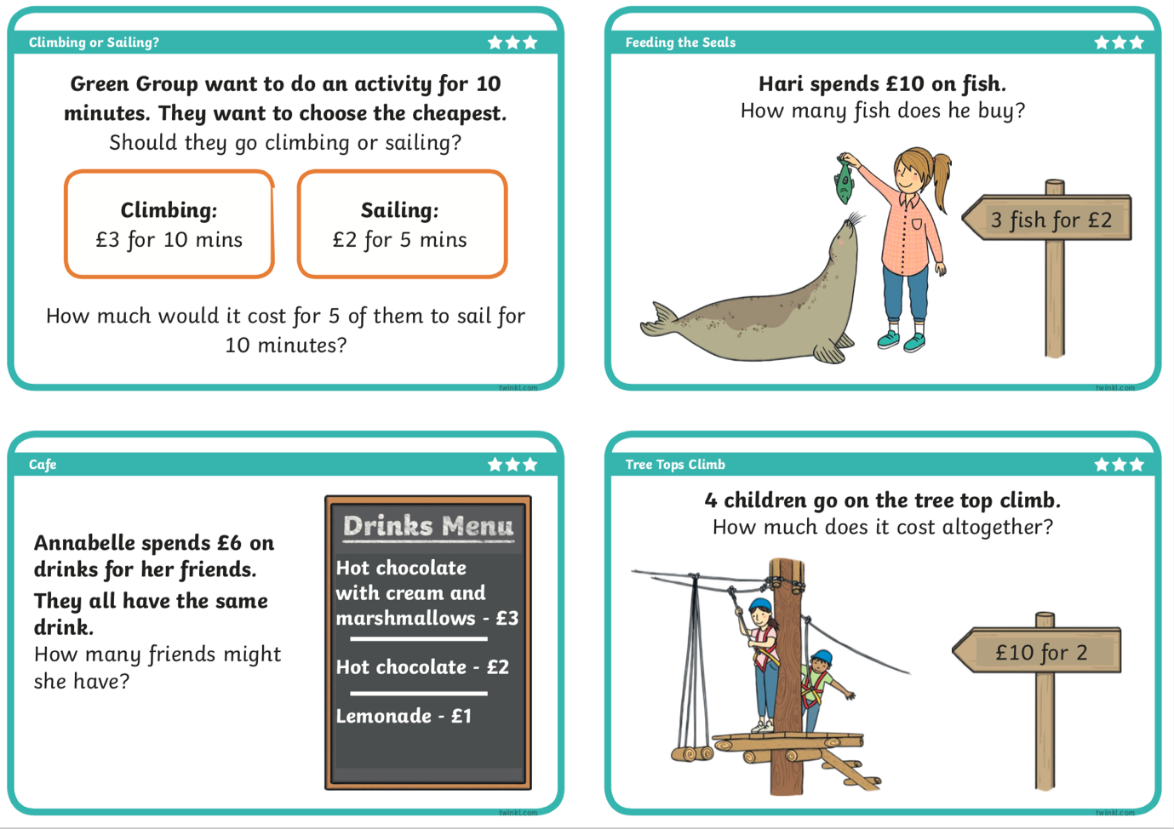

Friday
LI: To count in 2s, 3s, 5s and 10s to solve divisions; understand that division and multiplication are inverse operations; solve division problems in contexts.

Equal teams
Investigate which numbers of monsters from 1 to 30 can be divided into teams of 2, 3, 5 or 10 without leaving any left out. Record your results.
Can you predict whether a number can be grouped in to 2s, 5s or 10s?
What do you notice about those numbers which can be grouped into 5s (2s, 10s) and those which can’t?
Choose five numbers which can be grouped and record them as division sentences: 12 ÷ 2 = 6, 15 ÷ 5 = 3, etc.

