Feel free to have a go at some of these lovely activities that relate to our topic…
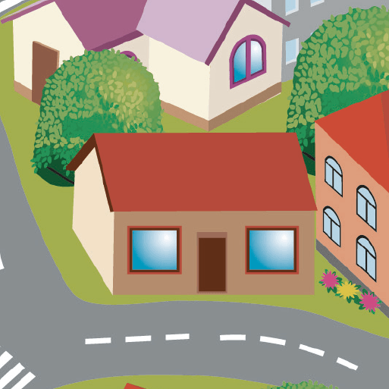
Street Detectives!
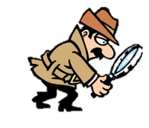

The following 2 activities all explore our local community in the past and in the present. We hope you enjoy them and we’d love to see your fantastic work on these activities! You can share your work by sending it to: homelearning@stjeromebilingual.org.
Miss Dear and Miss Reynolds☺
History 1
Old and new houses
This activity will help you to learn more about the houses in your local area and to practise the historical skills of comparing the old and the new to explain changes over time.

Look at the pictures of the different houses below (on pages 2 and 3 of this document). Can you try to put the houses in order from the oldest design to the most recent design. Discuss with someone at home why you have ordered them in that way?
- Historians look carefully at similarities and differences and use this to explain their thoughts about changes over time.

With help from someone at home, look at the dates/ eras of the different houses (in the top right corner) and check the houses are in the correct order.

Then, pick two houses and discuss the similarities and differences. Look at the features of the different houses (for example, chimneys, date plinths, leaded windows, thatched rooks, wooden beams, roof shapes, front door designs, e.g.).
- You can describe and compare more than 2 houses if you wish.

You can then present your findings and share them with us if you wish to do so. Below are some ideas of activities to present your work:
- You could make drawings of old and new houses, adding captions and labels to identify their features.
- Alternatively, you could take pictures of different houses you see or use the photographs below and use an iPad or laptop to add captions and labels to digital photographs.
Challenge: Next time you go for a walk, try to work out when the houses you see in Harrow were built. Let us know what you find out!

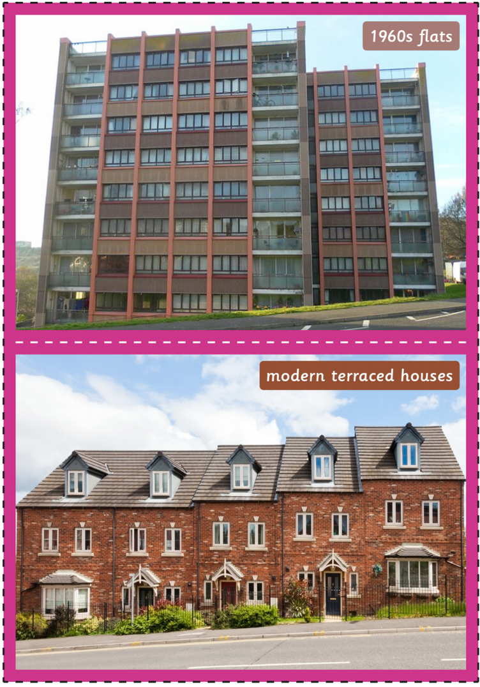
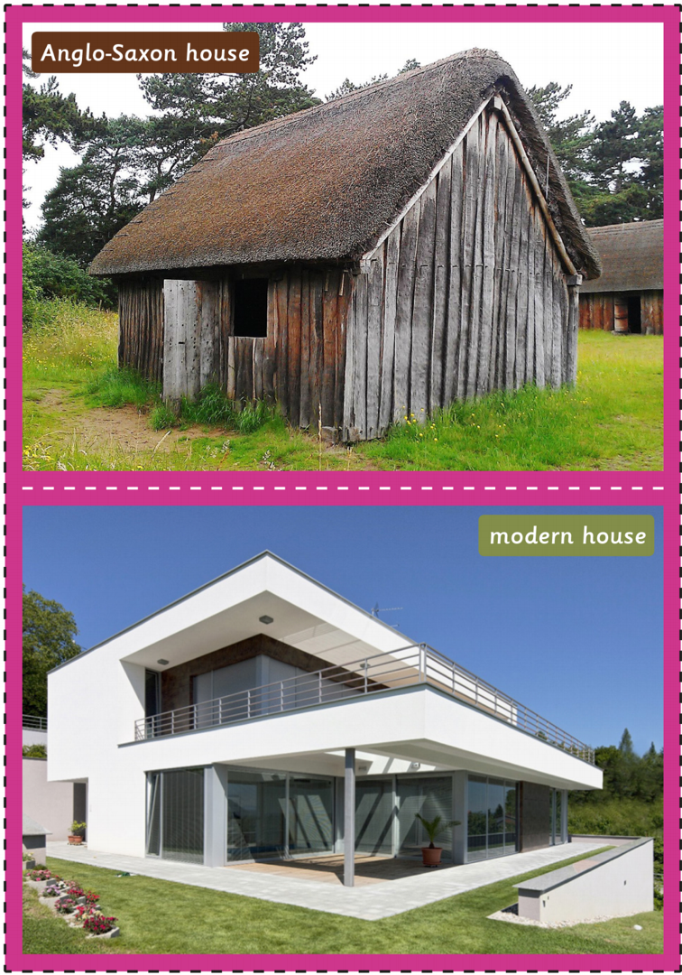
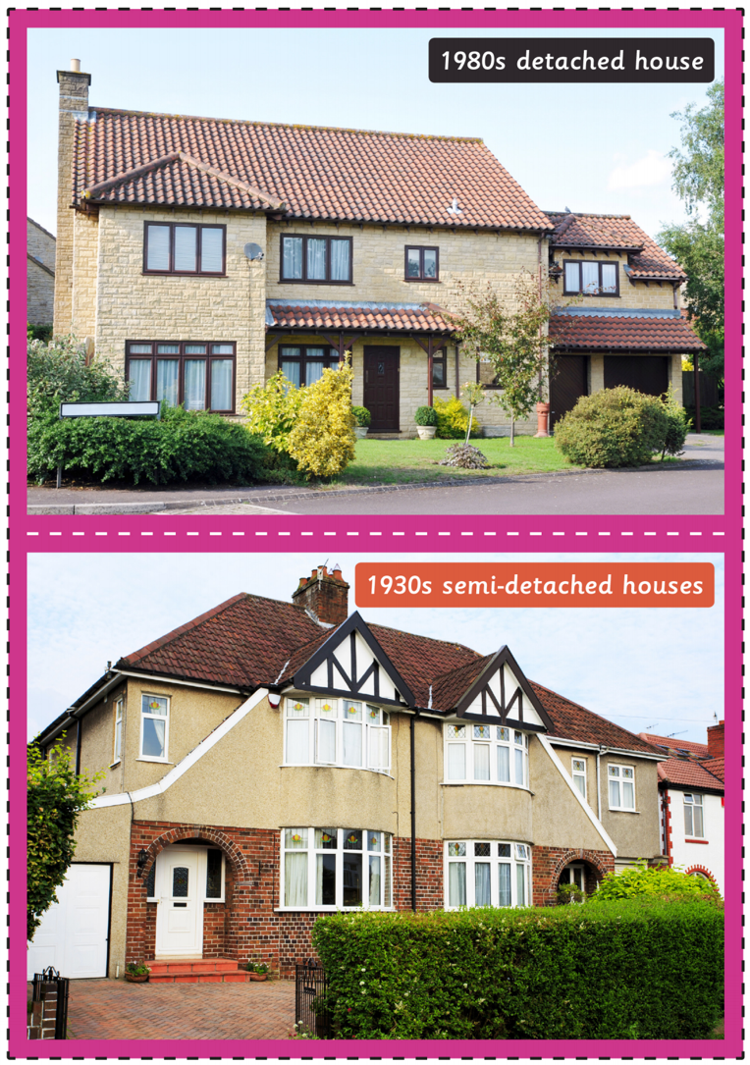
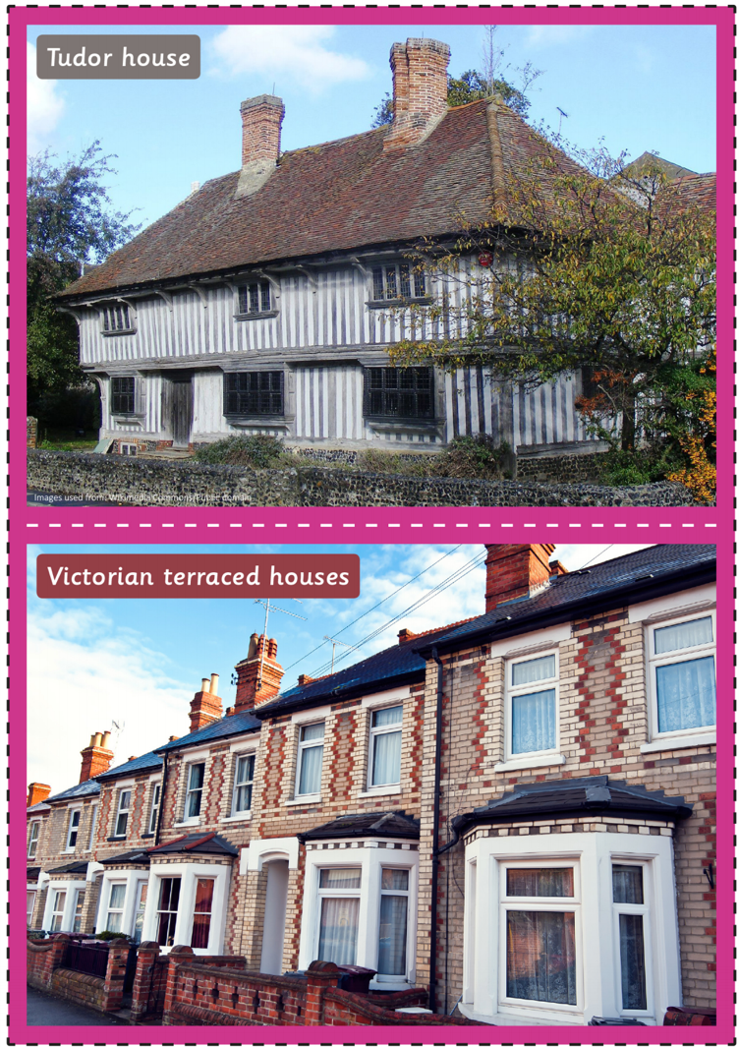
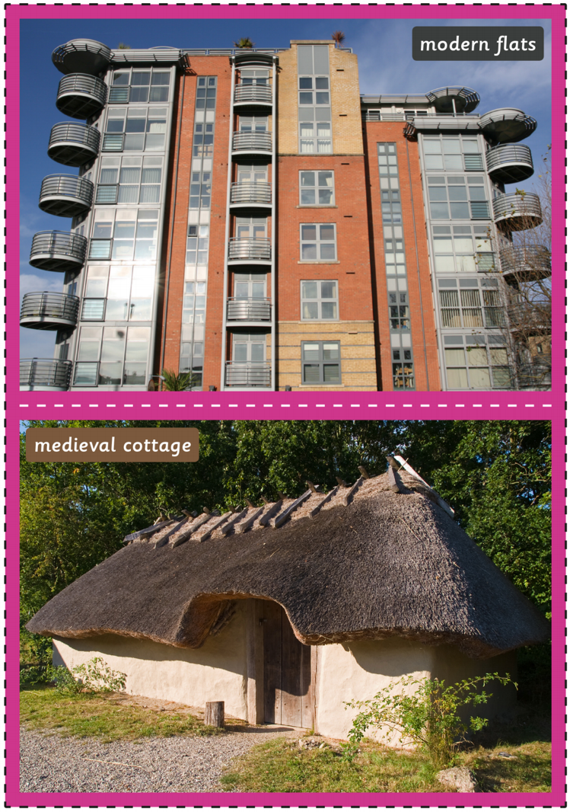
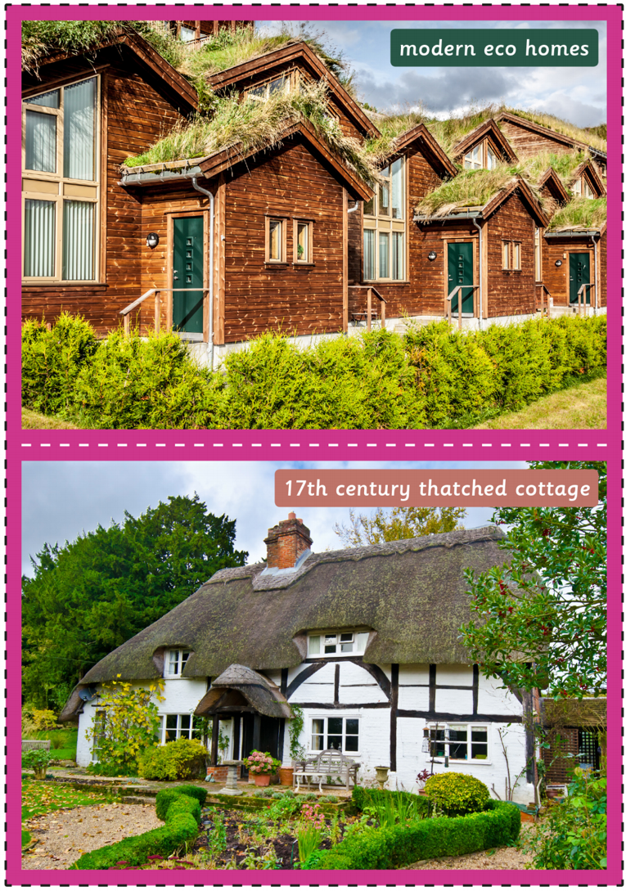
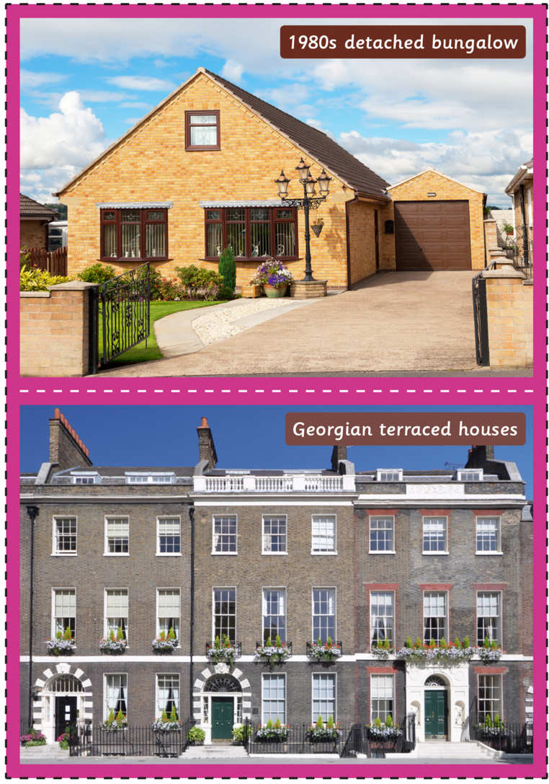

History 2
Old and new shops
This activity will help you to learn more about food shopping in the past and how it has changed over time.

Describe what you do when you go food shopping with your carers.
- Where to do you go?
- What happens in the shop?

Remember that historians look at similarities and differences between the past and present. They then use these to try to explain how things have changed over time.

Have a look at pictures of the Harrow Sainsburys shop in the past. These pictures are from the Sainsburys archives. The Sainsburys shop used to be found on 357-9 Station Road in Harrow. If you can, find out what we can find at this address nowadays.
- An archive is a collection of records of a place or person’s past.
Choose a picture and click on it. Read the caption on the side. Describe what is happening in the picture.
- Is it similar or different to how you shop today? Explain why.

Have a look at as many pictures as you want.

Then watch video about Shopping Then and Now for more information.
- Talk about what is the same and what is different.

You can also find some more information and photographs on the “Shops in the Past” document on our Home learning page.

If you wish to do so, make a Venn diagram to show the similarities and differences about shopping nowadays vs. shopping in the past. There is a Venn diagram template for you to use on page 5.

If you can, ask you parents and grandparents about how shopping has changed:
- Where did they go to do their shopping?
- What happened in the shops?
- Are there any foods that we can buy nowadays but that would not have been found before?

Challenge: Can you explain how and why shopping has changed to someone at home? Or send us a video to explain?
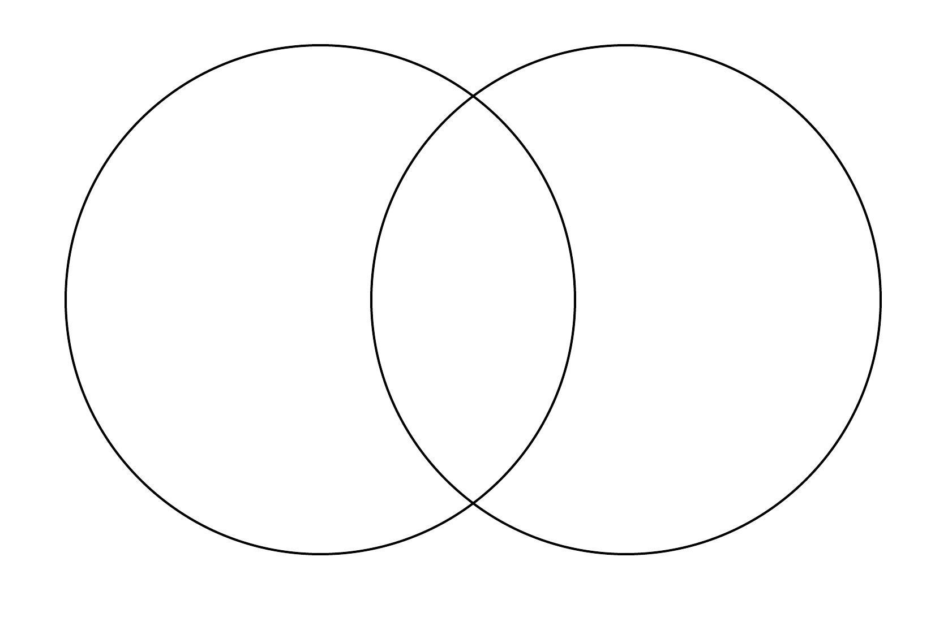
shopping in the present
shopping in the past

