Maths Home learning wc 13.7.20

Monday – Identifying ‘cup of tea’ numbers

[Click here](https://www.youtube.com/watch?v=Ftati8iGQcs&safe=true) for ‘counting by 10s song’

The multiples of ten can also be called ‘cup of tea’ numbers because from 10 onwards, they end ----ty. (twenty, thirty…)

It is important that we don’t confuse the multiples of 10 with numbers the teen numbers (thirteen, fourteen, fifteen).

Use the grid below to count from 1 to 100. When you come to a ‘cup of tea’ number, you can colour it in. You can also colour the cup of tea in the row at the bottom and put the number underneath it. The first one has been done for you. Continue until you reach the end of the grid. Count along the cups, saying the name of each number clearly. Look carefully how the ‘cup of tea’ numbers are written. Which number is written first? Which number is written next?

Cup of Tea Numbers

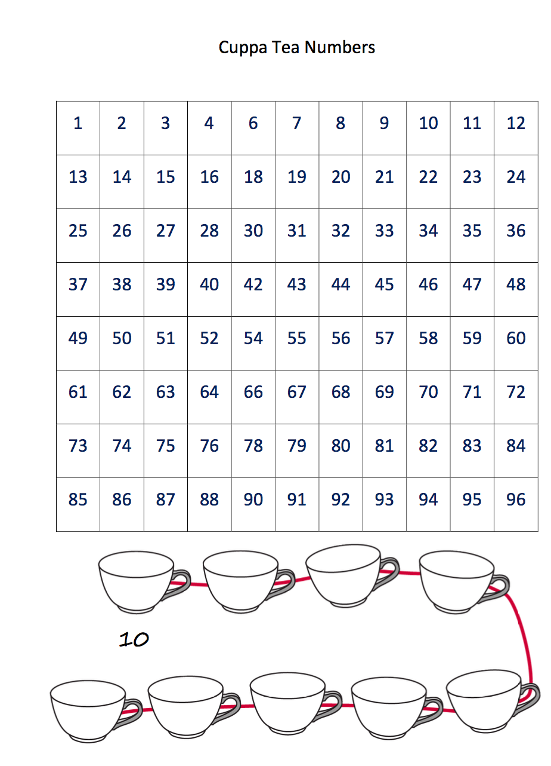

Tuesday – Filling in missing numbers up to 100

[Click here](https://www.youtube.com/watch?v=VVXY35E1674&safe=true) for missing numbers to 100 video.

Have a look at the grid below of numbers up to 50. Some numbers are missing. Can you fill in the missing numbers by looking at the row and column that the numbers are on?

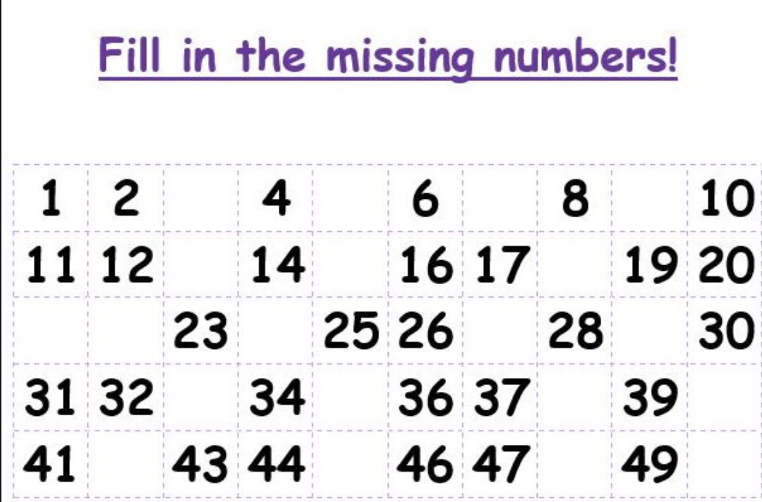

Now have a look at the grid of numbers to 100. Looking at the numbers in the rows and the columns of the missing numbers, can you fill in the missing numbers?

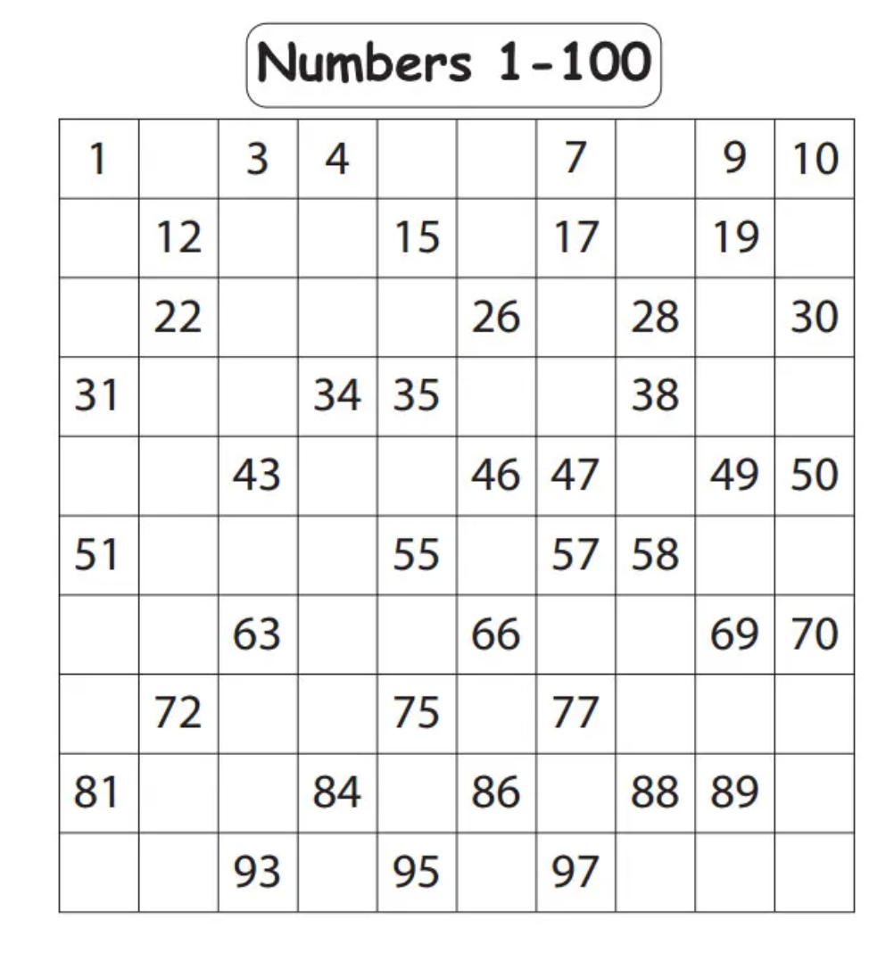

Wednesday – identifying 3D shapes

[Click here](https://www.bbc.co.uk/programmes/p0115gt4) for ‘3D shape song’

Go on a 3D shape hunt in your home. How many different 3D shapes can you find?

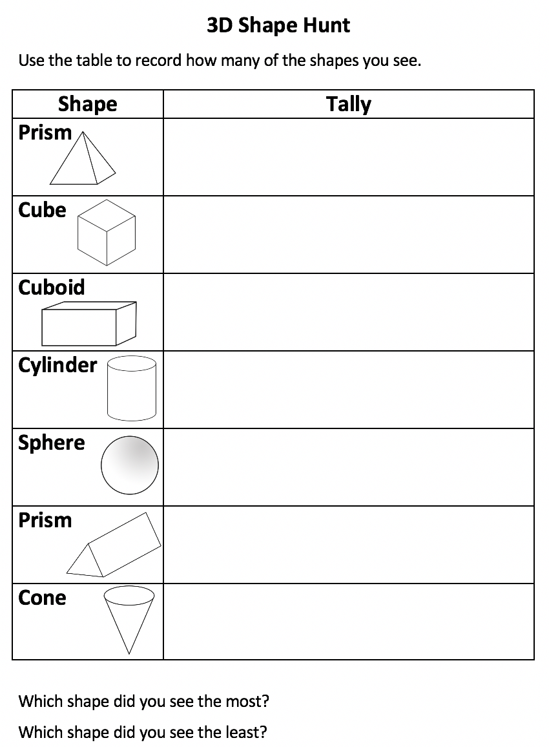

Thursday – Create a picture using 3D shapes

[Click here](https://www.bbc.co.uk/programmes/p0115gt4) for 3D shape song to listen to the song again.

Have a look in your home and try and find different boxes/materials to make your own 3D model. Could you make a robot or a castle? Think about the different 3D shapes that you can see in the pictures? Can you create a 3D model using as many different 3D shapes as possible? Have fun creating your own 3D model.

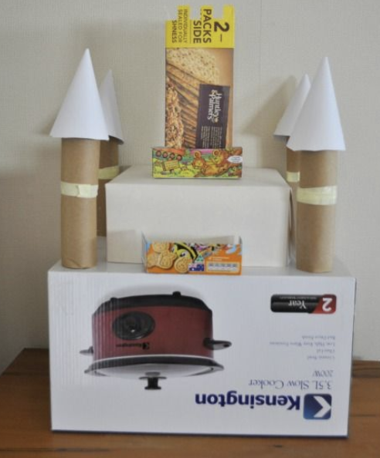

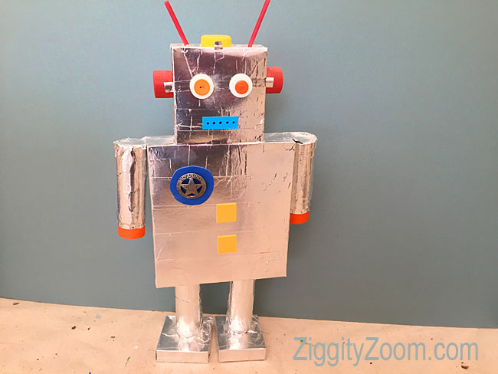

Friday – making your own 3D cube

Take a look at the net of a cube. If you can print it onto card, it will be more robust but it is not essential. On each face, write one number from 1-6 or the dots for each number to create your own dice.

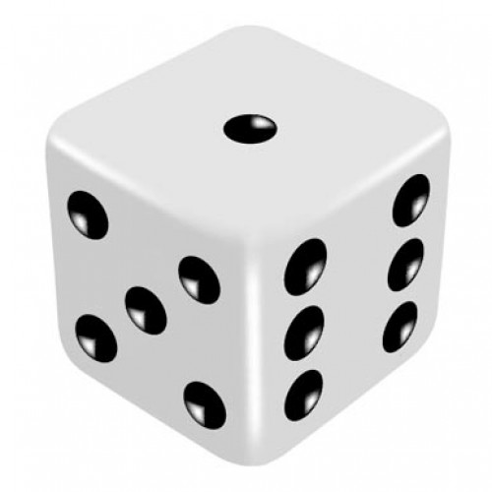

Over the Summer, enjoy playing games with your family using your dice.

We hope that you have a good Summer break and we’re really looking forward to seeing you in September. A huge well done to you all for completing your home learning.

