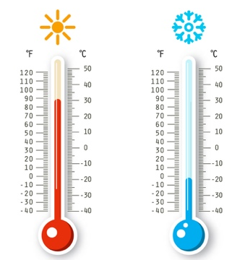
Splendid Skies

Science

Measuring Temperature
Today we are going to be learning about simple equipment used to take measurements. We are going to looking at how to measure temperature. What piece of equipment do you think we could use to measure temperature with? Discuss with your grown up or a sibling.

Watch the following links to find out more about measuring temperature with a thermometer:
VIDEO 1
VIDEO 2

Task 1
If you have a thermometer at home, every day when you wake up look at the temperature that your thermometer is showing. Note this temperature down and then do the same just before you go to sleep. Do this across the week and see how the temperatures change? What do you notice?

Task 2
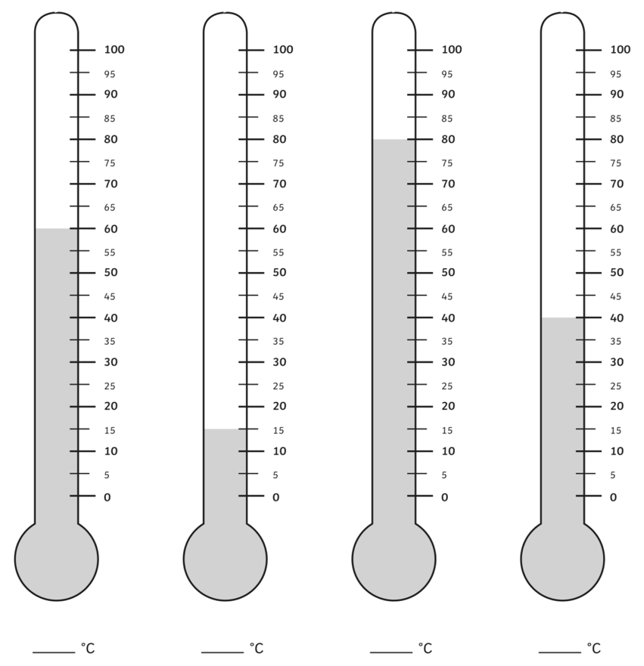
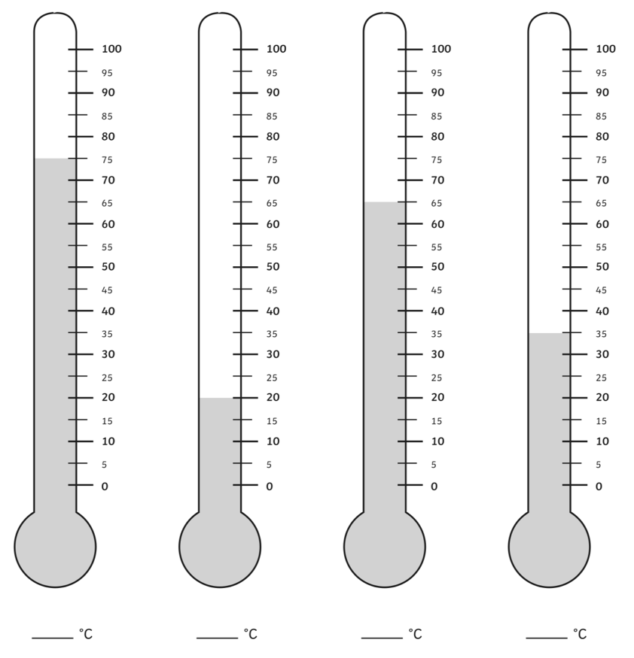
Look at the thermometers below. Can you see what temperature they are showing?

