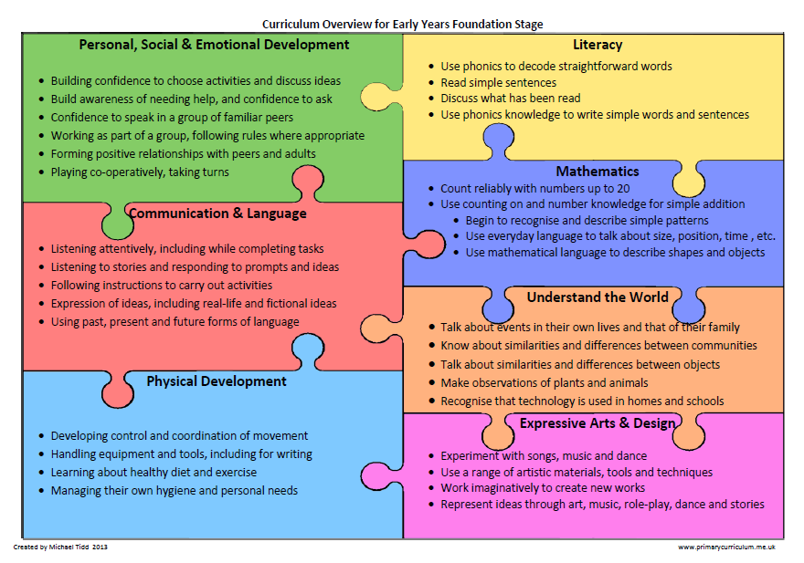

Week commencing: 13.7.20 – Each area of the Foundation Curriculum is carefully used in our planning to support your child’s ongoing and developing skills.

Complete a phonics activity *daily and practice handwriting words ending with the same two consonants: fill, drill, mess, less, dress, stiff, sniff, fluff. Make your own list of words and say them slowly, can you notice that although there are two letters at the end you only make the sound for one f-i-ll,
d-r-i-ll

Practise your handwriting by writing Do not make a mess when you fill your cup. Write it as neatly as you can.

*Letters and sounds daily lessons

Phase 4 Tricky Words song
Reading – share with your child a few of these books Phonic based reading books

Monday 13.7.20

Handa’s Surprise

This week we are looking at some lovely stories set in Africa. Watch the video of Handa’s Surprise and then see how many of the fruits you can name from memory, write them down in a list. Who do you think had the biggest surprise and why? Can you remember which animal took which fruit?

Create a story map and retell the story to a family member.
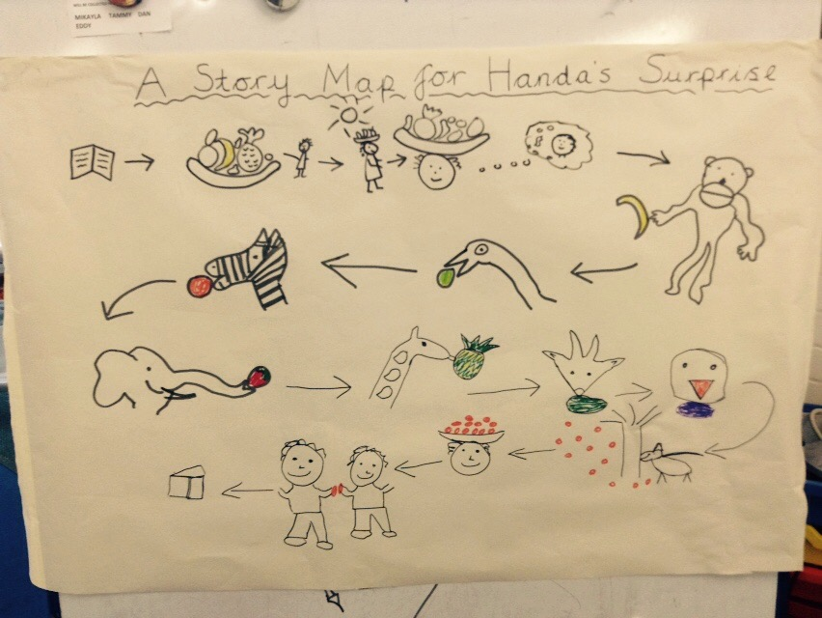

If you were going to collect some gifts for a friend, what would you give them?
What surprises have people organised for you? Can you think of a nice surprise that you could arrange for somebody else?
Do you remember singing this French song: J'aime les fruits ? You can learn more fruit names watching this animation Apprendre les fruits en français and Mathilde visiting a French supermarket on High Five Lesson 8 - Les fruits.

Tuesday

Have a look at the Pdf of wonderful, colourful African jewellery which is worn by women and men. It is believed that wearing and owning old African beads or jewellery can give luck, wisdom, hope and a good sense of well-being to the owner.

Create your own necklace using beads or pasta or small rolls of coloured paper or even use a paper plate.
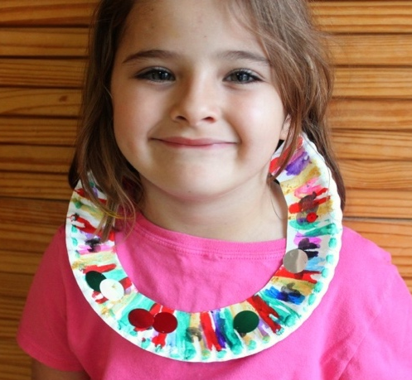
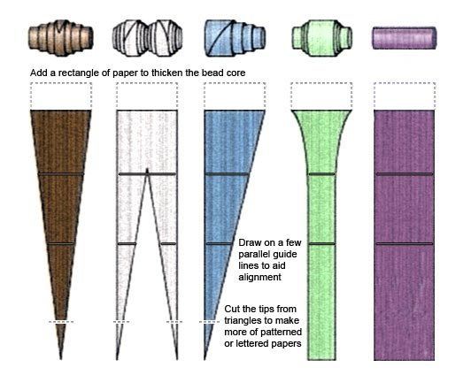

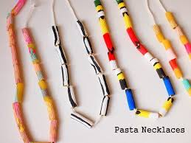

Wednesday

Handa's Hen

After watching this story, draw a picture of Handa’s hen, Mondi, with ten chicks and think of names for each chick and label them.

Write your own little number story about Handa and Akeyo. I wonder which African animals you might choose to put in your story? End your story by finding Handa’s hen and her ten chicks.

This is a great opportunity to revise our hen songs in French: Une poule sur un mur and Cot cot la poule.

Thursday

Over the last few weeks you have learned a lot about Africa, now its time for you to gather all your work together to create a book. You might choose to add photographs of work, add in your story writing or pictures into your book, you are the author and illustrator so be bold and start putting your ideas together.
What a lovely way to share your home learning in school by sharing your books with other children. I can’t wait to see them. We will make sure that when we are all together again we have time to enjoy your books in small groups.

You can include in your book some reference to all the French African songs you have learnt. Revisit the Reception Pinterest at anytime.

Friday

Anansi and the tug o’ war

This week’s Anansi story shows just what a trickster he really is – I bet the elephant and whale would be really embarrassed if they were to know what really happened.

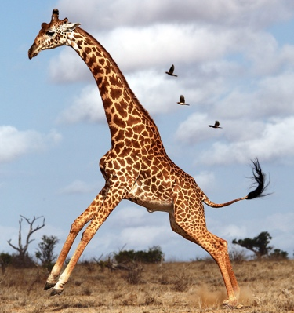
Can you think of some animals that you could draw having a tug of war, make it funny like an ant pulling against a giraffe!

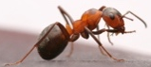

Do send pictures into school or take a photograph of your work and send it to:
homelearning@stjeromebilingual.org.

We love to see your hard work.

HAVE A GREAT WEEK
