Week Beginning 06/07/2020
Splendid Skies

Monday
I hope you had a fantastic week doing your home learning last week, I wonder what new things you learnt when you read your stories?

This week we are going to continue with our splendid skies’ topic. We have been thinking about all the different types of weather that may occur. I wonder if you have noticed anything different about the weather now that you have done all of this additional learning?

Each day this week, I would like you to keep a diary of the weather. At the end of this week, we will be creating a weather booklet detailing the weather on each day.
So, let’s start with today, what is the weather like today?

On your first day you may want to draw what the weather is like, then add a few sentences to explain what the weather has been like.
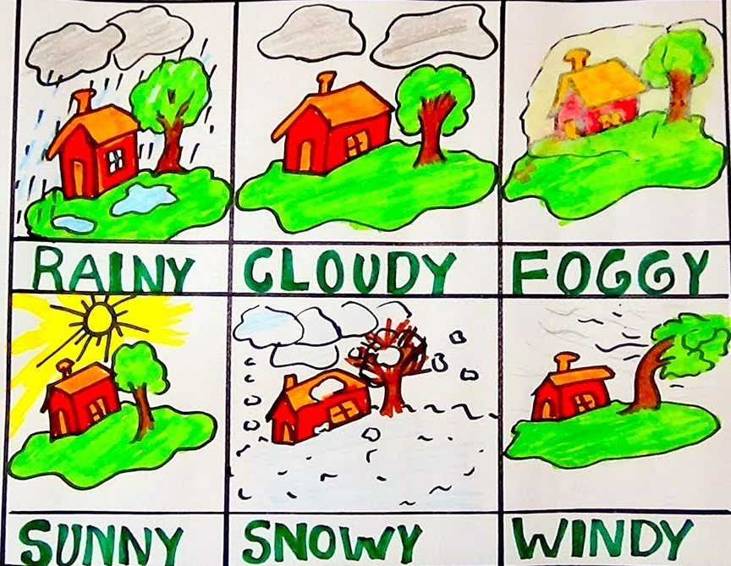
Here are some questions today.
- What is the weather like today?
- Is it sunny, windy, cloudy or rainy?
- Will the weather stay the same every day or will it change?
- How could you find out what the weather is like today?
- What season are we in at the moment?
Once you have answered all of these questions, remember you must record the information for the rest of the week.
Remember you may also want to draw some pictures.

Tuesday

I hope you enjoyed having a thinking about what the weather yesterday, remember to continue your diary for this week.

Today we are going to be thinking about all the different types of weather.
We are going to be looking at how we measure different types of weather.

I would like you to draw a picture of a type of weather. Then I would you to describe what that weather type is like. Once that is finished, I would then like you to explain how the weather is measured.

Here is an example of what I mean

Snow
This is what it looks like when it has snowed, there is lots of white ice on the ground and it becomes very cold.
When it snows you may be able to build different things in the snow, such as a snowman or you may be able to have a snowball fight!

The best way to measure snow is in millimetres. This tells you how deep the snow is, that’s how we know how much snow has fallen.

I wonder how many different types of weather you can think of?

Wednesday

Well done, I’m sure you have thought of lots of different types of weather. Remember to continue to fill in your weather diary!

Today we are going to continue to think about the weather.

I would like you to draw a picture of everything you can see outside. Have a look through your window and draw exactly what you can see.

Once you have created your drawing, I would like you to describe everything you can see in the picture.

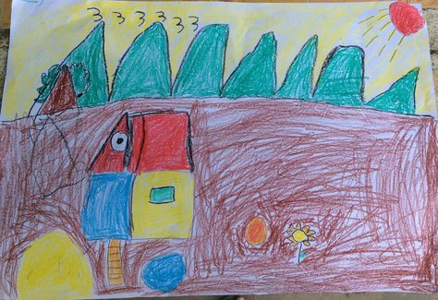
How many different adjectives can you use to describe what is happening within the picture?
The weather is sunny outside. The sun is shining and it is very hot. The clouds are looming in the sky and they are a greyish colour. There is a little bit of wind that is blowing the leaves on the trees. The leaves are moving very slowly in the breeze and the trees are barely shaking.
Remember you can send your pictures in to homelearning@stjeromebilingual.org.

Thursday

Remember to continue with your weather diary this week, including as much information as you can about the weather.
We have done lots of work this week thinking about the different types of weather. Today we are going to continue to think about making notes about how the weather has been.

I would like you to write a list about what the weather has been like each day, that way, when we write our letter you will be ready to write down all of the information.

Your notes may look like this.

Monday: The weather was sunny today, it was very warm. The sun was beaming through the clouds, this meant we could play outside.
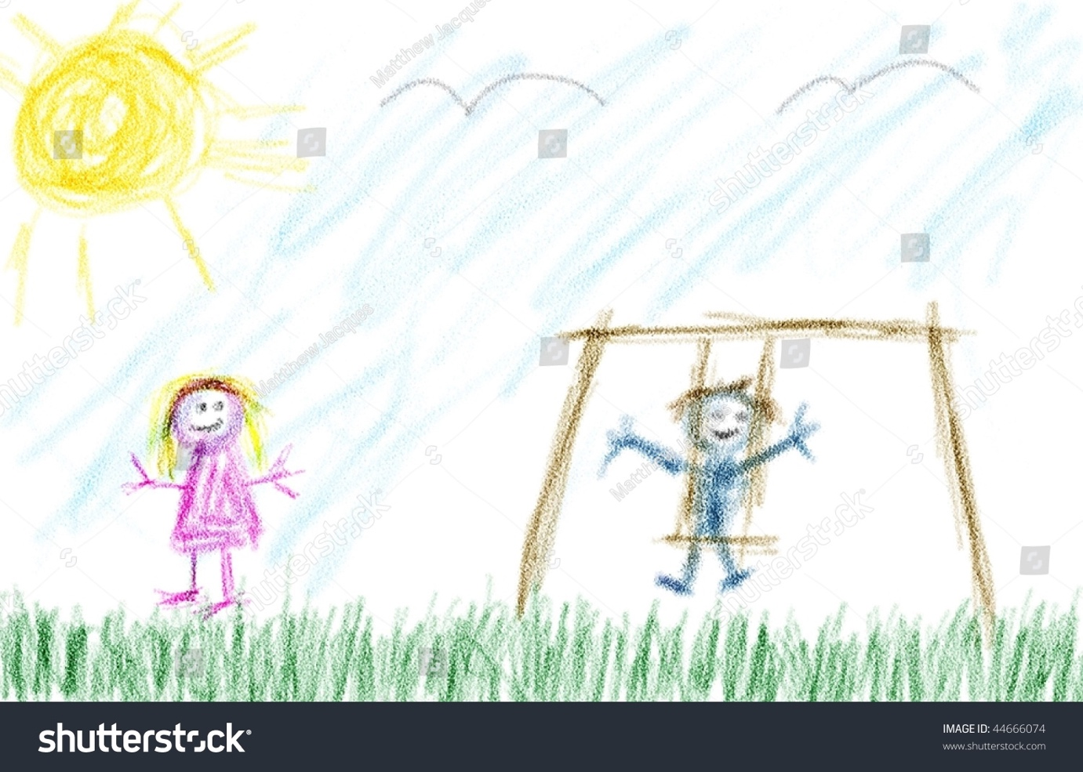

Friday

Well done, you have come to the end of your weather diary. Today we are going to continue to gather information about our weather diary, so remember to take notes for your weather diary.

This is the final day, so today we are going to be creating a booklet to keep all of the information about the weather inside.

Remember you can include lots of details inside your booklet.

Here is an example of how you may like to present your booklet. Remember to include lots of information about the weather and lots of beautiful pictures.

