Splendid Skies

Week Beginning 22/06/2020
Monday
Well done you have come to the end of your splendid skies’ topic. I hope you have enjoyed this topic. This week we will be recapping all of the learning that we have done in our topic so far. So, have a good think about what we have learnt!

Today we will be recapping our favourite elements of this topic. Have a look back at any pictures you have regarding this topic.

We are going to create a non-chronological report. Remember to use time connectives in your sentences. If you do not have pictures that you have taken on your topic, remember you can draw pictures if you no longer have any photographs.

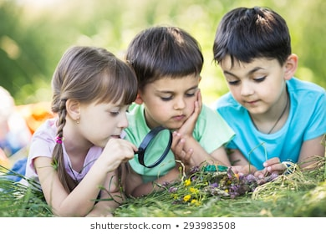
Here is an example:

This was one of my favourite days during the splendid skies’ topic. I enjoyed it because I was able to go outside and explore my local area. First, we went to the park. We had a look at the skies and how the colour of the sky changes according to the weather. Then we went to a grassy area. We had a look at the different flowers that were blooming during this time of year.

Tuesday
I am sure you have had lots of fun recapping what you have learnt in the topic so far.
Today we are going to be thinking about the different places we have heard about during this topic. In previous weeks we have had a look at all different postcards that were sent from teddy.
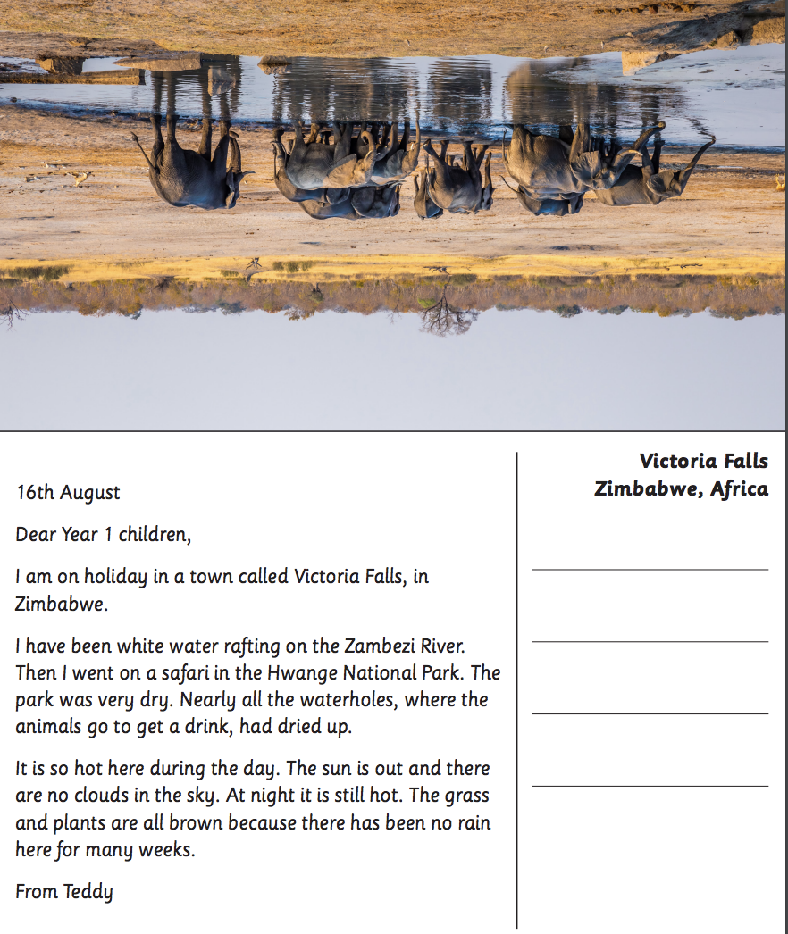
Today, I would like you to read Teddy’s postcards aloud once again. Once you have done so, I would then like you to research some information on the location Teddy has visited.
Think about how the weather affects what Teddy does as he travels the world. Talk about the kinds of things he can do in hot and cold places.
Use a map to locate where Teddy is and the countries he has visited.
Have a think about the temperature in the country that teddy has visited.
Have a think about the different activities Teddy may have done in the country he has visited.
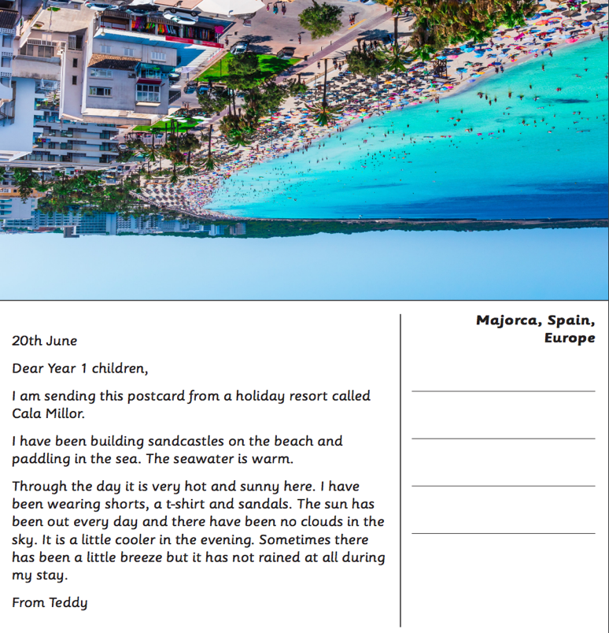
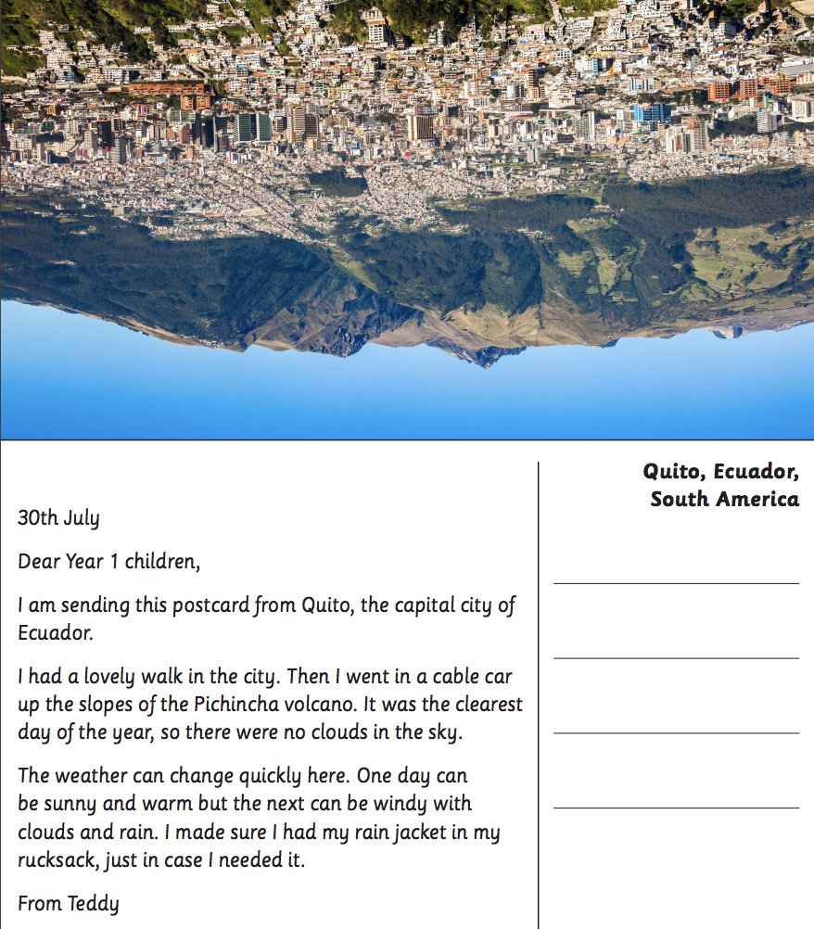
The postcards with the locations are below.

Wednesday
I hope you enjoyed researching all of these different countries.
Today we will be thinking about the different ways to report the weather, in particular a weather forecast.
Click here to watch this international weather report.

Once you have watched this weather report, can you discuss with a grown up the different types of weather words that you have heard. Maybe you can make a list of all of the weather words you have heard.

Now that you have heard lots of weather words, can you go outside and observe the weather. Feel free to take a pencil and paper outside to take some notes on the weather. Remember to use the language that you have found in the weather forecast.

What might a weather reporter say about today’s weather?

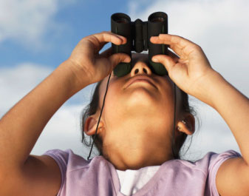

Thursday
Well done, I hope you have enjoyed making weather observations and I hope you have used lots of vocabulary in your notes regarding the weather forecast.

Today we are going to be continuing with our observation of the weather. I would like you to write a report about today’s weather. You may either like to use the weather as it is today, or the weather that you observed yesterday.

You should also add images to your weather report to explain what the weather is like on this particular day. The image may be either drawn or photographed.

Once you have completed this, please read your weather report aloud and check that it makes sense. If you need to, you should make any changes necessary to improve your work.

Here is an example of a weather report.

The weather today is very sunny. The temperature will reach highs of about 30 degrees. Although it still remains cloudy.

Friday
Fantastic work, you have come to the end of your splendid skies topic. I hope you have had lots of fun learning about the weather and everything to do with the different seasons changing.

Today is our last day of the splendid skies topic, and we are going to celebrate your success of coming to the end of the topic with a poem performance.

Today I would like you to perform your favourite weather poem. You can either find these online or have a look at the poems below. You may like to perform your poem to people in your household, perhaps you may even perform it by learning it by heart.

You could also record yourself reading the poem out loud. Remember to read the poem clearly, confidently and at the correct pace.

Here are some weather poems I have found, but you may like to find your own weather poems.
