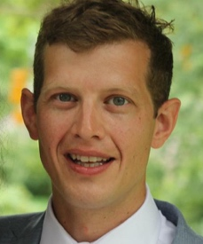

Salut et bienvenue à la classe 4JS!

I am a new teacher at St Jérôme Bilingual School and I will be your class teacher next year. I love computers, languages and learning new things. This summer, I will be practising my French so I am ready for St Jérôme next year and I will be spending lots of time with my dog, Misty. I love going for walks and playing football with her. I hope you will be ready to tell me some things that you like doing when we meet in September.

Our class is currently named after my initials and we would like to invite you to research artists around the world, who you could nominate to have our class named after. We will consider all your suggestions in the autumn term and democratically choose our class name together.

I know that you will be getting ready to come back to school over the summer. You will need to wear your uniform every day and bring your PE Kit to school. Please make sure everything is labelled with your name; even socks and shoes! When you come into school next year you will need to bring with you:
- Coat
- Small pencil case with the following items:
  - 2 HB pencils
  - 30cm ruler
  - Glue stick
  - 2 whiteboard pens (black ink please)
  - A pack of 12 colouring pencils
- Water bottle
- Small rucksack
Please make sure that all of your belongings have your name on them.
You will have your own locker to keep all your items safe.

When you come back to school please bring any work you have completed at home, especially your project about French Guiana. It will be great to see your hard work and to share your learning with the rest of our class. I know that there may be some learning from last year that we will need to go through again, but don’t worry I will help you. Try to keep reading over the summer. We have sent home information about the summer reading challenge and if you are looking for some great books have a look at this website which has a list of excellent books for every year group. https://schoolreadinglist.co.uk/category/reading-lists-for-primary-school-pupils/
I would love to know which books you have read and enjoyed. Don’t forget you can continue to practice your French using the St Jérôme School Pinterest boards. https://www.pinterest.co.uk/s_jrme/histoires-french-stories-ebooks/
https://www.pinterest.co.uk/s_jrme/boards/

We have lots of exciting learning planned for September. Our first topic is I am Warrior. We will be learning about Celts, Romans and what happened when the Romans invaded the Celtic Britain. We will also be learning about important parts of Roman life including gruesome gladiators, incredible inventions and nifty numbers. There are some great ideas attached (see below) that will help you to get ready for our first topic.

We will also be learning about:
- Burps, Bottoms and Bile: this topic is about human digestion. We will learn about what food types we need to keep healthy and how to make sure our teeth are in good condition.
- Traders and Raiders: we will be learning about how different groups (Angles, Saxons, Jutes, Frisians and then Vikings) invaded and traded throughout Britain after the Romans had left.
- Blue Abyss: we will be diving into oceans and seas to see who lives there, what they eat and how they behave.
- 1066: In this topic, we will be learning about a later invasion of the British Isles by Norman invaders. We will find out about great battles, the castles that they built to protect themselves and great works of art that they made to remember their victories.
- Misty Mountain, Winding River: In this topic, we will learn about mountain ranges and explore the ecosystems and land around them.

I’m sure you remember our 3 school rules and our school values. We will be thinking about these at the very beginning of the year and writing our class charter. You might want to start thinking about what we might want to include now? I’m sure you have been demonstrating our school values while you have been at home. Which is the most important school value?
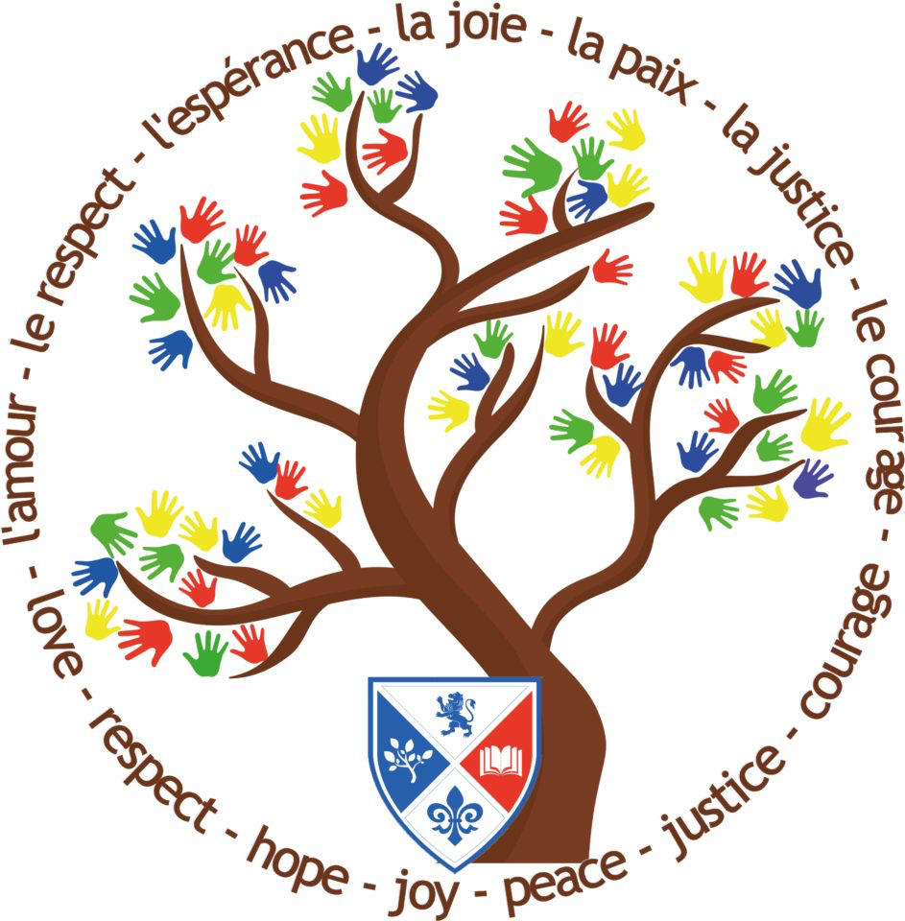

I hope you have a really good summer holiday and can enjoy some fun activities and some nice summer weather. I can’t wait to hear all about it in September.

Bonnes vacances!

Mr Spiller
