St Jérôme C E Bilingual School

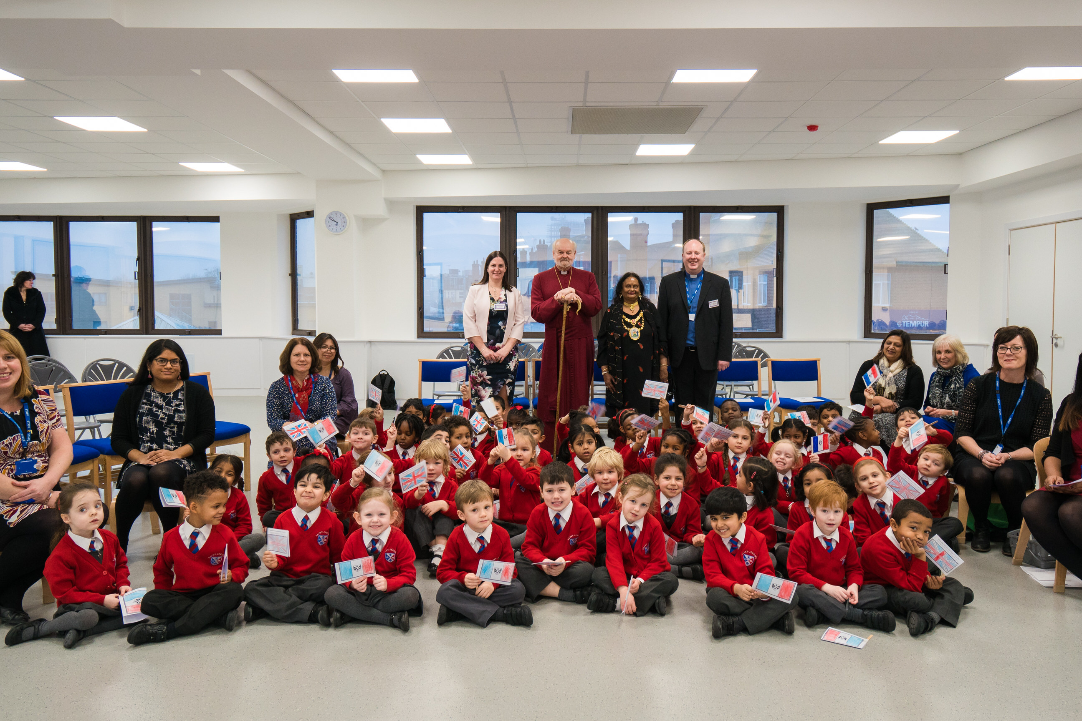
Official Opening of the School January 2017

Appointment of
Class Teachers for September 2021

Could you transform this space into a creative space for learning?

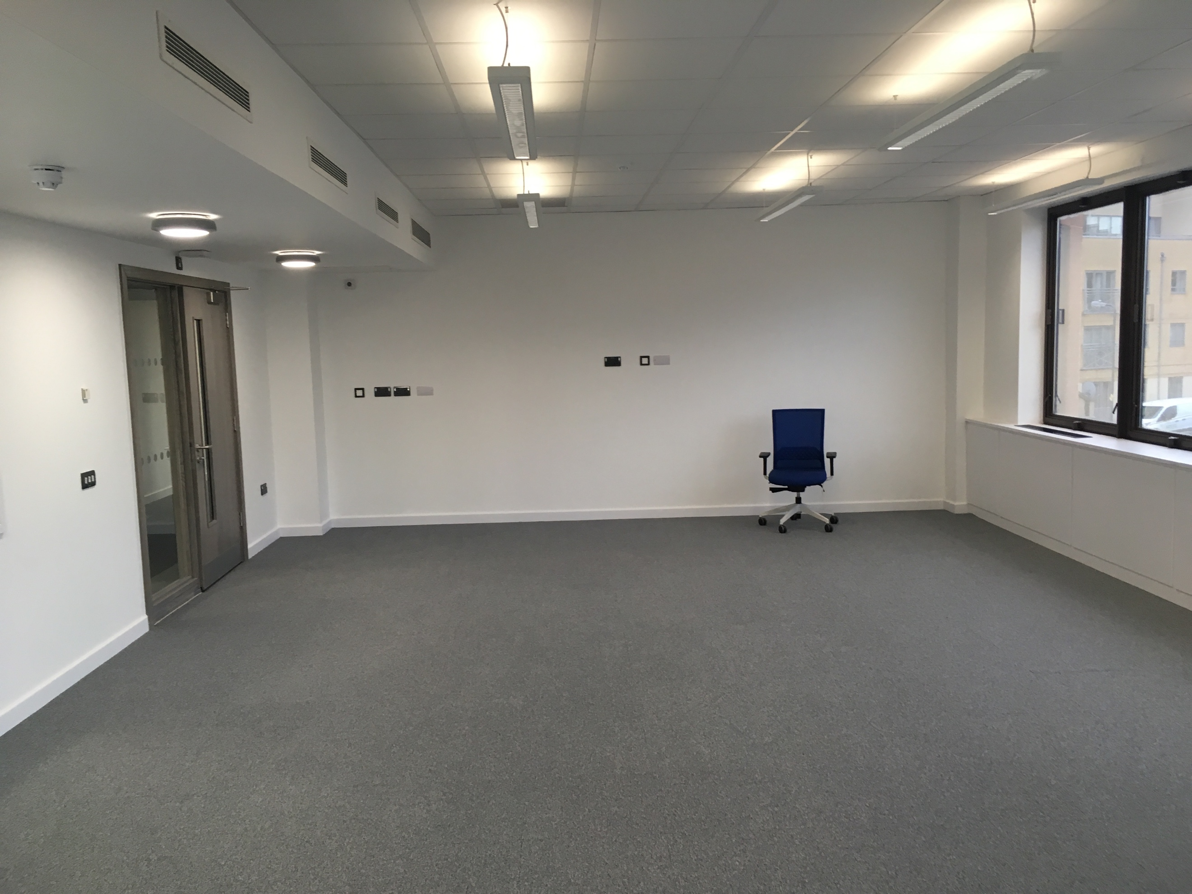
ADVERT

Could you support us to transform education and the lives of children in central Harrow?

We are looking for passionate and creative teachers who will join our teaching team from September 2021 to teach in Early Years, Key Stage 1 or Key Stage 2 (Year 3 or 4 or 5).

We are looking for teachers who want to be part of the ongoing creation of a school that is truly unique and innovative and that becomes an inspiration to others. You will be passionate about learning and teaching and supporting our bilingual curriculum and inclusive Christian ethos.

We welcome applications from both experienced teachers and also those who are newly qualified.

We can offer:
- Enthusiastic, well behaved and motivated learners with families who are highly supportive and passionate about the school
- An innovative educational approach and the opportunity to shape the development and ethos of our new school
- A highly supportive team and excellent opportunities for professional development and developing leadership skills
- A state-of-the-art learning environment and the opportunity to be involved in resourcing the school for the future
- The opportunity to develop your French language skills and to visit our link schools/ take part in language learning opportunities in France via our partnership with Eurostar
- The use of your own MacBook and iPad and the latest technology to support learning and teaching
- A competitive salary in the range of £29,915 to £45,766 (Outer London Scale) based on experience

If you feel that you could be part of our team and help to make our ambitious vision a reality, we would love to hear from you.

For further details and to look around our exciting school, subject to current Covid restriction please contact Karen Smith on office@stjeromebilingual.org please title your email recruitment

Completed application forms with a letter of application (2 sides of A4 maximum) should be sent to Karen Smith, School Business Manager, St. Jérôme Church of England Bilingual School 120 -138 Station Road Harrow Middx HA1 2DJ.

Applications close at 1pm on Friday 21st May 2021 – we may close applications early if the right candidate applies early.
St Jérôme C E Bilingual School is committed to the safeguarding of all children and all offers of employment are subject to the satisfactory references and an enhanced DBS Check.

Dear Candidate,

Welcome to St Jérôme C E Bilingual School

St Jérôme C E Bilingual school opened its doors to welcome the children of Harrow in September 2016. By September 2021, we will have up to 360 pupils from Reception to Year 5. We believe we offer a unique educational experience to our children. We are a Christian School that welcomes all people and seeks to share the love of God with our community in words and actions. We believe that teaching is a vocation and a ministry as we reach out to serve the children and families of central Harrow. We are also a bilingual school that is passionate about languages and we teach children in both English and French. We believe that this gives our children, the majority of whom already speak another language at home, a significant linguistic and cultural advantage. The ability to speak another language and to communicate with others opens doors and possibilities. Our dream for our children is that they will love both the English and French languages and that they will maintain other languages that they may speak at home and go on to learn many other ones. The progress that our children have already made is excellent and we are looking forward to seeing what is possible as they continue to grow and develop.

Opening the school took a significant amount of dedication from our founding team of local parents, the London Diocesan Board for Schools, our founding staff team and our many partners. Our partnerships continue to thrive and provide excellent opportunities for our children and staff. Our close partnership with Holy Trinity C E School Northwood has enabled us to develop our curriculum and Christian ethos and our partnership with Eurostar has enabled staff to visit France and for our Reception children to meet a train driver. Our partnership with Harrow School has supported the governance of the school and we have plans to enable St Jérôme pupils to benefit from the resources and facilities at Harrow. We have been in touch with experts in the field of Christian Education and children’s spirituality and as a result have been able to open an innovative ‘Godly Play’ classroom. We have also benefited from our partnership with Cambridge University with whom we are engaged in a longitudinal study on the impact of bilingualism on our pupils. Our research and partnerships have extended around the world as we have sought to find the best practice internationally and enable our children to interact with English and French speakers around the world.

We have very quickly become a popular and oversubscribed school and we were significantly oversubscribed on opening. Our parents are exceptionally supportive of our school and we have an active PTFA who have already raised substantial funds to support the future development of the school. We have a close relationship with the Parish of St John’s Greenhill and The Revd. Barry Hingston. Our children visit the church regularly and Barry and other members of the St John’s team are regular visitors to the school.

Our founding staff members and those who have joined our team as we have continued to grow have been able to benefit from the opportunity of helping to shape the school and bring our vision to reality. To be able to design classroom spaces and choose resources and educational approaches has been really exciting and our school learning environment is state of the art. We have chosen to use Apple technology which supports our innovative and creative bilingual curriculum. We have an extremely passionate and committed staff team who are looking forward to welcoming new members to our team. There is still much to do and to contribute to continue to grow our school. As a team, we strive to support and care for one another and we take very seriously the professional development of all our staff, knowing that a passionate and engaged staff team who love what they do will have a greater impact on our children. Our staff team is diverse and reflects the English/ French bilingual nature of the school. Staff communicate predominately in their mother tongue but we all have the opportunity to develop our language skills.

We are now looking for passionate and creative people who will join our teaching team from September 2021 to teach in Early Years, Key Stage 1 or 2. We are looking for teachers who want to be part of the creation and development of a school that is truly unique and innovative and that becomes an inspiration to others.

There is a lot of information about our school on our website and we warmly welcome visits to the school. Please contact us to arrange a visit. Completed application forms need to be returned to the school by 1pm on Friday 21st May 2021 along with a supporting statement of no more than 2 sides of A4, that addresses our person specification.

Thank you for your interest in St Jérôme Church of England Bilingual School and I very much look forward to receiving your application.

Revd. Daniel Norris
Executive Headteacher

Year 1 class room and Godly Play class room
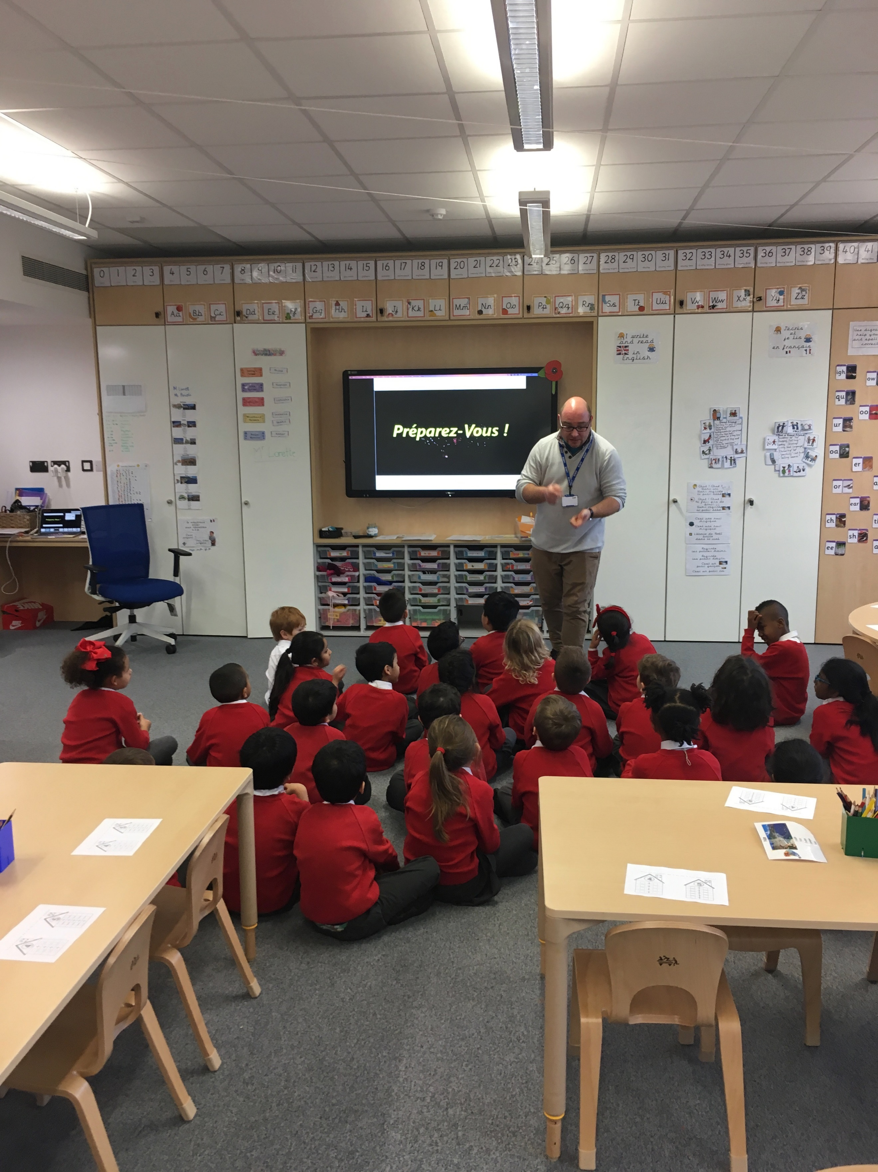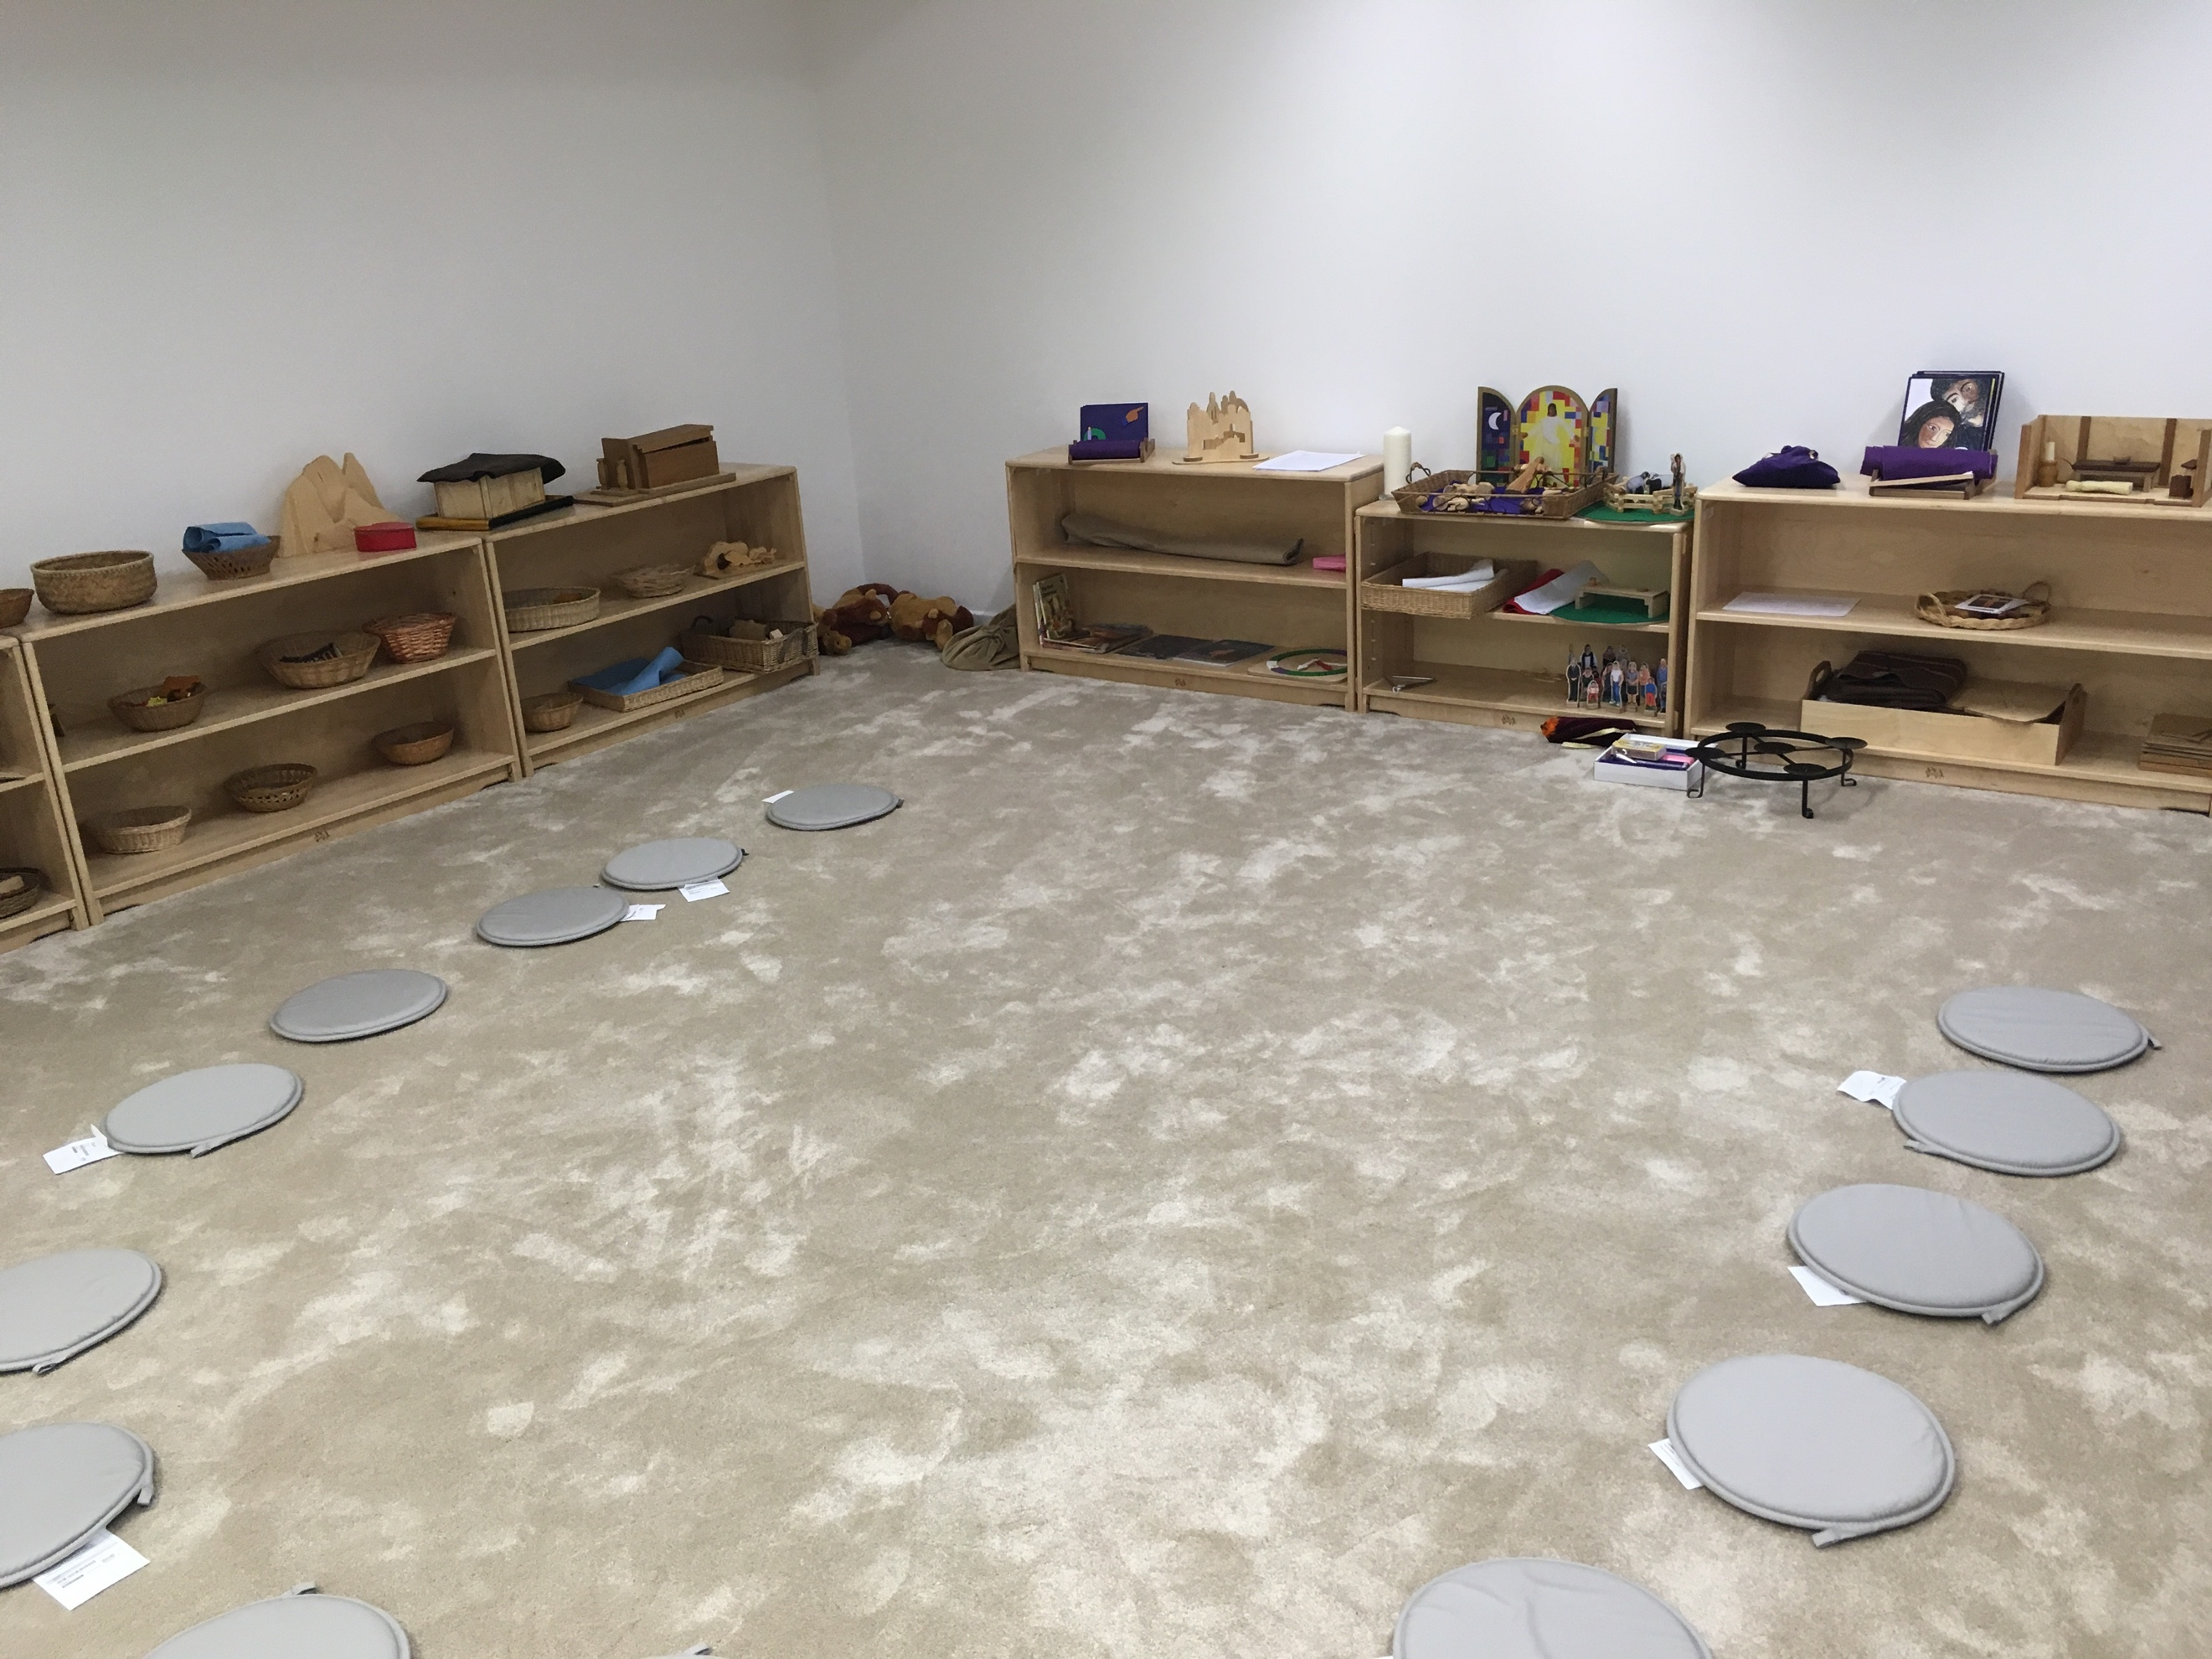

JOB DESCRIPTION

CLASS TEACHER

In addition to the general duties set out in `The school teachers' pay and conditions document', the following duties are attached to the post.

Every member of the teaching staff, regardless of other responsibilities, has a main role as a classroom teacher. The principle duties of any classroom teacher include:

TEACHING

To be able to teach children effectively in either English and French.

Set high expectations, which inspire, motivate and challenge pupils by:
- Establishing a safe and stimulating environment for pupils, rooted in mutual respect that reflects the bilingual nature and Christian ethos of the school.
- Setting goals that stretch and challenge pupils of all backgrounds, abilities and dispositions
- Demonstrating consistently the positive attitudes, values and behaviour, which are expected of pupils.
- Promoting good progress and outcomes for pupils by:
  - Being accountable for pupils’ attainment, progress and outcomes
  - Planning teaching to build on pupils' capabilities and prior knowledge
  - Guiding pupils to reflect on the progress they have made and their emerging needs
  - Demonstrating knowledge and understanding of how pupils learn and how this impacts on learning
  - Encouraging pupils to take a responsible and conscientious attitude to their own work and learning.

Demonstrate good subject knowledge by:
- Having a secure knowledge of the relevant subject(s) and curriculum areas, foster and maintain pupils’ interest in the subject, and address misconceptions
- Demonstrating a critical understanding of developments in the subject and curriculum areas, and promote the value of scholarship
- Demonstrating an understanding of and take responsibility for promoting high standards of Literacy, articulacy and the correct use of standard English and French

Plan and teach well-structured lessons by:
- Imparting knowledge and developing understanding through effective use of lesson time
- Promoting a love of learning and pupils’ intellectual curiosity
- Setting homework and planning other out-of-class activities to consolidate and extend the knowledge and understanding pupils have acquired
- Reflecting systematically on the effectiveness of lessons and approaches to teaching
- Contributing to the design and provision of an engaging bilingual curriculum within the relevant subject area(s).

Adapting teaching to respond to the strengths and needs of all pupils by:
- Knowing when and how to differentiate appropriately, using approaches which enable pupils to be taught effectively
- Having a secure understanding of how a range of factors can inhibit pupils’ ability to learn, and how best to overcome these
- Demonstrating an awareness of the physical, social and intellectual development of pupils, and know how to adapt teaching to support pupils’ education at different stages of development
- Having a clear understanding of the needs of all pupils, including those with special educational needs; those of high ability; those with English as an additional language; those with disabilities; and be able to use and evaluate distinctive teaching approaches to engage and support them.

Make accurate and productive use of assessment by:
- Knowing and understanding how to assess the relevant subject and curriculum areas, including statutory assessment requirements
- Making use of formative and summative assessment to secure pupils’ progress
- Using relevant data to monitor progress, set targets, and plan subsequent lessons
- Giving pupils regular feedback, both orally and through accurate marking, and encourage pupils to respond to the feedback.

Managing behaviour effectively to ensure a good and safe environment by:
- Having clear rules and routines for behaviour in classrooms, and taking responsibility for promoting good and courteous behaviour both in classrooms and around the school, in accordance with the school’s behaviour policy
- Having high expectations of behaviour and establishing a framework for discipline with a range of strategies, using praise, sanctions and rewards consistently and fairly.
- Managing a class effectively, using approaches which are appropriate to pupils’ needs in order to involve and motivate them
- Maintaining good relationships with pupils, exercise appropriate authority, and act decisively when necessary.

Fulfil wider professional responsibilities by:
- Making a positive contribution to the wider life and ethos of the school
- Developing effective professional relationships with colleagues, knowing how and when to draw on advice and specialist support
- Deploying support staff effectively to maximize learning
- Taking responsibility for improving teaching through appropriate professional development, responding to advice and feedback from colleagues
- Supporting and participating in research particularly in the area of the school’s bilingual specialism
- Communicating effectively with parents with regard to pupils’ achievements and well-being.

For teachers who are not newly qualified:
- To lead a curriculum subject
- To lead an extra-curricular activity

PERSONAL AND PROFESSIONAL CONDUCT

Uphold public trust in the profession and maintain high standards of ethics and behaviour, within and outside school, by:
- Treating pupils with dignity, building relationships rooted in mutual respect, and at all times observing proper boundaries appropriate to a teacher’s professional position
- Having regard for the need to safeguard pupils’ well-being, in accordance with statutory provisions
- Promoting an open and inclusive approach with respect for the rights of others
- Not undermining fundamental British values, including democracy, the rule of law, individual liberty and mutual respect, and tolerance of those with different faiths and beliefs ensuring that personal beliefs are not expressed in ways, which exploit pupils’ vulnerability or might lead them to break the law.
- Having proper and professional regard for the Christian ethos, policies and practices of the school and maintain high standards in their own attendance and punctuality
- Having an understanding of, and always act within, the statutory frameworks which set out their professional duties and responsibilities

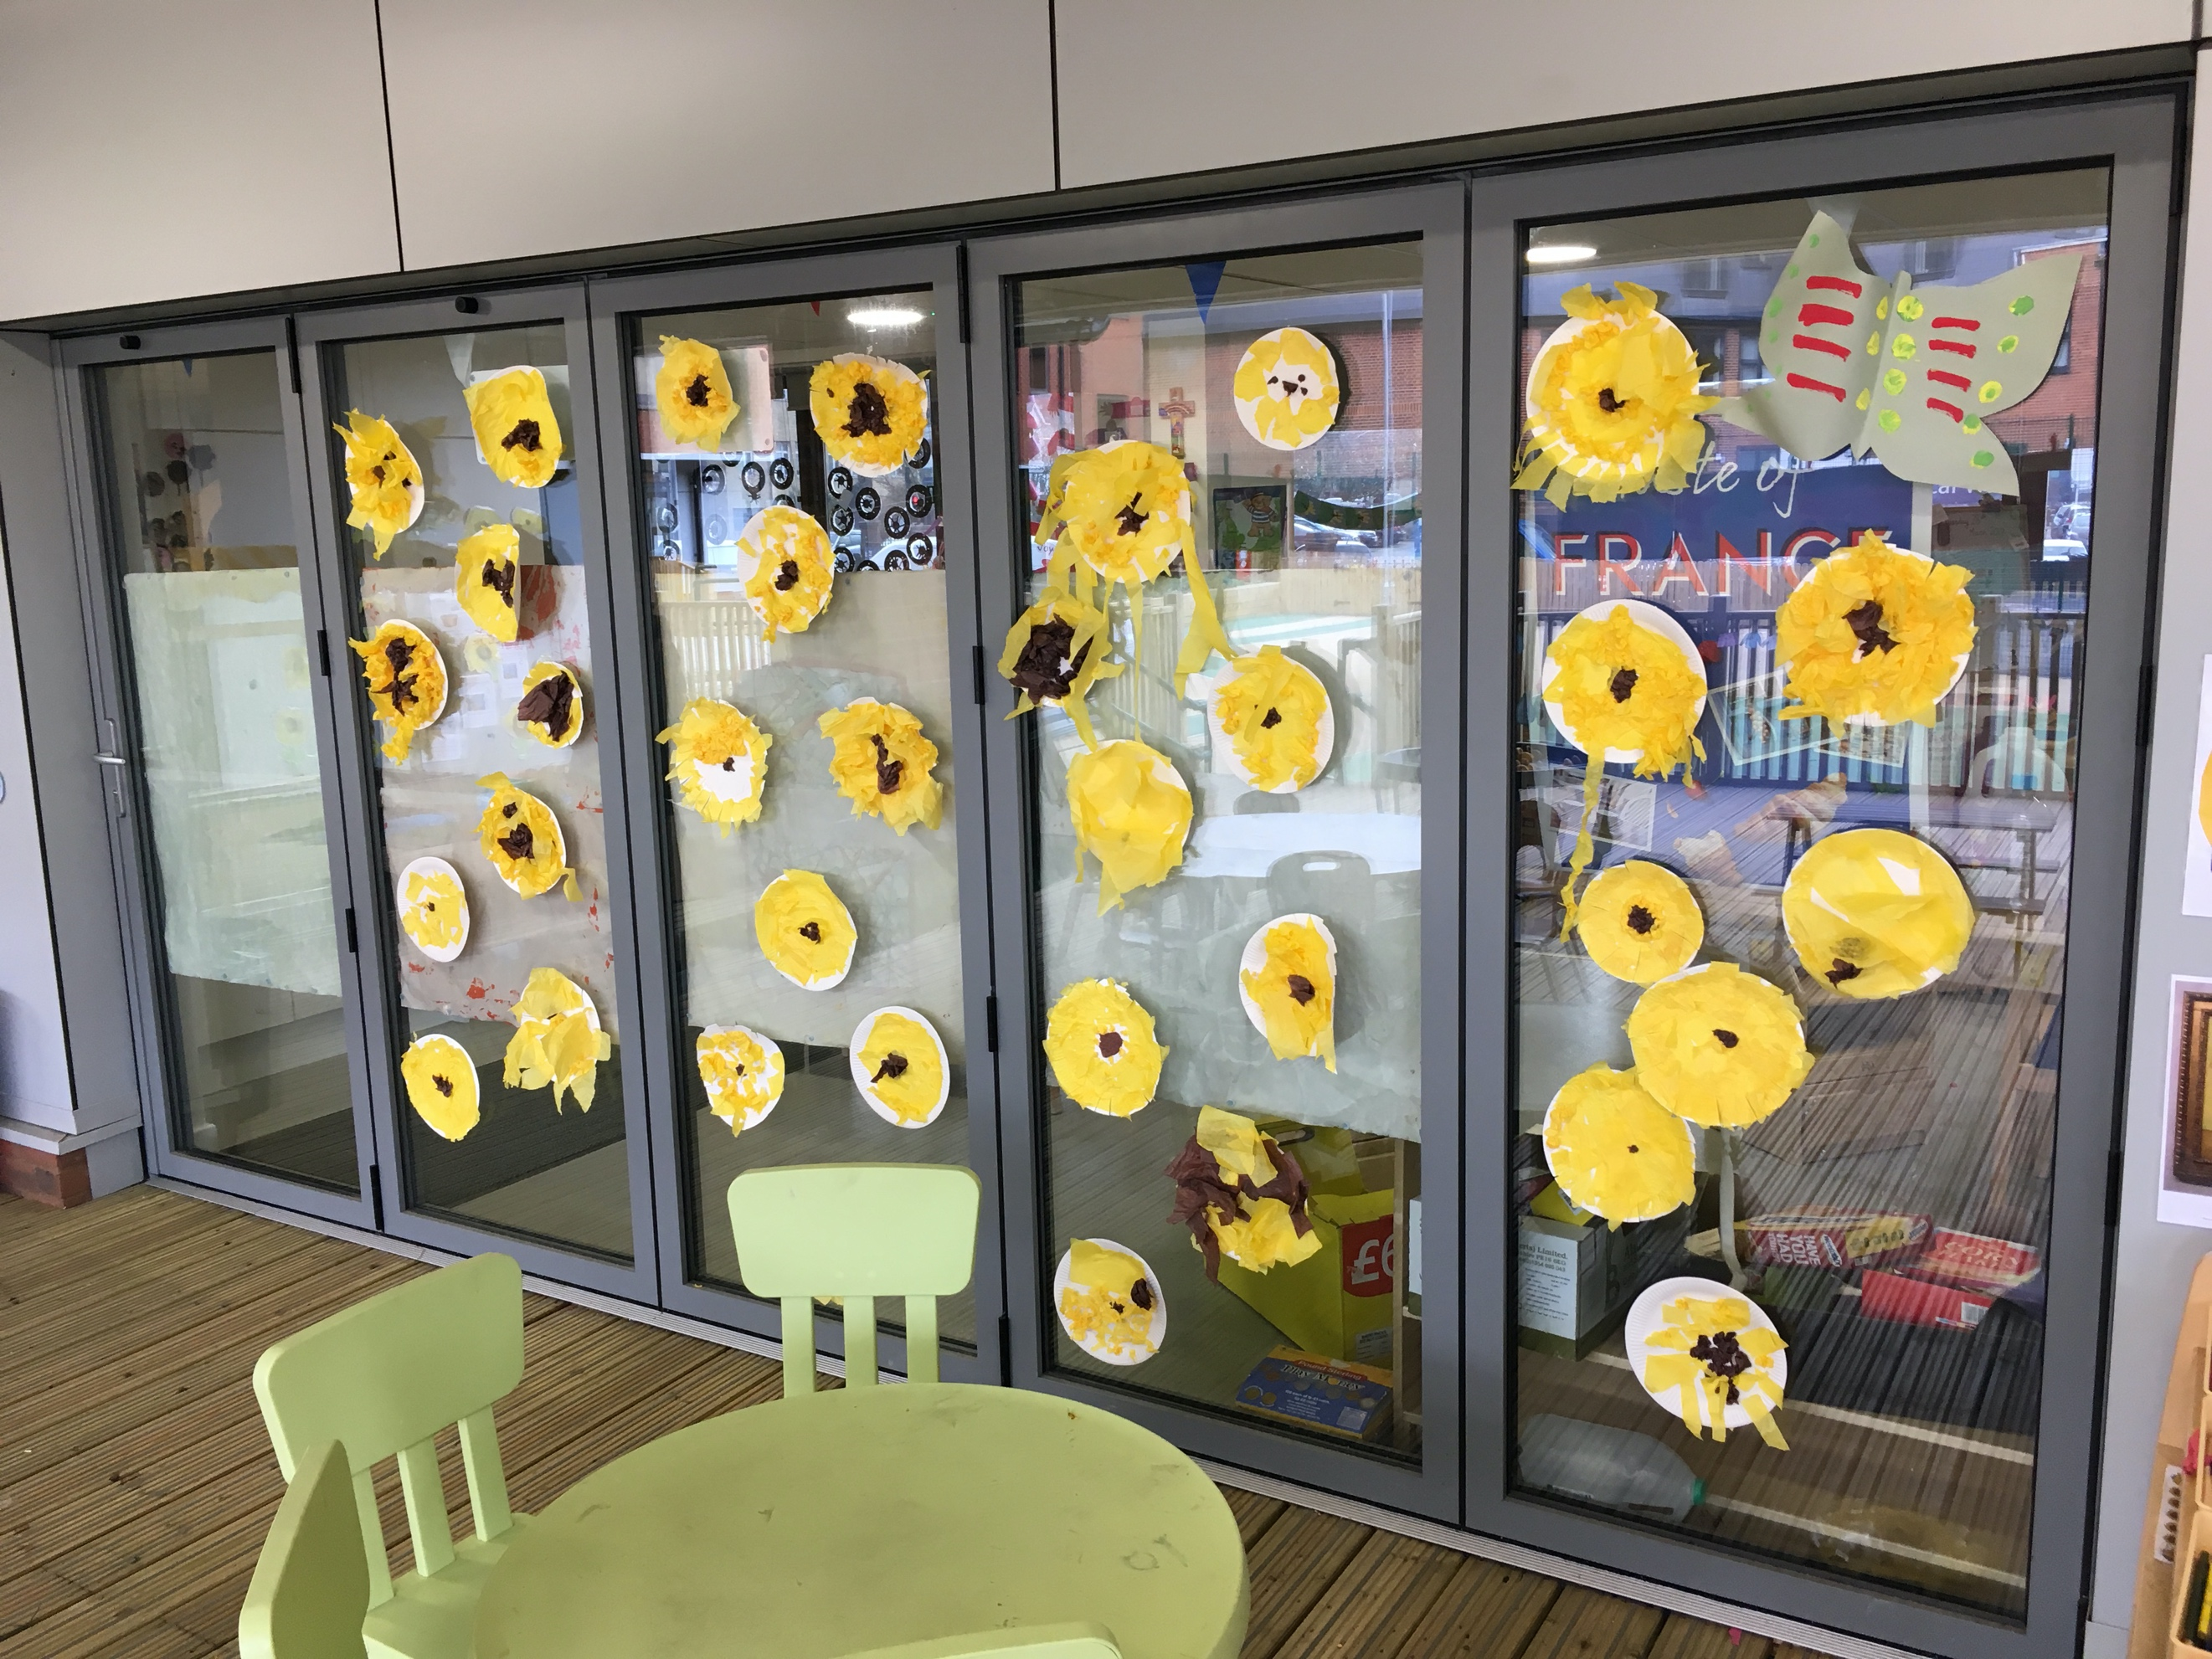

EYFS Outdoor Space

PERSON SPECIFICATION

CLASS TEACHER

 | Essential | Desirable
Qualifications | - Degree or equivalent  - UK Qualified Teacher status | - Further study or research in the field of Christian Education or Bilingual Education  - Qualification in French language or in Teaching French
Experience | - Experience of teaching EYFS, KS1 or KS2 as a qualified teacher in the UK that enabled pupils to make progress in learning and behaviour  - Experience of effective teaching of Phonics and reading that enables children to make rapid and sustained progress | - Experience of teaching in a bilingual environment  - Experience of teaching the French language or teaching the curriculum in French  - Experience of teaching in France or a Francophone country  - Experience of teaching in a Church of England Primary School
Knowledge and understanding | An excellent knowledge and understanding of:  - The theory and practice of providing effectively for the individual needs of all children (e.g. classroom organisation and learning strategies);  - Statutory National Curriculum requirements within the Early Years, KS1 and KS2;  - The monitoring, assessment, recording and reporting of children’s progress;  - The statutory requirements of legislation concerning Equal Opportunities, Health & Safety, SEND and Child Protection;  - The positive links necessary within school and with all its stakeholders; | An excellent knowledge and understanding of:  - The theory and practice of bilingual education and or supporting EAL learners  - The distinctive ethos of a Church of England School  - How technology can be used to enhance learning  - Knowledge of Godly Play
Skills | Class teachers will be able to:  - Plan effectively for the needs of all learners in the classroom;  - Differentiate well for all learners and adapt plans in the light of misconceptions;  - Understand how to accelerate the progress of pupils under achieving;  - Promote the school’s aims and ethos positively, and use effective strategies to monitor motivation and morale;  - Develop good professional relationships within a team;  - Establish and develop close relationships with parents, governors and the community;  - Communicate effectively (both orally and in writing) to a variety of audiences;  - Create a happy, challenging and effective bilingual learning environment. | Class teachers may be able to:  - Play a musical instrument and lead musical activities  - Lead the development of Reading, Phonics and Writing in English
Personal characteristics | - Be passionate about developing a bilingual approach to teaching and learning;  - Be willing to listen, take advice and adapt classroom practice;  - Be willing to be a life-long learner to improve classroom practice;  - Approachable  - Committed  - Empathetic  - Enthusiastic  - Organised  - Patient  - Resourceful | - A committed and practicing member of a Christian Church.  - Keen to undertake or contribute to research in the area of bilingual education and learning

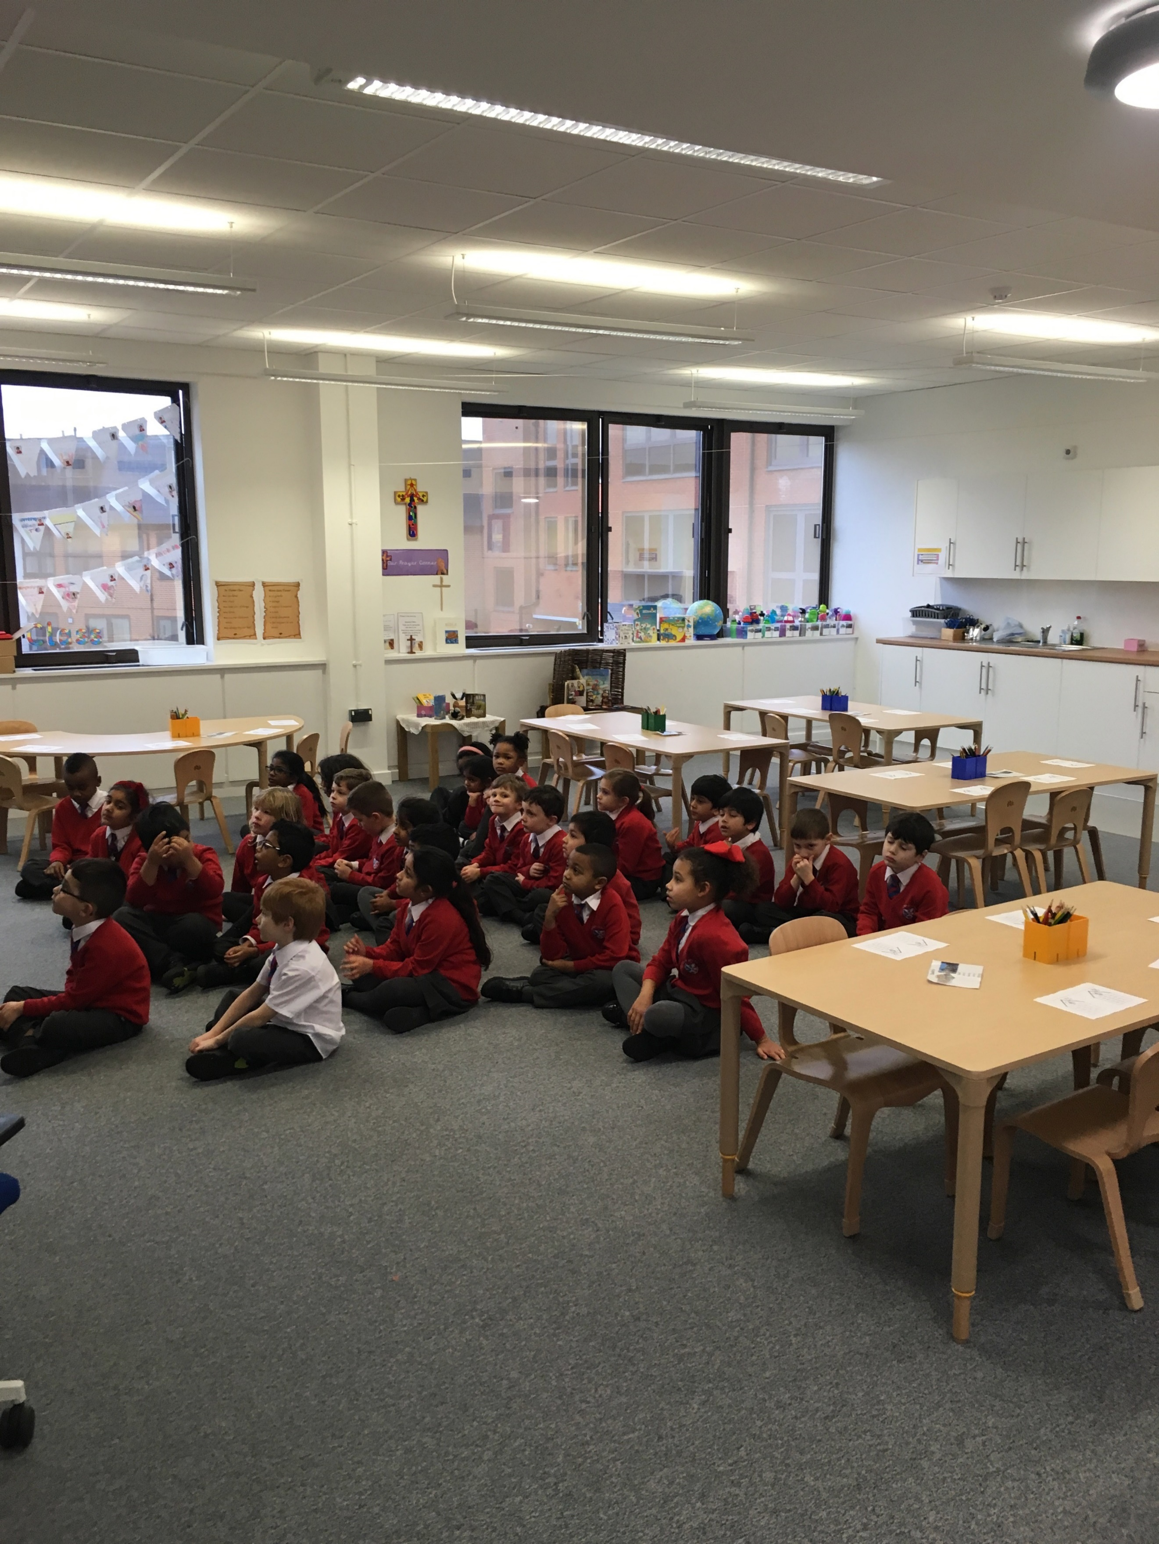
Year 1 Classroom

