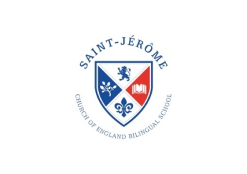

St. Jérôme Church of England   
Bilingual Primary School

Term Dates 2022-23

**Michaelmas Term 2022**

Term starts: Monday 5th September 2022

(Year 1 – Year 6 Pupils only)

Half Term: Friday 21st October 2022 to Friday 28th October 2022

Term ends: Thursday 15th December 2022

EYFS / KS1 at 1.30 pm and KS2 1:40 pm

**Epiphany Term 2023**

Term starts: Thursday 5th January 2023

Half Term: Monday 13th February to Friday 17th February 2023

Term ends: Friday 31st March 2023

EYFS / KS1 at 1.30 pm and KS2 1:40 pm

**Trinity Term 2023**

Term starts: Tuesday 18th April 2023

Bank Holiday: Monday 1st May 2023

Half Term: Monday 29th May to Tuesday 6th June 2023

Term ends: Thursday 20th July 2023

EYFS / KS1 at 1.30 pm and KS2 1:40 pm