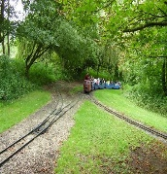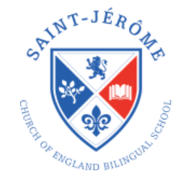

**Maths**

The children will continue to learn about **number and place value** ensuring they can count on or back from any number to 20. They will learn what 1 more and 1 less than a given number is and link this to **additional and subtraction**. They learn to add/subtract by counting on or back from a given number and use a number track to support. The children will learn to partition five, six and ten objects to find the different number bonds which total each number and write the corresponding number sentences.

When **problem solving** the children will understand that practical problems require a number sentence in order to solve the problem and will attempt to read and match the same. Children will revise all coins from1p to £2 and begin to assign value to these. They progress to making the value of 1 coin by using a number of different coins to the given value.

The children explore **measure** by using length, weight and capacity to directly compare different measures. They progress to using non-standard units of measurement to measure and compare a variety of different lengths to enhance their understanding.

**Reading**

Children will continue to take home a reading book set to their own ability each Friday to be returned the following Wednesday. It is expected that the children will read for 10 minutes per day during this time and we encourage you to take time to comment on their reading using their Reading Records.

**Homework**

Phonic homework will continue as normal.

In addition, one piece of maths homework will also now be sent home each Friday for completion by the following Wednesday. This will be set to your child’s mathematical ability.

It is with regret, that the provisionally planned visit to Cassiobury Park has been cancelled.

**Welcome back to Trinity Term 2!**   
  
I trust you all had a relaxing break with your family and were able to take time to celebrate the Queen’s Platinum Jubilee, representing 70 years on the thrown - what an achievement!

Please do take note of the new maths homework implemented for this term. This is to begin to prepare the children for the more formal maths which they will take on in Year 1.

For advice / support and any matters arising, please do not hesitate to contact me using the address: [office@stjeromebilingual.org](mailto:office@stjeromebilingual.org).

I wish you all a fabulous term ahead!

**Mrs Antoniou & the EYFS Team!**

**The Big Wide World!**

The children will learn about the global community to which they belong and explore how living things, communities and climates differ around the world. They will compare life in the United Kingdom with life on the African continent. The children will also begin to think about how they can care for their environment both locally and worldwide.

**English**

The children will work on basic sentence structure, learning how to punctuate their writing with a full stop and capital letter. They will use ‘Talk 4 Writing’ to begin to re-write and innovate their own stories.