St Jérôme C E Bilingual School

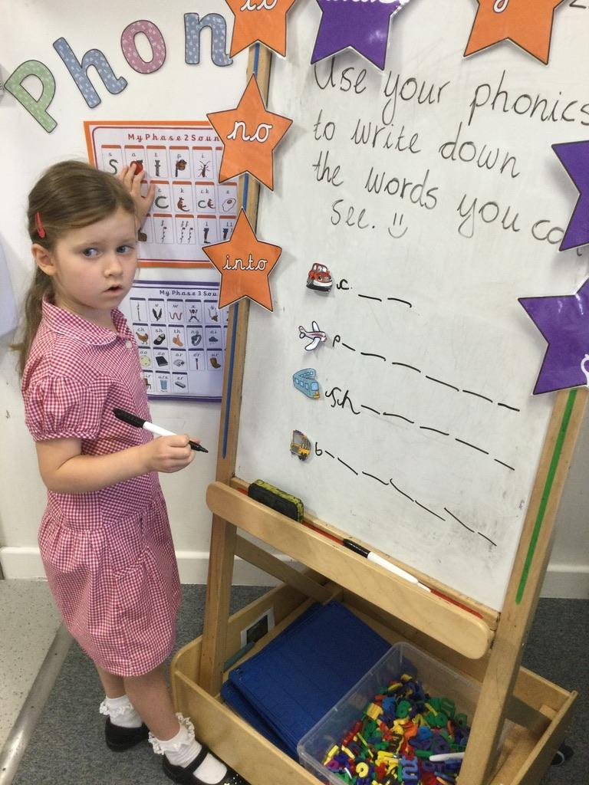

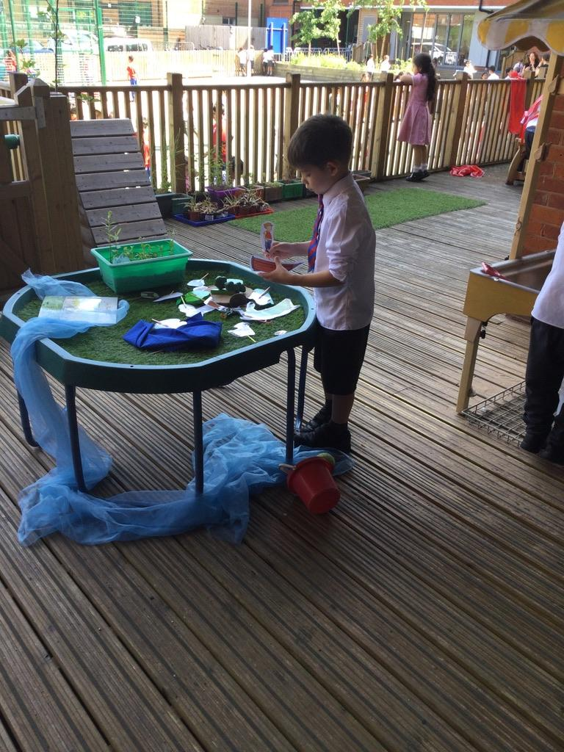

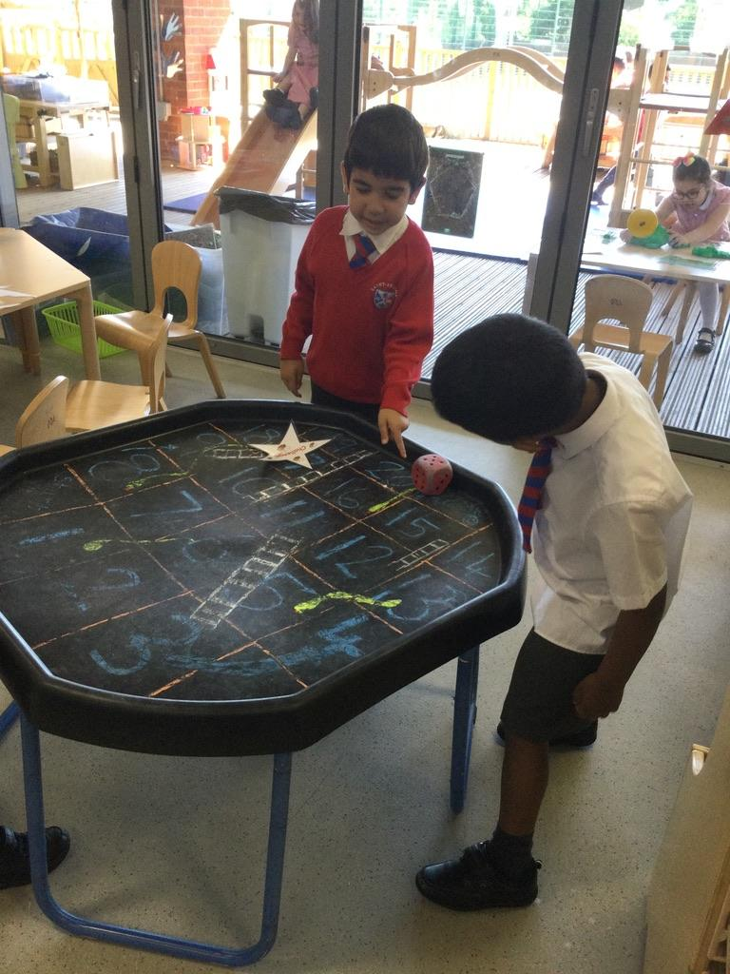
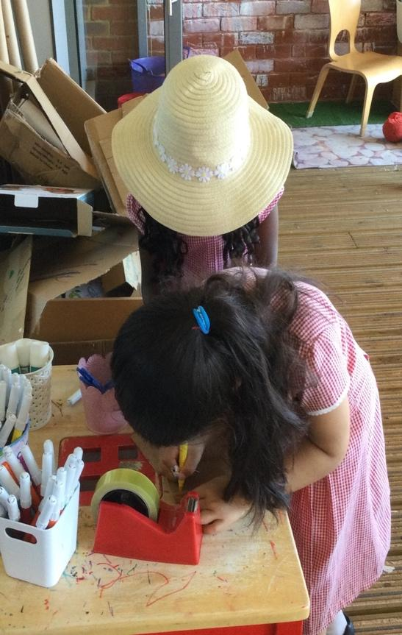

Transition to Year 1

Transition from Reception (EYFS)
into Year 1 (KS1)

The children have had a wonderful year in Reception and we are all proud of the progress they have made. We now endeavour to make your child’s transition to Year 1 a happy, positive experience for you all. This pack is designed to support this transition, lessening anxiety for both child and parent and therefore ensuring a smooth passage from current ‘play based learning’ towards a more formal approach to learning but one which will be both exciting and challenging as your child begins their journey through Key Stage 1.

There's a number of reasons why the transition from Reception to year 1 can be a little daunting for the children and our aim is to make this as calm and happy as possible.
- Firstly, learning in reception is play-based. Your child has had lots of freedom to choose their own activities and can move on to something else when they wish. In Year 1, learning becomes more formal, subject-based and adult-directed.
- Expectations increase in Year 1: your child will follow instructions, focus for longer periods and become more independent.
- There are fewer opportunities to 'let off steam' or to have some quiet time.
- Homework expectations can increase.
- Children have to cope with all of this, along with lots of other changes, such as a new teacher, new classroom and possibly new classmates.
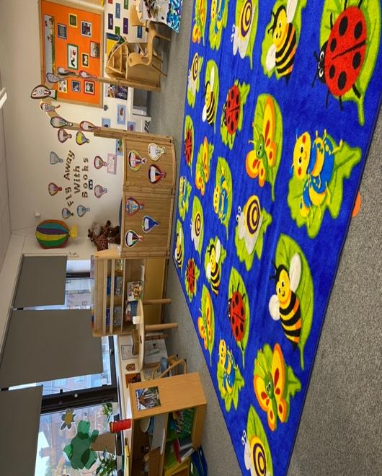
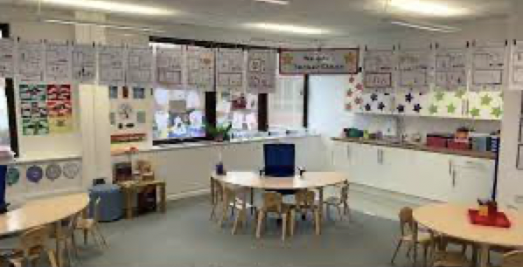
- For parents, there may be fewer opportunities for day-to-day contact with teaching staff.

What will St Jerôme School do to support my child
through this transition?

- We understand how difficult this transition can be and will support children using a variety of methods.
- Your child’s reception teacher will begin to discuss their move to Year 1 and more formal learning methods towards the end of the summer term so that children can get used to the new expectations.
- Your child will experience a transition afternoon, where the children will get the opportunity to spend some time in their new classroom with their new teacher, getting to know the new systems and expectations.
- Depending on the requirement of the cohort, your child’s Year 1 teacher may begin the new school year by continuing to allow some play-based learning opportunities, particularly for those children identified as needing this.

What can parents and carers do?
Talk positively about the move to Year 1 and play down your own anxieties if you have them. For example, instead of saying things like, 'You'll have to work a lot harder in year 1', say, 'It will be exciting to learn about new things, won't it?'
Talk to your little one about what is coming up in September. The summer holiday is a longer one, so it helps to keep the changes fresh in your child's mind. Talk about their new teacher and their friends – current and new ones!
Read, read, read. Reading with and to your child is the single most powerful thing you can do to prepare them for the year ahead.
Come to the ‘Meet the Teacher' meeting in the first term in order that you and your child’s class teacher can familiarise yourselves with each other. You will be given the opportunity to look around your child’s new classroom and ask any questions you may have.
Our School Values

Our school values are an important aspect of school life. Reminding your child of these values and using them at home throughout the summer will strengthen our pupils’ commitment to uphold these on their return to school in the Autumn.

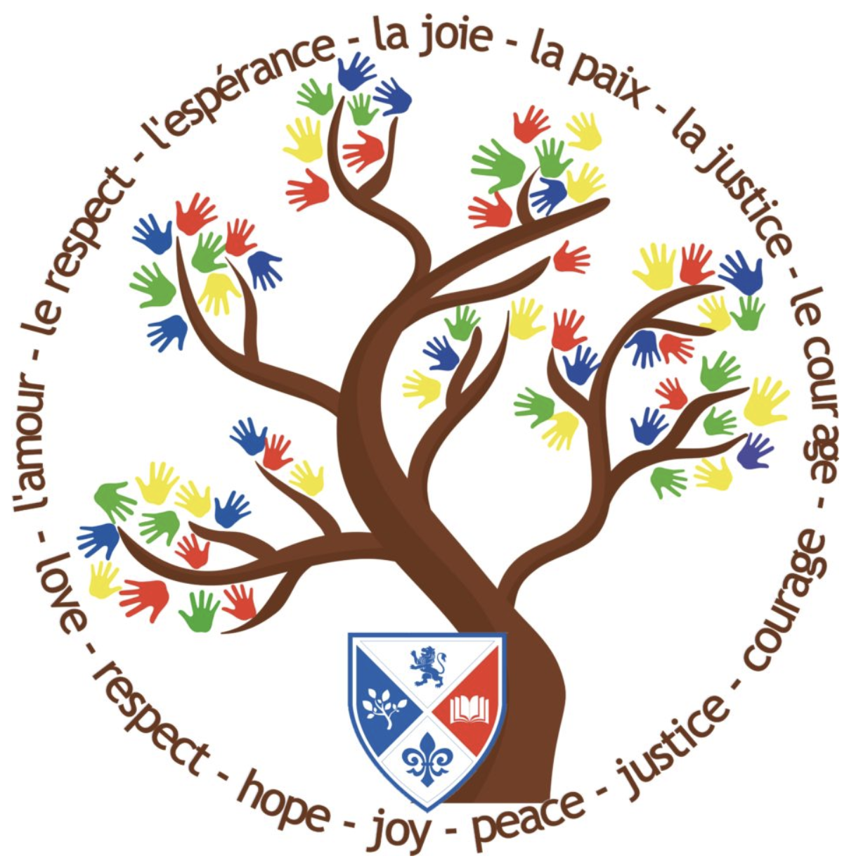
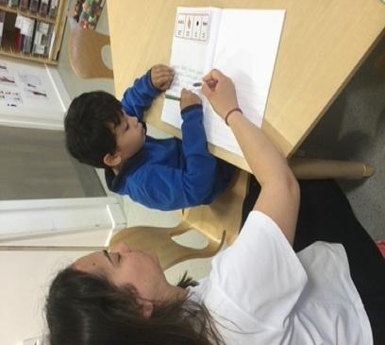
Learning Time

In Year 1 you will continue to learn phonics, develop new skills in maths and practise your reading and writing.

Learning in Year 1 is different. You will still be taught by your teacher on the carpet but then you will move to tables to complete your activities all together. You may sometimes work with a partner or in a group or sometimes you may work independently. You will always have the support of your teacher and any other adults in the classroom.

You will have new and exciting subjects to learn, such as Science, History and Geography and you will have different books to complete your work in for the different subjects. Just like Reception, each half term your topic will change to make learning interesting and you will continue to enjoy fun events such as educational visits, World Book Day and Sports Day!
Home Learning

Just as you did in Reception, you will be given some work to do at home.
We encourage you to read every day. You will be given a home reading record for your parents to record your reading progress at home. You will have English, Maths to complete and also some spellings to learn for a test each week.

It is important that you finish each piece of home learning that you are given as this consolidates everything you will have learnt throughout the week. This is how we make the best progress!

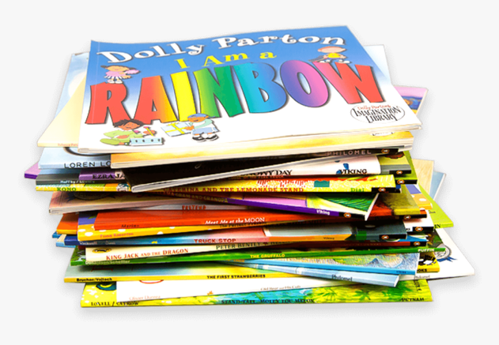

Summer Learning

The summer holiday is a long one so it is important that you try to continue your learning through the next few weeks. Below there are some ideas of what you could do.

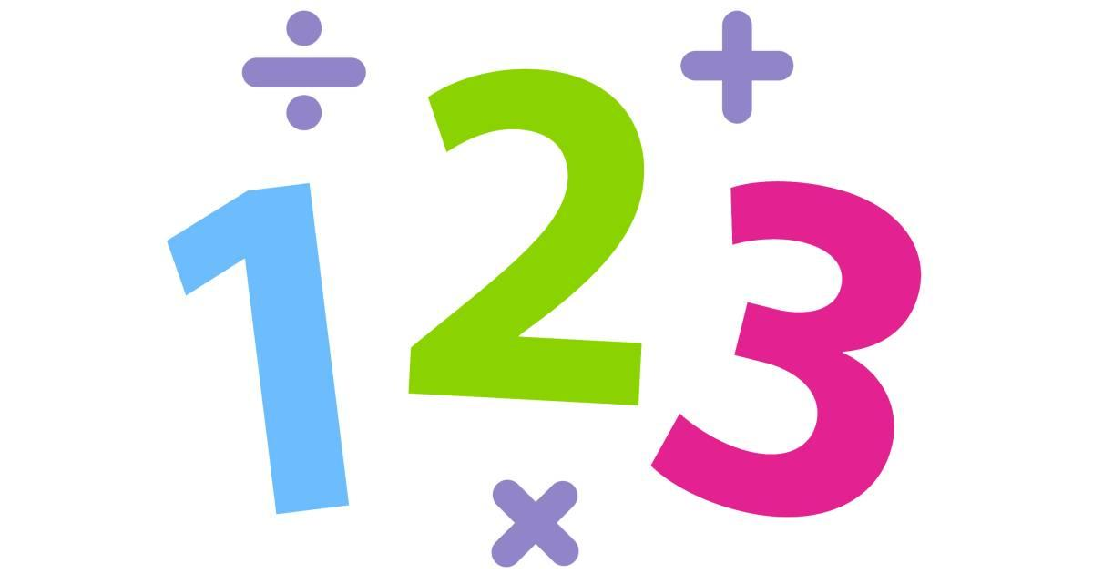
Maths:

- Practise counting, writing and ordering numbers to 30 and back or beyond!
- Begin to learn your 2 times table and your doubles to 10.
- Look for different 2-D and 3-D shapes around your home or environment and make a note of the different objects you find.
- Ask your parents or carers if you can count out different amounts of money when they pay for things at the shops.

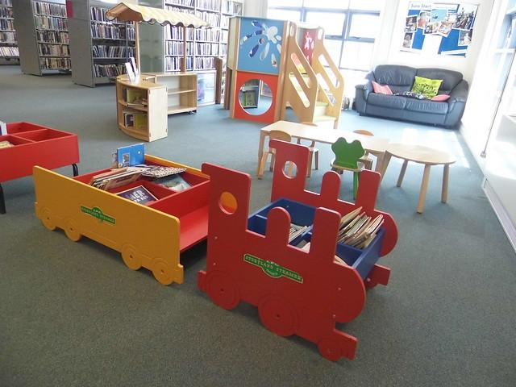
Reading:

- Visit the library
- Visit a book shop
- Read with a friend and swap books
- Find fun places to read like the beach or the park
- Make a note of the books you have read
- Login to Bug Club, where you will find lots of exciting books to read at your own level.
- Act out your favourite story!

Writing:

Write a sentence or a few sentences about the days of your holiday which you enjoyed the most. Space out these writing opportunities – for example, write one per week.

Try to include the following:
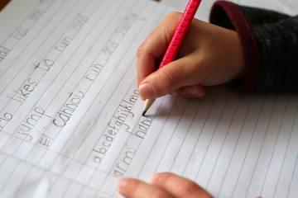

- a full stop and a capital letter
- an adjective
- use your best handwriting

The Year 1 staff look forward to welcoming you all back to school on Monday 5th September at 8.30am.

