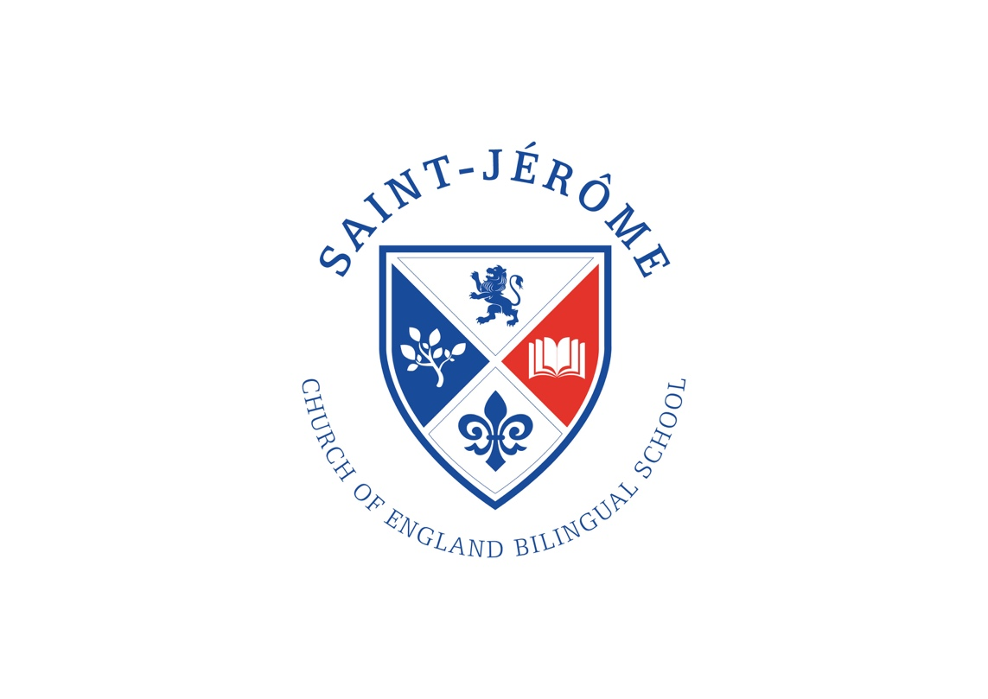

St. Jérôme Church of England
Bilingual School

SEND Information Report

September 2022

Executive Headteacher
Revd D. R. Norris

Chair of the Governing Body
Ian Fernandes

Please read in conjunction with our Inclusion Policy, which can be found in the ‘Our School’ section of our school website, under the heading: Inclusion. A link to the SEND local offer for Harrow can also be found in this section of our school website.
School | St. Jérôme Church of England Bilingual School
Type of school | Mainstream, Church of England, Free School Primary Academy
Number of pupils on roll | 402
Number of children identified as having SEND | 61
Number of children with an Education, Health and Care Plan (EHCP) | 4
WHAT DOES THE PROVISION AT ST. JÉRÔME LOOK LIKE FOR SEND?
Identifying and Assessing Special Educational Needs and Disabilities:
The focus, in the first instance, is on high quality learning and teaching for all pupils, which engages, motivates and challenges pupils from whatever their starting point. Through close tracking and monitoring of progress, we identify any areas of underachievement to establish the barriers to learning and determine if this is a SEND need or due to another factor.
Headteacher: Rev. Daniel Norris is responsible for:
- The day to day management of all aspects of school.
- Ensuring the Governing Body is kept up to date about any issues in school relating to SEND.
Inclusion Governor: Christian Penhale is responsible for:
- Making sure the school has an up-to-date SEND/Inclusion Policy and has a published offer of provision.
- Supporting the school in making sure that it has the appropriate provision to meet the needs of all learners.
Deputy Headteacher and SENCO: Sarah Cox is responsible for:
- Developing and reviewing the school’s SEND/Inclusion Policy to ensure that all children get a consistent, high quality response to meeting their needs.
- Liaising with professionals from external agencies who may be coming into school to help support children’s learning.
- Working with staff to achieve the best outcomes for children with SEND.
- Providing training and specialist support for teachers and support staff so that they are aware and confident about how to meet the needs of children with SEND.
HOW CAN PARENTS/CARERS LET THE SCHOOL KNOW THAT THEY ARE CONCERNED ABOUT THEIR CHILD?
- If you have any concerns we recommend you speak to your child’s class teacher initially.
- If further action is required, you are welcome to speak to the Phase Leader or our SENCO.
- The Headteacher is available to answer any concerns that cannot be resolved by our SENCO and Deputy Headteacher.
HOW DO WE IDENTIFY SEND?
Assessment is a continuous process throughout school. It is used to check that every child is making expected progress against the national expectations set for each year group. Adequate progress is defined as that which:
- Demonstrates progress against their individual starting points.
- Closes the attainment gap between a child and children of a similar age.
- Prevents the attainment gap growing wider
- Matches or is better than the previous rate of progress
- Ensures that a child has full access to the curriculum in line with their peers
- Demonstrates an improvement in self-help, social or personal skills
Definition of SEND in Code of Practice 2015:
‘A child or young person has SEND if they have a learning difficulty or disability which calls for special educational provision to be made for him or her.’
The SEND Code of Practice (2015) identifies less than expected progress as:
- Is significantly slower than that of their peers starting from the same baseline.
- Fails to match or better the child’s previous rate of progress.
- Fails to close the attainment gap between the child and their peers.
WHAT STEPS DO WE TAKE TO SUPPORT CHILDREN WITH SEND?
St. Jérôme School is an inclusive school that:
- Encourages the participation of pupils and their families;
- Integrates the work of Education, Health and Care providers;
- Follows a cyclical, graduated approach. The school uses the following graduated approach to respond to children’s Special Educational Needs and/or Disabilities:
1. Identified through ‘Raise the Concern’
Where a pupils’ attainment or progress is cause for concern teachers will share their concern with the child’s parents/carers and keep them regularly updated. The concern will be raised with the SENCO, who will monitor the quality of teaching and learning these children receive and they may be offered some additional support. Their progress will be closely monitored and evidenced. Parents/carers will be invited to discuss these concerns with the Class Teacher.
2. Individual Support Plans (Asses, Plan, Do, Review cycle)
If concerns persist the Class Teacher will be supported by the SENCO to identify up to 3 targets for the child to focus on. Teachers will receive guidance about the strategies and provision needed to support pupils towards meeting their targets. Parents/carers will be invited to discuss these targets with the Class Teacher. The targets will be monitored and evidenced over a number of weeks and then reviewed. Parents/carers will be invited to meet with the Class Teacher to review the progress made.
3. Placing children on the school’s SEND register.
If targets are not being met and there is concern that ‘everyday’ quality teaching is not enough to support the needs of the child then it may be decided that additional provision is required and specific learning programmes (in addition to those usually on offer in the classroom) are drawn up by the Class Teacher and SENCO. The provision is recorded on the school Provision Map and the child’s progress is carefully monitored. Parents/carers will be invited to discuss this provision with the SENCO and Class Teacher and to give permission for the child to be placed on our SEND register.
4. Specialist SEND support
If, despite receiving differentiated learning opportunities a child:
- makes little or no progress even when teaching approaches are targeted particularly in a child’s identified area of weakness
- shows persistent signs of difficulty in developing English or mathematical skills, which result in poor attainment in some curriculum areas
- presents with persistent emotional or behavioural difficulties, which are not met by the behavioural management techniques usually employed in the school
- has sensory or physical problems, and continues to make little or no progress despite the provision of specialist equipment
- has communication and/or interaction difficulties, and continues to make little or no progress despite the provision of a differentiated curriculum
then there is often the need for greater involvement of external agencies e.g. Speech and Language Therapists (SALT), Educational Psychologists (EP), Occupational Therapists (OT) etc… Parents/carers will be invited to meet with the SENCO to discuss the involvement of these specialist professionals.
5. Application for an Education, Health & Care (EHC) plan
Where a child’s needs are considerable and there is little progress following interventions and support from professional agencies the decision may be taken to request an Education, Health and Care (EHC) assessment from the Local Education Authority (LEA). Parents/carers will be fully involved in the process and have the opportunity to contribute to the request. Parents have the right to request an Education, Health and Care assessment directly from the Local Authority if they feel their child needs more support. If the local authority agree to an assessment, this may result in the issuing of an Education Health and Care Plan (EHCP) that outlines the child’s strengths and difficulties, as well as the provision required to meet the child’s Special Educational Needs.
HOW DO WE SUPPORT TRANSITION?
We recognise that ‘moving on’ can be difficult for a child with SEND and will take the following steps to ensure that any transition is a smooth as possible:
If your child is moving to another school:
We will contact the new school’s SENCO and ensure s/he knows about any special arrangements or support that needs to be made for your child. A social story or transition book may also help ease your child’s anxiety.
When moving classes in school:
Information will be passed on to the new class teacher in advance and in all classes, a planning meeting will take place with the new teacher. Your child may also have additional visits to their new classroom, or extra time to build a relationship with their new teacher. A social story or transition book may also help ease their anxiety.
In Year 6:
The SENCO will discuss the specific needs of your child with the SENCO of their secondary school. Your child may attend a small group session/s to support their understanding of the changes ahead. This may include creating a transition book, which includes information about themselves for the new school. All children will visit their High School and children with SEND may be offered additional visits to their new school and in many cases staff from the new school will visit your child at St Jerome.
If your child has an EHC plan, you will have the opportunity to name a secondary school setting during your Year 5 annual review meeting. The Local Authority will then consult with the school on your behalf to determine whether or not your child’s needs can be met in your school of preference.
Transition from Nursery:
Children with SEND are supported into Reception from Nursery settings with an invitation for parents to visit and attend a transition meeting with the Class teacher and the SENCO to prepare a transition plan. Whenever possible, we like to visit your child in their home setting to get to know your child a little better in the environment they are most comfortable in. Your child may also have additional visits to their new classroom, or extra time to build a relationship with their new teacher. A social story or transition book may also help ease their anxiety.
HOW DO WE INCLUDE CHILDREN WITH SEND ON SCHOOL TRIPS AND VISITS?
We encourage all children to attend educational trips and visits. In a few cases, the SENCO will discuss with parents before a school journey any specific arrangements for a child with SEND but this will not often be necessary.
HOW IS THE SCHOOL ENVIRONMENT MADE ACCESSIBLE FOR ALL CHILDREN?
We provide resources to support learning, and support the use of specialist equipment such as hearing systems or individual visualizers as necessary. We have a lift from the ground floor to all learning areas for those in a wheelchair. Individual care plans or risk assessments are developed for children with medical/additional needs in consultation with parents and health professionals as appropriate.
HOW IS FUNDING ALLOCATED TO CHILDREN WITH SEND?
The school budget, from Harrow Local Authority, includes funding to support children with SEND. The school identifies the needs of children on a whole school provision map to ensure that the SEND budget is used well. Additional funding may be allocated to SEND provision for individual children who have been assessed and issued with an Education, Health and Care Plan from the Local Authority.

