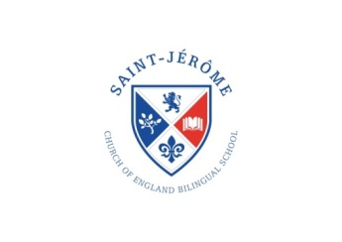

Saint Jérôme Church of England   
Bilingual Primary School

Term Dates 2023-24

**Michaelmas Term 2023**

Term starts: Wednesday 6th September 2023

(Year 1 – Year 6 Pupils only)

Half Term: Friday 20th October 2023 to Friday 27th October 2023

Term ends: Wednesday 20th December Term ends at 3.30pm / 3.40pm

**Epiphany Term 2024**

Term starts: Tuesday 9th January 2024

Half Term: Monday 12th February 2024 to Friday 16th February 2024

Term ends: Wednesday 27th March 2024 at 3.30pm / 3.40pm

**Trinity Term 2024**

Term starts: Tuesday 16th April 2024

Bank Holiday: Monday 6th May 2024

Half Term: Friday 24 May 2024 to Tuesday 4th June 2024

Term ends: Wednesday 24th July 2024 at 3.30pm / 3.40pm